SYSTEM ARCHITECTURE DOCUMENT
CyberRisk IQ
5 Spring Boot Services · Apache Kafka · PostgreSQL · React
Complete technical reference for architect assessment
Stack | Version / Notes
Frontend | React 18 + TypeScript + Recharts + REST consumption
API Gateway | Spring Cloud Gateway 4 — JWT, routing, rate limiting, CORS
Backend services | Spring Boot 3 (Java 21) — 4 microservices + 1 Python sidecar
Event bus | Apache Kafka — 6 topics, event-driven inter-service communication
Database | PostgreSQL 16 — schema-per-tenant, Spring Data JPA, Flyway
ML sidecar | Python Flask — GNN (PyTorch Geometric), LSTM (TensorFlow), SHAP
Auth / RBAC | OAuth2 + SAML2, Spring Security, Open Policy Agent (OPA)
Container | Docker + Kubernetes (K8s), Helm charts, GitHub Actions CI/CD

1. System Architecture Diagram
The diagram below shows all five layers of the CyberRisk IQ platform. Click any service box in the interactive version above. This static version is embedded for offline reading.

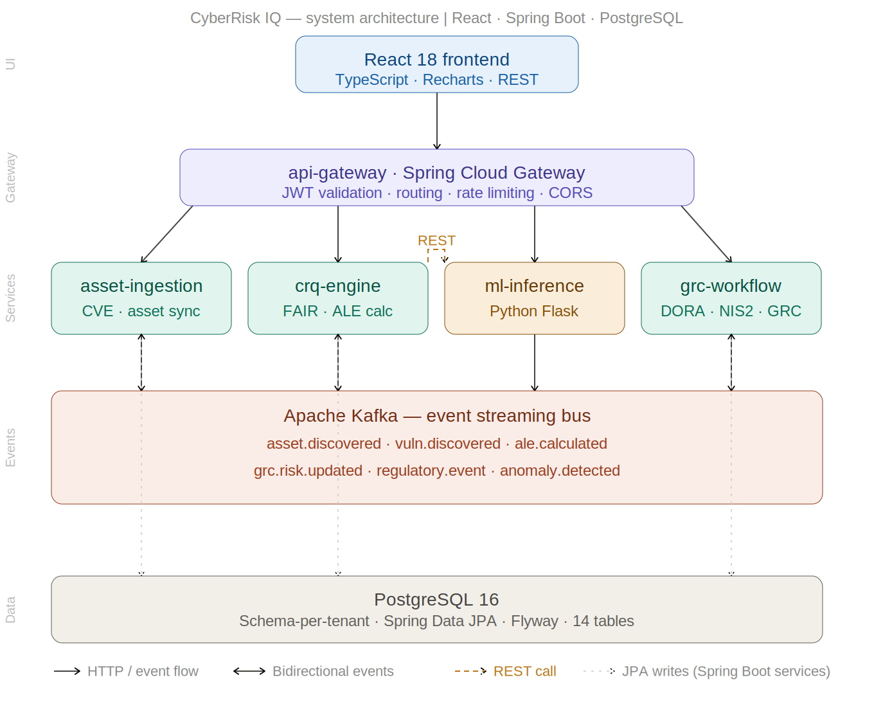

Symbol | Meaning
Solid arrow → | HTTP request flow (React → Gateway → Services) or Kafka event published
Bidirectional arrow ↕ | Services both publish AND consume on this Kafka topic
Dashed amber arrow - → | REST call from crq-engine to ml-inference Python sidecar
Dashed gray arrow - → | JPA direct database write from Spring Boot service to PostgreSQL
Teal boxes | Spring Boot 3 (Java 21) microservices
Amber box | Python Flask ML sidecar (optional, called via REST)
Purple box | Spring Cloud Gateway — single entry point for all traffic
Blue box | React 18 TypeScript frontend
Coral box | Apache Kafka event streaming bus
Gray box | PostgreSQL 16 — shared database, schema-per-tenant

2. Architecture Overview
ONE-PARAGRAPH SUMMARY
CyberRisk IQ is a five-layer, event-driven microservices platform. React consumes a REST API exposed by Spring Cloud Gateway. The gateway routes requests to four backend services. Services publish and consume events via Apache Kafka — decoupling them completely. All Spring Boot services persist to a shared PostgreSQL database using schema-per-tenant isolation. An optional Python Flask sidecar handles AI/ML inference and is called by the CRQ engine via REST.

2.1 Why event-driven — the key design decision
All inter-service communication uses Apache Kafka, not direct REST calls between services. This is the most important architectural decision to defend to your CTO.

Without Kafka — direct REST  If Asset service is slow or down, CRQ stalls. Services are tightly coupled. One failure cascades to everything. A new CVE cannot trigger automatic ALE recalculation without a synchronous call chain. | With Kafka — event streaming  Asset service publishes vulnerability.discovered. CRQ subscribes and recalculates ALE automatically. Services are fully decoupled. CRQ can be offline, come back up, and replay all missed events.

3. Apache Kafka — Event Topics
Topic | Published by | Consumed by | When triggered | Payload summary
asset.discovered | asset-ingestion | crq-engine, grc-workflow | New asset found or changed | asset_id, hostname, business_value, regulatory_scope, tenant_id
vuln.discovered | asset-ingestion | crq-engine | CVE matched to a customer asset | cve_id, cvss_score, epss_score, is_kev, affected_asset_ids, mitre_ttps
ale.calculated | crq-engine | grc-workflow | FAIR + Monte Carlo completes | asset_id, cve_id, ale_p10, ale_p50, ale_p90, vulnerability_ratio, roi
grc.risk.updated | grc-workflow | api-gateway (cache) | Risk register entry changed | risk_id, treatment, ale_p50, regulatory_flags, updated_at
regulatory.event | grc-workflow | grc-workflow (async) | DORA incident or NIS2 obligation triggered | event_type, tenant_id, classification, deadline, report_url
anomaly.detected | ml-inference | crq-engine | LSTM detects unusual telemetry | asset_id, reconstruction_error, severity, anomalous_features

4. The Five Services — Reference

S1 | api-gateway — Spring Cloud Gateway  Layer 2 · Entry point · JWT · routing · rate limiting · CORS

Single entry point for all external traffic. Validates every JWT before routing. Enforces per-tenant rate limits via Redis. Injects X-Tenant-ID header for downstream schema switching.

Responsibility | Implementation
JWT validation | Spring Security OAuth2 Resource Server. Validates RS256 tokens. Extracts tenant_id and role claims, forwards as request headers.
Routing | Spring Cloud Gateway routes in application.yml. /api/v1/risks/** → crq-engine-service, /api/v1/regulatory/** → grc-workflow-service.
Rate limiting | RequestRateLimiter filter. Redis-backed sliding window. 100 req/min per tenant (standard), 500 (professional).
Multi-tenancy | Extracts tenant_id from JWT, adds X-Tenant-ID header. Backend services use this to execute SET search_path before DB queries.

S2 | asset-ingestion-service — Spring Boot  Layer 3 · CVE ingestion · Asset discovery · Shadow AI · NHI · Connector framework

Data foundation of the platform. Connects to external security scanners via pluggable connector interface, normalises data to internal schema, and publishes Kafka events that trigger all downstream processing.

Responsibility | Implementation
Asset discovery | @Scheduled polling every 15 min. QualysConnector, TenableConnector implement SecurityConnector interface. Each runs as an independent Spring Bean, conditionally enabled via @ConditionalOnProperty.
CVE ingestion | NVD CVE feed every 6h. CISA KEV daily. EPSS (FIRST.org) daily. CVEs mapped to assets via CPE string matching. Publishes vuln.discovered to Kafka.
Shadow AI detection | DNS query log analysis. Known AI provider domain list. Outbound HTTP proxy log scan. Results stored as shadow_ai_tools table.
NHI discovery | Okta and Azure AD API scan every 24h. Credential risk scoring on 4 dimensions: days_since_last_use, privilege_level, mfa_enabled, graph-based blast radius.

// BaseConnector.java — all connectors implement this
public interface SecurityConnector {
List<RawAsset> fetchAssets();
List<RawVulnerability> fetchVulnerabilities();
}

// After normalisation, publish to Kafka:
kafkaTemplate.send(vuln.discovered,
tenantId.toString(), VulnerabilityEvent.from(saved));

S3 | crq-engine-service — Spring Boot  Layer 3 · FAIR model · Monte Carlo · ALE calculation · Remediation ROI

The intellectual core of the product. Listens for Kafka events, runs the FAIR model, executes 10,000-iteration Monte Carlo simulation using Apache Commons Math, and publishes ALE results.

FAIR component | Java class | Key calculation
Threat Event Frequency (TEF) | TefCalculatorService | Industry baseline × exposure multiplier (2.5x internet-facing) × EPSS boost × KEV boost (3x). Returns BetaPertDistribution.
Vulnerability (V = TC/CS) | VulnerabilityCalculatorService | Threat Capability 0-100 from exploit availability + EPSS. Control Strength 0-100 from 7 control types. Ratio capped at 1.0.
Loss Magnitude (LM) | LossMagnitudeService | Primary: IR + regulatory fines (DORA/NIS2 schedule) + downtime revenue loss. Secondary: churn + legal liability + reputation. Returns BetaPertDistribution.
Monte Carlo ALE | MonteCarloService | 10,000 iterations. Each: sample TEF × V = LEF, sample LM, ALE = LEF × LM. Output: P10, P50, P90 using Apache Commons Math Percentile.
Remediation ROI | RemediationService | Re-run Monte Carlo with patch_applied=true (CS += 40). ROI = (current P50 − projected P50) / remediation_cost. Sort descending.

// MonteCarloService.java — core ALE calculation (Apache Commons Math)
public AleResult simulate(BetaPertDistribution tef, double vuln,
BetaPertDistribution lm) {
double[] results = new double[10_000];
Random rng = new Random();
for (int i = 0; i < 10_000; i++)
results[i] = (tef.sample(rng) * vuln) * lm.sample(rng);
Percentile p = new Percentile();
p.setData(results);
return AleResult.builder()
.aleP10((long) p.evaluate(10)) // EUR best case
.aleP50((long) p.evaluate(50)) // EUR most likely
.aleP90((long) p.evaluate(90)) // EUR worst case
.build();
}

S4 | ml-inference-service — Python Flask  Layer 3 · Optional sidecar · Called by crq-engine via REST · GNN · LSTM · SHAP

Python Flask microservice deployed alongside Spring Boot services. crq-engine calls it via REST using MlInferenceClient.java backed by Resilience4j circuit breaker. This is the standard Java + Python sidecar pattern used by Netflix, Uber, and Spotify.

Algorithm | Purpose | REST endpoint | Library
GraphSAGE GNN | Models risk propagation through the asset graph — blast radius of a compromise | POST /api/v1/risk-propagation | PyTorch Geometric
LSTM Autoencoder | Detects behavioural anomalies in asset telemetry without labelled attack data | POST /api/v1/anomaly | TensorFlow/Keras
Isolation Forest | Identifies unusual risk scenarios outside standard FAIR patterns | POST /api/v1/outlier-scenarios | scikit-learn
SHAP | Explains which features drove each ALE score — stored as JSONB for EU AI Act compliance | POST /api/v1/explain | SHAP library

S5 | grc-workflow-service — Spring Boot  Layer 3 · DORA · NIS2 · EU AI Act · GRC register sync · RBAC · Board reporting

The first-mover capability of the platform. Consumes ale.calculated Kafka events and routes financial risk data into GRC registers, DORA ICT risk tables, NIS2 obligation trackers, board reports, and regulatory export formats. No current competitor does this automatically.

Capability | Implementation
GRC register sync | Consumes ale.calculated events. Creates/updates grc_risk_entries with ALE values, regulatory flags, SHAP explanation. Syncs to ServiceNow or MetricStream via REST connector every 15 minutes.
DORA compliance | DoraIncidentClassificationService evaluates 6 RTS criteria for Major vs Non-Major. Major triggers 72-hour workflow: Compliance Officer notification, EBA template generation, deadline tracking.
NIS2 compliance | Entity classification (Essential/Important). 10-domain obligation tracker. Incident notification with per-country authority endpoints and 24/72-hour deadlines.
EU AI Act | Shadow AI discovery classified against risk tiers. Conformity assessment workflow for High-Risk systems. SHAP-explainable outputs satisfy Article 13 transparency requirements.
RBAC enforcement | Spring Security @PreAuthorize on all endpoints. 8 roles: PLATFORM_ADMIN, CISO, SOC_ANALYST, COMPLIANCE_OFFICER, RISK_MANAGER, CFO, BOARD_MEMBER, IT_ENGINEER.
Board reporting | Auto-generated CISO briefing pack, CFO insurance gap analysis, board top-10 summary in EUR. PDF via iText 7. Zero manual assembly required.

5. PostgreSQL Data Model
MULTI-TENANCY: SCHEMA-PER-TENANT
Every tenant gets a dedicated PostgreSQL schema (tenant_abc123). TenantInterceptor extracts tenant_id from JWT and runs SET search_path TO tenant_{id} before every query. Complete SQL-level isolation — a query in one tenant schema physically cannot access another.

Table | Purpose | Key design notes
public.tenants | One row per customer organisation | Lives in shared public schema. annual_revenue and daily_revenue stored as BIGINT cents to avoid float drift.
assets | All discovered IT assets | business_value DECIMAL(4,1) drives Loss Magnitude. regulatory_scope TEXT[] avoids join table. ale_p10/p50/p90 BIGINT (EUR cents) updated by CRQ engine.
asset_connections | Asset-to-asset relationships for blast radius | Self-referencing join table. Queried via PostgreSQL recursive CTE — replaces Neo4j graph database entirely.
vulnerabilities | All CVEs matched to customer assets | epss_score DECIMAL(5,4) for precision. is_kev BOOLEAN flags CISA Known Exploited. mitre_ttps TEXT[].
asset_controls | Security controls per asset | 7 Boolean columns: mfa_enabled, edr_deployed, waf_enabled, siem_monitoring, privileged_access_mgmt, patch_applied. Drives Vulnerability ratio calculation.
risk_scenarios | ALE values per asset+CVE — core output | ale_p10/p50/p90 BIGINT. roi DECIMAL(8,2). shap_explanation JSONB (GIN indexed). treatment VARCHAR(20). Indexed on (tenant_id, ale_p50 DESC).
grc_risk_entries | GRC register entries linked to risk scenarios | grc_platform_ref stores ServiceNow/MetricStream record ID for bi-directional sync.
ale_history | Time-series ALE for trend charts | Append-only table. Indexed on (asset_id, recorded_at DESC). Separated from hot risk_scenarios to avoid table bloat.
dora_ict_risks | DORA ICT risk register | financial_impact BIGINT mapped from ale_p50. dora_articles TEXT[]. Formatted for EBA XBRL export.
dora_incidents | DORA incident log | classification MAJOR/NON_MAJOR. report_deadline TIMESTAMPTZ. criteria_met JSONB records which RTS criteria fired.
nis2_obligations | NIS2 10-domain obligation tracker | entity_class ESSENTIAL/IMPORTANT. domain VARCHAR(50). status NOT_STARTED/IN_PROGRESS/COMPLIANT/NON_COMPLIANT.
shadow_ai_tools | Shadow AI tools discovered | eu_ai_act_risk_tier VARCHAR. financial_exposure_eur BIGINT from FAIR scoring. users_detected INTEGER.

6. Technology Stack and Deployment
Category | Technology | Purpose
Frontend | React 18 + TypeScript + Vite | Role-based dashboards, ALE Recharts visualisations, JWT auth
API gateway | Spring Cloud Gateway 4 | JWT validation, routing, rate limiting, CORS, tenant header injection
Backend (x3) | Spring Boot 3 (Java 21) | asset-ingestion, crq-engine, grc-workflow — stateless, horizontally scalable
ML sidecar | Python Flask + PyTorch + TensorFlow + SHAP | GNN, LSTM autoencoder, Isolation Forest, SHAP explainability
Event bus | Apache Kafka 3.x + Spring Kafka | 6 topics, 3 partitions each, 7-day retention, manual offset commit
Database | PostgreSQL 16 + Spring Data JPA + Flyway | Schema-per-tenant, 12 tables, JPA repositories, migration versioning
Cache | Redis 7 | Gateway rate limiting, session tokens, Celery async task broker
Access control | Spring Security + OPA | @PreAuthorize RBAC + externally auditable OPA policies in Git
Secrets | HashiCorp Vault | API keys, DB credentials, certificates — no secrets in env vars
Containers | Docker + Kubernetes + Helm | Service deployment, HPA autoscaling on Kafka consumer lag metric
CI/CD | GitHub Actions + Terraform | Automated tests, Docker builds, K8s rolling deploys, IaC cloud-agnostic
Observability | Prometheus + Grafana | ALE calc latency, Kafka consumer lag, service error rates, DB pool metrics

6.1 Service startup order — critical for local dev and CI/CD
Order | Component | Why this order matters
1st | PostgreSQL | Flyway runs DB migrations on Spring Boot startup. All services fail if DB is not ready.
2nd | Redis | API gateway rate limiter connects to Redis on startup. Gateway health check fails without it.
3rd | Apache Kafka | Spring @KafkaListener attempts broker connection on startup. Start Kafka before any service that consumes topics.
4th | ml-inference-service | crq-engine calls this via REST. Resilience4j handles unavailability gracefully but start early to avoid circuit trips.
5th (parallel) | asset-ingestion + crq-engine + grc-workflow | No cross-service startup dependency. All three can start simultaneously once Kafka is ready.
6th | api-gateway | Start last so all backend services are healthy before accepting traffic from React.
7th | React frontend | Browser app — loads after gateway is accepting requests.

System Architecture Document · v1.0 · 11 May 2026 · Confidential — architect assessment

