A PROJECT TITLE
ON
Climate Pattern Analysis Using K-Means Clustering and PCA
Project report submitted in partial fulfilment of the requirements for the Course
MACHINE LEARNING
BACHELOR OF TECHNOLOGY
A.Y.: 2026-27
By
Gundla Laxmi Sri — Roll No. 2520030264
Kalavala Chaitanya — Roll No. 2520030266
Akkinepally Raghava Koundinya — Roll No. 2520030271
Under the Esteemed Guidance of
Gaddam Ravinder Babu
Assistant Professor, CSE
DEPARTMENT OF CSE

Abstract
Climate change and variations in weather conditions make it important to analyze climate data and identify meaningful patterns among different regions. This project, “Climate Pattern Analysis Using K-Means Clustering and PCA,” aims to develop an unsupervised machine learning system for discovering similar climate patterns from weather-related data. The dataset consists of parameters such as temperature, humidity, rainfall, wind speed, atmospheric pressure, and other relevant climate features. The data is first preprocessed by handling missing values, removing unnecessary records, and applying feature scaling to ensure that all features contribute appropriately to the analysis. Principal Component Analysis (PCA) is then applied for dimensionality reduction while preserving the maximum important information from the dataset. The transformed data is analyzed using the K-Means clustering algorithm to group regions with similar climatic characteristics. The optimal number of clusters is determined using the Elbow Method and Silhouette Score. The resulting clusters are visualized using PCA-based representations to make climate patterns easier to understand. The project demonstrates the application of unsupervised learning, dimensionality reduction, preprocessing, clustering, evaluation, and visualization for climate analysis. The identified patterns can support environmental monitoring, agricultural planning, climate research, and data-driven decision-making.
Keywords: Climate Analysis, K-Means Clustering, PCA, Unsupervised Learning, Silhouette Score, Elbow Method

1. Introduction

1.1 Purpose of the Project
Climate conditions vary significantly across geographical regions. Changes in temperature, rainfall, humidity, wind speed, atmospheric pressure, and cloud cover influence the environment and human activities. Because climate datasets contain many observations and interacting variables, manual analysis can be difficult.
This project uses unsupervised machine learning to discover similar climate characteristics without predefined labels. PCA is used to simplify the feature space and support visualization, while K-Means groups observations into meaningful climate patterns. The results can support environmental monitoring, agriculture, climate research, and data-driven planning.

1.2 Problem Statement
The problem is to analyze multivariate climate observations and group observations with similar climatic characteristics without using a predefined target label. The expected output is a set of climate clusters representing distinct patterns in the dataset, evaluated using the Elbow Method, Silhouette Score, cluster distribution, and PCA-based visualization.

1.3 Existing Methods and Disadvantages
Traditional climate analysis may examine individual weather variables or use manually defined categories. Such approaches can make it difficult to identify combined patterns across several climate parameters at the same time.
Multivariate clustering can consider several numerical variables together, but differences in feature scales can affect distance-based clustering and many dimensions can make direct visualization difficult. Therefore, scaling and dimensionality reduction are useful parts of the proposed analysis.

1.4 Proposed System
The proposed system follows a pipeline of climate-data inspection and cleaning, numerical feature selection, standardization, PCA, evaluation of candidate cluster counts using the Elbow Method and Silhouette Score, K-Means clustering, and climate-pattern interpretation. The final K=3 solution is interpreted as Hot-Humid, Cool-Rainy, and Moderate-Dry/Windy.

1.5 Research Objectives
- Prepare and inspect a suitable climate dataset for unsupervised analysis.
- Perform preprocessing and exploratory analysis of climate variables.
- Select relevant numerical climate features and standardize them.
- Apply PCA to reduce dimensionality while retaining important information.
- Develop K-Means clusters and evaluate candidate values of K using the Elbow Method and Silhouette Score.
- Interpret the resulting climate patterns and discuss their practical relevance.

2. Literature Survey
The project is related to recent research on climate-region clustering, rainfall regionalization, weather-regime classification, and weather-pattern analysis. The following studies are included as directly relevant background references.
S.No. | Title | Reference with DOI | Problem/gap | Objective | Methods | Inference | Future research
1 | Identification and Variability Analysis of New Homogeneous Summer Monsoon Rainfall Regions Over India by Using K-Means Clustering Technique | P. P. Sreekala and C. A. Babu, 2025, International Journal of Climatology, vol. 45, article e8759, doi: 10.1002/joc.8759. | Identify homogeneous rainfall regions. | K-Means and rainfall variability analysis. | Shows clustering can reveal homogeneous monsoon rainfall regions. | Use longer records and additional climate variables.
2 | Identifying recurring patterns of extreme daily precipitation using K-means algorithm: Uncovering spatial shift driven by climate change over the Italian Peninsula | Weather and Climate Extremes, vol. 51, article 100849, 2026, doi: 10.1016/j.wace.2025.100849. | Identify recurring extreme precipitation patterns. | K-Means precipitation-pattern analysis. | Shows clustering can identify recurring precipitation regimes. | Extend analysis across longer periods and regions.
3 | Use of multivariate techniques to regionalize rainfall patterns in semiarid Botswana | G. Nkoni, K. Mphale, N. Mbangiwa et al., 2024, Discover Environment, vol. 2, article 77, doi: 10.1007/s44274-024-00111-8. | Regionalize rainfall patterns. | Multivariate clustering/statistical analysis. | Shows data-driven rainfall regionalization is useful. | Combine more atmospheric variables and longer observations.
4 | Primary Factors and Synoptic Pattern Classification of Mega Asian Dust Storms in Korea | S. Lee, J. W. Yoon, and S. K. Park, 2024, Asia-Pacific Journal of Atmospheric Sciences, vol. 60, no. 5, pp. 655–667, doi: 10.1007/s13143-024-00374-4. | Classify complex dust-storm patterns. | Synoptic-pattern classification and atmospheric analysis. | Highlights pattern classification for atmospheric studies. | Study more event types and wider regions.
5 | Innovative Trend Analysis Technique with Fuzzy Logic and K-Means Clustering Approach for Identification of Homogenous Rainfall Region | Quaternary Science Advances, vol. 15, article 100227, 2024, doi: 10.1016/j.qsa.2024.100227. | Identify homogeneous rainfall regions. | Trend analysis, fuzzy logic, and K-Means. | Combining clustering with trend analysis supports regional interpretation. | Test alternative clustering and uncertainty methods.
6 | Clustering Data Meteorologi Wilayah Indonesia Timur dengan Metode K-Means dan Fuzzy C-Means | G. Andrian, D. Arisandi, and T. Handhayani, 2024, INTI Nusa Mandiri, vol. 18, no. 2, pp. 100–106, doi: 10.33480/inti.v18i2.5039. | Cluster meteorological data. | K-Means and Fuzzy C-Means. | Shows clustering applicability to meteorological observations. | Compare more clustering algorithms and longer datasets.
7 | A New Year-Round Weather Regime Classification for North America | S. H. Lee, M. K. Tippett, and L. M. Polvani, 2023, Journal of Climate, vol. 36, no. 20, pp. 7091–7108, doi: 10.1175/JCLI-D-23-0214.1. | Classify recurring weather regimes. | Weather-regime classification and atmospheric patterns. | Provides a systematic regime-classification framework. | Investigate changes under future climate scenarios.
8 | Identifying Probabilistic Weather Regimes Targeted to a Local-Scale Impact Variable | Environmental Data Science, vol. 3, article e25, 2024, doi: 10.1017/eds.2024.29. | Connect large-scale regimes with local impacts. | Probabilistic weather-regime analysis. | Links weather regimes with local-scale impacts. | Explore more local variables and applications.
9 | Probabilistic Forecasting of Regional Solar Power Incorporating Weather Pattern Diversity | H.-H. Huang and Y.-H. Huang, 2024, Energy Reports, vol. 11, pp. 1711–1722, doi: 10.1016/j.egyr.2024.01.039. | Weather diversity affects regional solar forecasting. | Weather-pattern analysis and probabilistic forecasting. | Shows weather patterns can support downstream decisions. | Integrate additional weather and renewable-energy variables.
10 | Weather Regimes in Northern Eurasia: Statistics, Predictability and Associated Weather Anomalies | Atmosphere, vol. 15, no. 11, article 1392, 2024. | Analyze weather regimes and anomalies. | Weather-regime statistical analysis. | Demonstrates regime-based climate interpretation. | Study regime persistence and future climate changes.

3. Methodology

3.1 Proposed System Flow Diagram
Climate Dataset → Data Cleaning → Feature Selection → Standardization → PCA → Elbow Method + Silhouette Score → K-Means → Climate Pattern Interpretation
Stage | Description
Climate Dataset | Indian Climate Dataset (2024–2025)
Data Cleaning | Check missing values and duplicates
Feature Selection | Select 8 numerical climate features
Standardization | Make feature scales comparable
PCA | Reduce dimensionality and support visualization
Cluster Evaluation | Use Elbow Method and Silhouette Score
K-Means | Group similar climate observations
Interpretation | Analyze the climate patterns

3.2 Dataset Description
The project uses the Indian Climate Dataset (2024–2025) from Kaggle, containing approximately 7,310 daily records and 13 columns: Date, City, State, Temperature_Max, Temperature_Min, Temperature_Avg, Humidity, Rainfall, Wind_Speed, AQI, AQI_Category, Pressure, and Cloud_Cover. Eight numerical climate features were selected: Temperature_Max, Temperature_Min, Temperature_Avg, Humidity, Rainfall, Wind_Speed, Pressure, and Cloud_Cover. There is no predefined target label because the task is unsupervised clustering.

3.3 Experimental Setup
The project software includes Python 3, Jupyter Notebook/Google Colab/Visual Studio Code, scikit-learn, pandas, NumPy, Matplotlib, Seaborn, and a CSV climate dataset. The supplied abstract specifies Windows 10/11 or Ubuntu Linux as the operating-system environment.

3.4 Data Preprocessing
- Dataset size: 7,310 rows × 13 columns.
- Duplicate rows: 0.
- Completely empty rows: 0.
- Completely empty columns: 0.
- Missing values: 0; therefore no imputation was required.
- Selected 8 numerical climate features for clustering.
- Applied feature scaling/standardization because variables have different units and ranges.
- No target-label preparation or train/test split was used because this is an unsupervised problem.

3.5 Exploratory Data Analysis
The selected climate variables were examined for relationships. Temperature_Max, Temperature_Min, and Temperature_Avg have strong positive correlations, with the relevant pairwise correlations approximately 0.90, 0.97, and 0.98. These relationships support the use of PCA to summarize correlated information.

3.6 Feature Engineering and Feature Selection
The final clustering analysis uses eight numerical climate features. Date, City, State, and AQI_Category were not used as clustering features because the objective is to group observations based on numerical climate characteristics.

3.7 Model Building and Training
K-Means clustering was applied to the standardized climate-feature space. Candidate cluster counts from K=2 to K=10 were examined. K-Means assigns observations to centroids, updates the centroids, and repeats this process until the clustering stabilizes.

3.8 Hyperparameter Tuning
The principal clustering parameter was the number of clusters, K. The Elbow Method examined the decrease in inertia as K increased. Silhouette Score assessed how well observations fit their assigned clusters relative to neighboring clusters. K=2 had the highest recorded silhouette score of approximately 0.453, but K=3 was selected because it was in the elbow region and produced more interpretable climate regimes.

3.9 Model Evaluation
Accuracy, Precision, Recall, F1-score, and ROC-AUC are not appropriate because there are no predefined class labels. Clustering performance is evaluated using inertia/Elbow behavior, Silhouette Score, cluster distribution, and the interpretability of the final clusters.

4. Results and Discussion

4.1 Preprocessing Results
Check | Result | Status
Dataset size | 7,310 × 13 | Retained
Duplicates | 0 | No removal
Missing values | 0 | No imputation
Selected features | 8 numeric | Used
Target label | None | Unsupervised

4.2 Model Performance
Because this is an unsupervised clustering project, the generic classification metrics in the template are replaced with clustering-appropriate measures.
Configuration | Silhouette Score | Elbow Observation | Cluster Interpretation | Selection | Remarks
K=2 | ≈0.453 | Elbow comparison | Two broad groups | Not selected | Highest recorded silhouette
K=3 | Not specified | Elbow region | Three climate patterns | Selected | More interpretable
K=4 | Not specified | Elbow region | More detailed groups | Not selected | Less interpretable than K=3
K=5–10 | Not specified | Beyond main elbow region | More groups | Not selected | Higher complexity
Final K=3 | — | Elbow-consistent | Hot-Humid; Cool-Rainy; Moderate-Dry/Windy | Final | Used for final analysis
Note: Exact K=3 and K=4 silhouette values were not supplied in the project materials, so they are not invented here.

4.3 Visual Results and Discussion
PCA produced PC1 with 36.20% explained variance and PC2 with 12.93%, giving 49.13% combined explained variance for the two-dimensional representation.
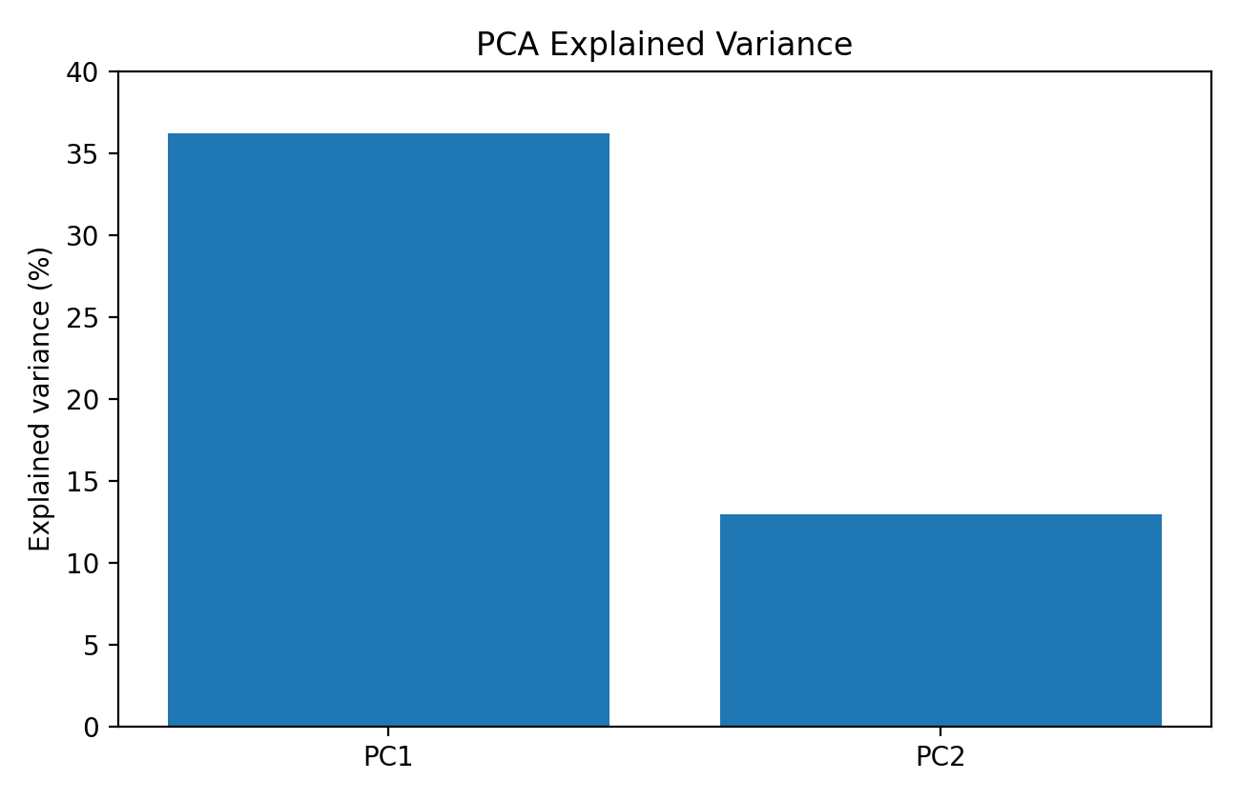
Figure 1. PCA explained variance for PC1 and PC2.
The final K=3 solution contains 2,425 Hot-Humid observations, 2,385 Cool-Rainy observations, and 2,500 Moderate-Dry/Windy observations.
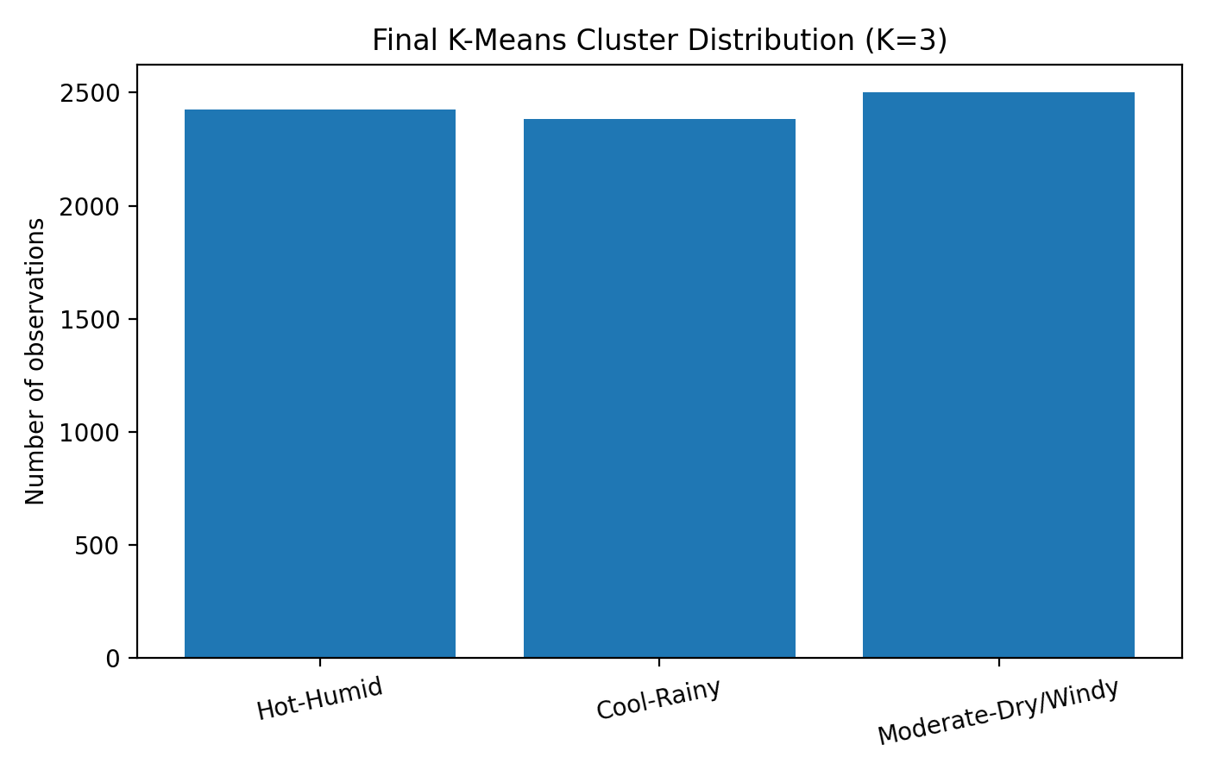
Figure 2. Distribution of observations across the final three clusters.
Cluster 0 is Hot-Humid: higher temperature and humidity, with lower rainfall and lower wind. Cluster 1 is Cool-Rainy: cooler conditions, higher rainfall, and relatively high pressure. Cluster 2 is Moderate-Dry/Windy: moderate temperature, lower humidity and rainfall, stronger winds, and lower cloud cover.
The three clusters are relatively balanced in size, while the PCA representation provides a lower-dimensional view for understanding the grouping. Together, the evaluation measures and cluster characteristics support the selected K=3 interpretation.

5. Conclusion
This project demonstrates an unsupervised machine learning approach for identifying climate patterns from Indian climate observations. The data was inspected and cleaned, eight numerical climate features were selected and standardized, PCA was used for dimensionality reduction and visualization, and K-Means clustering was evaluated for K values from 2 to 10. Although K=2 achieved the highest recorded silhouette score of approximately 0.453, K=3 was selected because it was consistent with the elbow region and provided more interpretable climate regimes. The final patterns were Hot-Humid, Cool-Rainy, and Moderate-Dry/Windy. The study shows how preprocessing, dimensionality reduction, clustering, evaluation, and visualization can be combined for climate analysis.

6. Future Work
- Use larger and multi-year datasets.
- Include geographic coordinates and regional information.
- Perform seasonal and extreme-weather analysis.
- Compare DBSCAN, Gaussian Mixture Models, and hierarchical clustering.
- Add more climate and environmental variables.
- Develop an interactive dashboard.
- Use real-time or regularly updated climate data.
- Validate clusters using external climate or regional information.

7. References
[1] P. P. Sreekala and C. A. Babu, 2025, International Journal of Climatology, vol. 45, article e8759, doi: 10.1002/joc.8759. Identification and Variability Analysis of New Homogeneous Summer Monsoon Rainfall Regions Over India by Using K-Means Clustering Technique
[2] Weather and Climate Extremes, vol. 51, article 100849, 2026, doi: 10.1016/j.wace.2025.100849. Identifying recurring patterns of extreme daily precipitation using K-means algorithm: Uncovering spatial shift driven by climate change over the Italian Peninsula
[3] G. Nkoni, K. Mphale, N. Mbangiwa et al., 2024, Discover Environment, vol. 2, article 77, doi: 10.1007/s44274-024-00111-8. Use of multivariate techniques to regionalize rainfall patterns in semiarid Botswana
[4] S. Lee, J. W. Yoon, and S. K. Park, 2024, Asia-Pacific Journal of Atmospheric Sciences, vol. 60, no. 5, pp. 655–667, doi: 10.1007/s13143-024-00374-4. Primary Factors and Synoptic Pattern Classification of Mega Asian Dust Storms in Korea
[5] Quaternary Science Advances, vol. 15, article 100227, 2024, doi: 10.1016/j.qsa.2024.100227. Innovative Trend Analysis Technique with Fuzzy Logic and K-Means Clustering Approach for Identification of Homogenous Rainfall Region
[6] G. Andrian, D. Arisandi, and T. Handhayani, 2024, INTI Nusa Mandiri, vol. 18, no. 2, pp. 100–106, doi: 10.33480/inti.v18i2.5039. Clustering Data Meteorologi Wilayah Indonesia Timur dengan Metode K-Means dan Fuzzy C-Means
[7] S. H. Lee, M. K. Tippett, and L. M. Polvani, 2023, Journal of Climate, vol. 36, no. 20, pp. 7091–7108, doi: 10.1175/JCLI-D-23-0214.1. A New Year-Round Weather Regime Classification for North America
[8] Environmental Data Science, vol. 3, article e25, 2024, doi: 10.1017/eds.2024.29. Identifying Probabilistic Weather Regimes Targeted to a Local-Scale Impact Variable
[9] H.-H. Huang and Y.-H. Huang, 2024, Energy Reports, vol. 11, pp. 1711–1722, doi: 10.1016/j.egyr.2024.01.039. Probabilistic Forecasting of Regional Solar Power Incorporating Weather Pattern Diversity
[10] Atmosphere, vol. 15, no. 11, article 1392, 2024. Weather Regimes in Northern Eurasia: Statistics, Predictability and Associated Weather Anomalies

Signature of the Guide Course Instructor

