**Main Activity:**

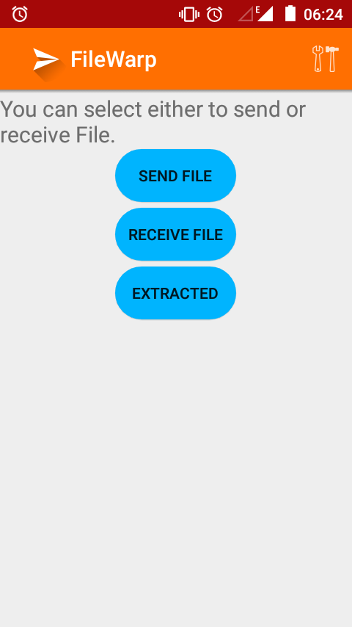

The main activity contains 3 buttons, send file will mask file with mp3 for sending. Receive file is to extract the files from received mp3. Extracted will show the files extracted. There is settings action button in the action bar.

**Selection of files to send:**

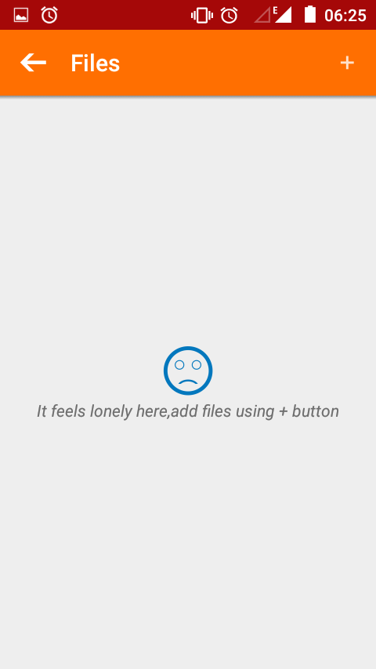

When user clicks send file button in main activity this activity is started. Using the '+' button in the action bar user can add desired files. User can select files from different folders also.

**Built in file browser:**

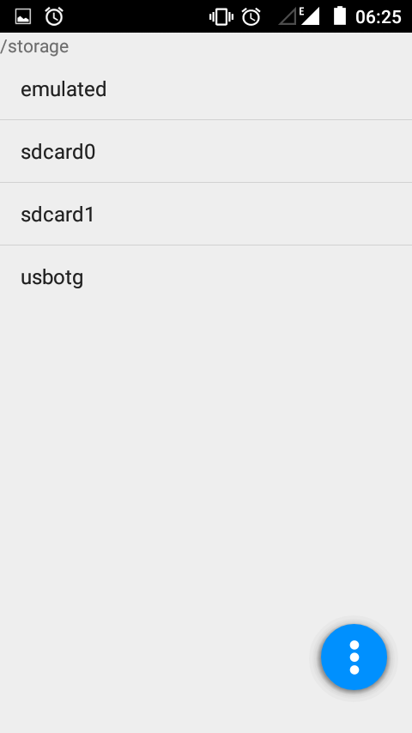

When user clicks '+' action button in the previous activity this file browser is opened. User can desired file. The app finds the sdcard and internal storage to make the default startup path. User can make desired path as startup path from settings or they can make current opened path in file browser as startup path using 3 dots button at the bottom right corner.

**Multiple file selection:**

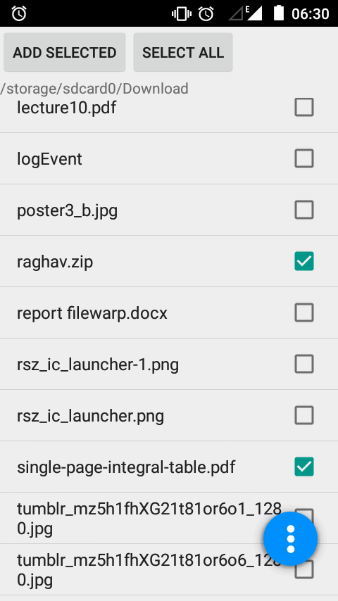

Multiple files can be selected by long clicking a list item in file browser. Adding folders as a whole is not allowed.

**Selected files display:**

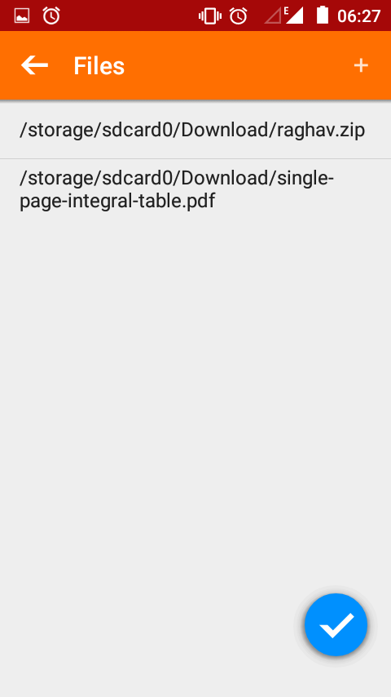

When user finishes adding desired files the added files can be seen here. The files will be masked with mp3 when user clicks done(✔) button in bottom right corner.

**Select messenger:**

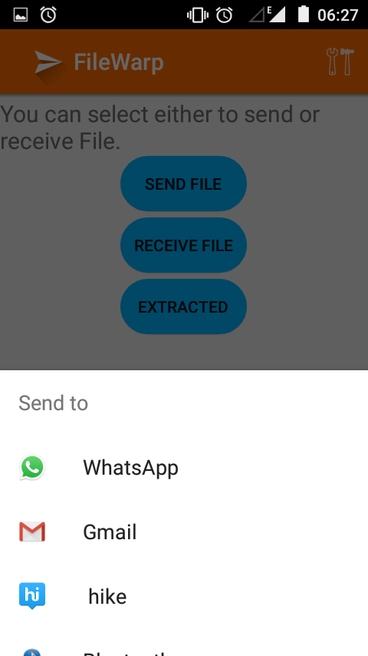

Once user clicks done button a conversion dialog will popup after it finishes the user will be asked to select the messenger to send through. The masked mp3 can be accessed from other file managers at default_storage/FileWarp/.

**Received mp3 file selection:**

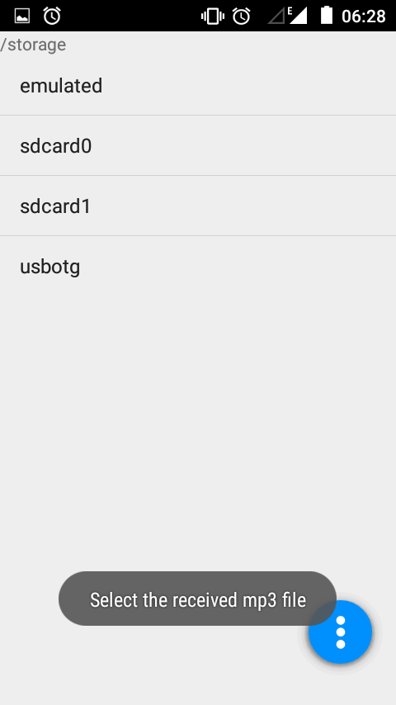

When user wants to extract files from received mp3 and clicks on receive file from main activity a mp3 browser is opened. On selecting the received mp3 file the files in it is extracted to

Default_storage/FileWarp/extracted/.Users can view extracted files by clicking extracted button in main activity.

**Extracted files:**

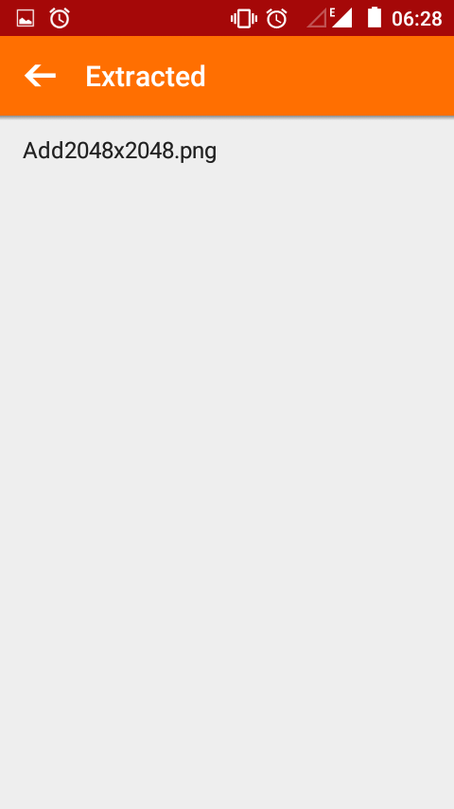

Here all the extracted files can be seen.

**Settings:**

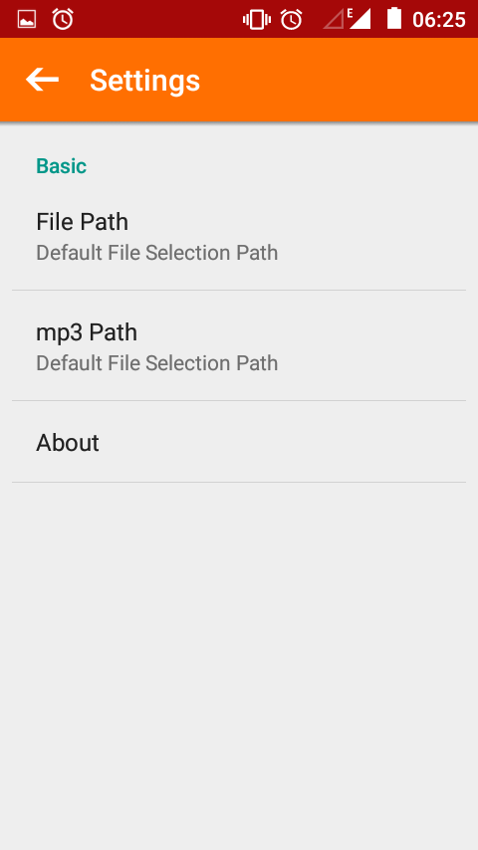

In settings the startup path for both file browser and mp3 browser can be selected.