what is an exception
exception is an abnormal condition which occurs during the execution of a program
it will affect the normal flow of the prog. if we don't handle it properly then prog terminate abnormally. to handle exception we can use try() catch() block
throwable is parent of all classes it cotain two classes error and exception
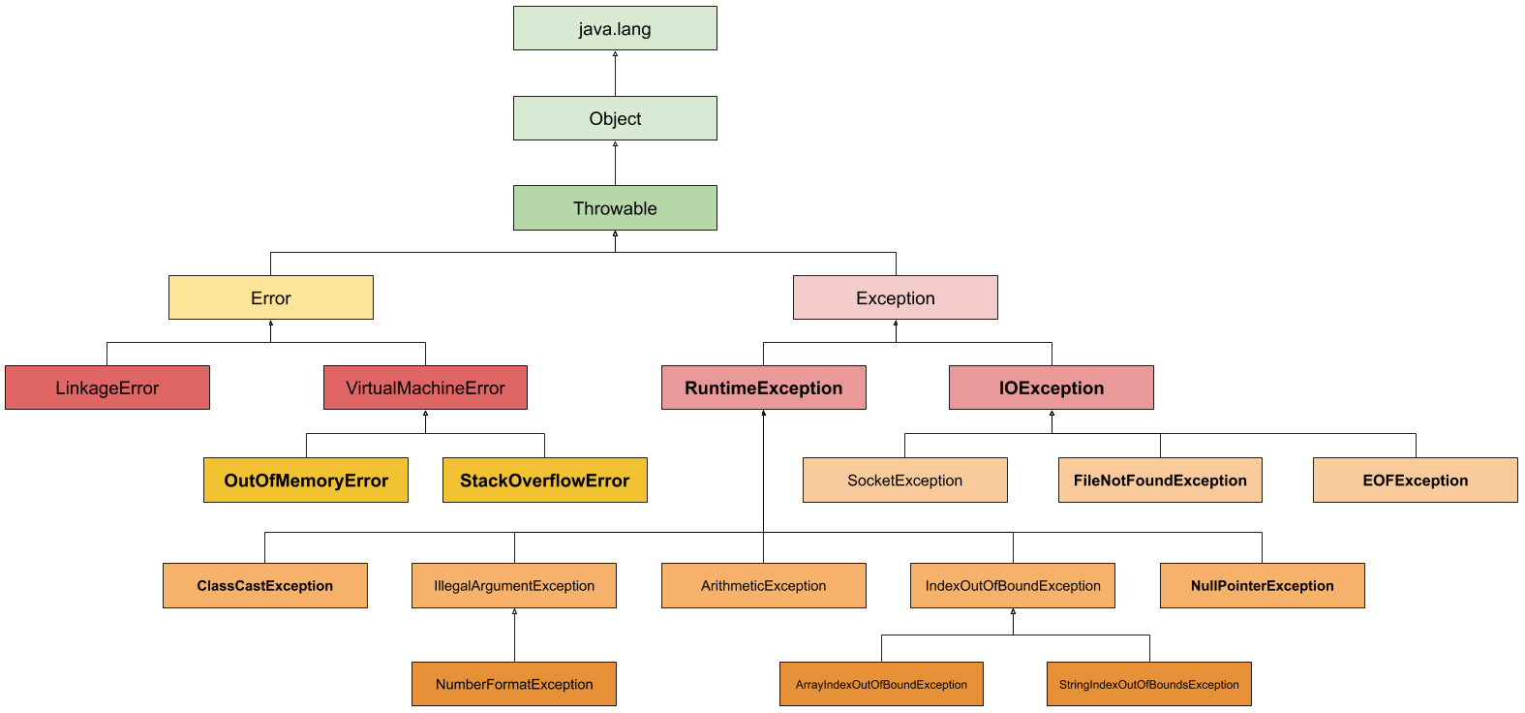
Exception vs Error
Exception can be recovered using try catch block by programmer
Error is irrecoverable by the programmer
Can we write only try() block without catch() and finally() No

Difference between throw and throws
Throw
- Throw is used to explicitly throw an exception
- Throw cannot propagated
- Throw is used with in the method
- Throw cannot throw multiple exception
Throws
- Throws is used to declare a exception
- Throw can propagated
- Throws is used in method signature
- Throws can throw multiple exceptions

