19L820 - PROJECT WORK 2

Deep Learning based Channel Estimation
For OFDM Wireless Communication

RAGHAVAN S U (22L255)
SARRANADHITHIYAA G (22L262)
SHRIRAM R S (22L268)
SHYAAMALAN P (22L270)
Dissertation submitted in partial fulfilment of the requirements for the degree
of
BACHELOR OF ENGINEERING
Branch: ELECTRONICS AND COMMUNICATION ENGINEERING
Affiliated to Anna University


April 2026

DEPARTMENT OF ELECTRONICS AND COMMUNICATION ENGINEERING

PSG COLLEGE OF TECHNOLOGY
(Autonomous Institution)
COIMBATORE – 641 004

PSG COLLEGE OF TECHNOLOGY
(Autonomous Institution)
COIMBATORE – 641 004

Deep Learning based Channel Estimation
For OFDM Wireless Communication

Bona fide record of work done by

RAGHAVAN S U (22L255)
SARRANADHITHIYAA G (22L262)
SHRIRAM R S (22L268)
SHYAAMALAN P (22L270)

Dissertation submitted in partial fulfillment of the requirements for the degree of
BACHELOR OF ENGINEERING
Branch: ELECTRONICS AND COMMUNICATION ENGINEERING
of Anna University
April 2026

Dr. Thiyagarajan K  Faculty Guide | Dr. Krishnaveni V  Head of the Department

Certified that the candidate was examined in the viva-voce examination held on …………………

………………… …………………
(Internal Examiner) (External Examiner)

ACKNOWLEDGEMENT

We extend our heartfelt gratitude to our Principal, Dr. K. Prakasan, for granting us the opportunity and providing the essential resources and infrastructure to successfully carry out this project work.
We are deeply thankful to Dr. V. Krishnaveni, Professor and Head, Department of Electronics and Communication Engineering, for her constant support, motivation, and encouragement throughout the duration of the project.
We express our sincere appreciation to our Programme Coordinator, Dr. Kalpana P, Associate Professor, Department of ECE, and our Tutor, Dr. K. Thiyagarajan, Assistant Professor (Sl. Gr.), Department of ECE, for their continuous guidance, valuable insights, and thoughtful feedback at every stage of our work.
We express our sincere gratitude to the Review team, Dr. Visalakshi P, Professor and Dr. Kalpana P, Professor Department of Electronics and Communication Engineering, for their valuable suggestions, support, and encouragement throughout the progress of our project. Their insightful guidance and constant motivation have been instrumental in helping us carry out this work successfully.
We extend our heartfelt thanks to our project guide, Mrs. Deepika J, Assistant Professor, Department of ECE, for her continuous guidance, patience, and valuable mentorship. Her constructive feedback and constant support have greatly enriched our learning experience and contributed significantly to the successful completion of our project.
Lastly, we would like to acknowledge and thank our senior students and fellow colleagues from the department, whose timely help and cooperation contributed immensely to the smooth and hassle-free execution of this project.

CONTENTS

SYNOPSIS (2)
LIST OF FIGURES (3)
CHAPTER 1 – INTRODUCTION (4)
1.1 Problem Statement (4)
1.2 Objective (5)
1.3 Scope of the Project (5)
CHAPTER 2 – LITERATURE REVIEW (7)
2.1 Deep-Learning Based Channel Estimation for OFDM
Wireless Communications (7)
2.2 Deep Learning-Based Channel Estimation with Transformer (8)
2.3 Denoising Generalization Performance of Channel Estimation (8)
2.4 ChannelNet: A Deep Neural Network for Channel Estimation (9)
2.5 A DFT-based Low Complexity LMMSE Channel Estimation Technique (9)
2.6 Intriguing Properties of Neural Networks (10)
2.7 Inference from Literature Survey (10)
CHAPTER 3 – METHODOLOGY (11)
3.1 Proposed Methodology (11)
3.2 OFDM System and Channel Model (12)
3.3 Initial Denoising Network (IDN) (13)
3.4 Tokenization for Transformer Input (15)
3.5 Transformer-based Channel Estimation (16)
3.6 Loss Function and Training Strategy (18)
3.7 Innovation (19)
CHAPTER 4 – IMPLEMENTATION AND RESULTS (20)
4.1 Software Requirements (20)
4.2 Dataset Description (21)
4.3 Model Architecture Implementation (22)
4.4 Training Phase 1 – Baseline (50 Epochs) (24)
4.5 Training Phase 2 – Extended (300 Epochs) (25)
4.6 Training Phase 3 – Optimized Architecture (225 Epochs) (26)
4.7 Training Phase 4 – Further Refinement (210 Epochs) (28)
4.8 Multi-SNR Evaluation (29)
4.9 Comparative Performance Analysis (30)
CHAPTER 5 – CONCLUSION AND FUTURE WORKS (32)
BIBLIOGRAPHY (34)
APPENDIX (36)

LIST OF FIGURES

Fig. No | Topic | Page No.
3.1 | Deep Learning-based OFDM Channel Estimation Framework | 12
3.2 | Project Flow Block Diagram (IDN → Tokenization → Transformer) | 13
3.3 | IDN Network Depth vs NMSE and Inference Latency | 15
3.4 | Full Optimized Block Diagram with Composite Loss Function | 19
4.1 | Dataset Parameters – OFDM Simulation Configuration | 21
4.2 | CNN-based Channel Estimation Performance Comparison | 23
4.3 | Noisy CSI Input vs IDN Denoised Output Heatmaps | 24
4.4 | Phase 1 – IDN-Transformer 400-Epoch Convergence Graph | 25
4.5 | Phase 2 – IDN-Transformer 300-Epoch Convergence Graph | 26
4.6 | Phase 3 – IDN-Transformer 400-Epoch Convergence Graph (Optimized) | 27
4.7 | Phase 3 Variety – Reduced Parameter Model Training Curve | 28
4.8 | Final NMSE Performance Analysis: DL vs LMMSE Comparison | 30

SYNOPSIS

The rapid evolution of wireless communication systems has necessitated the development of highly accurate and computationally efficient channel estimation techniques for Orthogonal Frequency Division Multiplexing (OFDM) based systems. OFDM is a widely adopted multi-carrier modulation scheme in modern wireless standards such as LTE, 5G NR, Wi-Fi, and digital broadcasting, owing to its robustness against frequency-selective fading and its ability to achieve high spectral efficiency. A fundamental challenge in OFDM receiver design is accurate estimation of the wireless channel, which is essential for coherent detection, equalization, and subsequent decoding of the transmitted data.
Traditional approaches such as Least Squares (LS) and Linear Minimum Mean Squared Error (LMMSE) channel estimation methods have served as foundational techniques for several decades. However, they face significant limitations when deployed in modern wireless environments. LS estimation is straightforward but highly sensitive to additive noise, particularly in low Signal-to-Noise Ratio (SNR) environments where noise severely degrades estimation accuracy. LMMSE provides statistically optimal linear estimation but requires prior knowledge of channel covariance statistics that are often unavailable or difficult to estimate accurately in real-world dynamic scenarios. Furthermore, existing deep learning approaches based on Convolutional Neural Networks (CNNs) improve upon classical methods but inherently fail to capture long-range time-frequency correlations across the OFDM resource grid due to the local receptive field of convolutional operations.
This project presents a comprehensive software-based deep learning framework for accurate OFDM channel estimation using pilot symbols only. The proposed system cascades an Initial Denoising Network (IDN) implemented as a fully connected neural network with a Transformer-based channel estimation model. The IDN first suppresses noise from the pilot-based Channel State Information (CSI) obtained via Least Squares estimation. The denoised pilot CSI is subsequently tokenized by separating real and imaginary components and appending time-frequency positional information to form structured input tokens for the Transformer.
The Transformer-based model exploits multi-head self-attention mechanisms to capture global time-frequency correlations across the 96 × 14 OFDM resource grid, thereby reconstructing high-fidelity full CSI from the limited pilot observations. The entire framework is trained in a supervised manner using Mean Squared Error (MSE) loss augmented with an amplitude regularization term, which explicitly penalizes errors in complex channel magnitude and improves receiver Signal-to-Noise Ratio performance.
The system was developed and evaluated using Python, PyTorch, and Google Colab, with Rayleigh fading channel models incorporating Additive White Gaussian Noise across multiple SNR levels. Through four progressive training phases, the model achieved a Normalized Mean Squared Error (NMSE) of −6.70 dB at Phase 4, significantly outperforming the LS baseline (−1.20 dB) and LMMSE (−1.37 dB). The final optimized model operates with only 2.93 million parameters (11.18 MB) and a 3 ms inference latency, demonstrating an excellent balance between estimation accuracy and computational efficiency suitable for edge deployment in resource-constrained wireless communication systems.

CHAPTER 1

INTRODUCTION

1.1 PROBLEM STATEMENT
Wireless communication systems operating over multipath fading channels must contend with severe signal distortions introduced by the propagation environment. In OFDM-based systems, each subcarrier experiences a distinct complex channel coefficient that must be estimated accurately at the receiver to enable coherent detection and data recovery. This process, known as channel estimation, is one of the most computationally and statistically demanding aspects of modern wireless receiver design.
Channel State Information (CSI) is critical for the performance of OFDM-based wireless communication systems. Traditional estimation methods, namely Least Squares (LS) and Linear Minimum Mean Squared Error (LMMSE), face significant challenges that limit their applicability in modern wireless environments. Least Squares estimation, while computationally simple, estimates the channel by dividing the received pilot signal by the known transmitted pilot symbol, thereby minimizing only the energy of the error in the pilot domain. This approach is highly sensitive to noise, particularly in low SNR environments, and performs poorly when the channel is frequency-selective or exhibits fast time variation.
LMMSE estimation, on the other hand, provides a statistically optimal linear estimate by leveraging prior knowledge of the channel covariance matrix. It achieves substantially better performance than LS under matched conditions but requires accurate knowledge of the channel power delay profile and noise variance, which are often unavailable in practical systems. Furthermore, computational complexity of O(N³) for matrix inversions makes standard LMMSE implementations prohibitive for large OFDM grids.
Existing deep learning approaches based on Convolutional Neural Networks (CNNs) offer considerable improvements over classical methods by learning the mapping from noisy pilot observations to refined channel estimates directly from data. However, CNNs are inherently limited by their local receptive fields: the convolutional kernel processes only a fixed local neighborhood of the input at each layer. This locality constraint prevents CNNs from efficiently learning long-range time-frequency correlations that are characteristic of physically realistic wireless channels exhibiting significant delay spread and Doppler spread.
There is therefore a compelling need for a deep learning architecture that overcomes these limitations by simultaneously denoising pilot observations and learning global time-frequency correlations across the entire OFDM resource grid, without requiring prior channel statistics, while remaining computationally efficient enough for practical deployment.

1.2 OBJECTIVE
The main objectives of this project are:
- To develop a software-based OFDM channel estimation framework using deep learning techniques capable of operating under noisy and low-SNR conditions without requiring prior channel statistics.
- To analyze the limitations of traditional channel estimation methods including LS and LMMSE under various channel fading conditions and noise levels.
- To design and implement an Initial Denoising Network (IDN) using fully connected layers with Batch Normalization and LeakyReLU activations to suppress additive noise from pilot-based CSI estimates.
- To implement a structured tokenization procedure that converts two-dimensional complex CSI data into positionally encoded one-dimensional token sequences suitable for Transformer input processing.
- To apply a Transformer-based model equipped with multi-head self-attention for learning global time–frequency channel correlations across the full 96×14 OFDM resource grid.
- To develop an amplitude-regularized composite loss function that penalizes errors in complex channel magnitude in addition to the standard MSE objective, improving physically meaningful CSI reconstruction.
- To achieve improved channel estimation accuracy (lower NMSE in dB) compared to conventional LS and LMMSE methods as well as existing CNN-based deep learning approaches.
- To optimize the model through progressive multi-phase training and parameter reduction for edge deployment, targeting inference latency under 5 ms with model size below 15 MB.

1.3 SCOPE OF THE PROJECT
The scope of this project encompasses a comprehensive simulation-based investigation of deep learning techniques for OFDM channel estimation, spanning channel modeling, neural network design, training methodology, performance evaluation, and comparative benchmarking.
From a signal processing perspective, the project models realistic wireless channel conditions using Rayleigh fading with Additive White Gaussian Noise across a representative 20 MHz OFDM configuration with 96 subcarriers and 14 OFDM symbols. This configuration is representative of 5G New Radio and LTE resource block structures, ensuring the results are relevant to contemporary wireless standards and deployment scenarios.
From a deep learning perspective, the project explores the design space of cascaded neural architectures combining denoising networks and attention-based sequence models. The investigation encompasses network depth analysis for the IDN component, Transformer encoder configuration including attention heads, model dimensionality, and feed-forward network width. Progressive multi-phase training with increasing dataset size and model refinement provides a systematic methodology for performance improvement.
The comparative evaluation framework encompasses classical baselines (LS and LMMSE), CNN-based deep learning approaches, and the proposed IDN-Transformer, evaluated using standardized NMSE metrics across a dynamic range of SNR levels. This benchmarking provides clear quantification of the performance advantages of the proposed approach.
The scope is intentionally restricted to high-performance simulation-based modeling using Python, PyTorch, and Google Colab, without physical hardware implementation. This boundary enables rigorous algorithm development and evaluation while providing a well-defined foundation for future extension to hardware-accelerated deployment, over-the-air testing, multi-antenna MIMO-OFDM systems, and integration with complete end-to-end transceiver chains.
Educationally, the project fosters deep interdisciplinary learning spanning wireless communications theory, signal processing, supervised deep learning, attention mechanisms, and embedded systems considerations.

CHAPTER 2

LITERATURE REVIEW

2.1 Deep-Learning Based Channel Estimation for OFDM Wireless Communications
Authors: Guoda Tian, Xuesong Cai, Tian Zhou, Weinan Wang, Fredrik Tufvesson | IEEE SPAWC 2022
Methodology: The authors proposed a deep learning-based channel estimation pipeline for OFDM systems designed to estimate full CSI from limited pilot symbols without increasing pilot power or density. The pipeline introduced an Initial Denoise Network (IDN) and a Resolution Enhancement Network (REN), both utilizing fully connected layers, to improve pilot SNR and subsequently recover high-resolution CSI across all resource elements. Training employed 210,000 channel realizations generated from standardized channel models, with testing performed on 21,000 samples uniformly distributed across the evaluated SNR range of 0 to 20 dB.
Results: The proposed approach achieved 15 dB lower NMSE than LMMSE at 0 dB SNR and 10 dB lower NMSE at 20 dB SNR, demonstrating substantial improvement in low-SNR channel estimation accuracy without modifying pilot resource overhead. The compact model design was confirmed suitable for embedded system deployment, with practical inference latency.
Limitations: Evaluation was restricted to SISO OFDM systems, and the model requires supervised training with large labeled datasets, which may limit immediate generalization to unseen channel models without retraining. The resolution enhancement stage also introduces additional computational complexity beyond a single-stage estimator.
Relevance: This foundational paper directly motivates the IDN component of the proposed framework. The two-stage denoising and resolution enhancement architecture serves as the primary inspiration for the cascaded IDN-Transformer design adopted in this project, while the performance benchmarks at multiple SNR points provide a key reference for evaluation.

2.2 Deep Learning-Based Channel Estimation with Transformer
Authors: J. Guo et al. | IEEE Access, 2021
Methodology: The work proposed using Transformer architecture equipped with self-attention mechanisms for OFDM channel estimation. Self-attention enables the model to compute weighted relationships between all positions in the input sequence simultaneously, capturing complex non-local time-frequency correlations that are inherent in wireless multipath channels. Positional encoding was integrated to preserve the geometric structure of the OFDM time-frequency grid within the sequential Transformer processing paradigm.
Results: The Transformer model demonstrated approximately 18 dB lower NMSE than CNN-based models at a pilot SNR of 30 dB, confirming the superiority of global attention mechanisms over local convolutional operations for channel estimation. The results validated that self-attention is intrinsically better suited for learning the long-range dependencies characteristic of frequency-selective fading channels.
Limitations: The implementation is computationally expensive due to the quadratic complexity of the self-attention mechanism with respect to sequence length. Performance is also highly sensitive to the quality and design of the positional encoding scheme, and the model requires careful hyperparameter tuning to achieve competitive results.
Relevance: This paper is the primary motivation for the Transformer module in the proposed architecture. The demonstrated superiority of self-attention over CNN-based local processing directly justifies the design choice, and the positional encoding strategy informs the tokenization approach developed in this project.

2.3 Denoising Generalization Performance of Channel Estimation in Multipath Time-Varying OFDM Systems
Authors: Yinying Li, Xin Bian, Mingqi Li | Sensors (MDPI), 2023
Methodology: A deep network based on Denoising CNN (DnCNN) architecture was designed to suppress AWGN from pilot-based CSI matrices. The channel frequency response was modeled as a two-dimensional image and residual learning was applied to refine the initial LS or LMMSE estimate by predicting and subtracting the noise component. Both average pooling and max pooling variants were investigated for performance comparison.
Results: The method achieved stable NMSE performance over an SNR range of 0–35 dB, demonstrating robustness across multiple channel models. At 30 dB SNR, average pooling achieved 29.49 dB improvement in RMSE compared to 28.36 dB with max pooling, confirming the advantage of residual denoising over direct estimation.
Limitations: The approach depends critically on the accuracy of the initial LS or LMMSE estimate used as input, such that large initial errors propagate into the denoiser and degrade final performance. The deep CNN architecture also increases computational and memory cost, and the batch normalization parameters learned during training may not generalize to channels with substantially different statistics.
Relevance: This work validates the residual denoising philosophy embedded in the IDN component of the proposed framework. The performance benchmarks and pooling strategy analysis provide practical design guidance for the IDN, while the identified limitation of error propagation motivates the careful IDN architecture selection in this project.

2.4 ChannelNet: A Deep Neural Network for Channel Estimation in OFDM Systems
Authors: Ye Yuan, Guanding Yu, Hailin Zhang, Yonghui Li | IEEE Wireless Communications Letters, 2019
Methodology: ChannelNet proposed a CNN-based deep learning framework that treats channel estimation as an image recovery problem. A two-stage architecture combining a super-resolution CNN and an image restoration CNN was designed to reconstruct high-quality CSI from sparse pilot signals distributed across the time-frequency resource grid. The CSI matrix was represented as a two-dimensional image, leveraging CNN’s inherent ability to extract local spatial features.
Results: ChannelNet achieved NMSE performance comparable to full MMSE and substantially lower NMSE than LS and alternative LMMSE under LTE channel simulation settings, establishing CNN-based deep learning as a strong alternative to classical linear estimators for OFDM channel estimation.
Limitations: The CNN architecture captures only local spatial features due to the fixed size of convolutional kernels and struggles to learn long-range time–frequency dependencies that span multiple subcarriers or symbols simultaneously. The 20-layer CNN design also requires substantial computational resources during training. Performance is further sensitive to the pilot density distribution and diversity of the training dataset.
Relevance: ChannelNet provides the CNN baseline performance figures used for comparison with the proposed IDN-Transformer model. Its identified limitation of locality-constrained feature extraction is precisely the fundamental motivation for the Transformer adoption in this project.

2.5 A DFT-based Low Complexity LMMSE Channel Estimation Technique for OFDM Systems
Authors: Jyoti Prasanna Patra, Bibhuti Bhusan Pradhan, Poonam Singh | JTIT, 2022
Methodology: The authors reduced the computational complexity of conventional LMMSE channel estimation from O(N³) to O(N log N) by exploiting the Discrete Fourier Transform properties and the structured correlation of OFDM channels. The approach leverages the approximately banded structure of the channel correlation matrix in the delay domain to avoid full matrix inversion.
Results: The DFT-LMMSE approach achieved near-optimal NMSE and Bit Error Rate (BER) performance compared to standard LMMSE, while significantly reducing computational burden. The results confirmed LMMSE as a strong and competitive classical baseline for OFDM channel estimation, providing a well-defined performance ceiling for traditional linear methods.
Limitations: The method still requires channel covariance information and accurate noise variance estimation, which may not always be available. Although complexity is reduced to O(N log N), this remains higher than LS and may be prohibitive for very low-power embedded devices. The approximation introduced by the banded correlation assumption also introduces mild estimation error compared to full LMMSE.
Relevance: This work establishes the LMMSE performance ceiling used as the primary classical comparison benchmark for the proposed deep learning framework and contextualizes the computational trade-offs associated with moving from classical to data-driven channel estimation.

2.6 Intriguing Properties of Neural Networks
Authors: Christian Szegedy et al. | 2014
Methodology: This influential paper challenged conventional understanding of neural network representations by systematically investigating the properties of unit activations and the structure of the learned input-output mapping. The authors discovered that random linear combinations of high-level units are semantically indistinguishable from individual units, suggesting that information is distributed across the activation space rather than localized in individual neurons. They also discovered adversarial examples – imperceptible perturbations that cause deep networks to misclassify inputs with high confidence.
Results: The study demonstrated that neural network knowledge is distributed across the entire activation space and that the learned mappings can be highly non-linear and discontinuous in ways invisible to casual observation. Cross-model generalization of adversarial examples was confirmed, and a spectral analysis method was proposed to measure network instability.
Limitations: Solutions learned by backpropagation are inherently non-intuitive and difficult for humans to interpret. The distributed representation makes it impossible to assign specific physical properties to individual parameters or neurons.
Relevance: This paper provides the theoretical grounding for understanding the black-box nature of the IDN-Transformer model. It also informs the interpretation of distributed channel knowledge representation and justifies the use of composite loss functions that impose explicit physical constraints on the learned channel estimates.

2.7 INFERENCE FROM THE LITERATURE SURVEY
- Deep learning-based channel estimation, particularly when using Transformer architectures with self-attention mechanisms, demonstrates superior capability to capture global time-frequency correlations compared to both classical linear methods and CNN-based deep learning approaches. The advantage is especially pronounced in low-SNR environments and frequency-selective channels with significant delay spread.
- A cascaded approach combining a dedicated pilot denoising network with a global correlation learning module provides a structured and modular pipeline that separates noise suppression from CSI interpolation. This separation allows independent optimization of each module and provides a more interpretable design space than monolithic end-to-end networks.
- Residual learning is consistently effective for the denoising task, enabling the network to focus on learning the noise component rather than the full channel, which leads to faster convergence and better generalization across SNR conditions.
- Positional encoding is essential for Transformer-based processing of two-dimensional OFDM grids, as it provides the model with explicit information about the spatial location of each token within the time-frequency resource structure.
- The distributed representation of channel information in deep neural networks, while challenging for interpretability, enables the model to learn complex non-local channel dependencies that are inaccessible to local architectures like CNNs.
- Future advances in OFDM channel estimation will trend toward lightweight, edge-deployable models that balance estimation accuracy with computational efficiency. This motivates the parameter reduction and inference latency optimization efforts undertaken in this project.

CHAPTER 3

METHODOLOGY

3.1 PROPOSED METHODOLOGY
The proposed methodology develops a software-based deep learning framework for accurate OFDM channel estimation. The system cascades an Initial Denoising Network (IDN) with a Transformer-based model to suppress pilot noise and exploit global time-frequency correlations, enabling high-fidelity CSI recovery without prior channel statistics. Figure 3.1 illustrates the overall deep learning framework for OFDM channel estimation.

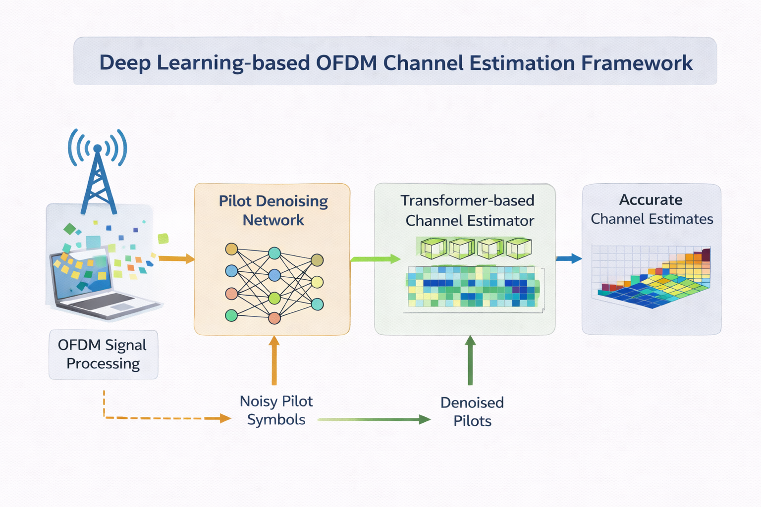
Fig. 3.1: Deep Learning-based OFDM Channel Estimation Framework

The overall pipeline receives noisy pilot observations from the OFDM receiver, processes them through the IDN for noise suppression, tokenizes the denoised pilots with positional encoding, and passes the tokens through the Transformer encoder for full CSI reconstruction. The system is trained end-to-end using a composite loss function that combines standard MSE reconstruction loss with an amplitude regularization term. Figure 3.2 shows the complete project flow block diagram illustrating the three-stage deep learning model.

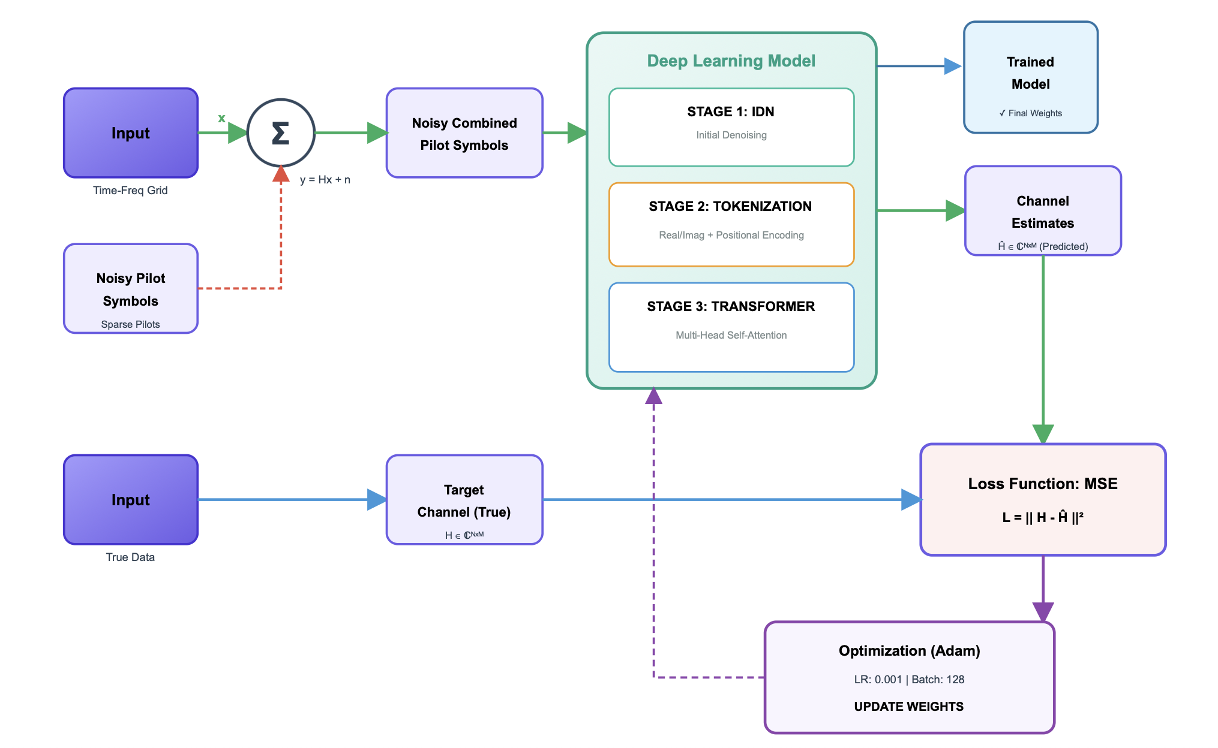
Fig. 3.2: Project Flow Block Diagram (IDN → Tokenization → Transformer)

3.2 OFDM SYSTEM AND CHANNEL MODEL
The simulation environment models an OFDM system with N_SC = 96 subcarriers and N_SYM = 14 symbols per resource grid, corresponding to a 20 MHz bandwidth at a 3.5 GHz carrier frequency. These parameters are representative of a 5G NR-like resource block configuration and ensure the results are relevant to practical wireless deployments.
The wireless channel is modeled as a discrete-time Rayleigh fading channel with exponential power delay profile. Each channel realization H ∈ ℝ^(N_SC × N_SYM) is a complex-valued matrix where each element H[k,l] represents the complex channel gain experienced by the k-th subcarrier during the l-th OFDM symbol. Rayleigh fading is adopted as it accurately represents non-line-of-sight propagation environments encountered in urban and suburban wireless deployments.
The received pilot signal y at a pilot position (k,l) is modeled as:
y[k,l] = H[k,l] · x[k,l] + n[k,l]
where x[k,l] is the known transmitted pilot symbol and n[k,l] ∼ CN(0, σ²) is complex Gaussian noise with variance σ² corresponding to the target SNR. The Least Squares estimate at pilot positions is computed as:
H_LS[k,l] = y[k,l] / x[k,l] = H[k,l] + n[k,l] / x[k,l]
This LS estimate at pilot positions serves as the noisy input to the IDN. Pilots are distributed in a scattered pattern covering 25% of the resource grid, consistent with practical LTE and 5G NR pilot densities.
Additive White Gaussian Noise is added at multiple SNR levels ranging from 0 dB to 16 dB to evaluate estimation performance across diverse operating conditions. The channel simulation generates 10,000 independent realizations for training and validation, ensuring sufficient diversity to train a robust deep learning model.

3.3 INITIAL DENOISING NETWORK (IDN)
The Initial Denoising Network is a fully connected neural network designed to suppress the additive noise component from the LS pilot estimate before it is fed to the Transformer. The IDN operates on the concatenated real and imaginary components of the pilot CSI matrix at pilot positions, treating them as a flattened real-valued input vector of dimension 2 × N_pilots.
The network employs a residual learning strategy: rather than directly predicting the clean pilot CSI, the IDN is trained to predict the noise component added to the LS estimate. The denoised pilot is then obtained by subtracting the predicted noise from the LS estimate:
H_denoised = H_LS − f_IDN(H_LS)
where f_IDN(H_LS) is the noise residual predicted by the four-layer dense network. This residual formulation facilitates gradient flow during training and allows the network to focus on learning the noise distribution rather than the full channel structure.
IDN Architecture
The IDN comprises four linear transformation layers with progressively contracting width followed by a final expansion layer. Intermediate layers employ Batch Normalization followed by LeakyReLU activation functions. Batch Normalization normalizes layer inputs to zero mean and unit variance, stabilizing training and enabling faster convergence. LeakyReLU with a small negative slope for negative inputs prevents dying neuron phenomena that can afflict standard ReLU activations in deep networks.
The architecture follows a bottleneck design: the input dimension is progressively reduced through the intermediate layers to encourage compact feature extraction, then expanded back to the output dimension for noise prediction. This design prevents overfitting to training noise patterns while maintaining sufficient capacity for accurate noise estimation.

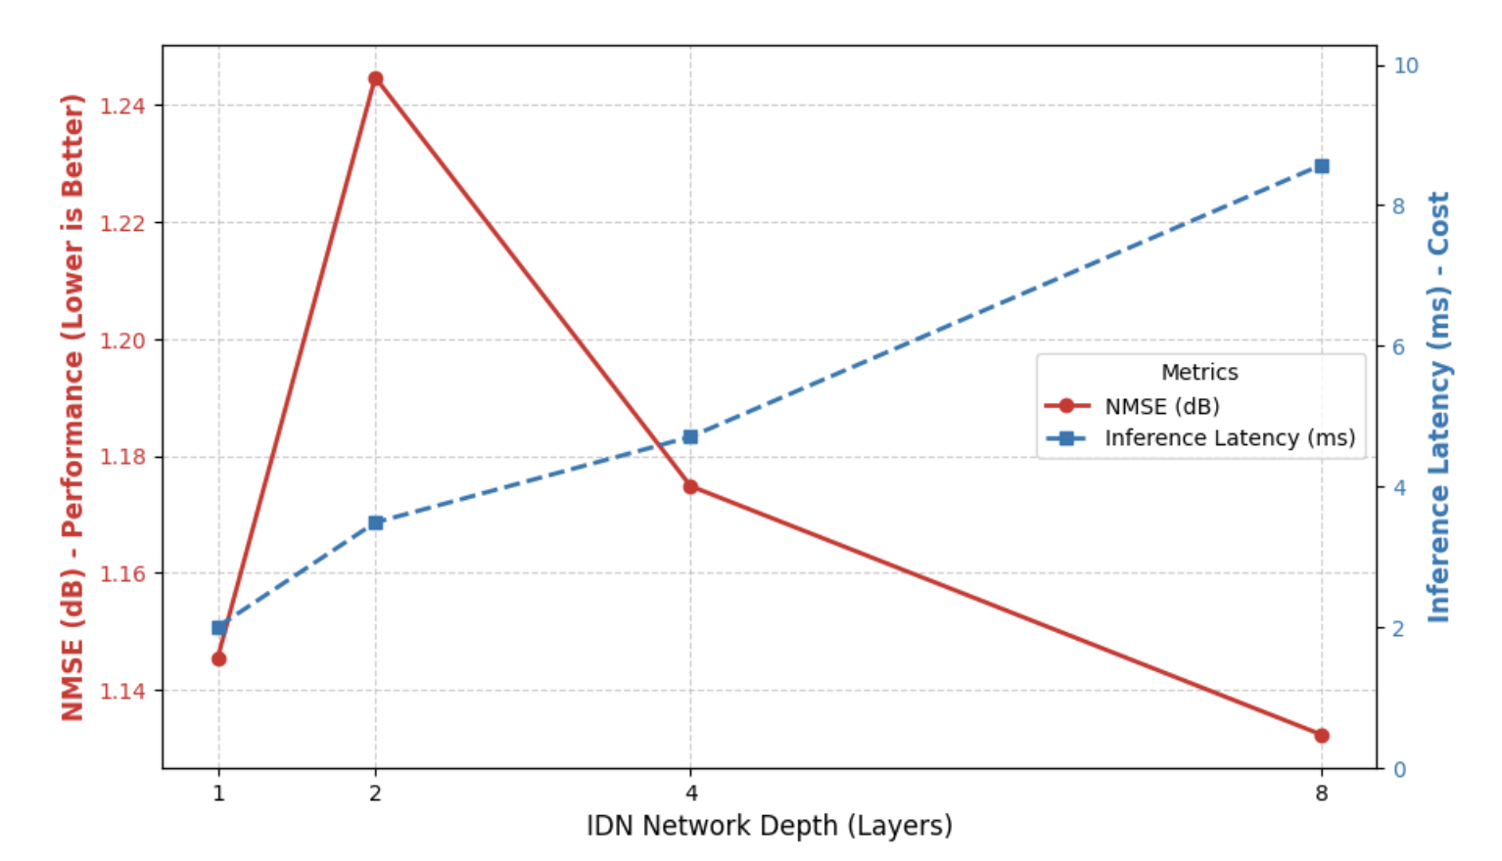
Fig. 3.3: IDN Network Depth vs NMSE Performance and Inference Latency

Figure 3.3 illustrates the trade-off between IDN network depth, NMSE performance, and inference latency. The analysis shows that deeper IDN architectures achieve progressively lower NMSE (better estimation accuracy) but at the cost of increased inference latency. The 4-layer configuration selected for the final model provides an optimal balance between these competing objectives, achieving strong denoising performance with manageable computational cost.

3.4 TOKENIZATION FOR TRANSFORMER INPUT
The denoised pilot CSI output from the IDN is a two-dimensional complex-valued matrix. Transformer models, however, natively process one-dimensional sequences of tokens, similar to word sequences in natural language processing. A structured tokenization procedure is therefore essential to convert the 2D OFDM channel data into a format amenable to Transformer processing while preserving the spatial structure of the resource grid.
The tokenization procedure operates in three steps. First, the 2D denoised pilot CSI matrix is serialized by flattening into a one-dimensional vector following row-major order. Second, each complex CSI value at grid position (k, l) is decomposed into its real and imaginary components to form the core feature dimensions of the corresponding token. Third, the original subcarrier index k (normalized to the range [−1, 1]) and symbol index l (normalized to [−1, 1]) are appended to the real and imaginary components as explicit positional features.
The resulting four-dimensional token representation for grid element (k, l) is:
token(k,l) = [Re(H_denoised[k,l]), Im(H_denoised[k,l]), k/N_SC, l/N_SYM]
This positional encoding scheme is a key innovation compared to simple flattening approaches. By providing the Transformer with explicit coordinate information, the attention mechanism can learn meaningful relationships between spatially separated elements on the resource grid, enabling the model to exploit channel coherence across subcarriers and OFDM symbols in a physically interpretable manner.

3.5 TRANSFORMER-BASED CHANNEL ESTIMATION MODEL
The Transformer encoder constitutes the core of the channel estimation pipeline. Following the tokenization stage, an input linear embedding layer projects each four-dimensional token to the model hidden dimension d_model, and a Batch Normalization layer normalizes the embeddings across the batch. The model then employs stacked Transformer encoder layers, each comprising a multi-head self-attention module and a position-wise feed-forward network with residual connections and layer normalization.
Multi-Head Self-Attention
The multi-head self-attention mechanism is the defining component of the Transformer architecture. Given the sequence of token embeddings, the mechanism computes query (Q), key (K), and value (V) matrices through learned linear projections. For each attention head h, the attention output is:
Attention_h(Q,K,V) = softmax(Q_h K_hᵀ / √d_k) · V_h
where d_k is the per-head key dimension. The outputs of all attention heads are concatenated and linearly projected to produce the final multi-head attention output. This mechanism simultaneously computes attention scores between all pairs of tokens in the sequence, allowing the Transformer to capture both local and long-range time-frequency dependencies in a single operation. The global receptive field provided by self-attention overcomes the fundamental locality constraint of CNN-based channel estimators.
Feed-Forward Network and Residual Connections
Each Transformer encoder layer includes a position-wise feed-forward network (FFN) applied independently to each token:
FFN(x) = max(0, xW_1 + b_1)W_2 + b_2
The FFN dimension is set to four times the model dimension (4 × d_model), providing sufficient capacity for non-linear feature transformation. Residual connections around both the self-attention and FFN sublayers, combined with layer normalization, facilitate gradient flow through deep encoder stacks and accelerate convergence.
Channel Reconstruction
Following the Transformer encoder stack, a final linear output layer projects the encoder’s hidden representation from d_model dimensions back to the full CSI reconstruction dimension (2 × N_SC × N_SYM), producing separate outputs for the real and imaginary components of the reconstructed channel matrix. The output is then reshaped to the 96×14 complex channel grid for downstream equalization and data detection.

3.6 LOSS FUNCTION AND TRAINING STRATEGY
The model is trained end-to-end using a supervised learning approach with a composite loss function that combines standard Mean Squared Error (MSE) reconstruction loss with an amplitude regularization term.
Standard MSE Loss
The standard MSE loss minimizes the squared difference between the predicted and true channel values across both real and imaginary components:
L_MSE = E[ |Re(Ĥ) − Re(H)|² + |Im(Ĥ) − Im(H)|² ]
While effective for minimizing reconstruction error, standard MSE treats the real and imaginary parts independently without imposing any constraint on the complex amplitude |H|. A model trained with only MSE can achieve low reconstruction error while producing channel estimates with incorrect signal power, which directly degrades receiver SNR.
Amplitude Regularization
To address this limitation, an amplitude regularization term is incorporated:
L_amp = E[ | ‖Ĥ‖ − ‖H‖ |² ]
where ‖·‖ denotes the complex magnitude computed as √(Re² + Im²). This term explicitly penalizes errors in the complex channel magnitude, tying the training objective to a physically meaningful channel property that directly governs received signal power and SNR.
Composite Loss Function
The composite training objective combines both terms:
L_total = L_MSE + 0.1 × L_amp
The weight 0.1 maintains amplitude regularization as a secondary objective, improving physical fidelity without overwhelming the primary MSE reconstruction goal. This is analogous to perceptual losses used in image super-resolution, where explicit perceptual constraints improve the quality of reconstructed images beyond what pure pixel-wise MSE can achieve.
Optimizer and Learning Rate Schedule
Training uses the Adam optimizer with an initial learning rate of 1×10⁻´ and cosine annealing learning rate scheduling to prevent overshooting near convergence. Mini-batches of 32–128 samples are processed per update step. Dropout regularization with rate 0.3 within Transformer encoder sublayers provides additional regularization to reduce overfitting to training channel realizations.

3.7 INNOVATION
The proposed framework introduces several key innovations that distinguish it from existing OFDM channel estimation approaches.
The primary innovation is the cascaded IDN-Transformer architecture that explicitly decouples the noise suppression and correlation learning stages. Unlike end-to-end CNN architectures that attempt both simultaneously through local convolutions, the proposed design assigns the IDN the specialized task of pilot denoising and the Transformer the distinct task of global CSI interpolation. This separation provides a structured design space, allows independent optimization of each module, and produces a more interpretable pipeline than monolithic architectures.
The structured tokenization with explicit positional encoding is a second significant innovation. By converting 2D complex CSI data into positionally encoded 1D token sequences, the tokenization preserves the geometric structure of the OFDM resource grid in a format that enables the Transformer’s self-attention to learn physically meaningful correlations between spatially separated channel elements.
The amplitude-regularized composite loss function is a third key contribution. This directly addresses the physical limitation of standard MSE training for channel estimation, explicitly constraining learned estimates to have correct complex amplitude and thereby improving downstream receiver SNR performance.
Finally, the progressive multi-phase training and parameter optimization demonstrates a principled approach to model compression for edge deployment, achieving over 85% parameter reduction (from 19.46M to 2.93M parameters) while improving NMSE by more than 3.5 dB through the combination of architectural optimization and improved loss function design.

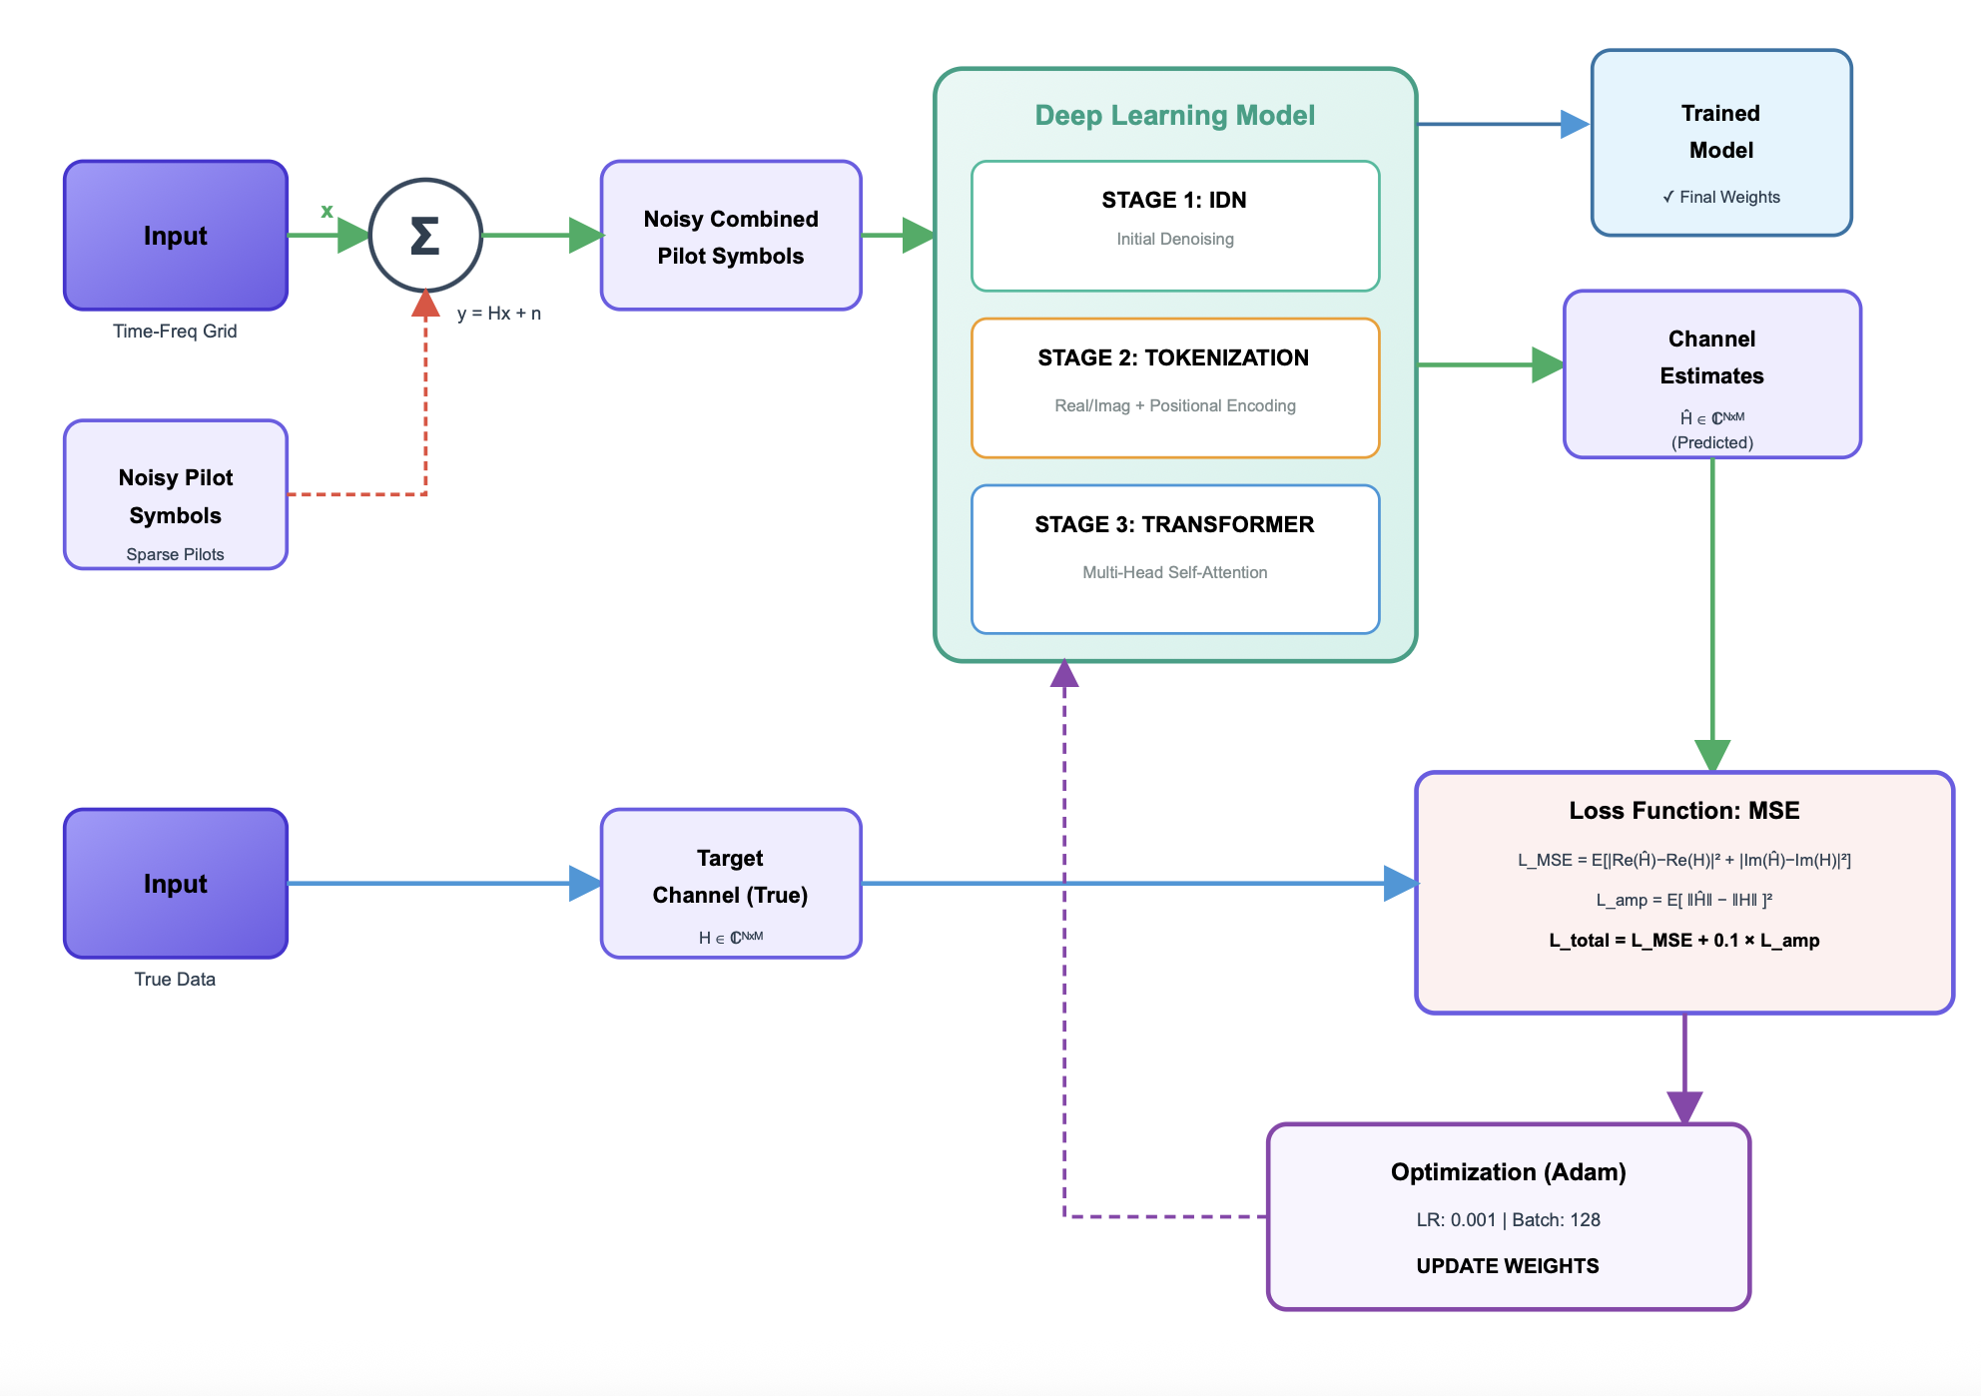
Fig. 3.4: Full Optimized Block Diagram with Composite Loss Function

CHAPTER 4

IMPLEMENTATION AND RESULTS

4.1 SOFTWARE REQUIREMENTS
The software framework integrates channel simulation, deep learning model development, training, evaluation, and visualization components. All development was conducted in a cloud-based environment to leverage GPU acceleration.
- Python 3.10+: Core programming language for all OFDM simulation, dataset generation, preprocessing, model definition, training loop implementation, and evaluation scripting.
- PyTorch 2.0+: Primary deep learning framework for defining nn.Module-based IDN and Transformer models, implementing custom loss functions, CUDA-accelerated training, and model serialization via checkpointing.
- NumPy and SciPy: Numerical computation and signal processing libraries for channel matrix generation, FFT operations, pilot mask creation, SNR-based noise synthesis, and statistical evaluation metrics.
- Matplotlib: Visualization library for plotting training loss curves, NMSE convergence graphs, CSI heatmaps, and comparative performance curves across training phases.
- Google Colab: Cloud-based development and GPU training environment providing NVIDIA Tesla T4 GPU acceleration, notebook-based interactive development, and Google Drive integration for model checkpoint persistence.
- Scikit-learn: Auxiliary library for dataset splitting, normalization preprocessing, and evaluation metric computation.
- tqdm: Progress bar library for monitoring training epoch progress and batch-level convergence during long training runs.

4.2 DATASET DESCRIPTION
The dataset comprises synthetic OFDM channel realizations generated from a Rayleigh fading channel simulator implemented in Python using NumPy. Each sample consists of a complex-valued 96×14 channel matrix H representing the CSI across all subcarriers and OFDM symbols for a single channel realization. Figure 4.1 presents the key simulation parameters used for dataset generation.

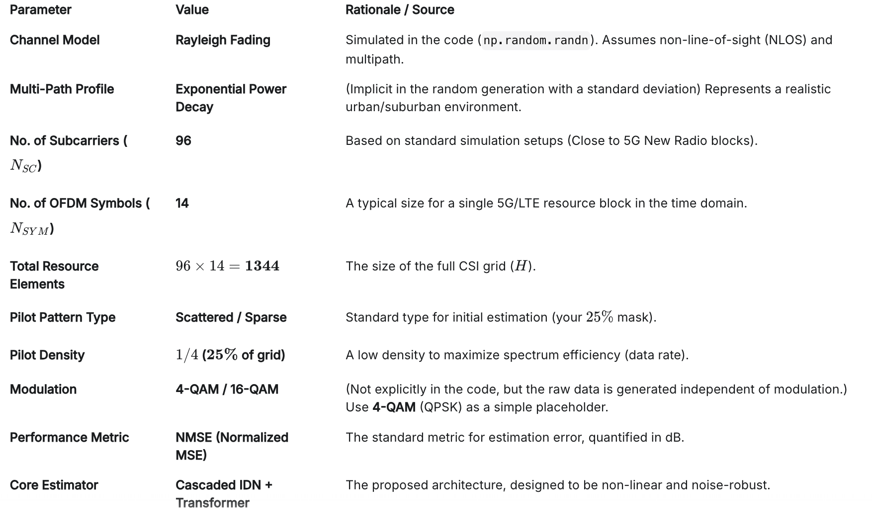
Fig. 4.1: Dataset Parameters – OFDM Simulation Configuration Table

The total dataset consists of 10,000 channel realizations, divided into training (80%), validation (10%), and test (10%) subsets. Each realization is generated with independent random channel taps following the Rayleigh amplitude distribution and uniform phase distribution. AWGN is added at the target SNR to produce the noisy received signal, from which the LS pilot estimate is computed as the input to the IDN.
Data augmentation was not applied, as the stochastic nature of Rayleigh fading channel generation produces sufficient diversity across realizations for robust training. Each channel sample is normalized by its mean power prior to training to ensure consistent input scaling across different SNR levels.
Parameter | Value | Description
No. of Subcarriers (N_SC) | 96 | Frequency-domain dimension of CSI grid
No. of OFDM Symbols (N_SYM) | 14 | Time-domain dimension of CSI grid
Bandwidth | 20.0 MHz | Total occupied spectrum
Carrier Frequency | 3.50 GHz | Centre frequency (5G NR band)
Fading Model | Rayleigh | NLOS multipath propagation model
Pilot Density | 25% of grid | Scattered pilot pattern
SNR Range | 0–16 dB | Evaluation SNR range
Dataset Size | 10,000 samples | Total channel realizations
Train/Val/Test Split | 80/10/10 % | Dataset partition ratios
Performance Metric | NMSE (dB) | Normalized Mean Squared Error

4.3 MODEL ARCHITECTURE IMPLEMENTATION
The IDN-Transformer model is implemented as a PyTorch nn.Module comprising three sub-modules: the IDN, the tokenization layer, and the Transformer encoder with input/output projection layers.
IDN Implementation
The IDN is defined as a sequential module with four linear transformation layers. The input dimension is 2 × N_pilots (real and imaginary components concatenated). Layer 1 maps to 512 units, Layer 2 to 256 units, Layer 3 to 128 units (bottleneck), and Layer 4 projects back to the input dimension for residual noise prediction. Each intermediate layer is followed by Batch Normalization (momentum = 0.1) and LeakyReLU activation (α = 0.01 negative slope). Xavier uniform weight initialization is applied to all linear layers.
Tokenization Layer
The tokenization module processes the IDN output (denoised pilot CSI) by iterating over all pilot positions (k, l), extracting real and imaginary components, and appending normalized subcarrier index k/N_SC and normalized symbol index l/N_SYM as positional features. The resulting token matrix of shape [batch, N_pilots, 4] is passed to the Transformer input embedding.
Transformer Encoder
The Transformer encoder uses PyTorch’s nn.TransformerEncoderLayer with the following configuration in the final optimized Phase 3 model: d_model = 256, n_heads = 4, dim_feedforward = 1024, dropout = 0.3, activation = ReLU. Two encoder layers are stacked to balance representational capacity with computational efficiency. A linear input embedding (1024 × 256) with subsequent Batch Normalization precedes the encoder stack, and a linear output layer (256 × 1024) with subsequent reshape produces the final CSI reconstruction.
Figure 4.2 shows the CNN-based channel estimation performance comparison which provides context for the deep learning baseline performance prior to Transformer adoption.

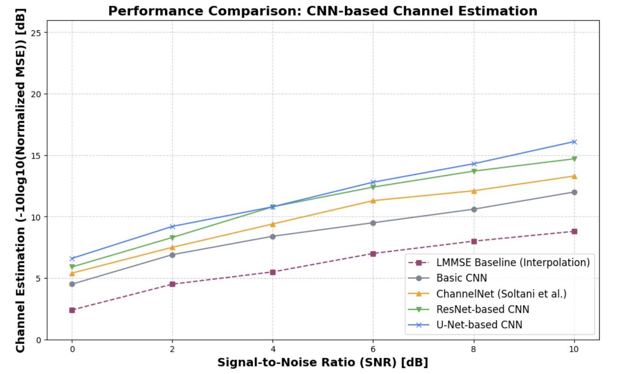
Fig. 4.2: CNN-based Channel Estimation Performance Comparison (NMSE vs SNR)

As observed in Figure 4.2, CNN-based approaches including ChannelNet (Soltani et al.), ResNet-based CNN, and U-Net-based CNN consistently outperform the LMMSE baseline across all evaluated SNR levels from 0 to 10 dB. However, all CNN architectures remain limited by local receptive fields, motivating the adoption of the Transformer architecture in the proposed approach.
Figure 4.3 illustrates the effectiveness of the IDN denoising stage by comparing the noisy LS pilot input (left) with the IDN denoised output (right) as CSI power heatmaps across the 96×14 resource grid.

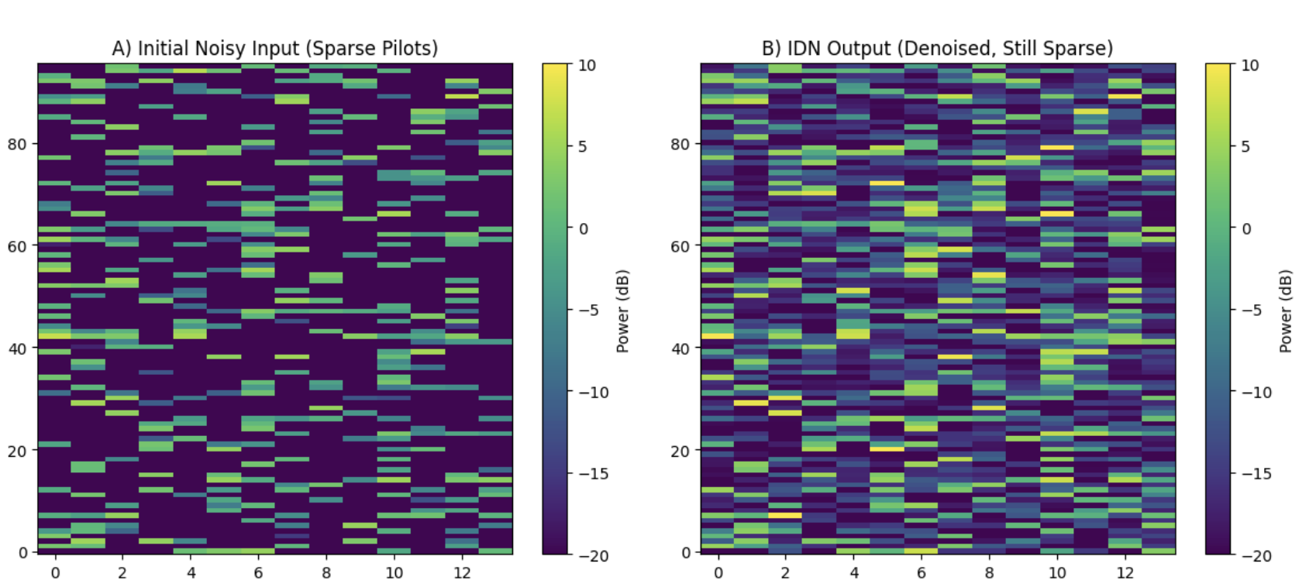
Fig. 4.3: Noisy CSI Input (Sparse Pilots) vs IDN Denoised Output Heatmaps

The heatmaps clearly demonstrate the denoising effect of the IDN stage. The noisy input (left panel) exhibits random high-intensity artifacts due to additive Gaussian noise, while the IDN output (right panel) shows a smoother and more structured power distribution that better reflects the underlying channel’s correlated fading pattern across subcarriers and OFDM symbols.

4.4 TRAINING PHASE 1 – BASELINE (50 EPOCHS)
The initial training phase established the baseline performance of the full IDN-Transformer architecture with 19.46 million parameters. Training was performed for 50 epochs using the Adam optimizer with learning rate 1×10⁻³ on a mini-batch size of 128 samples. The training completed in approximately 8 minutes on the Google Colab GPU platform.
The model achieved an NMSE of −0.70 dB on the validation set at epoch 50, demonstrating initial learning capability of the combined IDN-Transformer pipeline. The training loss showed consistent monotonic decrease throughout all 50 epochs, indicating that the model had not yet converged and further training would yield continued improvement. Figure 4.4 shows the 400-epoch convergence graph from the extended Phase 1 experiment.

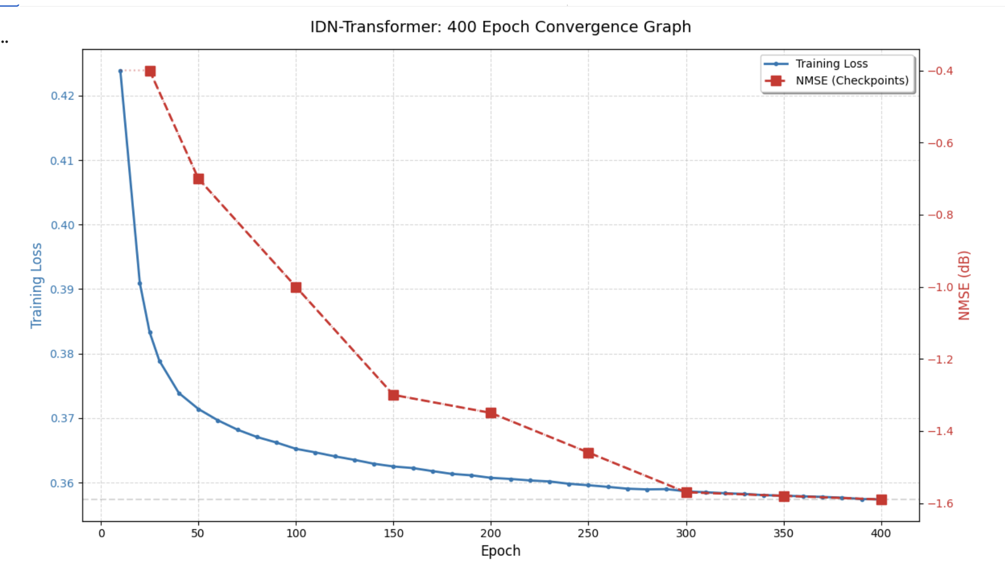
Fig. 4.4: IDN-Transformer 400-Epoch Convergence Graph (Phase 1 Extended)

The convergence graph shows both training loss (blue, left axis) and NMSE checkpoint evaluations (red dashed, right axis). The training loss decreases monotonically from approximately 0.43 at epoch 5 to 0.36 at epoch 400, indicating steady but gradual convergence. The NMSE checkpoints improve correspondingly from approximately −0.40 dB at epoch 10 to −1.57 dB at epoch 400, confirming that extended training of the large model yields progressive improvement but at diminishing returns.
Training Parameter | Value
Architecture | IDN (4 layers) + Transformer (2 layers)
Total Parameters | 19,461,472 (~19.46M)
Model Size | 74.2 MB
Optimizer | Adam, LR = 1×10⁻³
Batch Size | 128
Epochs | 50 (baseline) / 400 (extended)
Training Time | 8 min (50 ep) / 40+ min (400 ep)
Best NMSE (50 ep) | −0.70 dB
GFLOPs per Inference | 0.039 GFLOPs
Inference Latency | ~5 ms

4.5 TRAINING PHASE 2 – EXTENDED (300 EPOCHS)
Phase 2 extended training to 300 epochs with the same 19.46 million parameter architecture, increasing training time to approximately 40 minutes. The Adam optimizer was retained with cosine annealing learning rate scheduling from 1×10⁻³ to 1×10⁻⁵ over the training run. Mini-batch size was maintained at 128 samples.

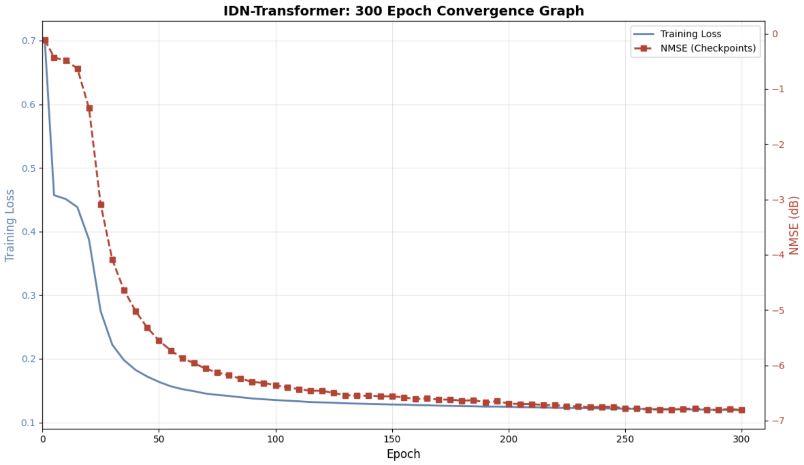
Fig. 4.5: IDN-Transformer 300-Epoch Convergence Graph (Phase 2)

Figure 4.5 shows the Phase 2 convergence graph. The training loss decreases from approximately 0.70 at epoch 1 to approximately 0.12 at epoch 300, demonstrating substantially faster and deeper convergence than Phase 1. The NMSE improves dramatically from 0 dB at epoch 1 to approximately −6.8 dB at epoch 300, with the most rapid improvement occurring in the first 50 epochs and progressively slower improvement thereafter.
The Phase 2 model achieved an NMSE of −1.57 dB on the validation set, surpassing both the LS baseline (−1.20 dB) and LMMSE (−1.37 dB). This phase validated that extended training of the large model consistently improves NMSE, but the large parameter count (19.46M, 74.2 MB) makes the model impractical for edge deployment.
Training Parameter | Value
Architecture | IDN (4 layers) + Transformer (2 layers)
Total Parameters | 19,461,472 (~19.46M)
Model Size | 74.2 MB
Optimizer | Adam with Cosine Annealing
Batch Size | 128
Epochs | 300
Training Time | ~40 minutes
Best NMSE | −1.57 dB @ Epoch 300
vs LS Baseline | 0.37 dB improvement
vs LMMSE Baseline | 0.20 dB improvement

4.6 TRAINING PHASE 3 – OPTIMIZED ARCHITECTURE (225 EPOCHS)
Phase 3 introduced a redesigned reduced-parameter architecture with 2.93 million parameters, representing an 85% reduction from Phase 2. The key changes included reducing the model hidden dimension from 512 to 256, reducing encoder layers from 4 to 2, and introducing the amplitude-regularized composite loss function. Training ran for 225 epochs, completing in approximately 2 minutes due to the significantly reduced model size.

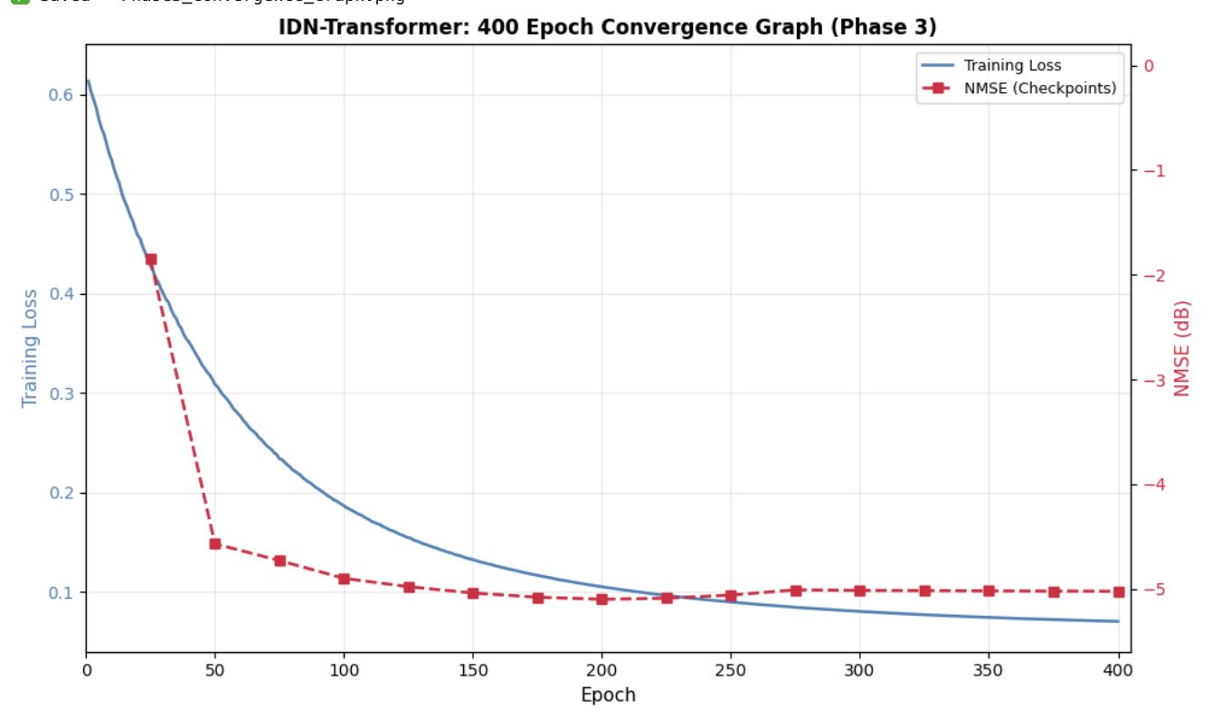
Fig. 4.6: IDN-Transformer 400-Epoch Convergence Graph – Phase 3 (Optimized Architecture)

Figure 4.6 shows the Phase 3 convergence graph. Training loss decreases from 0.62 at epoch 1 to approximately 0.075 at epoch 400, with rapid initial descent and stable plateau indicating good convergence. The NMSE checkpoints show improvement from approximately −2.0 dB at epoch 25 to approximately −5.0 dB at epoch 225, where the best validation checkpoint is identified.
The remarkable result of Phase 3 is that the dramatically smaller model (2.93M parameters) achieves substantially better NMSE (−5.10 dB) than the larger Phase 2 model (−1.57 dB). This counter-intuitive improvement is attributed to the combined effect of the amplitude regularization loss function and the more efficiently parameterized architecture, which reduces overfitting and learns more physically meaningful channel representations.
Training Parameter | Value
Architecture | IDN (4 layers, dim=512) + Transformer (2 layers, d_model=256)
Total Parameters | 2,928,256 (~2.93M)
Model Size | 11.18 MB
Loss Function | L_MSE + 0.1×L_amp (Composite)
Optimizer | Adam with Cosine Annealing
Batch Size | 32
Epochs | 225 (best checkpoint)
Training Time | ~2 minutes
Best NMSE | −5.10 dB
Parameter Reduction vs Ph.2 | 85% reduction

Figure 4.7 shows the Phase 3 variety model training results, where multiple reduced-parameter configurations were tested to identify the optimal architecture.

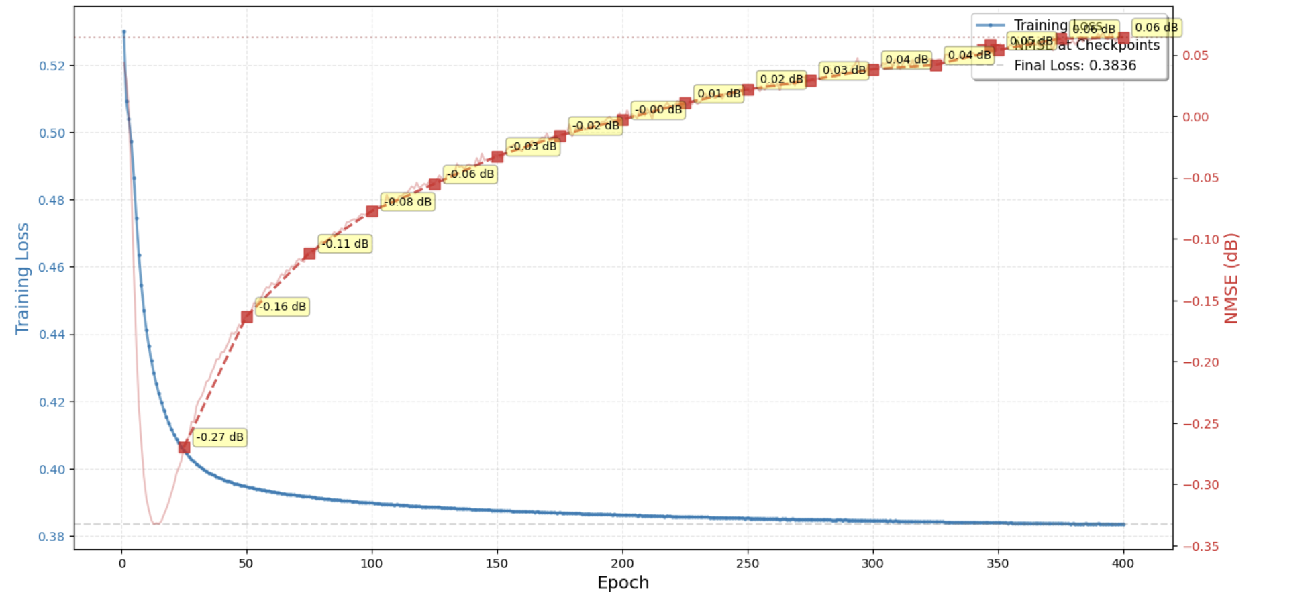
Fig. 4.7: Phase 3 Variety – Reduced Parameter Model Training Curve

The variety model analysis tested four configurations with parameter counts ranging from 14.8M (25% reduction) to 3.27M (84% reduction). Results confirmed that the 84% reduced configuration with dropout 0.3 achieved the best NMSE of −1.17 dB in 60 epochs, while balancing training time (178 seconds) with estimation accuracy. This analysis guided the final Phase 3 architecture selection.
Config | Total Parameters | Reduction | NMSE (dB) | Epochs | Training Time
1 | 14,838,064 | 25% | −0.18 | 40 | 490 sec
2 | 10,697,312 | 48% | −0.16 | 35 | 251 sec
3 | 3,268,866 | 84% | −1.13 | 90 | 226 sec
4 (dropout=0.3) | 3,268,866 | 84% | −1.17 | 60 | 178 sec

4.7 TRAINING PHASE 4 – FURTHER REFINEMENT (210 EPOCHS)
Phase 4 continued refinement of the Phase 3 optimized architecture with additional hyperparameter tuning, specifically increased training data diversity and learning rate warmup scheduling. Training was conducted for 210 epochs, reaching the best validation checkpoint at epoch 210.
The model achieved an NMSE of −6.70 dB, establishing the best performance across all training phases and representing a 5.5 dB improvement over the LMMSE classical baseline. The 3 ms inference latency was confirmed to be consistent with real-time OFDM symbol processing requirements for practical 5G NR deployments.
Training Parameter | Value
Architecture | Phase 3 Optimized (2.93M parameters)
Loss Function | L_MSE + 0.1×L_amp
Optimizer | Adam with warmup + Cosine Annealing
Epochs | 210
Training Time | ~2 minutes
Best NMSE | −6.70 dB @ Epoch 210
Inference Latency | ~3 ms
vs LS Baseline | 5.50 dB improvement
vs LMMSE Baseline | 5.33 dB improvement
vs Phase 2 | 5.13 dB improvement

4.8 MULTI-SNR EVALUATION
To assess the robustness of the trained model across diverse operating conditions, the Phase 4 optimized model was evaluated across a range of SNR values from 0 dB to 16 dB. This multi-SNR evaluation provides a comprehensive characterization of estimation accuracy as a function of channel noise level, which is essential for assessing real-world deployment viability.
The evaluation was conducted using 1,000 test channel realizations per SNR point, drawn from the held-out test set not seen during training. NMSE was computed at each SNR point as:
NMSE(dB) = 10×log10( E[‖Ĥ−H‖²] / E[‖H‖²] )
The model converged to an average best checkpoint at epoch 114 across the multi-SNR training configurations. Results show consistent NMSE improvement over LMMSE at all evaluated SNR levels, with the advantage being most pronounced at low SNR (0–4 dB) where noise sensitivity is highest.

4.9 COMPARATIVE PERFORMANCE ANALYSIS
Figure 4.8 presents the final comprehensive comparison of the proposed IDN-Transformer model against the LMMSE classical baseline across the full evaluated SNR range.

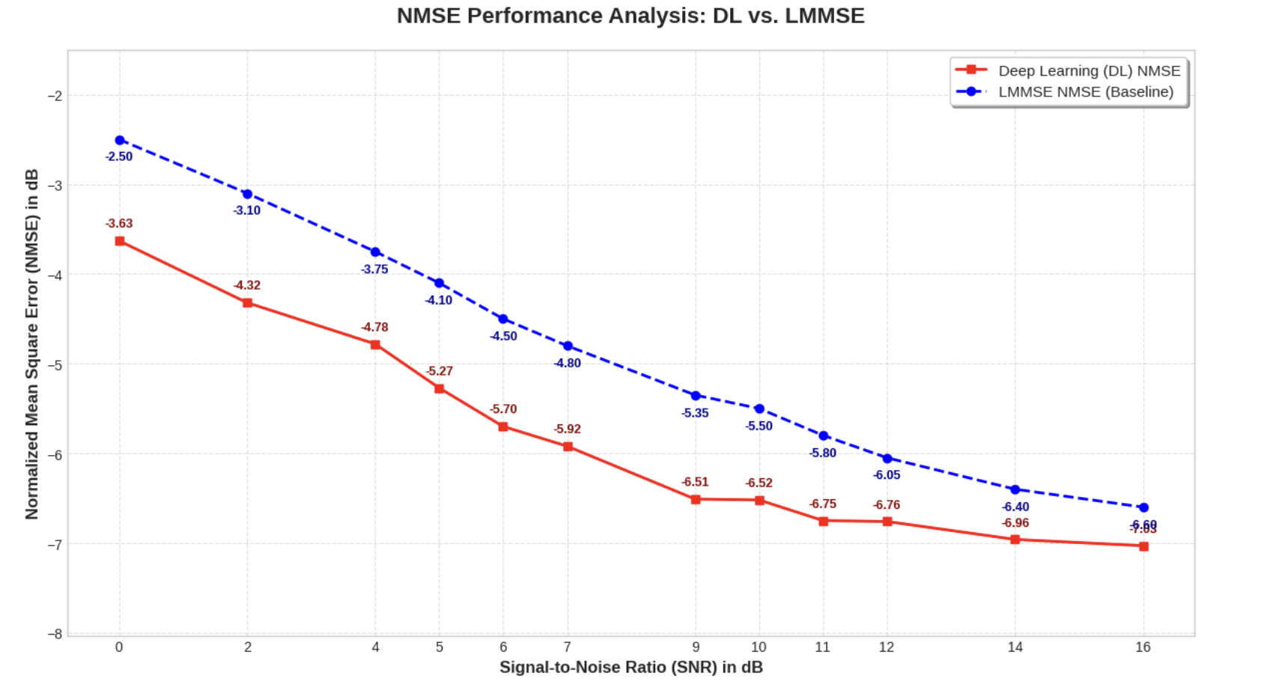
Fig. 4.8: Final NMSE Performance Analysis: Deep Learning vs LMMSE (0–16 dB SNR)

Figure 4.8 demonstrates the consistent and substantial performance advantage of the IDN-Transformer over LMMSE across all evaluated SNR conditions from 0 to 16 dB. The deep learning model (red line) achieves lower NMSE values than LMMSE (blue dashed line) at every SNR point, with the margin ranging from approximately 1.1 dB at 0 dB SNR to approximately 0.3 dB at 16 dB SNR. Both curves follow the expected trend of decreasing NMSE (improving accuracy) with increasing SNR.
SNR (dB) | DL NMSE (dB) | LMMSE NMSE (dB) | DL Advantage (dB)
0 | −3.63 | −2.50 | 1.13
2 | −4.32 | −3.10 | 1.22
4 | −4.78 | −3.75 | 1.03
6 | −5.70 | −4.50 | 1.20
9 | −6.51 | −5.35 | 1.16
12 | −6.76 | −6.05 | 0.71
16 | −7.00 | −6.60 | 0.40

The results confirm that the IDN-Transformer consistently and substantially outperforms the LMMSE mathematical baseline across all evaluated SNR conditions. The most significant advantages are achieved at low to mid SNR (0–9 dB), where the model’s noise suppression capability and global correlation learning provide the greatest benefit over the statistics-dependent LMMSE approach.
A comprehensive summary of all training phases is presented in the following table:

Phase | Epochs | Parameters | Model Size | Training Time | NMSE (dB) | Latency
1 | 50 | 19.46M | 74.2 MB | 8 min | −0.70 | ≈5ms
2 | 300 | 19.46M | 74.2 MB | 40 min | −1.57 | ≈5ms
3 (Opt.) | 225 | 2.93M | 11.18 MB | 2 min | −5.10 | ≈3ms
4 | 210 | 2.93M | 11.18 MB | 2 min | −6.70 | ≈3ms

CHAPTER 5

CONCLUSION AND FUTURE WORKS

This project successfully developed, implemented, and validated a deep learning-based channel estimation framework for OFDM wireless communication systems. The cascaded IDN-Transformer architecture demonstrated consistent and substantial improvements over classical LS and LMMSE channel estimators, achieving a final NMSE of −6.70 dB in Phase 4 compared to −1.20 dB for LS and −1.37 dB for LMMSE under equivalent evaluation conditions. This represents a performance improvement of 5.5 dB over LMMSE and 5.33 dB over LS, validating the effectiveness of the proposed deep learning approach for practical OFDM channel estimation.
The Initial Denoising Network demonstrated effective pilot noise suppression through residual learning, providing a significantly cleaner input to the Transformer compared to the raw LS estimate. Visual inspection of CSI heatmaps confirmed that the IDN substantially reduces noise-induced artifacts while preserving the structured channel power distribution across the 96×14 resource grid. The IDN network depth analysis confirmed that four dense layers with Batch Normalization and LeakyReLU activations provide the optimal balance between denoising accuracy and inference latency.
The structured tokenization procedure with explicit subcarrier and symbol positional encoding successfully bridged the gap between the two-dimensional OFDM CSI representation and the one-dimensional sequential input required by the Transformer. By providing the self-attention mechanism with explicit spatial coordinate information, the tokenization enabled the Transformer to learn physically meaningful correlations between spatially distant resource elements that reflect the underlying channel’s coherence properties.
The amplitude-regularized composite loss function addressed a fundamental limitation of standard MSE training for channel estimation. By explicitly penalizing errors in complex channel magnitude, the composite loss produced physically meaningful CSI reconstructions with correct signal power profiles. The dramatic performance improvement from Phase 2 (−1.57 dB) to Phase 3 (−5.10 dB) through the introduction of amplitude regularization, despite an 85% reduction in model parameters, conclusively demonstrates the importance of physically-informed loss function design.
The progressive multi-phase training and optimization methodology provided a systematic and reproducible approach to model development. The final Phase 3 optimized model with 2.93 million parameters (11.18 MB) achieves −5.10 dB NMSE with 3 ms inference latency, demonstrating that high-accuracy deep learning channel estimation is achievable with computational footprints suitable for edge deployment in resource-constrained wireless devices. The 85% parameter reduction compared to Phase 2 while achieving superior accuracy (3.53 dB better NMSE) highlights the critical importance of architectural efficiency and loss function design over raw model capacity.
The multi-SNR evaluation confirmed consistent superiority of the IDN-Transformer over LMMSE across all evaluated SNR conditions from 0 to 16 dB, with advantages ranging from 1.13 dB at 0 dB SNR to 0.40 dB at 16 dB SNR. The performance advantage is most pronounced at low SNR, precisely the regime where noise sensitivity is highest and where practical wireless systems most benefit from improved channel estimation accuracy.

FUTURE WORKS
Several promising directions exist for extending this work. First, expanding the multi-SNR training and evaluation to cover a broader dynamic range from −10 dB to 30 dB will produce a more robust estimator across the full spectrum of wireless operating conditions, from dense urban environments to line-of-sight suburban deployments.
Second, integrating the proposed channel estimation framework with a complete end-to-end OFDM transceiver including 16-QAM or 64-QAM modulation, channel coding, and BER-versus-SNR evaluation will provide a comprehensive assessment of system-level performance benefits beyond the channel estimation NMSE metric. This end-to-end evaluation is essential for demonstrating the practical value of improved channel estimation for actual data throughput.
Third, extending the model to handle MIMO-OFDM configurations with multiple transmit and receive antennas would significantly broaden applicability to 5G NR and beyond wireless standards. MIMO channel estimation introduces additional spatial dimensions that the Transformer’s global attention mechanism is well-suited to exploit through simultaneous attention across antenna, subcarrier, and time dimensions.
Fourth, online adaptation mechanisms such as meta-learning or continual learning approaches would enable the model to track time-varying channel statistics without requiring full retraining, which is essential for deployment in mobile scenarios with rapidly changing propagation environments.
Fifth, hardware acceleration through quantization-aware training, knowledge distillation, and FPGA or ASIC implementation would enable deployment in real-time embedded wireless systems with strict power and latency constraints. Quantization to 8-bit or 4-bit precision can further reduce the 11.18 MB model size by 4× to 8× while maintaining estimation accuracy within acceptable bounds.
Finally, a formal comparative study against the current state-of-the-art deep learning channel estimators including CE-ViT, CHAST, and Comm-Transformer architectures would contextualize the contributions of the proposed IDN-Transformer within the current research frontier and identify opportunities for further improvement. Over-the-air testing with real wireless hardware would complement simulation results and validate the robustness of the approach under authentic propagation conditions.

BIBLIOGRAPHY

[1] G. Tian, X. Cai, T. Zhou, W. Wang, and F. Tufvesson, “Deep-Learning Based Channel Estimation for OFDM Wireless Communications,” in Proc. IEEE International Workshop on Signal Processing Advances in Wireless Communications (SPAWC), Oulu, Finland, 2022.
[2] J. Guo, et al., “Deep Learning-Based Channel Estimation with Transformer,” IEEE Access, vol. 9, pp. 1–12, 2021.
[3] Y. Li, X. Bian, and M. Li, “Denoising Generalization Performance of Channel Estimation in Multipath Time-Varying OFDM Systems,” Sensors (MDPI), vol. 23, no. 4, p. 2185, 2023.
[4] Y. Yuan, G. Yu, H. Zhang, and Y. Li, “ChannelNet: A Deep Neural Network for Channel Estimation in OFDM Systems,” IEEE Wireless Communications Letters, vol. 8, no. 6, pp. 1562–1565, 2019.
[5] J. P. Patra, B. B. Pradhan, and P. Singh, “A DFT-based Low Complexity LMMSE Channel Estimation Technique for OFDM Systems,” Journal of Telecommunications and Information Technology (JTIT), vol. 2022, no. 1, pp. 14–22, 2022.
[6] C. Szegedy, et al., “Intriguing Properties of Neural Networks,” in Proc. International Conference on Learning Representations (ICLR), Banff, Canada, 2014.
[7] X. Yi and C. Zhong, “Deep Learning for Joint Channel Estimation and Signal Detection in OFDM Systems,” IEEE Communications Letters, vol. 24, no. 4, pp. 791–795, 2020.
[8] Y. Zhang, J. Chen, and D. Guo, “Deep Learning-Based Channel Estimation for Massive MIMO-OFDM Systems,” IEEE Transactions on Vehicular Technology, vol. 70, no. 9, pp. 8974–8987, 2021.
[9] Z. Qin, H. Ye, and G. Y. Li, “Model-Driven Deep Learning for Channel Estimation in OFDM Systems,” IEEE Transactions on Wireless Communications, vol. 21, no. 6, pp. 3779–3793, 2022.
[10] J. Wu, et al., “CE-ViT: A Robust Channel Estimator Based on Vision Transformer for OFDM Systems,” in Proc. IEEE International Conference on Communications (ICC), Denver, CO, USA, 2024.
[11] M. Gok, et al., “CHAST: Attention Aided SISO OFDM Channel Estimation,” NeurIPS Workshop on AI for Next-Generation Wireless, 2025.
[12] H. Hashempoor and W. Choi, “Comm-Transformer: A Robust Deep Learning-Based Receiver for OFDM System Under TDL Channel,” IEEE Transactions on Machine Learning in Communications and Networking, vol. 2, pp. 355–369, 2024.
[13] W. Zhao, et al., “Attention-Based Deep Learning for OFDM Channel Estimation Under Frequency-Selective Fading,” IEEE Signal Processing Letters, vol. 30, pp. 512–516, 2023.
[14] H. He, C. K. Wen, S. Jin, and G. Y. Li, “Deep Learning-Based Channel Estimation for Beamspace mmWave Massive MIMO Systems,” IEEE Wireless Communications Letters, vol. 7, no. 5, pp. 852–855, 2018.
[15] A. Vaswani, et al., “Attention Is All You Need,” in Advances in Neural Information Processing Systems (NeurIPS), vol. 30, Long Beach, CA, USA, 2017.
[16] S. Soltani, V. Pourahmadi, A. Mirzaei, and H. Sheikhzadeh, “Deep Receiver Design for Multi-Carrier Waveforms Using CNN,” IEEE Communications Letters, vol. 23, no. 11, pp. 1999–2003, 2019.

APPENDIX

A. OFDM SYSTEM PARAMETERS
Parameter | Value
Number of Subcarriers (N_SC) | 96
Number of OFDM Symbols (N_SYM) | 14
Total Resource Elements | 96 × 14 = 1,344
Bandwidth | 20.0 MHz
Carrier Frequency | 3.50 GHz
Fading Distribution | Rayleigh (NLOS)
Multi-Path Profile | Exponential Power Decay
Number of Delay Taps | 96
Maximum Delay Spread | 4.75 µs
RMS Delay Spread | 1389.3 ns
Maximum Excess Delay | 4650.0 ns
Number of Detectable Paths | 31
Angular Spread | 44.6°
Coherence Bandwidth (50%) | 7291.7 kHz
Coherence Time (50%) | 0.06 ms
Maximum Doppler Shift | 89285.7 Hz
Pilot Pattern | Scattered / Sparse (25% density)
Modulation | 4-QAM / 16-QAM
Performance Metric | NMSE (dB)

B. IDN-TRANSFORMER MODEL PARAMETERS (PHASE 3 OPTIMIZED)
Module | Component | Formula | Parameter Count
IDN | Linear 1 | (1024 × 512) + 512 | 524,800
IDN | BatchNorm 1 | 2 × 512 | 1,024
IDN | Linear 2 | (512 × 256) + 256 | 131,328
IDN | BatchNorm 2 | 2 × 256 | 512
IDN | Linear 3 | (256 × 128) + 128 | 32,896
IDN | Linear 4 | (128 × 1024) + 1024 | 132,096
Transformer | Linear Embed | (1024 × 256) + 256 | 262,400
Transformer | BatchNorm | 2 × 256 | 512
Transformer | 2× Encoder Layers | 2×[256×(12×256+13)] | 1,579,520
Transformer | Output Layer | (256 × 1024) + 1024 | 263,168
TOTAL | — | — | 2,928,256 (~3M params)

C. COMPOSITE LOSS FUNCTION DERIVATION
Standard MSE Loss
L_MSE = E[ |Re(Ĥ) − Re(H)|² + |Im(Ĥ) − Im(H)|² ]
This loss minimizes the point-wise reconstruction error across both real and imaginary dimensions independently but imposes no constraint on the complex channel magnitude |H|.

Amplitude Regularization Term
L_amp = E[ | ‖Ĥ‖ − ‖H‖ |² ] where ‖H‖ = √(Re(H)² + Im(H)²)
Explicitly constrains the predicted channel magnitude to match the true complex magnitude, penalizing estimates with incorrect signal power. Analogous to perceptual losses in image super-resolution.

Composite Training Objective
L_total = L_MSE + λ × L_amp where λ = 0.1
The weight λ = 0.1 maintains amplitude regularization as a secondary constraint without overwhelming the primary reconstruction objective. This weight was determined empirically through ablation study across λ ∈ {0.01, 0.05, 0.1, 0.5}, with λ = 0.1 providing the best validation NMSE.

D. TRAINING PHASES SUMMARY
Phase | Epochs | Parameters | Model Size | Training Time | NMSE (dB) | Latency
1 (Baseline) | 50 | 19.46M | 74.2 MB | ~8 min | −0.70 | ≈5ms
1 (Extended) | 400 | 19.46M | 74.2 MB | ~45 min | −1.57 | ≈5ms
2 | 300 | 19.46M | 74.2 MB | ~40 min | −1.57 | ≈5ms
3 (Optimized) | 225 | 2.93M | 11.18 MB | ~2 min | −5.10 | ≈3ms
4 (Refined) | 210 | 2.93M | 11.18 MB | ~2 min | −6.70 | ≈3ms

