***Project Report Template***

1. ***INTRODUCTION***
   1. **Overview**

Vehicle Management System is a software which is helpful for operators and passangers for to find their routes, passangers detailes and time management.It provides a variety of services to the organization.This helps the organization to reduce the manual work.It provides transparent relationship with users/drivers/employees delivering a high level of service and support,which in turn improves organization time and money.

***1.2 Purpose***

Improve fleet safety and working conditions. Improve behaviour and performance of drivers and beat unsafe driving.schedule shifts and work hours. Leverage driver retention. Manage fuel efficiency. Keep track of malfunctions

***2. PROBLEM DEFINTION AND DESIGN THINKING***

***2.1 Empathy map***

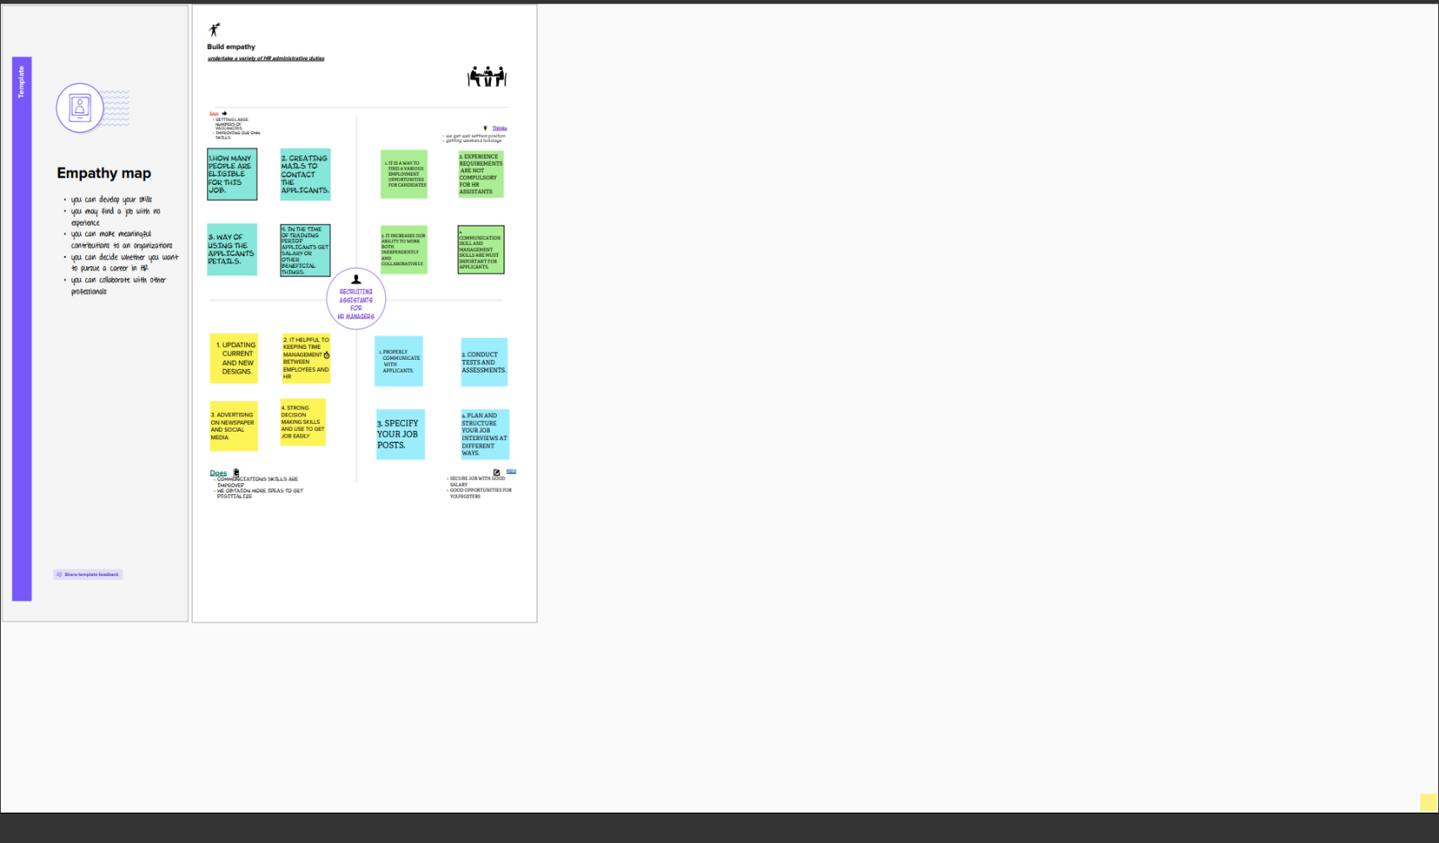

***2.2 Ideation and Brainstorming Map***

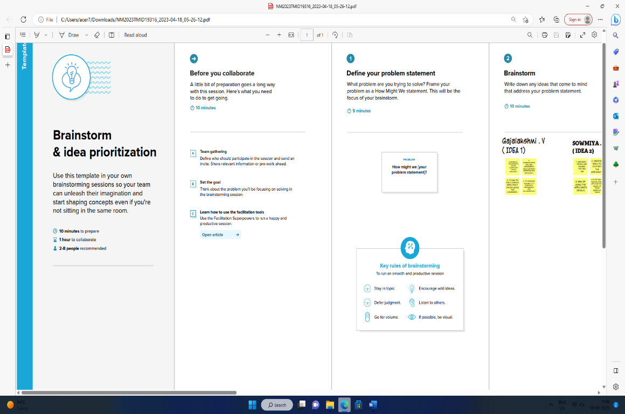

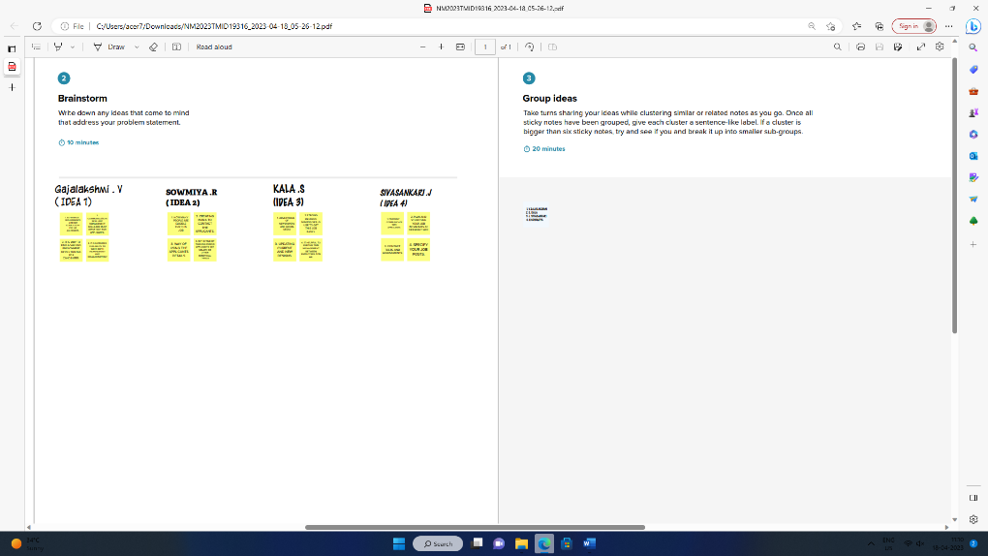

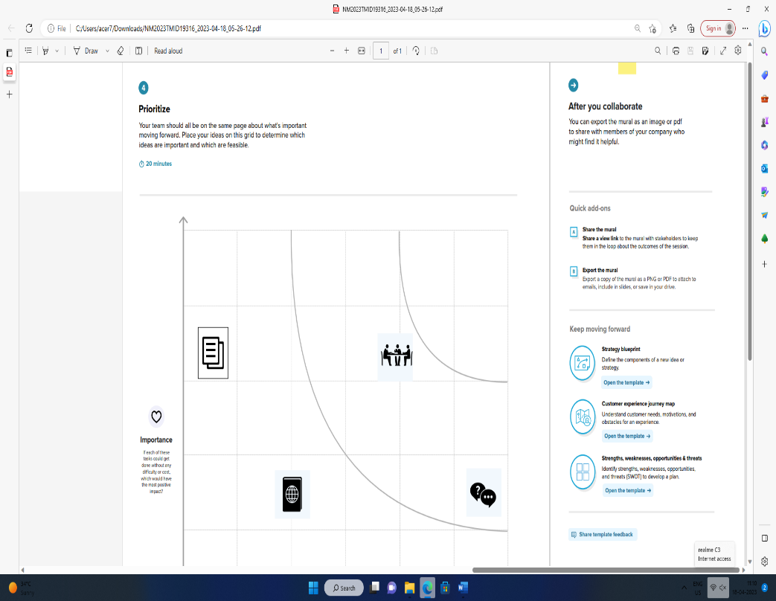

***3. RESULT***

***3.1 Data Model***

|  |  |
| --- | --- |
| OBJECT NAME | Fields in the Object |
| ***Vehicle Management*** | |  |  | | --- | --- | | **Field Label** | **Data type** | | Vehicle type | TEXT | | Site name | AUTO NUMBER | |
| ***Reviews*** | |  |  | | --- | --- | | **Field Label** | **Data type** | | Reviews | TEXT | | Review number | AUTO NUMBER | |

***3.2 Activity and Screenshot***

**MILESTONE:1-5**

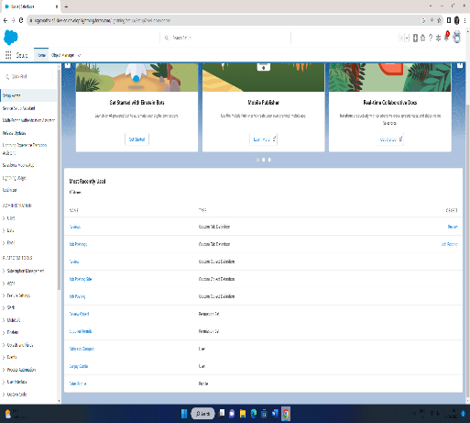 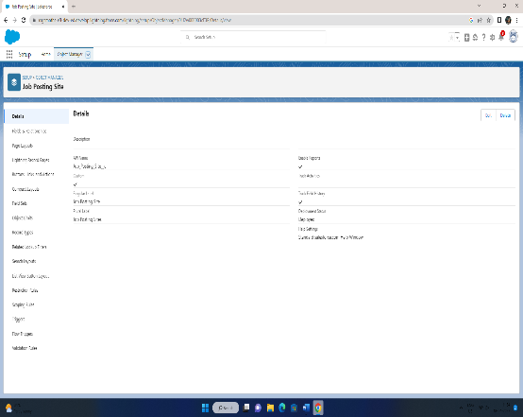

**MILESTONE:6-10**

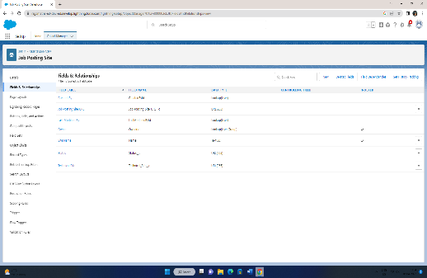 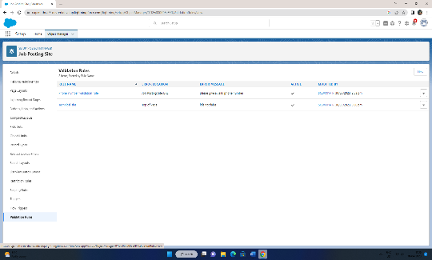

**MILESTONE:11-12**

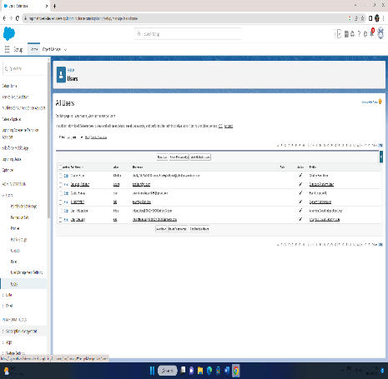 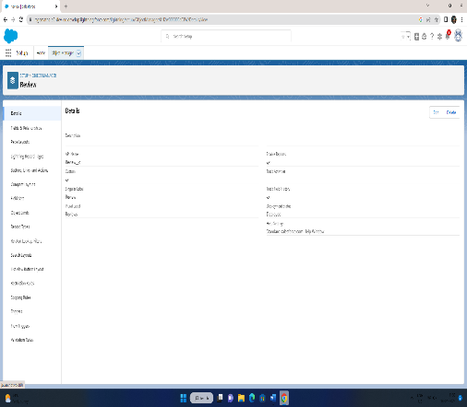

***4. Trailhead Public Profile URL***

**TEAM LEADER : https://trailblazer.me/id/raghavan07**

**TEAM MEMBER 1 : https://trailblazer.me/id/viswb3**

**TEAM MEMBER 2 : https://trailblazer.me/id/spathip7**

**TEAM MEMBER 3** : **https://trailblazer.me/id/muthu04**

***5. ADVANTAGES AND DISADVANTAGES***

ADVANTAGES:

* Vehicle maintenance and management
* Passenger safety and management
* Keep track of malfunctions and scams
* To maintain all the details safely
* Better customer service and customer retention.

DISADVANTAGES

* Some systems can be so complimented.
* The cost is too much for small business owners
* Needs proper network infrastructure for all time
* It seems more difficult for initial learners.

***6. APPLICATIONS***

* Entry level interview questions and answers
* Attention to detail interview questions and answers
* Extensive multi-tasking skills
* Excellent oral and written communication skills
* Develop and maintain strong working relationship management

***7. CONCLUSION***

In today world, the Vehicle Management place a very significant role in the daily life. On the one hand, the soft and hard vehicle management influence on the business and lets them development rapidly. It can improve employee’s motivation in a business and pay attention to company’s policy and law respectively, which can increase the efficiency of company and get higher profits.

***8. FUTURE SCOPE***

The scope is always high, request you to learn more and more about the techniques of recruitments this will help you in vehicle management industry. Scope for vehicle management is promising, there are many special in VM you can choose to master your career in. Recruitments is one of the special most sought after by consultancies and corporate.