Steps

1. Installing the GIT Hub Bash

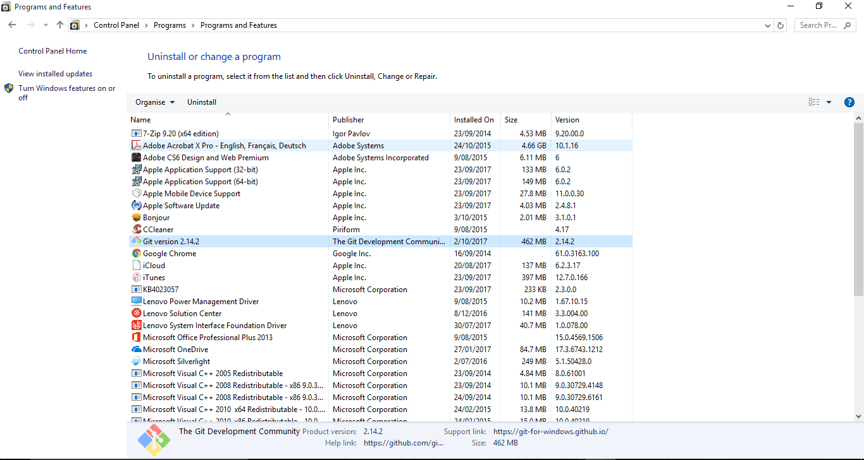

1. Running the GIT Hub Bash

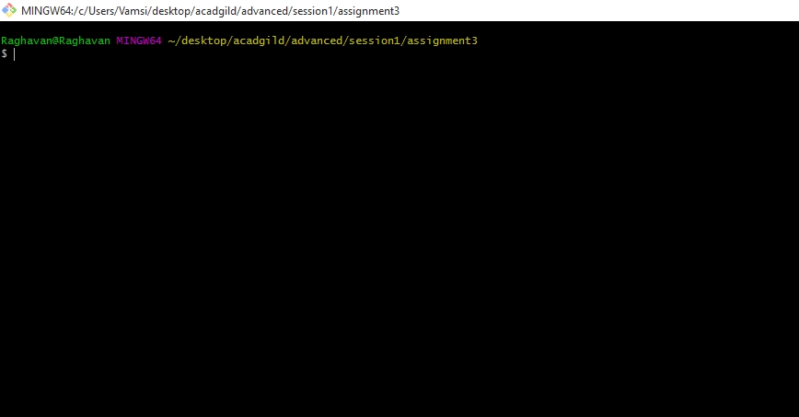

1. Cloning the ANGULAR GITHUB SEED

Run the following command in GIT BASH

**git clone https://github.com/angular/angular-seed.git**

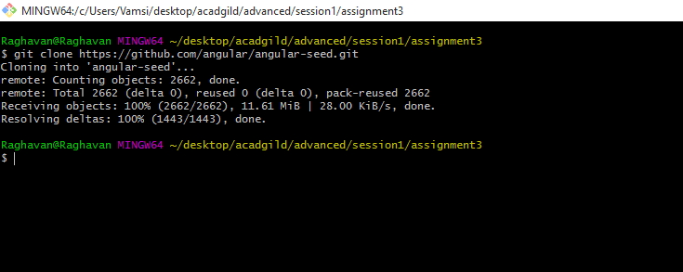

1. Installing the required packages using NPM install

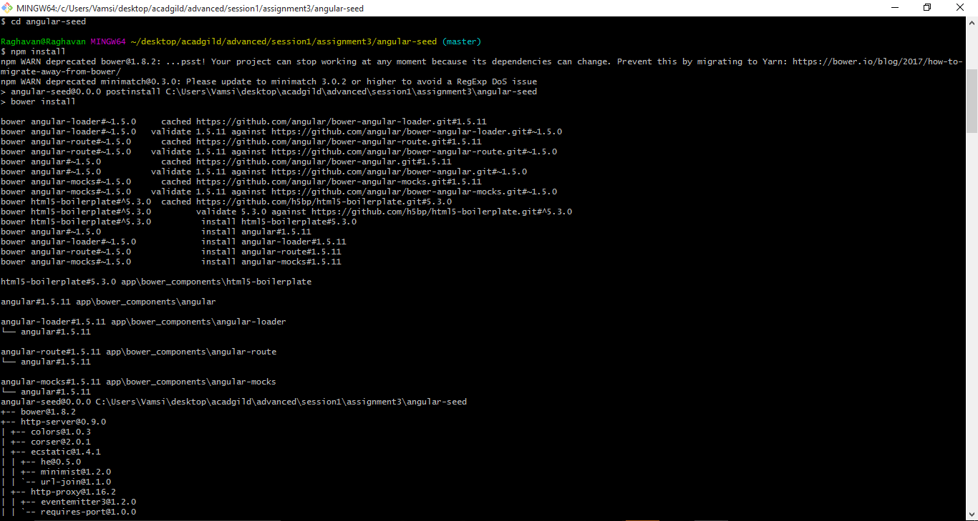

1. Starting the application using npm start

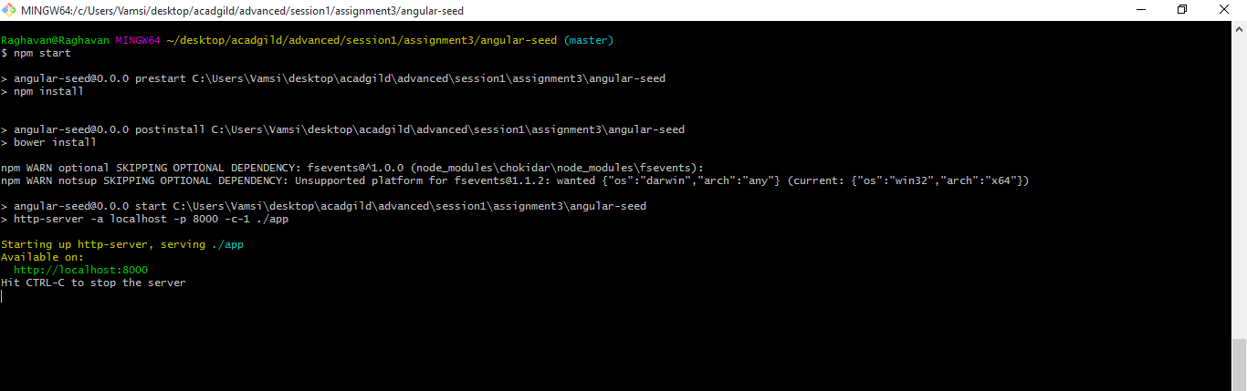

1. Running the app in browser

