Steps

1. Create new Project using ng new ‘MyApp’.
2. Install the required packages using npm install
3. Start the application using npm start
4. Once the application is running successfully in the browser, Open the application folder in Visual Studio Code

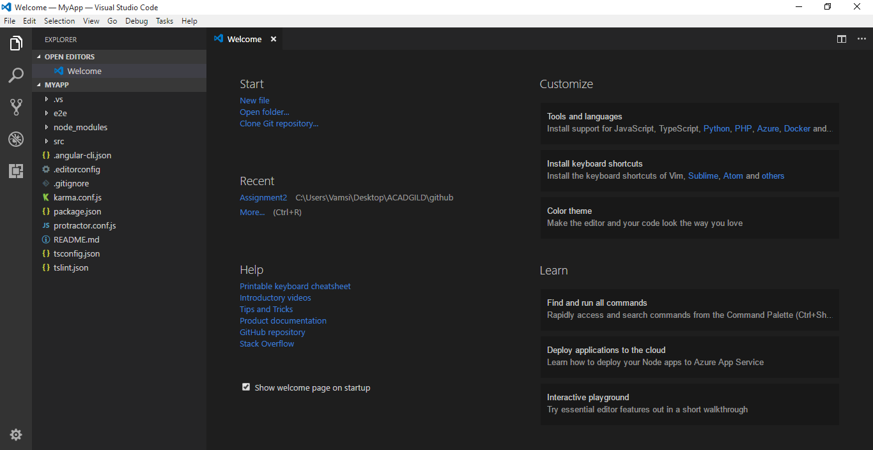

1. Install the bootstrap through npm

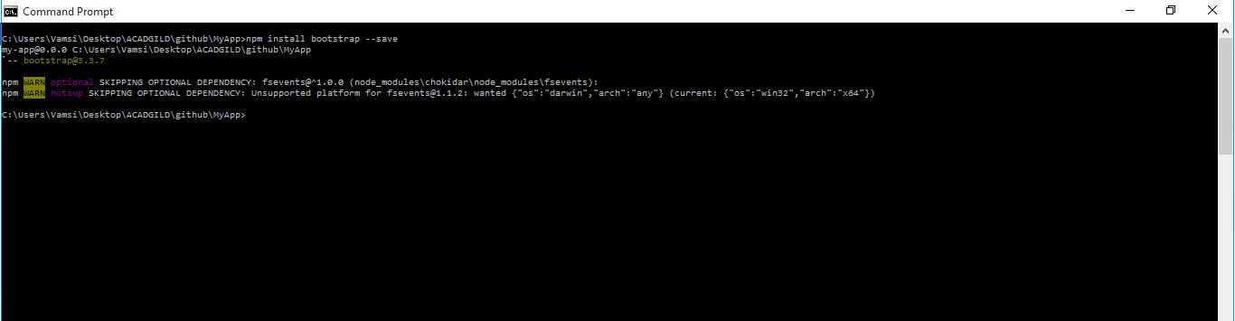

1. Add the button to the app.component.html

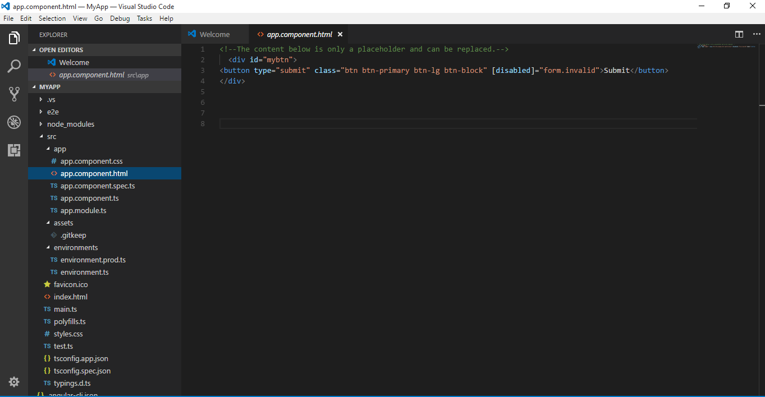

1. Add the required Bootstrap libraries to the angular.cli.json

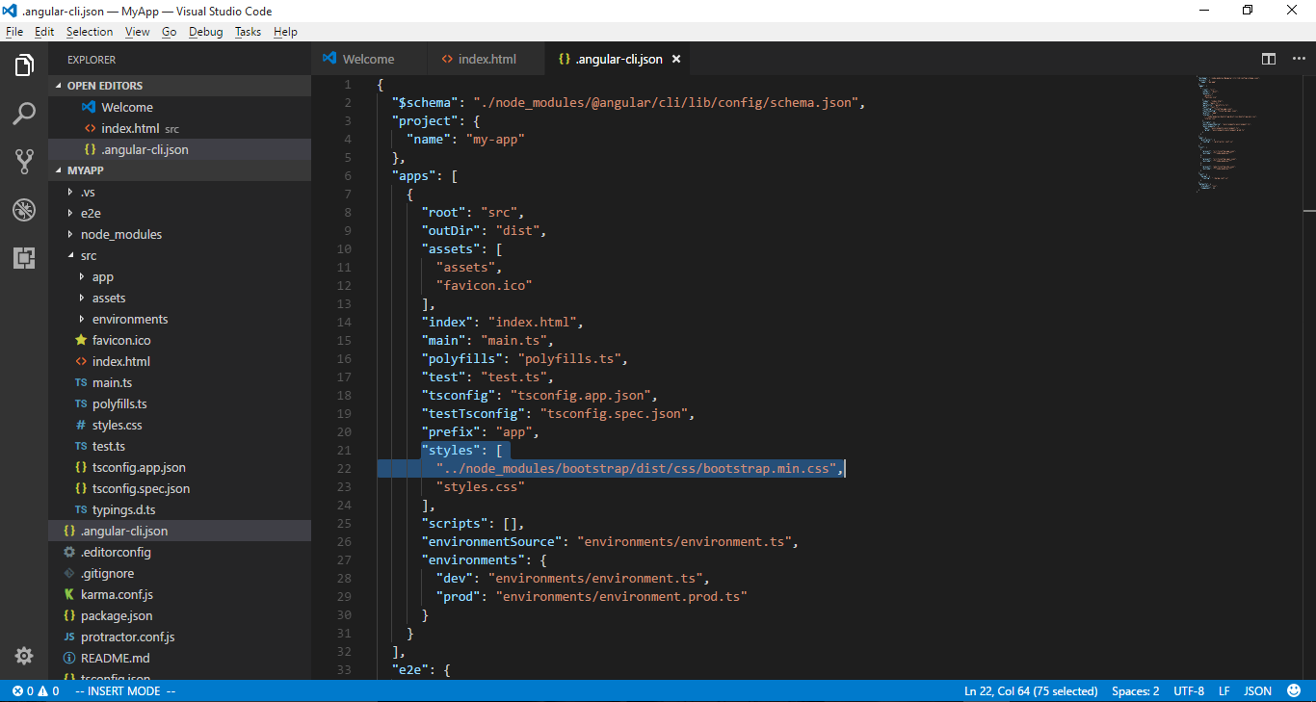

1. Applying CSS to the Div element and button inside it

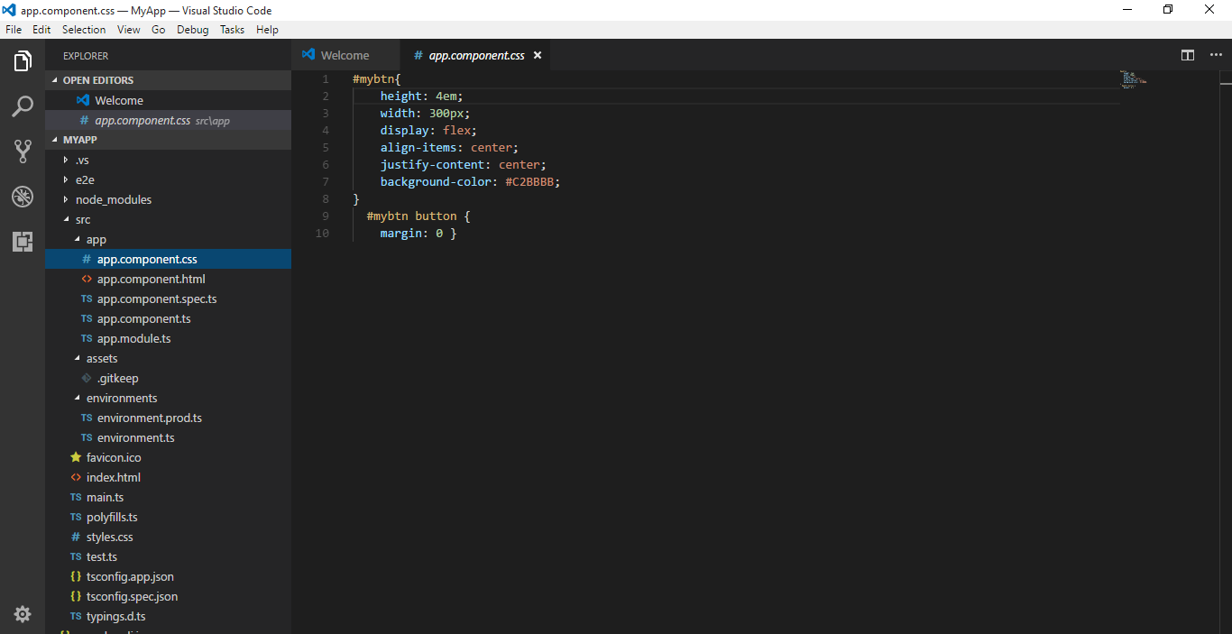

1. Check the changes in the browser

