**What is Javascript?**

Popular programming language

Uses:

* Front end development
* Backend development
* Anything possible with javascript

Javascript runs on browser originally

2009 – Node was introduced, JS script now can be run outside the browser

**Javascript vs Ecmascript**

EcmaScript is a specification

Javascript is implementation of Ecmascript

**Editors**

We use VSCode

Node js installed

Live server plugin added in VSCode

<script> tag is used to place all javascript code

Place it at the end of body so that the page is rendered on time and creates good user experience

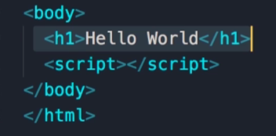

**Separation of concern**

Large applications will have it in a separate file

**Javascript in node**

node index.js

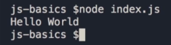

**Variables**

**let** keyword

let name;

Rules

Cannot be reserved keyword

They should have meaningful names

Cannot start with Number (1name)

They cannot contain space or hyphen (-)

Should use camelCase

Variable names are case sensitive

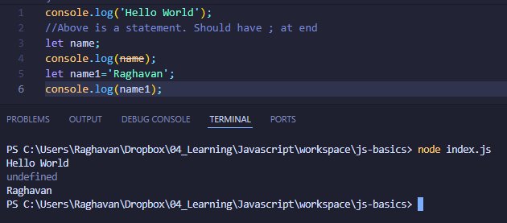

**Constants**

If value of variable should not change then use constant

const interestRate = 0.3;

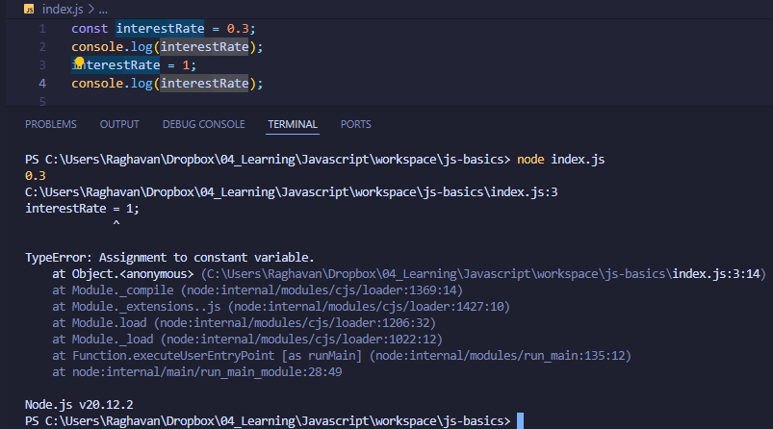

**Primitive types**

2 category of types

1. Primitive/value types
   1. String
   2. Number
   3. Boolean
   4. Undefined
   5. null
2. Reference types
   1. Object
   2. Array
   3. Function

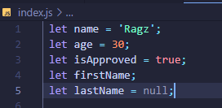

**Dynamic typing**

Type of variable can be changed during runtime. This is one differentiating factor

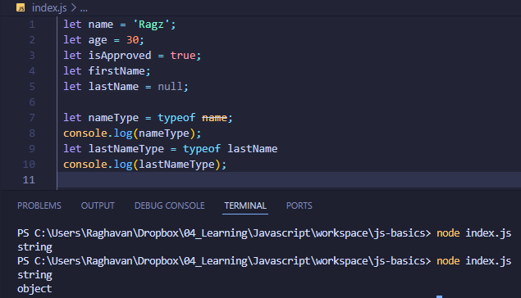

**Objects**

Object is like an object in real life

let person = {

    name: 'Ragz',

    age: 30

};

console.log(person);

// Dot notation

person.age = 15;

person.name = 'Hello';

console.log(person.age);

// Bracket notation

person['name'] = 'Mary';

console.log(person.name);

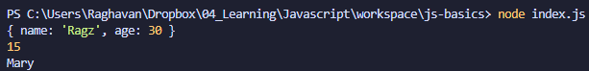

**Arrays**

Array is to store a list

let selectedColors = ['red', 'blue'];

console.log(selectedColors);

console.log(selectedColors[0]);

selectedColors[2] = 'green';

console.log(selectedColors[2]);

let type = typeof selectedColors;

console.log(type);

console.log(selectedColors.length);

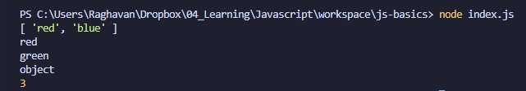

**Functions**

function greet() {

    console.log('Hello world');

}

greet();

function greet(name) {

    console.log('Hello ' + name);

}

greet('Ragz');



**Type of functions**

1. Function with no return
2. Function with return

function square (s) {

    return s*s;

}

console.log(square(2));

