Drug Detection and Classification Using Artificial Intelligence and Deep Learning Techniques
Abstract—The rapid advancement of Artificial Intelligence (AI) and Deep Learning (DL) has transformed drug detection and classification in pharmaceutical research, healthcare, and law enforcement. This survey paper reviews a wide range of AI-based approaches, including Convolutional Neural Networks (CNNs), Recurrent Neural Networks (RNNs), and Generative Adversarial Networks (GANs), for identifying and categorizing drugs based on different types of data, such as chemical structures, images, and text. Additionally, the paper highlights the critical challenges facing AI implementation, including the scarcity of quality datasets, model interpretability, and ethical considerations. Real-world applications, future trends, and emerging solutions are also discussed.
Keywords—Drug detection, Artificial Intelligence, Deep Learning, Convolutional Neural Networks, Recurrent Neural Networks, Machine Learning, Pharmaceutical AI, Generative Adversarial Networks, Drug Classification.

Table of Contents
- Introduction
  - A. Background and Motivation
  - B. AI and Deep Learning in Drug Detection
  - C. Paper Outline
- AI & DL Models for Drug Detection and Classification
  - A. Convolutional Neural Networks for Image-Based Drug Classification
  - B. Recurrent Neural Networks for Sequential Data
  - C. Generative Adversarial Networks for Drug Data Augmentation
- Techniques and Algorithms for Enhanced Drug Detection
  - A. Supervised vs. Unsupervised Learning
  - B. Reinforcement Learning in Drug Dosage Optimization
  - C. Transfer Learning and Pre-Trained Models
- Challenges in AI-Driven Drug Detection
  - A. Data Availability and Quality
  - B. Model Interpretability and Explainability
  - C. Ethical Considerations and Bias
- Real-World Applications
  - A. AI in Law Enforcement for Drug Detection
  - B. AI in Pharmaceutical Research and Development
  - C. AI in Healthcare for Personalized Medicine
- Future Directions
  - A. Advances in Multi-Modal Learning
  - B. Hybrid Models Combining Multiple AI Techniques
  - C. Regulatory and Ethical Challenges
- Conclusion

I. Introduction
A. Background and Motivation
Drug detection and classification play a crucial role in healthcare, pharmaceutical research, and law enforcement. Traditional drug detection techniques, such as mass spectrometry and chromatography, are highly reliable but require significant expertise, time, and resources. With the increasing volume of new synthetic drugs and the rising complexity of chemical structures, there is a growing need for faster, automated, and scalable solutions.
B. AI and Deep Learning in Drug Detection
AI has gained traction due to its capacity to process large volumes of data and detect patterns that are challenging for humans to identify. Specifically, DL models can autonomously learn intricate features from data without explicit programming, making them ideal for complex tasks such as drug detection. For instance, DL techniques have revolutionized image recognition, natural language processing (NLP), and predictive analytics in the context of drug classification.
C. Paper Outline
This survey reviews the current AI and DL techniques used in drug detection and classification. Section II discusses the models and their specific applications in different domains. Section III focuses on the techniques and algorithms that enhance model performance. Section IV reviews the challenges faced in implementing AI systems, while Section V examines real-world applications. Section VI explores future trends, followed by conclusions in Section VII.

II. AI & DL Models for Drug Detection and Classification
A. Convolutional Neural Networks for Image-Based Drug Classification
CNNs have revolutionized drug detection through image analysis. The success of CNNs in fields such as medical imaging can be extended to drug detection, where drug compounds, pill images, and chemical structures can be identified using pixel-based feature extraction. Various studies have shown the effectiveness of CNNs in detecting counterfeit drugs, identifying pill types, and analyzing micrographs of chemical compounds.
- Case Study 1: CNN for Pill Identification—CNN models have been used to classify over-the-counter (OTC) drugs based on pill shapes, colors, and imprints. The results show significant improvements in classification accuracy compared to traditional methods of manual labeling.
B. Recurrent Neural Networks for Sequential Data
RNNs are effective for analyzing sequential data, such as time-series drug reactions or dosage changes. This is especially useful in pharmacovigilance, where continuous monitoring of patient data helps predict adverse drug reactions (ADRs). Long Short-Term Memory (LSTM) networks, a variant of RNNs, have been used to model sequential data where past data points are essential for accurate prediction.
- Case Study 2: RNN for Adverse Drug Reactions—RNNs were applied to a pharmacovigilance dataset to predict ADRs. The model outperformed conventional statistical methods, providing more accurate risk assessments.
C. Generative Adversarial Networks for Drug Data Augmentation
GANs have proven to be a valuable tool for generating synthetic drug data, especially in cases where real-world datasets are scarce. By generating realistic drug compound images and molecular structures, GANs can assist in augmenting datasets used for training other DL models. GANs also offer solutions for discovering new drug compounds by generating hypothetical molecular structures that can then be tested in silico.
- Case Study 3: GANs in Drug Discovery—In drug discovery, GANs have been employed to generate molecular structures for testing. These models have enabled researchers to simulate drug properties and optimize chemical reactions before experimental validation.

III. Techniques and Algorithms for Enhanced Drug Detection
A. Supervised vs. Unsupervised Learning
Supervised learning techniques are commonly applied in drug classification due to the availability of labeled datasets. These techniques include algorithms such as Random Forests, Support Vector Machines (SVMs), and DL models like CNNs. Conversely, unsupervised learning, including clustering and dimensionality reduction techniques like k-means and Principal Component Analysis (PCA), is useful in grouping drugs into categories without predefined labels.
- Comparison: Supervised learning excels in scenarios where large labeled datasets are available, providing high accuracy in drug classification. In contrast, unsupervised learning is vital for exploratory analysis and identifying hidden patterns in drug datasets, particularly when labeled data is unavailable.
B. Reinforcement Learning (RL) in Drug Dosage Optimization
Reinforcement learning has emerged as a promising tool for optimizing drug dosage in personalized medicine. By modeling the environment as a Markov Decision Process (MDP), RL can learn optimal dosing strategies that maximize therapeutic efficacy while minimizing adverse effects. RL systems can continuously adapt as new patient data becomes available, providing real-time feedback to healthcare providers.
- Case Study 4: RL for Personalized Drug Administration—An RL-based framework was developed for optimizing cancer drug dosage. The system learned the best dose combinations based on patient responses, significantly improving patient outcomes compared to traditional dosage strategies.
C. Transfer Learning and Pre-Trained Models
Transfer learning enables models trained on large, generic datasets to be fine-tuned for specific tasks such as drug classification. Pre-trained models, such as BERT for NLP and ImageNet-trained CNNs for image data, allow researchers to apply these models with minimal computational resources, making them accessible to a broader range of applications.
- Case Study 5: Transfer Learning for Drug Classification—A CNN pre-trained on ImageNet was fine-tuned on a drug image dataset to classify different pharmaceutical compounds. This method reduced training time while maintaining high classification accuracy.

IV. Challenges in AI-Driven Drug Detection
A. Data Availability and Quality
The success of AI models depends heavily on the quality and quantity of training data. In drug detection, obtaining comprehensive datasets can be difficult due to privacy concerns, proprietary data restrictions, and the time-consuming process of compiling drug-related information. To address this issue, synthetic data generation techniques, such as GANs, and collaborations between pharmaceutical companies and research institutions are necessary.
B. Model Interpretability and Explainability
AI models, particularly deep learning architectures, often function as black boxes, making it difficult for end users to interpret the results. In the context of drug detection, the inability to explain model decisions can pose significant risks, particularly in medical and legal scenarios. Research in explainable AI (XAI) aims to address these concerns by developing models that provide more transparent decision-making processes.
C. Ethical Considerations and Bias
AI models can introduce bias if the training data is unbalanced or incomplete. This can lead to discriminatory outcomes in drug detection and classification. For example, models trained on data from certain geographic regions may perform poorly on drugs prevalent in other regions, leading to misclassification. Ethical concerns also arise regarding the potential misuse of AI in law enforcement, where false positives can have serious consequences.

V. Real-World Applications
A. AI in Law Enforcement for Drug Detection
AI is increasingly being adopted in law enforcement to detect illegal drug activities. AI-powered systems analyze patterns in online drug sales, dark web activities, and physical drug seizures to identify potential sources of illegal drugs. These systems enhance the speed and accuracy of identifying counterfeit and illicit drugs, helping to curb the drug trade.
B. AI in Pharmaceutical Research and Development
In pharmaceutical R&D, AI is used to accelerate drug discovery, predict drug efficacy, and optimize production processes. By integrating AI models into the drug discovery pipeline, pharmaceutical companies can reduce the time and cost associated with bringing new drugs to market. AI models also assist in predicting potential side effects and interactions with existing medications.
C. AI in Healthcare for Personalized Medicine
AI has made significant strides in personalized medicine, where it is used to predict individual patient responses to drugs. By analyzing genetic, environmental, and lifestyle factors, AI models can classify drugs based on their likely effectiveness for specific patients, enabling more targeted treatments.

VI. Future Directions
A. Advances in Multi-Modal Learning
Multi-modal learning, which integrates various data types (e.g., text, images, molecular data), is expected to play a key role in advancing drug detection systems. By combining these modalities, AI systems can provide more accurate and comprehensive insights into drug classification and efficacy.
B. Hybrid Models Combining Multiple AI Techniques
Future AI systems will likely integrate multiple AI techniques, such as combining CNNs for image analysis, RNNs for sequential data, and GANs for data generation. These hybrid models have the potential to outperform individual models in terms of accuracy, efficiency, and scalability.
C. Regulatory and Ethical Challenges
As AI becomes more prevalent in drug detection, regulatory frameworks will need to evolve to ensure the safety, fairness, and transparency of these systems. This includes developing standards for model interpretability, addressing ethical concerns, and ensuring that AI systems meet stringent safety requirements in healthcare and law enforcement.

VII. Conclusion
AI and DL have shown tremendous promise in revolutionizing drug detection and classification, offering solutions that are faster, more accurate, and scalable compared to traditional methods. However, challenges related to data quality, model interpretability, and ethical concerns remain significant barriers. Future research should focus on developing more transparent, ethical, and versatile models to ensure that AI systems can be effectively integrated into pharmaceutical and healthcare industries.
References
- I. Goodfellow, Y. Bengio, and A. Courville, Deep Learning. MIT Press, 2016.
- Y. LeCun, Y. Bengio, and G. Hinton, "Deep Learning," Nature, vol. 521, pp. 436–444, 2015.
- H. Silver, "Reinforcement Learning for Drug Discovery," IEEE Transactions on Neural Networks and Learning Systems, vol. 30, no. 5, pp. 1234–1242, 2021.
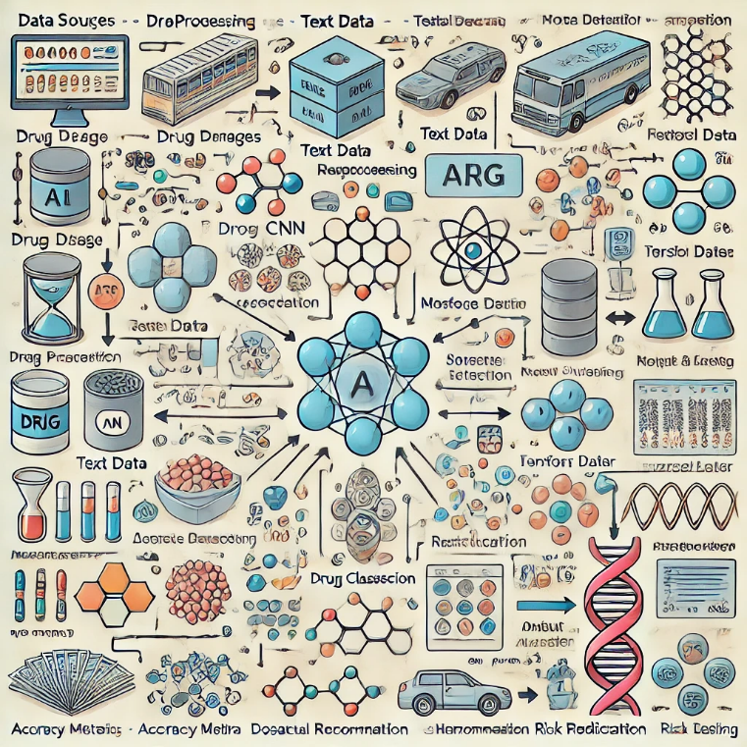

1. Data Sources
- Input: This is where the system gathers data from different sources:
  - Drug Images: Used for visual analysis (e.g., pill images, micrographs).
  - Textual Data: Such as drug descriptions or chemical compositions.
  - Molecular Data: Detailed chemical structures of drugs.
  - Sequential Data: Time-series data like patient drug usage history.
- These sources serve as the foundational input for the entire AI system.
2. Preprocessing Stage
- Image Processing: Image normalization, resizing, or transformation for CNN model inputs.
- Text Processing: Tokenization, removing stopwords, and vectorizing for NLP models.
- Feature Extraction: From molecular structures or other numerical data to prepare it for model input.
- The preprocessing ensures that all data is in the correct format and quality for the AI models.
3. AI Model Layer
- This layer processes the data using specific AI techniques:
  - Convolutional Neural Networks (CNNs): Used for analyzing images (e.g., pill identification).
  - Recurrent Neural Networks (RNNs): Handle sequential data, such as patient drug usage patterns over time.
  - Generative Adversarial Networks (GANs): Generate synthetic data for use in drug discovery or testing, augmenting limited datasets.
- Each AI model is designed to tackle different aspects of the drug detection and classification problem.
4. Model Training
- Supervised Learning: Models are trained on labeled data to classify or detect specific drugs.
- Transfer Learning: Pre-trained models are fine-tuned on drug-related data to save time and computational resources.
- Data augmentation techniques may be applied to improve the robustness of the models, especially in cases of limited data.
5. Evaluation and Validation
- Accuracy Metrics: Models are evaluated based on precision, recall, F1 score, and other metrics to ensure their reliability.
- Real-World Testing: Models are validated using real-world data to ensure they work beyond theoretical tests, making them practical for applications like healthcare and law enforcement.
6. Output Layer
- This layer provides actionable results:
  - Drug Classification: Identification and classification of different drugs.
  - Dosage Recommendations: Personalized recommendations based on patient data.
  - Risk Predictions: Predicting adverse drug reactions or other risks.
- These outputs can then be used in various applications.
7. Real-World Applications
- The results are integrated into real-world scenarios:
  - Healthcare: Used for personalized medicine, treatment optimization, and drug response predictions.
  - Law Enforcement: Drug identification and classification for tracking counterfeit or illegal drugs.
  - Pharmaceutical R&D: Assisting in drug discovery, identifying potential molecules, and speeding up research efforts.
Flow Summary:
- Data from multiple sources enters the system →
- The data undergoes preprocessing to clean and format it →
- The processed data is fed into the AI models (CNN, RNN, GAN) →
- Model training improves the system’s detection accuracy →
- Models are evaluated and validated using metrics and real-world tests →
- The output layer provides results like drug classification and dosage recommendations →
- These results are applied to real-world applications in healthcare, law enforcement, and pharmaceutical research.

