Codes: https://github.com/Raghavarora09/AWS-Step-Functions-with-Lambda.git

Create a new lambda function.

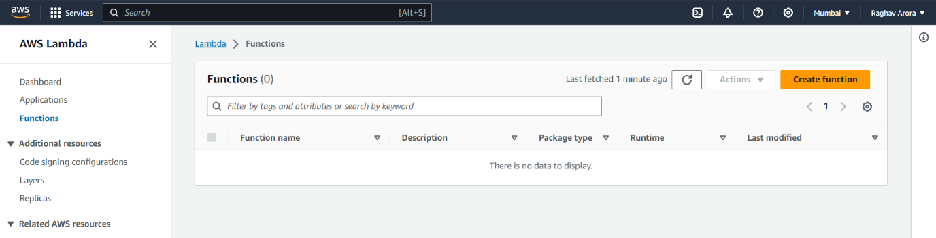

Select the runtime as Python 3.8

Click on create.

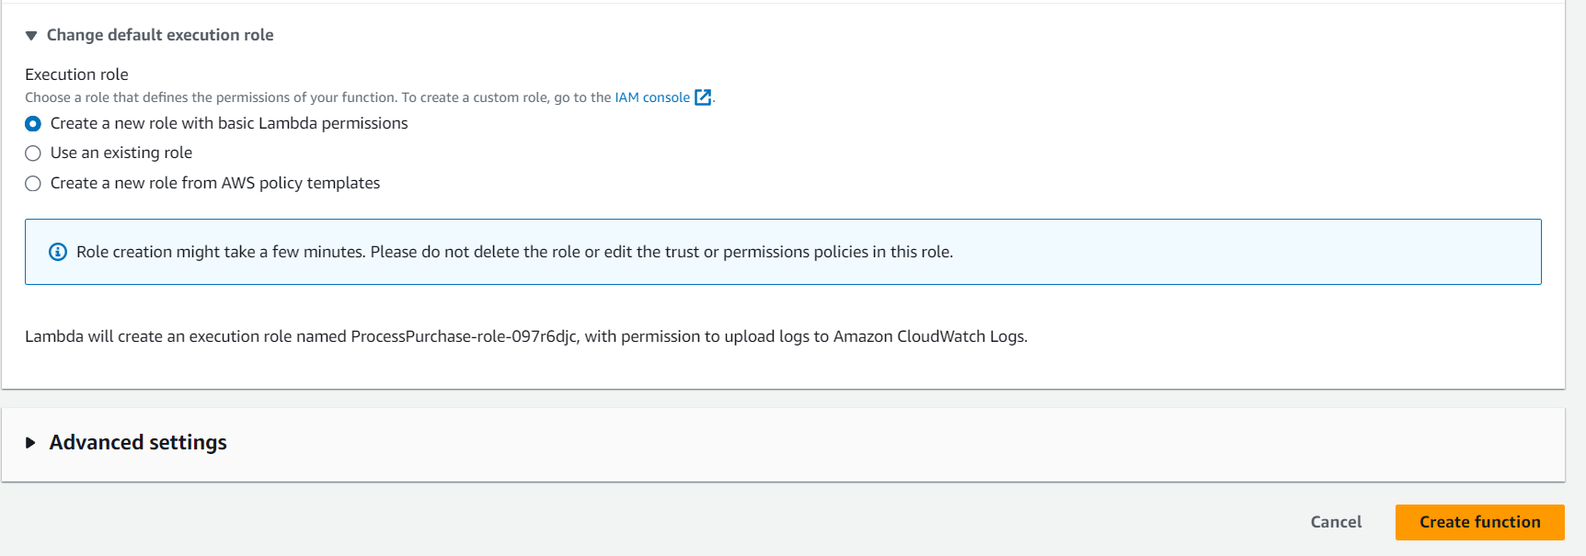

Add the lambda function code and in the runtime settings click on edit to change the lambda handler

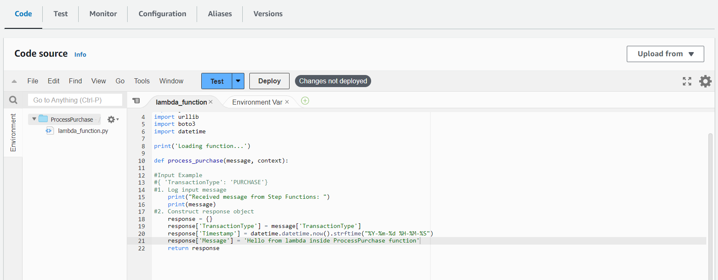

Give the handler name as lambda_function.process_purchase(which will be same as the function in the lambda code) and save it.

And add the lambda code and change the lambda handler in the same way.

Now go to Step Functions and select Create your own template.

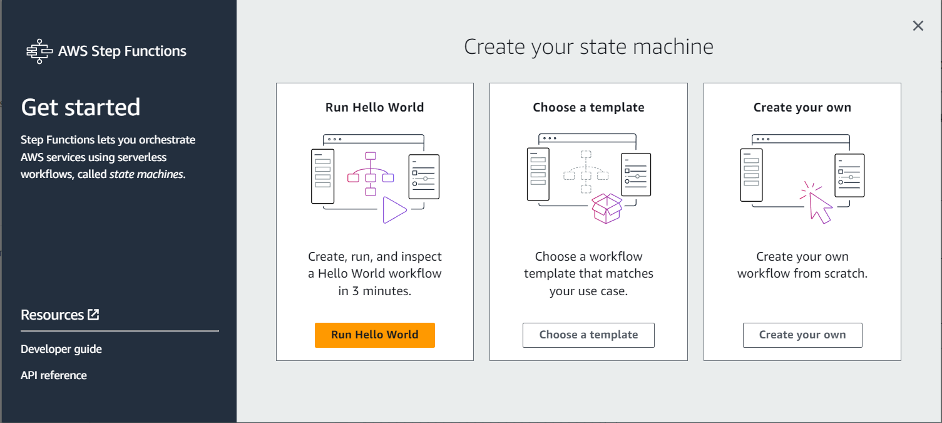

Give the name as TransactionProcessor 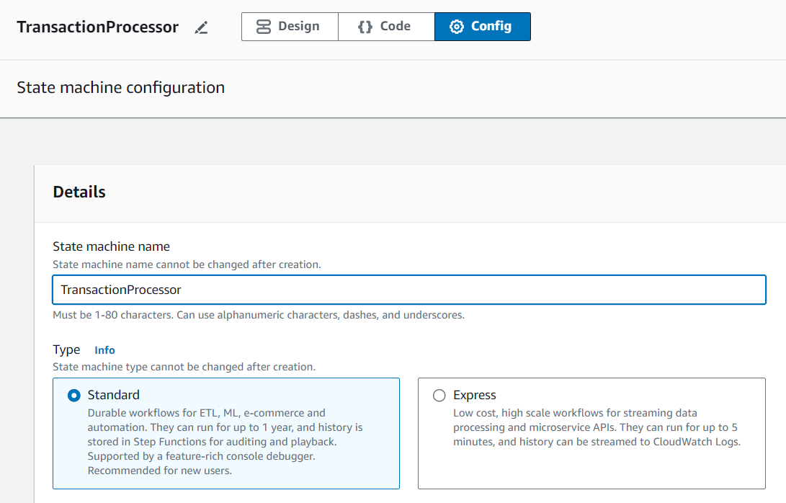

Add the code and replace the resources with the respective ARN’s of lambda functions.

And click on Create

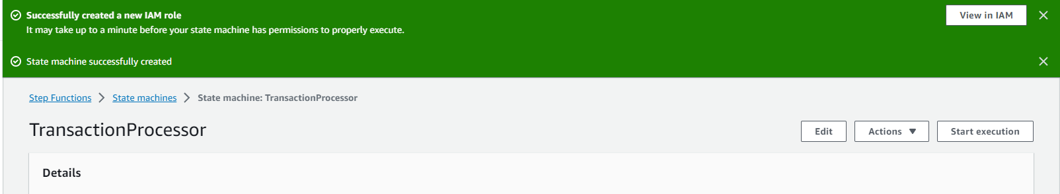

Now start execution and give the input

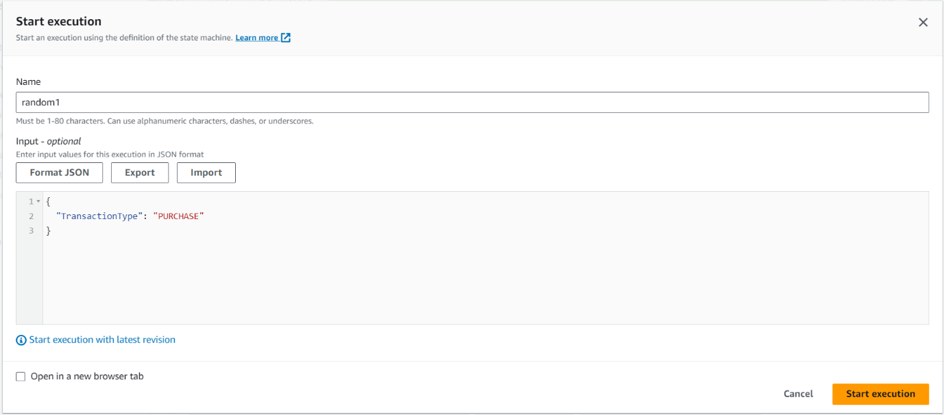

The graph will be highlighted as to which state is being used.

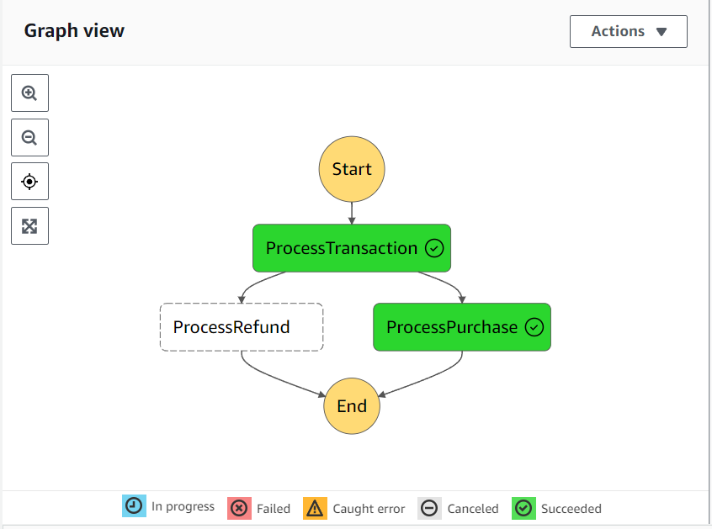

You can select a state to get the information as to what’s the Input and Output and other details.

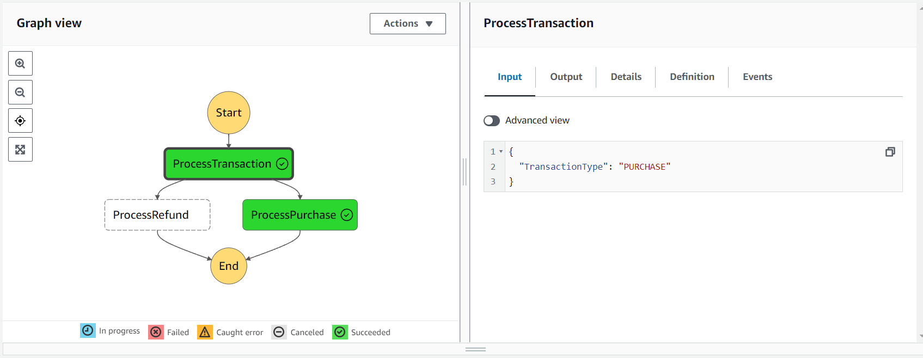

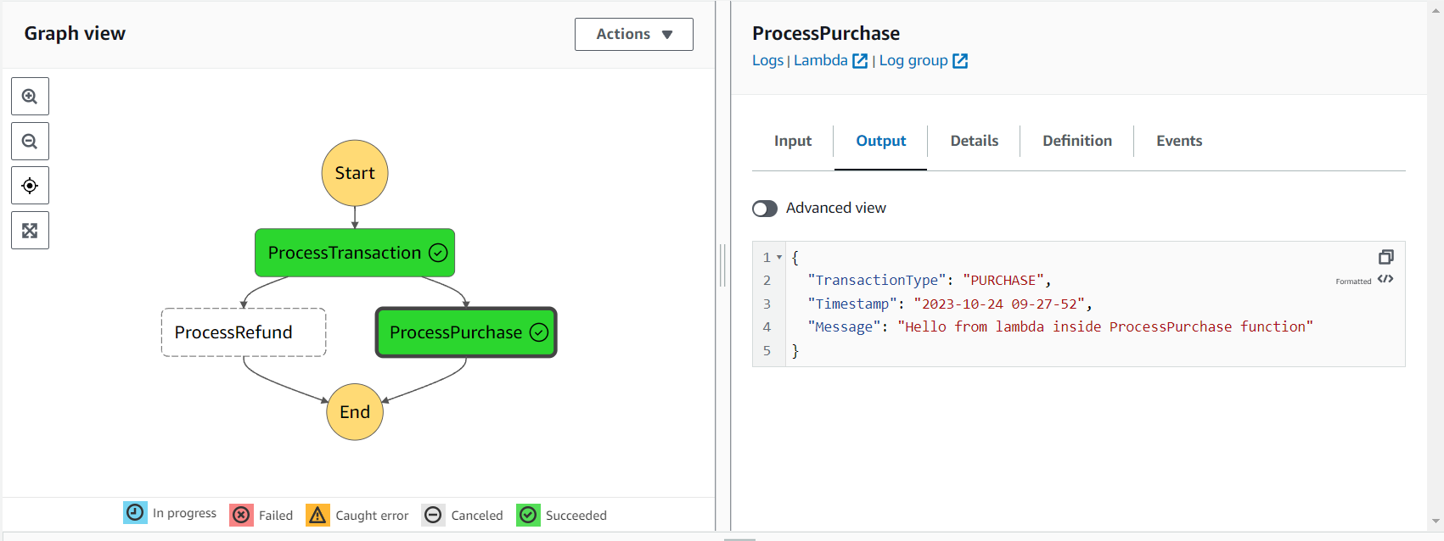

Now do the same for REFUND input.

