Raghav Arora

12113494

docker-compose: wordpress on mysql db

1. Create the docker-compose.yaml file to set up the necessary service and environment.

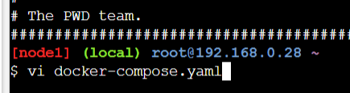

1. Inside the file define the version(which is version of the Docker Compose file format being used)

services (the services that your Docker Compose configuration will manage)

inside services give names of services which are to be used (wordpress and mysql)

define the image to be used (use of :tag is optional if not defined latest image will be pulled)

in wordpress service define the ports tag for mapping a port to the container port to run the service

give the environment variables you want to (this include host, username, password, name)

give the volumes tag which defines named volumes that the services use to store persistent data.

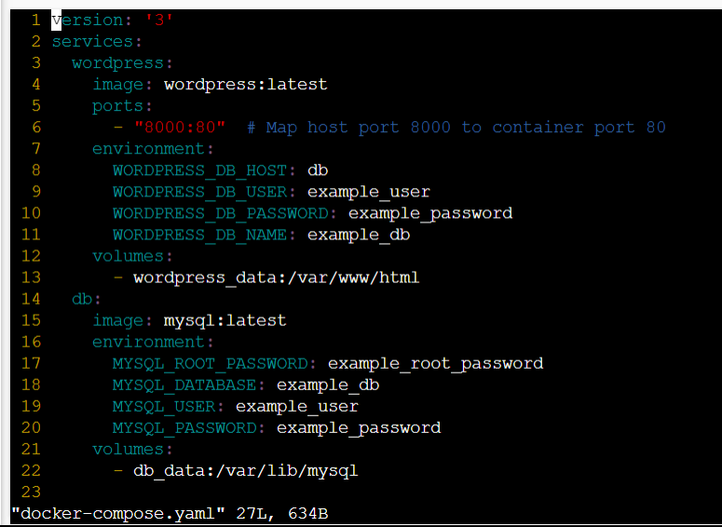

Save the file using esc :wq

1. Run the command docker-compose up -d

This will download the images and run them. Here the -d defines that the containers will run in detached mode, so that further commands can be run on the same terminal.

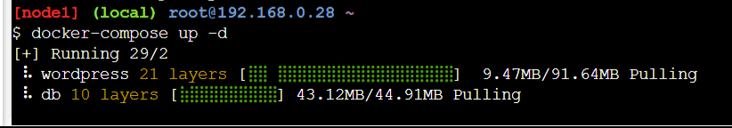

1. To check if the services are running properly.

Use the command curl localhost:8000 (which is the port we mapped the container port 80 to run the wordpress service)

Or open the 8000 port directly on another tab of browser

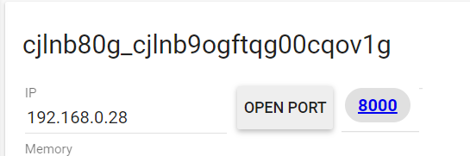

1. The wordpress service will be up and running

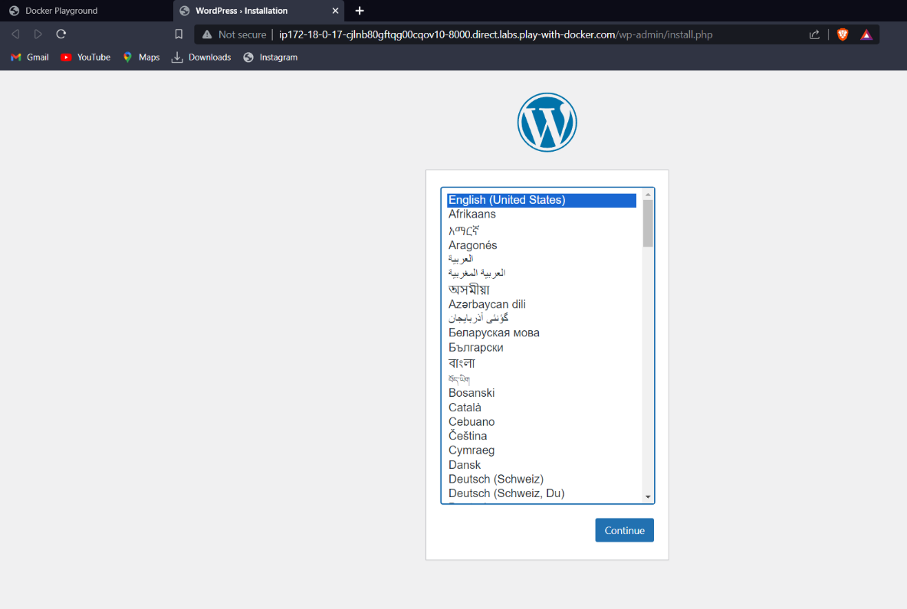

1. To shut down the service use the command “docker-compose down”

