**To stick navbar to top**

{

Position : sticky,

Top: 0

}

**Steps To Implement Radio Button In React**

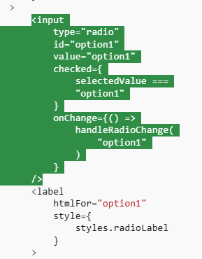

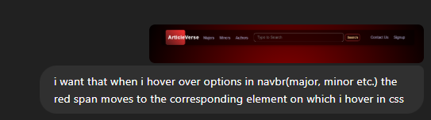

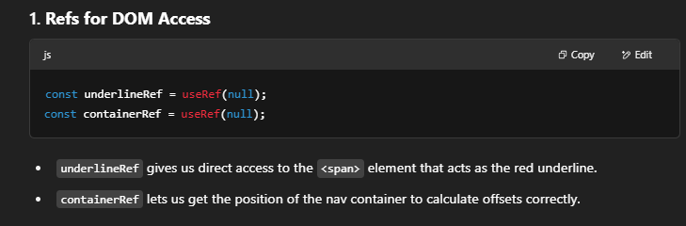

**2. Hover Handling (onMouseEnter)**

const handleMouseEnter = (e) => {

const itemRect = e.target.getBoundingClientRect(); // gets size and position of the hovered link

const containerRect = containerRef.current.getBoundingClientRect(); // same for nav container

underline.style.width = `${itemRect.width}px`; // match the hovered link width

underline.style.left = `${itemRect.left - containerRect.left}px`; // move it to the hovered link's position

};

This means:

* When you hover over "Majors", "Minors", or "Authors", we dynamically set the underline's **left offset and width** to match that nav item.

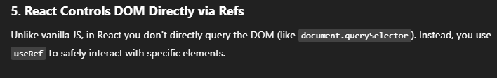

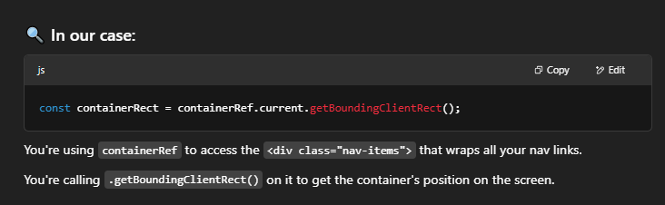

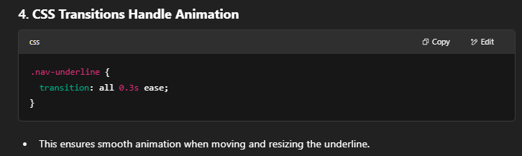**ZUSTAND** BOILERPLATE

npm install zustand

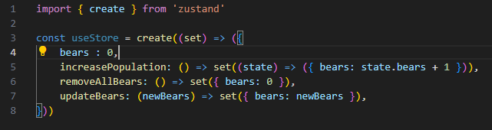

Now export it as 🡪 export const useStore = ….

And then import it as import useStore from “../src/useStore.js”

Then use its states as

Const { bears, updateBears } = useStore()

**uploading images in react (type=file)**

