**Assignment -1**

**Student Details:**

**Name Surname:** Raghavendhra Rao Devineni

**Student-id:** 21072747

**Subject:** Applied Data Science -1

**Date of Submission:** 11-11-2022

**Dataset:**

**Dataset_title:** IDA Credits & Grants for Haiti, Colombia, Mexico, Peru, Chile

**Dataset-Link:**

[**https://finances.worldbank.org/Loans-and-Credits/IDA-Credits-Grants-for-Haiti-Colombia-Mexico-Peru-/jwfq-649z**](https://finances.worldbank.org/Loans-and-Credits/IDA-Credits-Grants-for-Haiti-Colombia-Mexico-Peru-/jwfq-649z)

**\*\*\* I have chosen to download the data in a .csv format from the link \*\*\***

**GitHub Code Repository link:**

<https://github.com/Raghavendhra-herts/Applied_data_science1_Assignment-1/tree/main>

**Overview**

I have chosen the dataset from the “[**World Bank Group Finances]**”. The International Development Association (IDA) credits are public and publicly guaranteed debt extended by the World Bank Group **[https://financesapp.worldbank.org/]**. IDA provides development credits, grants and guarantees to its recipient member countries to help meet their development needs for “Haiti, Colombia, Mexico, Peru, Chile”. **[World Bank Group]** Credits from IDA are at concessional rates. Data are in U.S. dollars calculated using historical rates. This dataset contains the latest available snapshot of the IDA Statement of Credits and Grants.

**Graph-1: Line Graph**

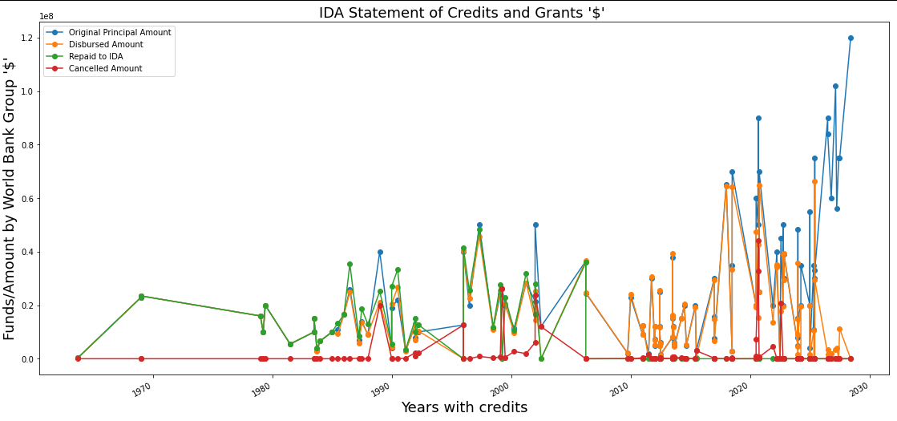

In the above line graph, it shows the funds provided by the World bank group to meet their development needs for following countries such as “Haiti, Colombia, Mexico, Peru, Chile” from the year “1965” to “2030”.

I have chosen the line graph because it differentiates the changes over a short and long period of time.

The graph shows in which year the funds have been borrowed ($) more for development, amount disbursed, loan amount repaid to IDA & canceled amount, also in which years the funds have been repaid to IDA. From the graph over the period of 2015 to 2030 there is more demand for funds for development by all countries. But during the interval from 1970 to 2005, 85% of the amount ($) has been repaid to IDA from borrowed amounts ($).

**Graph 2: Bar Graph**

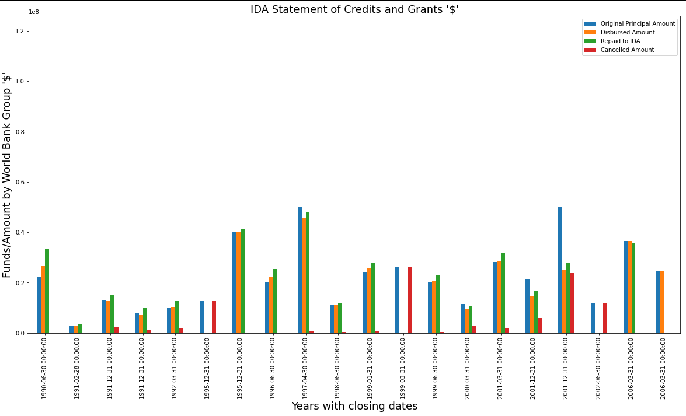

The bar graph compares the funds released by the World Bank Group to countries for their developing needs. I have chosen a bar graph, because it compares the results with different groups and is easy to understand.

From the above graph it clearly shows that from the year 1990 to 2006, 80% of the amount ($) borrowed for development has been repaid to World Bank Finances. And during the years i.e., in 1995,1999, 2022 no amount ($) (0%) has been paid in these years, graphs show funds in those years have been canceled.

And in the year 1995 and 2006 all the amount ($) (100%) that is borrowed from the finance group has been repaid completely by the borrowing countries.

**Graph 3: Histogram Graph**

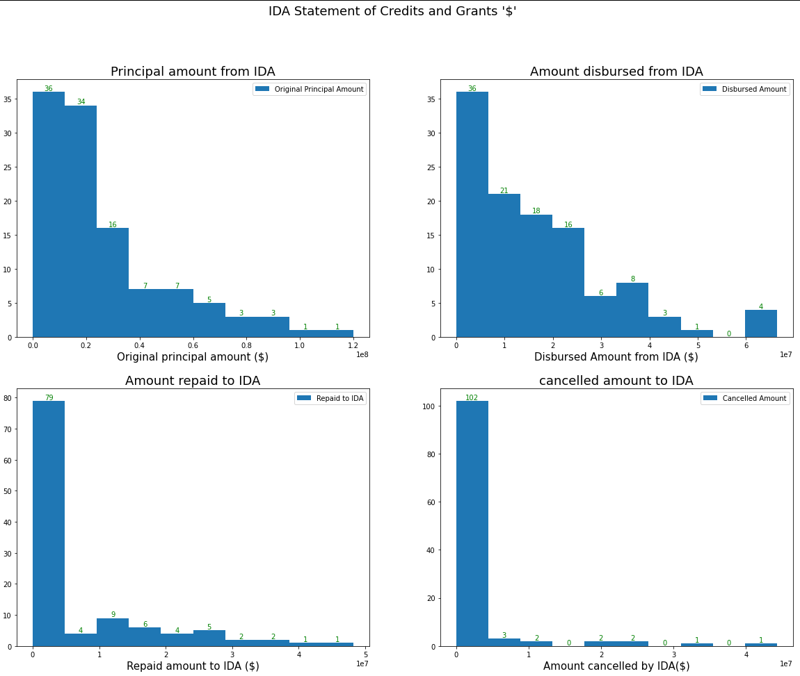

The above graph is Histogram. I have chosen this graph because it determines the maximum and minimum data points from the column we choose, which helps to compare the data with other data columns by controlling the column using bins. And I have generated each graph in one call using subplots.

Each graph represents columns from the dataset such as “Original Principal Amount”, “Disbursed Amount”, “Repaid to IDA”, “Cancelled Amount”. From the above graph at index-1 i.e., “original principal amount” represents the highest principal amount is $120,000,000.0 and lowest amount is $1,000,000 from the dataset.

And from index-2 i.e., “Disbursed Amount” represents the highest principal amount is $66,399,462.28 and lowest amount is $0 from the dataset.

At index-3 i.e., “Repaid to IDA” represents the highest principal amount is $48,243,756.33 and lowest amount is $1,000,000 from the dataset.

At index-4 i.e., “Canceled Amount” represents the highest principal amount is $44,260,989.78 and lowest amount is $0 from the dataset.