From the chosen dataset, an analysis for 5 different countries and the inter-relation of the listed factors on climate changing such as : “CO2 Emission”, “Electric Power Consumption” were observed over the period of years from 2000 - 2015

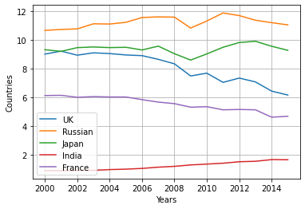

**Figure-1**

The above figure represents a line graph. The graph displays the data from the year 2000-2015. I have chosen five different countries ("United Kingdom", "Russia", "Japan", "India", "France") from dataset.

From figure (1) countries like "Russia" and "Japan" are constantly high in producing CO2 Emission, which reflected in consuming more electricity power over the years as shown in Figure (2), which is more compared to "United Kingdom" & "India". And both the countries "United Kingdom" and "France" as from the graph their emission rate is rapidly decreasing every year, but “France” seen to be utilizing more power consumption from 2008 to 2014.

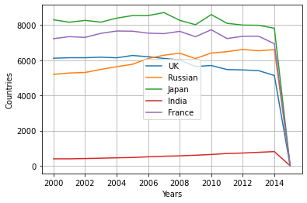

Figure (2)

But "India" as shown from Figure (1) & (2) it's constantly increasing their carbon emission as well as Electric Power Consumption every year which leads to major changes in climate.

