# **Assignment 1**

1. Install Power BI Desktop and share the final screenshot of the report view page which appears when power desktop starts.

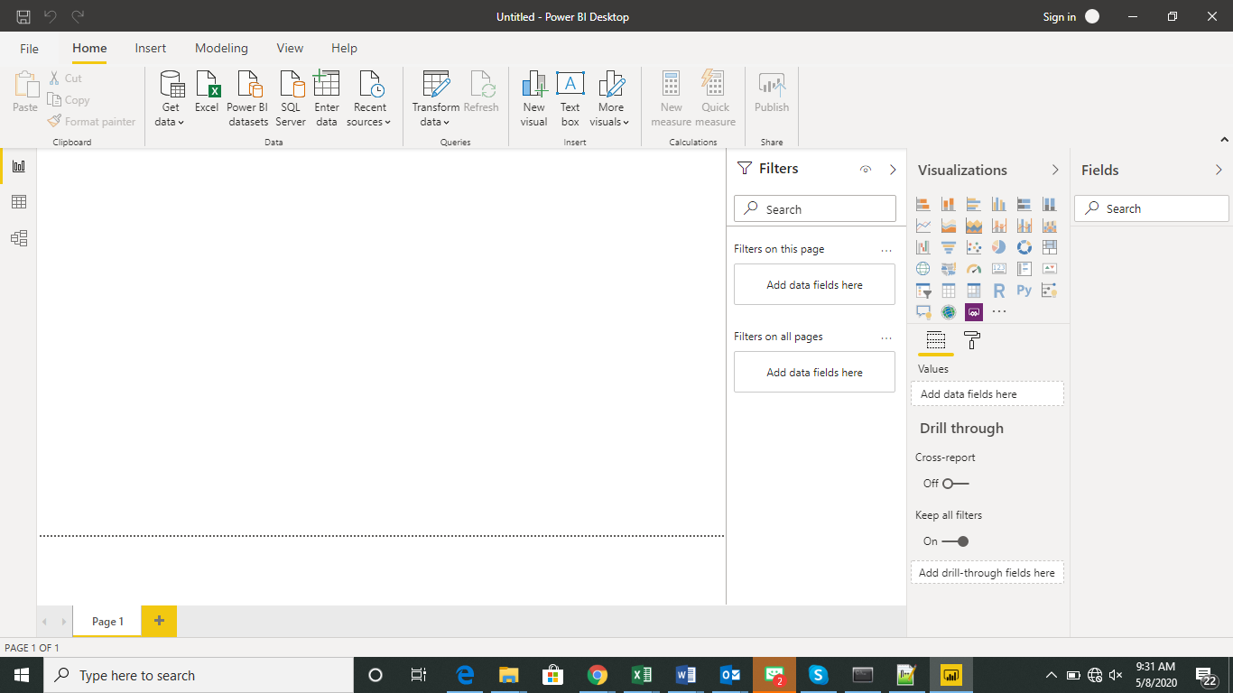

1. Prepare a document and with the following screenshot

− Report View

− Data View

− Model View

− Power Query Editor

− Advance Editor

Report View

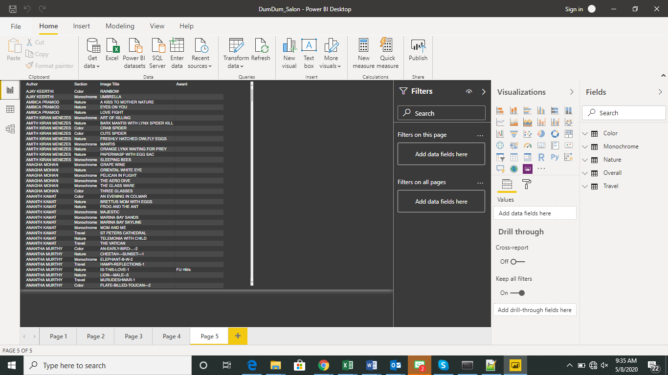

Data View

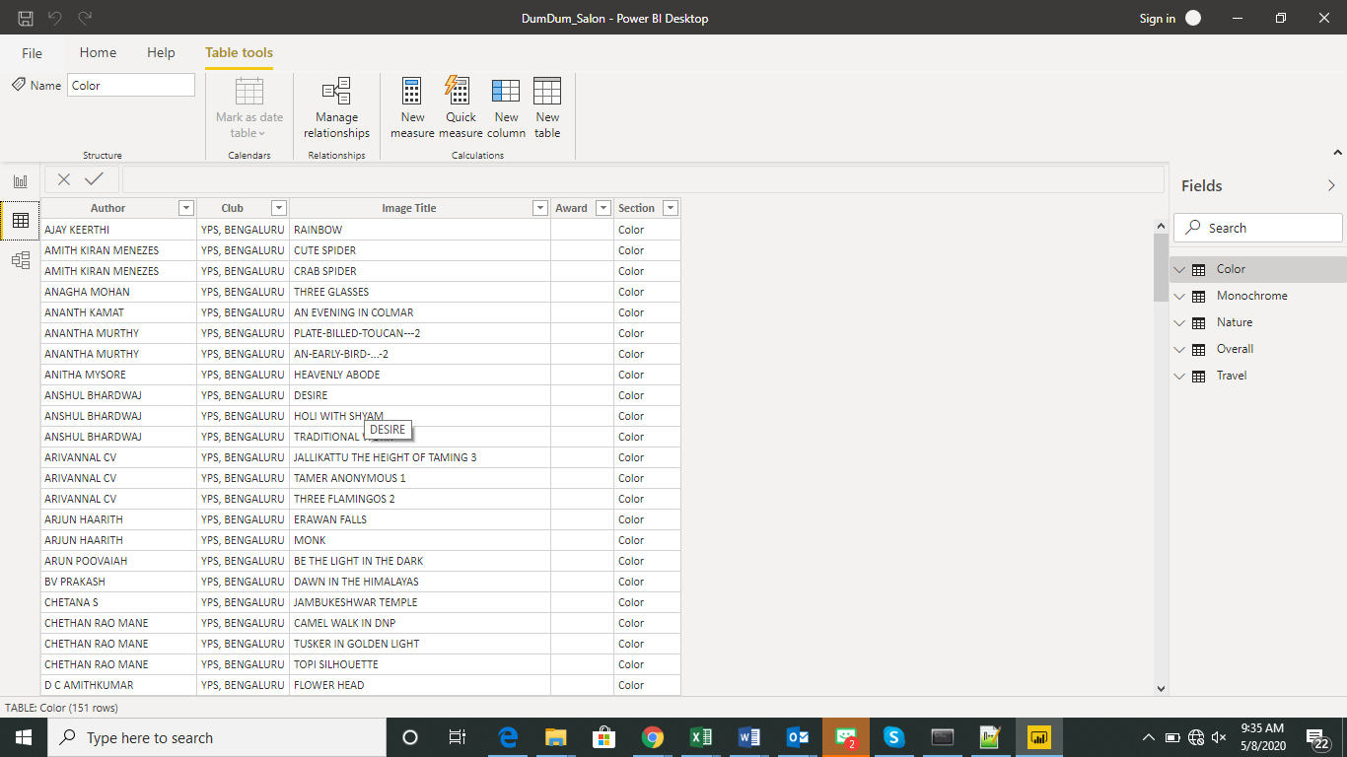

Model View

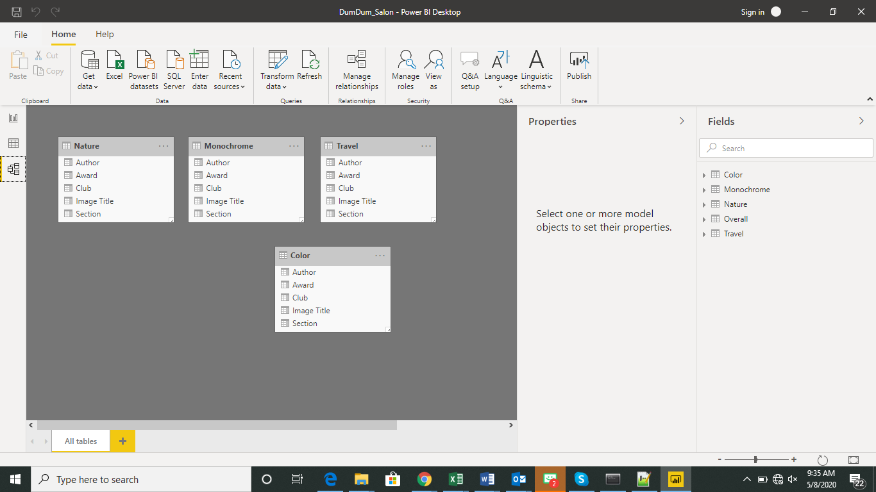

Power Query Editor

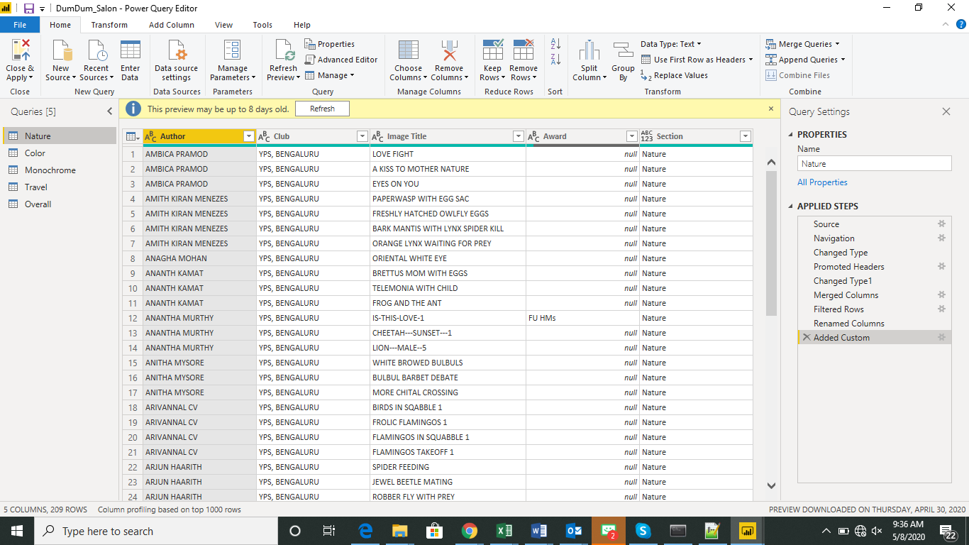

Advance Editor

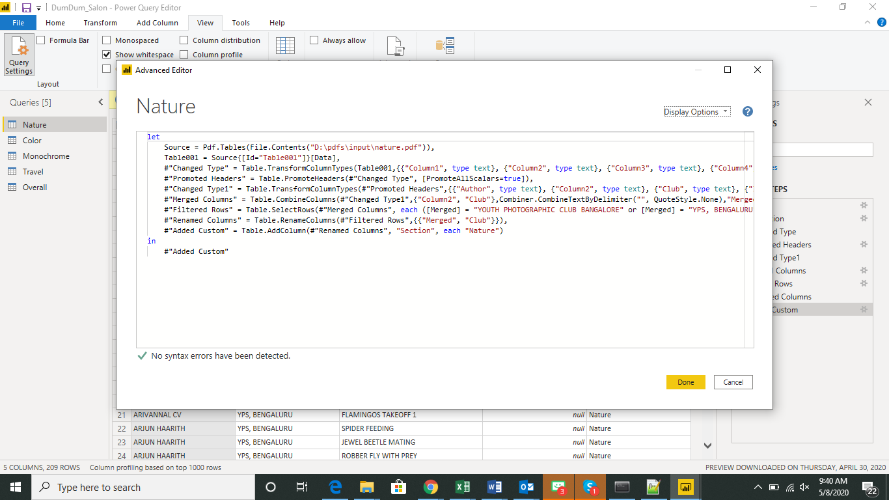

1. Prepare a document with details of the following along with their price

* Power BI Desktop

Power BI Desktop is the free version of Power BI that you can install on your local computer as a program, and acts as a companion desktop application to the full version of Power BI.

* Power BI Pro

Power BI Pro is the full version of Power BI, complete with the ability to use Power BI for both building dashboards and reports and unlimited viewing, sharing and consumption of your created reports. Power BI Pro is licensed individually, so if organization has 100 users, 100 licenses have to be procured

* Power BI Premium

Power BI Premium is the most expensive tier of Power BI currently available. Power BI Premium allows large data sets, improved performance, API access, Large storage size, Geo distribution, Powerful BI Report server. The licensing is bulk and depends on dataset and reports size, rather than number of users