**Devops Engineer with 3 Years of Experience in AWS Cloud Infrastructure Management, Trouble shooting and Monitoring and deploying in Linux based Systems**

# Name Name

**Mobile:** +91-xxxxxx

**Email**: [**xxxxxxxxxxxxxx@gmail.com**](mailto:xxxxxxxxxxxxxx@gmail.com)

**Certification: AWS Certified Solutions Architect Associate**

### BRIEF OVERVIEW

* 3 Years of extensive experience in Installation, Implementation and Administration of industry's leading Redhat Enterprise Linux in AWS Public Cloud environment and Automation with Devops Tools.
* Effective system & fault handling of Linux servers, system resource allocation.
* Deploying applications using DevOps culture in Jenkins pipeline and Integrations to different tools for Automation

### OBJECTIVE

* To use my skills, experience and adaptability to obtain a systems administration, engineering or architect position where I am constantly challenged. My greatest strength is my ability to walk into a new environment and be functional immediately. I am quick to learn and adapt to new situations, configurations and technologies.

### 

### CERTIFICATION

**AWS Certified Solutions Architect Associate**

**Expires: Jan xxxx**

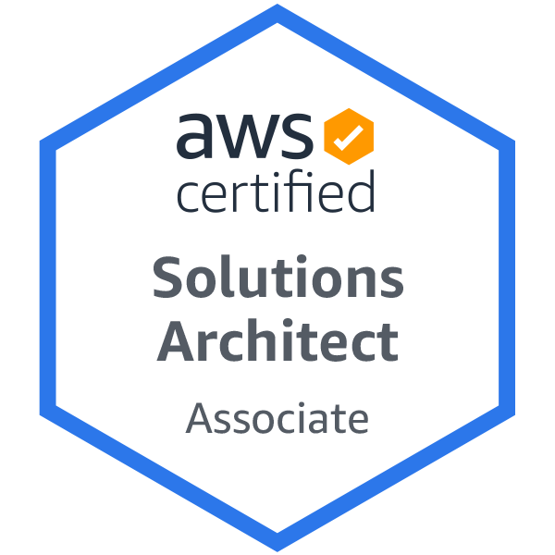

[**Certificate Credential Link**](https://www.youracclaim.com/badges/25e48d02-fa97-4454-980a-d8df681708fd?source=linked_in_profile)

**PROFESSIONAL EXPERIENCE**

**xxxxxx xxxxx Pvt Ltd April xxxx – January xxxx**

**Worked as : Devops Engineer**

**Location : Bengaluru**

**Projects : RBT(Ring Back Tune), PWA(Progressive Web Application), CCC, Voltron(Managing Digital Storefront Applications), IVR(Interactive Voice Response App), Application Framework, UMP(Messaging Application), Prism(Charging Application)**

**Client : MTN, Vodacom, Zain, Lebara, Dialog, Orange, DU, Telephonica**

**Work Profile : Centos/Red Hat Linux, Jenkins, Git, Docker, Ansible, Nexus, SonarQube, Shell Scripting,VPC,EC2,IAM,S3,Route53,Cloudwatch,JIRA,Python**

**xxxxxxxxxxxxxe Technologies Pvt Ltd April xxxx – April xxxx Working as : AWS Cloud Administrator**

**Location : Bengaluru**

**Client : Schneider Electric**

**Work Profile :Redhat Enterprise Linux, AWS, Jenkins, Shell Scripting, VPC, IAM**

Architectural and BAU support Task in present role include.

**AWS Activities :**

* Hands-on experience designing, building and operating scalable IT infrastructures in AWS cloud
* Configuring and deploying EC2 instances behind Auto Scaling & ELB.
* Worked with JIRA tickets to create Route53 records and managing hosted zones.
* Good experience in working and creating records for Application and Network Load balancers.
* Generating and importing SSL certificates in Amazon certificate Manager and adding to Loadbalacers using SNI
* Configuring and monitoring Cloud Watch metrics & setting Alarms.
* Working with AWS services: ELB, EFS, VPC, Route 53, Auto Scaling, IAM, S3, and Glacier.
* Good Exposure to EFS for collecting Application logs from 8 Different systems.
* Created SNS topics to send email notifications and integrating it with various services.
* Taking the corrective actions based on the cloud watch alarms.
* Taking the RDS snapshots when requested by the DB Teams.
* Deploying the EC2 linux instances using the custom AMI..
* Administrating the cloud infra by logging as IAM user.
* Monitoring the infrastructure using Cloud Watch tool.
* Working on IAM roles and policies, attaching the roles to EC2 as per the business need.
* Resolving the instance states when the instance turn to 1/2 state.
* Strong understanding of AWS services, such as EC2, Route53, IAM, and ELB.
* Hands-on experience on AWS services - EC2, VPC, RDS, ELB, S3, Cloud watch

**DevOps:**

* Building pipelines in Jenkins and integrating the jobs with Github,Bitbucket repo.
* Integrating Jenkins with Nexus and creating repoin it to upload Artifacts
* Integration of Jenkins with SonarQube for Code quality testing
* Having Experience in writing Declarative pipeline for Springboot based projects
* Worked with scripted pipelines for maven and tomcat based project pipeline implementation
* Good exposure of Docker in building images and running containers on fly
* Implementation of Docker compose for deploying stack of containers
* Using Ansible as integration with Jenkins as a Software and configuration management tool.
* Experience with automation/configuration management using Ansible tool.
* Complete CI/CD Implementation for maven and tomcat based projects using declarative pipelines
* Worked on webhook based github projects for triggering builds in Jenkins.
* Hands on experience in setting up Nginx(as reverse proxy,Load balancing) and Apache2.
* Good Experience with Tomcat and Maven to build and deploy JAVA based Applications.
* Deployed war/jar files on destination docker containers as a part of sprint releases every 15 days.
* Worked with JIRA Ticketing tool in a agile based environment for troubleshooting issues
* Using CI/CD pipeline to deploy Java based Applications to Tomcat with the help of Maven,Jenkins and Git.
* Hands on Experience in Setting up Docker containers with Nginx proxy.
* Understanding the Devops life cycle strategy, and knowledge of the integration tools: Jenkins, automation tools Ansible, with the continuous monitoring tool: Nagios.
* Having knowledge on implementing and writing Terraform stacks in Aws for Infrastructure automation
* Good knowledge of Kubernetes implementation using KOPS and EKS
* Knowledge of integrating Kubernetes with ELK stack or Elastic Search, Fluentd(logstash)
* Knowledge on integrating Kibana with Kubernetes clusters for logging
* Having knowledge on Integrating Prometheus and Grafana Labs for monitoring Kubernetes Clusters.
* Good knowledge of using python scripting in automation tasks

**Linux Activities:**

* LVM management in Linux.
* Daily tasks in Databases like MariaDB and Mysql by taking backups and running cron jobs
* Working on monitoring all linux server disk space, memory etc.
* Responsible for effective installation/configuration, operation, and maintenance of Linux systems hardware and software and related infrastructure.
* Package management installation with RPM & YUM management in Red hat Linux.
* Perform ongoing performance tuning, hardware upgrades, and resource optimization as required Configure CPU, memory, and disk partitions as required.
* Perform daily system monitoring, verifying the integrity and availability of all hardware, server resources, systems and key processes, reviewing system and application logs, and verifying completion of scheduled jobs such as backups.
* Experience in working with Bash scripting for automating some projects installation process and also for automating few Backups using Cronjobs

**EDUCATION**

|  |  |  |
| --- | --- | --- |
| **COURSE** | **ACADEMIC YEAR** | **University** |
| **B.Tech** | **xxxx** | **xxxxxxxxx Technological University (VTU)** |

STRENGTHS

* Result oriented with an ability to rapidly incorporate new ideas.
* Strong communication, interpersonal, learning and organizing skills.
* Ability to manage stress and time effectively.
* Believe in Self Confidence.

**PERSONAL DETAILS**

* Languages known: English, xxxxxxx, xxxxxxx, Hindi
* Marital Status: xxxxxx.
* Passport : Valid