Retail Data Management using
AWS Glue ETL Pipeline

Table of Contents
Table of Contents 1
1. Introduction 1
2. Objectives 1
3. AWS Services Used 1
4. Architecture Diagram 1
5. Prerequisites 1
6. Dataset Description 1
6.1 Product Details Dataset 1
6.2 Transactions Dataset 1
7. Implementation 1
7.1 Step 1: Navigate to Amazon S3 1
7.2 Step 2: Create Amazon S3 Input Bucket 1
7.3 Step 3: Create Input Folders 1
7.4 Step 4: Upload Product Details CSV 1
7.5 Step 5: Upload Transactions CSV 1
7.6 Step 6: Create S3 Output Bucket 1
7.7 Step 7: Open AWS Glue 1
7.8 Step 8: Create Glue Database 1
7.9 Step 9: Create Product CSV Classifier 1
7.10 Step 10: Create Transaction CSV Classifier 1
7.11 Step 11: Create IAM Role — GlueETLRole 1
7.12 Step 12: Create and Configure Product Crawler 1
7.13 Step 13: Run Product Crawler 1
7.14 Step 14: Create and Configure Transaction Crawler 1
7.15 Step 15: Run Transaction Crawler 1
7.16 Step 16: Verify Glue Tables 1
7.17 Step 17: Create Visual ETL Job 1
7.18 Step 18: Add Product Data Source 1
7.19 Step 19: Add Transaction Data Source 1
7.20 Step 20: Add and Configure the Join Transform 1
7.21 Step 21: Configure Join Keys 1
7.22 Step 22: Configure Amazon S3 Target 1
7.23 Step 23: Configure Job Details 1
7.24 Step 24: Save and Name the ETL Job 1
7.25 Step 25: Run the ETL Job 1
7.26 Step 26: Verify ETL Output 1
8. Common Errors Encountered 1
8.1 Error 1: Invalid Security Token 1
8.2 Error 2: Insufficient Source Nodes 1
8.3 Error 3: No Source Key / All Fields Must Have Options Selected 1
9. Result 1
10. Conclusion 1
11. Learning Outcomes 1

1. Introduction
In modern retail operations, enterprises generate vast volumes of transactional and product-related data on a daily basis. Managing, transforming, and deriving insights from this data requires a robust, scalable, and cost-effective data pipeline. Amazon Web Services (AWS) provides a comprehensive suite of cloud services that enable organisations to build such pipelines with minimal infrastructure management.
This project demonstrates the design and implementation of a fully serverless Extract, Transform, and Load (ETL) pipeline using AWS Glue — AWS's fully managed ETL service. The pipeline ingests raw CSV data from Amazon S3, automatically infers schema using Glue Crawlers, performs a relational join between product and transaction datasets through a Visual ETL job, and writes the enriched output back to a designated Amazon S3 output bucket.
The project was implemented on an AWS sandbox environment under the account odl_user_2296017 in the US East (N. Virginia) region, following industry-standard practices for cloud-based data engineering.

2. Objectives
The primary objectives of this project are as follows:
- To design and deploy a scalable, serverless ETL pipeline using AWS Glue for retail data management.
- To organise raw retail datasets in Amazon S3 with a structured folder hierarchy for product and transaction data.
- To automate schema discovery and table creation using AWS Glue Crawlers and custom CSV Classifiers.
- To configure appropriate IAM roles and permissions to enable secure access between AWS Glue and Amazon S3.
- To perform a data join between the Product Details and Transactions datasets using the AWS Glue Visual ETL interface.
- To store the transformed output data in a designated S3 output bucket for downstream analytics.
- To document common errors encountered during implementation and their resolutions.

3. AWS Services Used
The following AWS services were utilised in the implementation of this ETL pipeline:

Service | Purpose
Amazon S3 | Object storage for raw input datasets (product-files and transaction-files) and transformed output data.
AWS Glue Data Catalog | Centralised metadata repository that stores table definitions and schema information for all datasets.
AWS Glue Crawlers | Automated schema discovery agents that connect to S3 data sources, infer data schema, and populate the Data Catalog.
AWS Glue Classifiers | Custom CSV classifiers that define the format, delimiter, and heading configuration for CSV files.
AWS Glue Visual ETL | No-code/low-code interface in AWS Glue Studio for designing ETL pipelines visually using a drag-and-drop graph editor.
AWS IAM | Identity and Access Management service used to create the GlueETLRole with appropriate permissions for Glue to access S3 and other services.

4. Architecture Diagram
The following diagram illustrates the overall architecture of the AWS Glue ETL pipeline implemented in this project:

[ Architecture Diagram ]
The pipeline follows a linear Extract → Transform → Load (ETL) flow: raw CSV files stored in Amazon S3 input buckets are crawled by AWS Glue Crawlers (using a custom IAM role) to populate the Glue Data Catalog. The Visual ETL job reads from both catalog tables, performs an inner join on the ProductID field, and writes the enriched data to the S3 output bucket.

5. Prerequisites
The following prerequisites are required before implementing this ETL pipeline:
- An active AWS account with administrative or appropriate IAM permissions.
- Access to AWS Management Console in the US East (N. Virginia) region (us-east-1).
- The Product Details CSV file containing columns: ProductID, Product, Product Category.
- The Transactions CSV file containing columns: Order ID, Order Date, Ship Date, Aging, Ship Mode, Product ID, Sales, Quantity, Discount, Profit, Shipping Cost, Order Priority, Customer ID.
- Basic understanding of AWS S3, IAM roles, and ETL concepts.
- Permissions to create S3 buckets, IAM roles, and Glue resources.

6. Dataset Description
Two CSV datasets were used in this project to simulate a real-world retail data scenario:

6.1 Product Details Dataset
The Product Details dataset (product details.csv) contains the master product catalogue for the retail organisation. It includes 1.2 KB of data with the following fields:
- ProductID — Unique numeric identifier for each product (e.g., 101, 102, 103).
- Product — Name of the product (e.g., Car Media Players, Samsung Mobile, Apple Laptop).
- Product Category — Category classification (e.g., Auto & Accessories, Electronic).

6.2 Transactions Dataset
The Transactions dataset (transactions.csv) is a 4.8 MB file containing detailed order-level transactional data. It includes the following fields:
- Order ID — Unique identifier for each order (e.g., AU-2015-1).
- Order Date and Ship Date — Timestamps for order placement and shipment.
- Aging — Number of days between order and shipment.
- Ship Mode — Shipping class (e.g., First Class, Second Class).
- Product ID — Foreign key linking to ProductID in the product dataset.
- Sales, Quantity, Discount, Profit — Financial and quantity metrics.
- Shipping Cost — Cost associated with shipment.
- Order Priority — Priority classification (e.g., Critical, High, Medium).
- Customer ID — Unique customer identifier.
The join operation between these two datasets is performed on ProductID (Product Details) = Product ID (Transactions), producing a comprehensive enriched dataset for analytics.

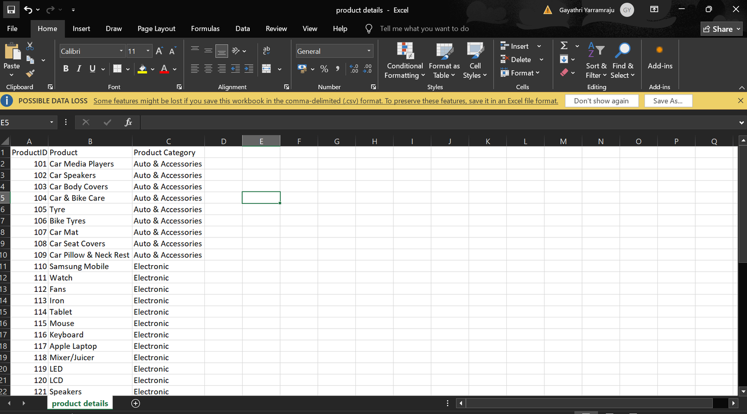
Figure 6.1: Product Details Dataset — CSV Preview in Microsoft Excel
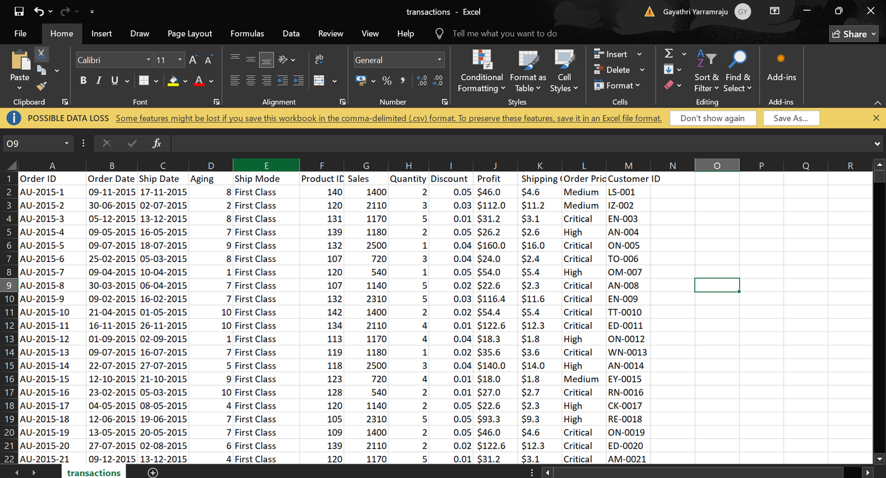
Figure 6.2: Transactions Dataset — CSV Preview in Microsoft Excel

7. Implementation
This section details each step of the AWS Glue ETL pipeline implementation in chronological order, accompanied by annotated screenshots.

7.1 Step 1: Navigate to Amazon S3
Step 1: Navigate to Amazon S3
Objective: Access the Amazon S3 service landing page from the AWS Management Console.
Explanation:
Amazon S3 (Simple Storage Service) is the foundational storage layer for this ETL pipeline. To begin, the user navigates to S3 from the AWS Console by searching for "S3" in the top search bar. The S3 landing page presents key options including creating a new bucket, configuring pricing, and accessing documentation. At this point, no buckets have been created yet, and the objective is to set up structured storage for the raw CSV datasets. The console is accessed in the US East (N. Virginia) region to ensure low latency and availability of all required AWS Glue services in the same region.
Why This Step Is Required: Amazon S3 serves as the primary data lake storage for both the input datasets and the ETL output. Without S3, there is no persistent storage layer for the pipeline. All raw files must be uploaded here before any Glue crawler or ETL job can access them.
Expected Output: The Amazon S3 service page is accessible, showing the "Create a bucket" option prominently.

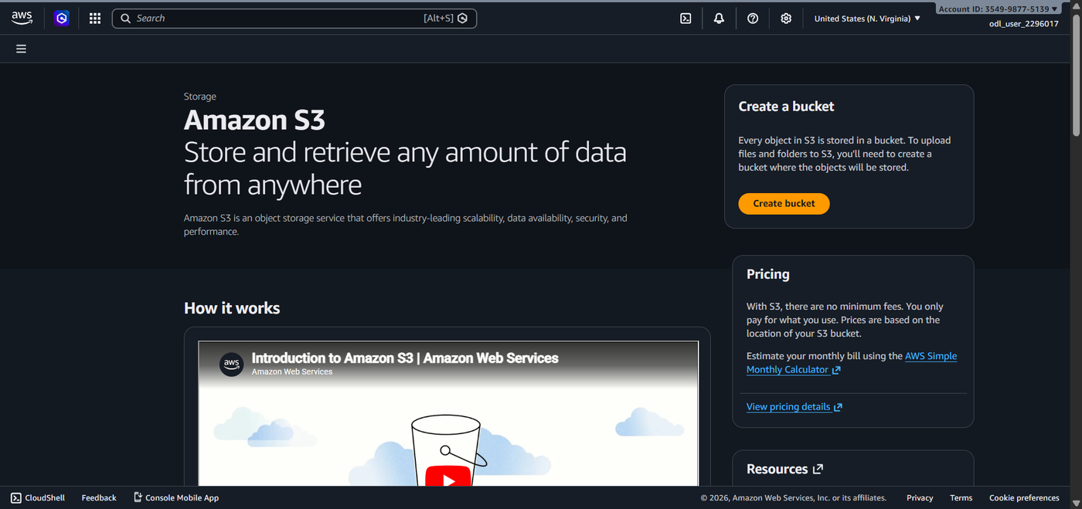
Figure 7.1: Amazon S3 — Service Landing Page

7.2 Step 2: Create Amazon S3 Input Bucket
Step 2: Create the Input S3 Bucket (etl-cep-01)
Objective: Create a dedicated Amazon S3 bucket to store the raw input CSV datasets.
Explanation:
From the S3 service page, clicking "Create bucket" opens the bucket configuration panel. The bucket is named etl-cep-01-2296017 using a globally unique naming convention that includes the user identifier suffix. The bucket type is set to "General purpose", the namespace is configured as "Global namespace", and ACLs are disabled for security best practice. Block all public access is enabled to ensure no accidental public exposure of data. Bucket versioning is disabled for this demonstration, and no encryption key is specified beyond the default S3 server-side encryption. After reviewing the settings, the bucket is created successfully.
Why This Step Is Required: A dedicated input bucket provides a structured and isolated storage location for raw source data. Using a separate bucket for input versus output ensures clean data separation, prevents accidental overwrites, and follows AWS data engineering best practices for pipeline design.
Expected Output: A green success banner appears: "Successfully created bucket etl-cep-01-2296017". The bucket is empty and ready for folder creation.

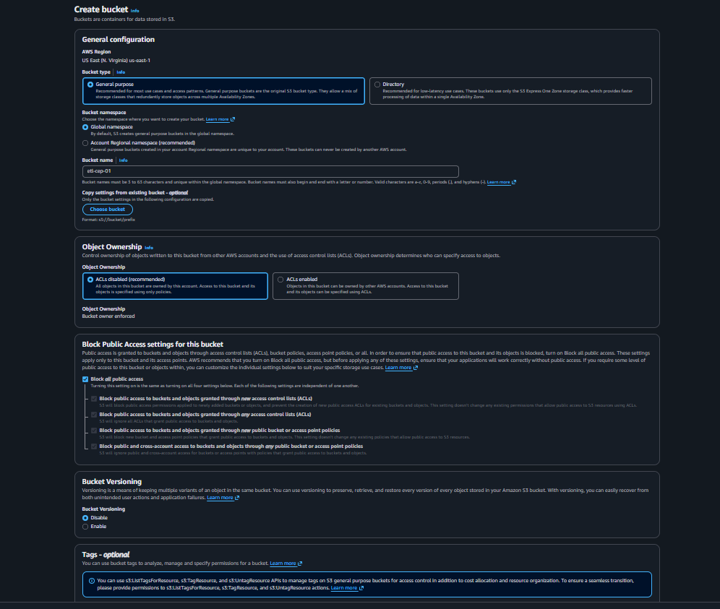
Figure 7.2: Amazon S3 — Create Bucket Configuration Form
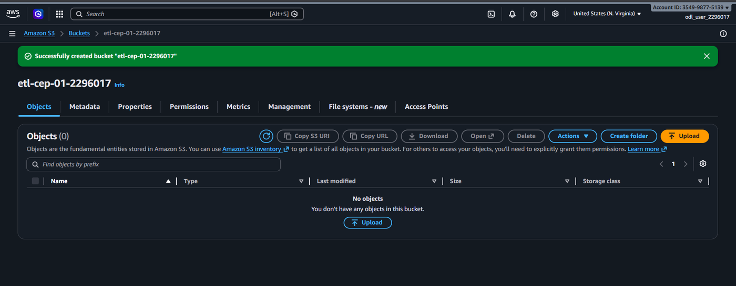
Figure 7.3: Amazon S3 — Input Bucket Successfully Created

7.3 Step 3: Create Input Folders
Step 3: Create product-files and transaction-files Folders
Objective: Create two logical folder prefixes inside the input S3 bucket to organise the datasets.
Explanation:
Within the etl-cep-01-2296017 bucket, two folders are created using the "Create folder" button: product-files and transaction-files. In Amazon S3, folders are not true file system directories; instead, they are object key prefixes that simulate a directory hierarchy. The folder creation form shows the folder name input with server-side encryption defaulting to the bucket settings. Both folders are created sequentially. After successful creation, the bucket view shows "Objects (2)" with product-files/ and transaction-files/ listed as Folder types.
Why This Step Is Required: Organising datasets into separate folders is essential for the Glue Crawlers to target specific data sources accurately. By pointing each crawler at a dedicated folder prefix, schema inference is isolated to the correct dataset. This also prevents cross-contamination of schemas between product and transaction data.
Expected Output: The bucket objects view shows two folders: product-files/ and transaction-files/ with type "Folder".

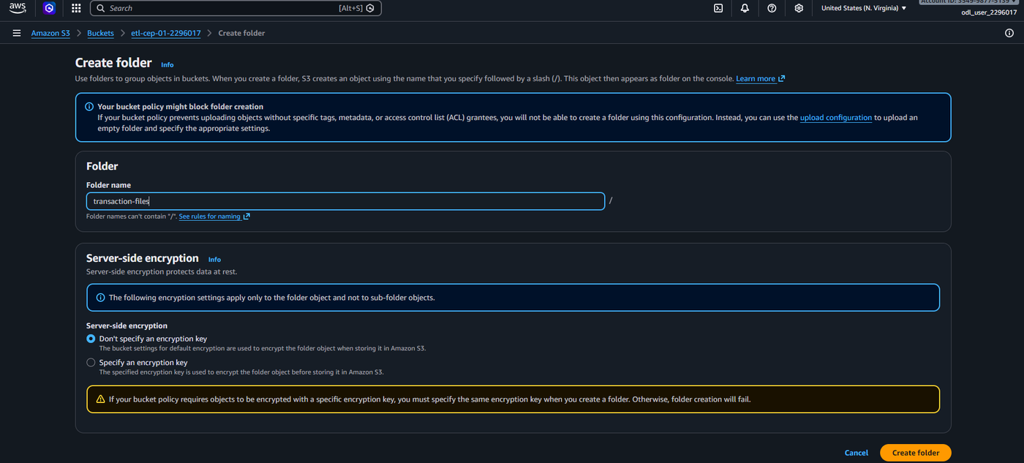
Figure 7.4: Amazon S3 — Create Folder Interface (transaction-files)
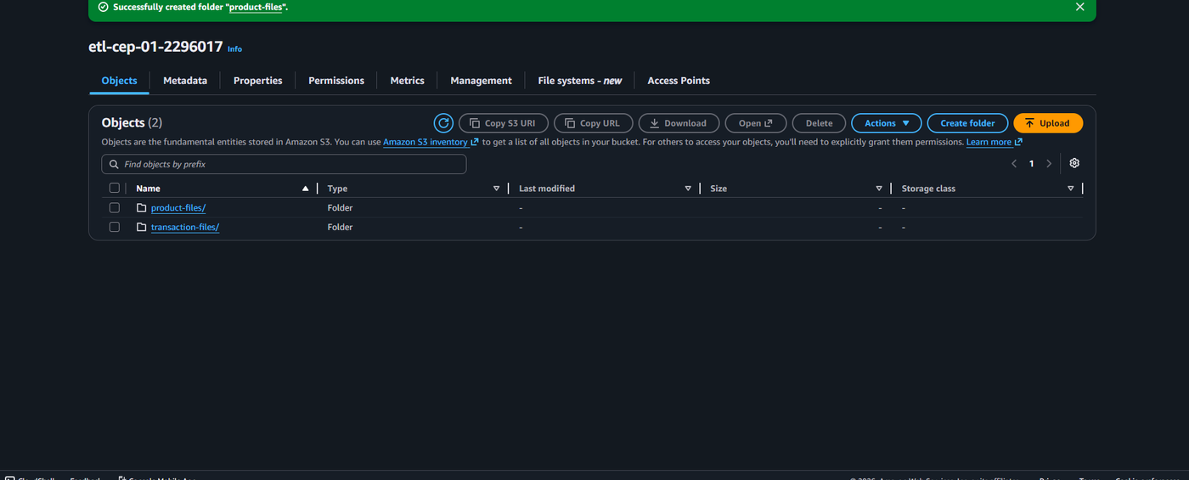
Figure 7.5: Amazon S3 — Both Input Folders Successfully Created

7.4 Step 4: Upload Product Details CSV
Step 4: Upload product details.csv to the product-files Folder
Objective: Upload the Product Details CSV dataset to the designated S3 folder.
Explanation:
The Product Details CSV file is sourced from the local machine (Downloads > Course_End_Project_Dataset > Dataset folder). Navigating into the product-files/ folder inside the S3 bucket, the "Upload" button is used to browse and select the product details.csv file. After selecting the file, the upload is initiated. The Upload Status page confirms successful completion: Destination is s3://etl-cep-01-2296017/product-files/, 1 file of 1.2 KB was uploaded with 100% success, and 0 files failed. The file type is displayed as text/csv.
Why This Step Is Required: The Product Details CSV is one of the two primary data sources for the ETL join operation. It must reside in S3 before the Glue Crawler can access and infer its schema. Without this file, the product-crawler will have no data to crawl and no table definition will be created in the Glue Data Catalog.
Expected Output: Upload Status page shows: 1 file (1.2 KB) uploaded to s3://etl-cep-01-2296017/product-files/ with status "Succeeded".

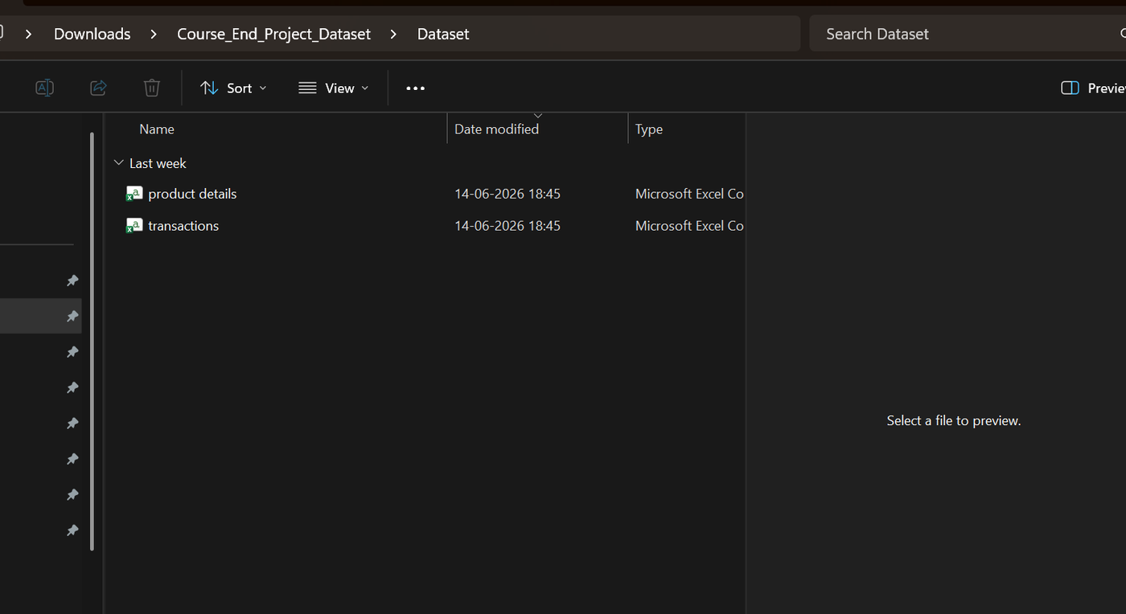
Figure 7.6: Local File System — Dataset Folder Showing product details and transactions Files
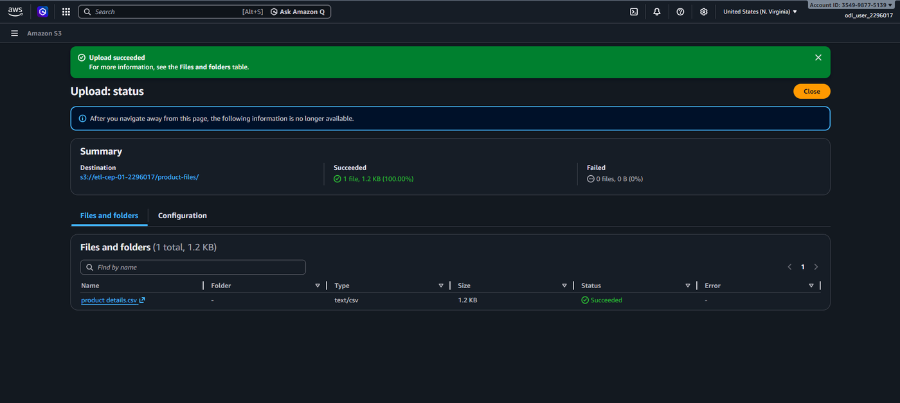
Figure 7.7: Amazon S3 — Product Details CSV Upload Successful

7.5 Step 5: Upload Transactions CSV
Step 5: Upload transactions.csv to the transaction-files Folder
Objective: Upload the Transactions CSV dataset to the designated S3 folder.
Explanation:
Following the same upload procedure, the transactions.csv file is uploaded into the transaction-files/ folder within the same input S3 bucket. This file is significantly larger at 4.8 MB, reflecting the extensive transactional history contained within. The Upload Status page confirms successful completion with Destination s3://etl-cep-01-2296017/transaction-files/, 1 file of 4.8 MB uploaded with 100% success rate. The file is classified as text/csv.
Why This Step Is Required: The Transactions CSV is the second primary data source for the ETL pipeline. It must be stored in a separate folder from the product data to allow the transaction-crawler to target it independently. The transactional data is the larger dataset and forms the "many" side of the product-to-transaction relationship.
Expected Output: Upload Status page shows: transactions.csv (4.8 MB) uploaded successfully to the transaction-files/ folder with status "Succeeded".

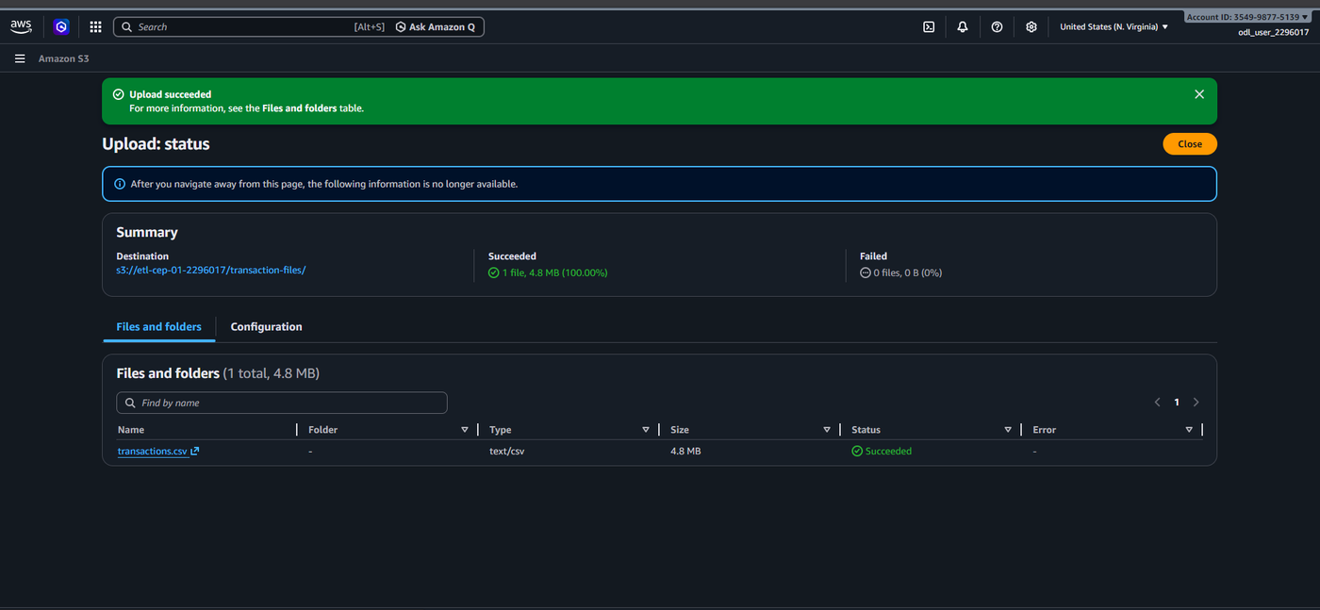
Figure 7.8: Amazon S3 — Transactions CSV Upload Successful

7.6 Step 6: Create S3 Output Bucket
Step 6: Create the Output S3 Bucket (etl-cep-output-01)
Objective: Create a separate Amazon S3 bucket to store the transformed ETL output data.
Explanation:
A second S3 bucket named etl-cep-output-01-2296017 is created using the same bucket creation process. This bucket follows the same security configuration: ACLs disabled, block all public access enabled, versioning disabled. The output bucket serves a different purpose from the input bucket — it is the write destination for the AWS Glue ETL job results. Keeping output data in a separate bucket from input data is a critical architectural best practice that prevents the Glue job from reading its own output during subsequent runs and avoids namespace conflicts.
Why This Step Is Required: Separating input and output S3 buckets is a data engineering best practice. It ensures data lineage traceability, prevents accidental overwriting of source data, and allows different lifecycle policies and access controls to be applied to raw versus processed data.
Expected Output: A green success banner confirms: "Successfully created bucket etl-cep-output-01-2296017". The bucket is empty and ready to receive ETL job output.

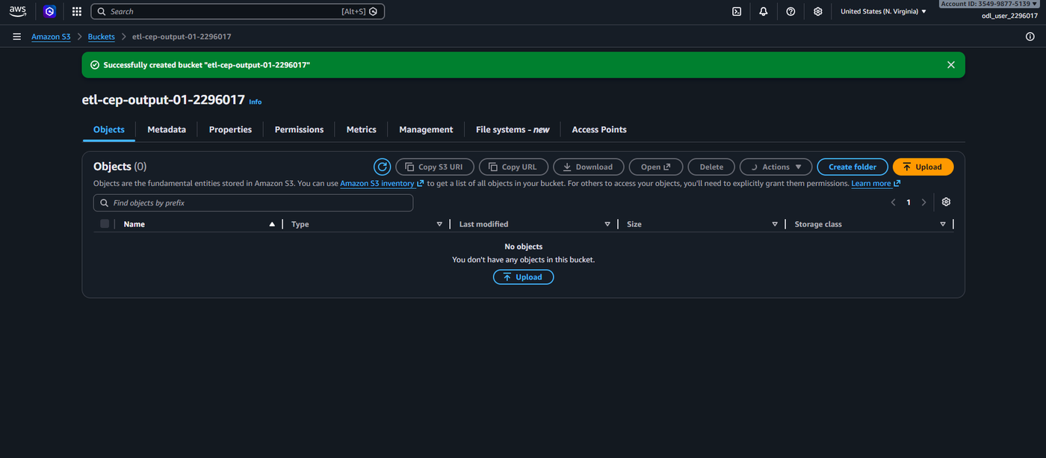
Figure 7.9: Amazon S3 — ETL Output Bucket Successfully Created

7.7 Step 7: Open AWS Glue
Step 7: Navigate to the AWS Glue Service Console
Objective: Access the AWS Glue service from the AWS Management Console.
Explanation:
AWS Glue is accessed by searching for "Glue" in the AWS Console search bar or by selecting it from the Services menu under Data Lakes and Analytics. The AWS Glue homepage presents a comprehensive overview of the service, including an introduction to its core capabilities: ETL job management, data catalog browsing, and crawler-based schema discovery. The left navigation panel shows all Glue components: ETL jobs (Visual ETL, Notebooks, Job run monitoring), Data Catalog (Catalogs, Databases, Tables), Crawlers, Classifiers, and Data connections. The service is accessed in the same US East (N. Virginia) region as the S3 buckets.
Why This Step Is Required: AWS Glue is the core service of this ETL pipeline. It provides all the data discovery, transformation, and cataloguing capabilities needed. Accessing Glue in the same region as the S3 buckets ensures low-latency communication and avoids cross-region data transfer charges.
Expected Output: The AWS Glue service homepage is displayed with the navigation panel showing all available Glue components.

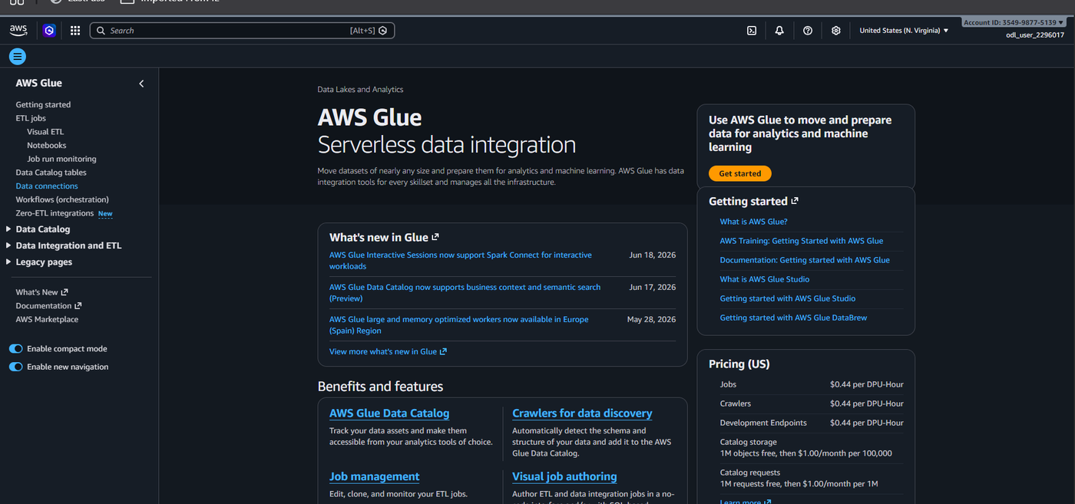
Figure 7.10: AWS Glue — Service Homepage

7.8 Step 8: Create Glue Database
Step 8: Create the abc-retail Glue Database
Objective: Create a logical database in the AWS Glue Data Catalog to house the retail data tables.
Explanation:
From the AWS Glue left panel, navigating to Data Catalog > Databases and clicking "Add database" opens the Create Database form. The database type is set to "Glue Database" (standard). The database name is configured as abc-retail in lowercase as required by Glue naming conventions. No description or S3 location URI is provided for this project. Clicking "Create database" submits the form. The Databases page then shows Databases (1) with abc-retail listed, created on June 26, 2026 at 13:15:58 UTC under catalog 354998775139.
Why This Step Is Required: The Glue Database is a logical container within the Data Catalog that groups related table definitions. Without a database, the Glue Crawlers have nowhere to write their discovered table schemas. All subsequent crawlers in this pipeline are configured to target the abc-retail database.
Expected Output: The Databases page shows the newly created abc-retail database with its source catalog ID.

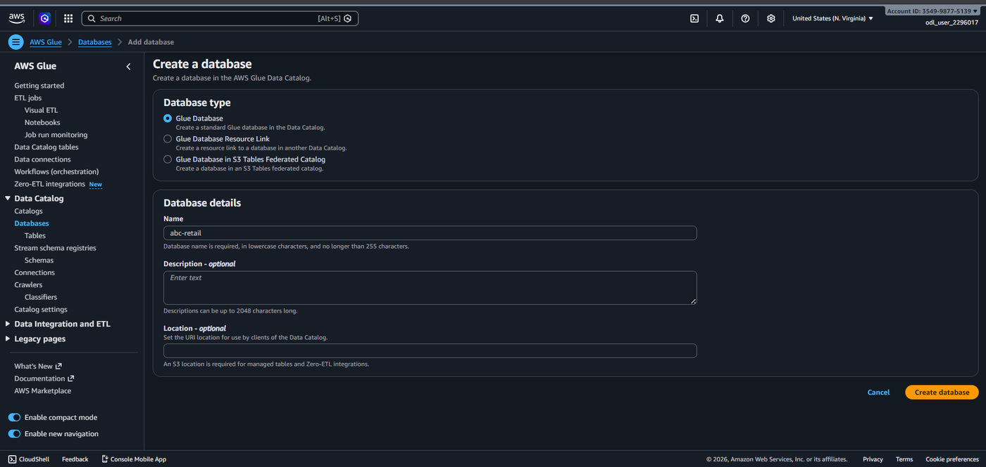
Figure 7.11: AWS Glue — Create Database Form (abc-retail)
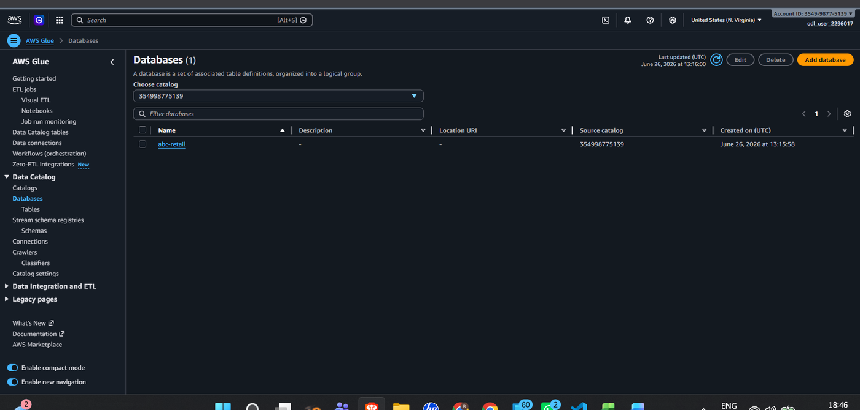
Figure 7.12: AWS Glue — abc-retail Database Successfully Created

7.9 Step 9: Create Product CSV Classifier
Step 9: Create the cust_classifier CSV Classifier
Objective: Create a custom CSV classifier to properly parse the Product Details CSV file.
Explanation:
Navigating to Data Catalog > Crawlers > Classifiers and clicking "Add classifier" opens the Create Classifier form. The classifier name is set to cust_classifier. The classifier type is selected as CSV (to filter and extract data from CSV files). The CSV Serde is set to None, the Column delimiter is Comma (,), the Quote symbol is Double-quote ("). Column headings is set to "Has headings" so the first row of the CSV is treated as the header row. Processing options include "Disable whitespace trimming" checked. No custom datatypes are specified. Clicking "Create" registers the classifier.
Why This Step Is Required: Custom classifiers override Glue's default schema detection behaviour. By explicitly configuring the CSV format (delimiter, quote character, heading presence), the classifier ensures that the Product Details file is parsed correctly, with proper column naming from the header row. Without this, Glue might misidentify column boundaries or treat headers as data rows.
Expected Output: The Classifiers page shows cust_classifier listed as type CSV, created on June 26, 2026 at 13:21:50 UTC.

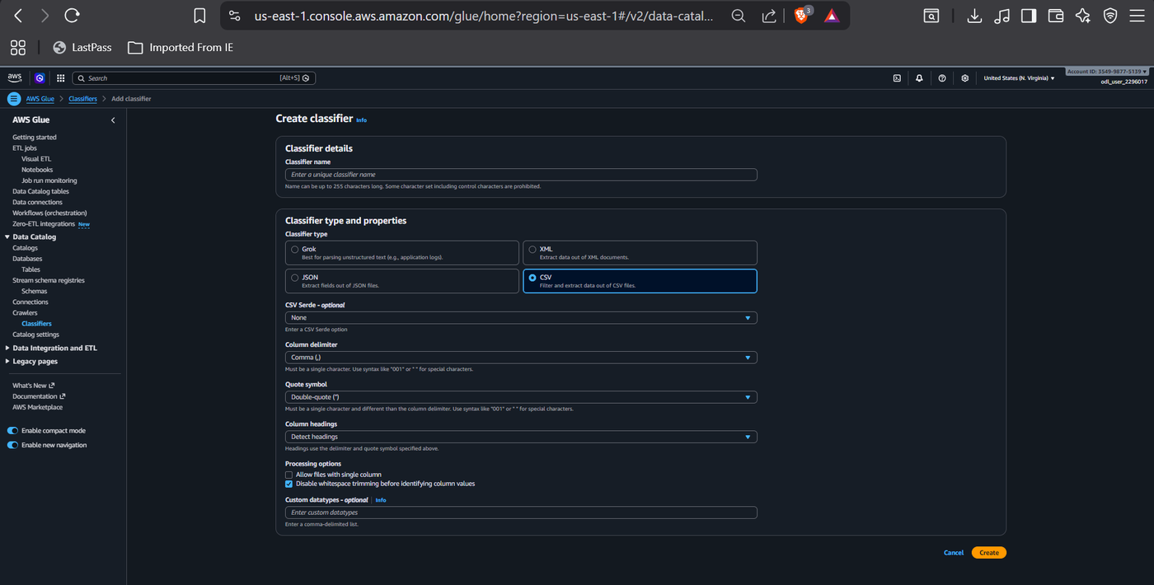
Figure 7.13: AWS Glue — Create CSV Classifier (cust_classifier) for Product Data
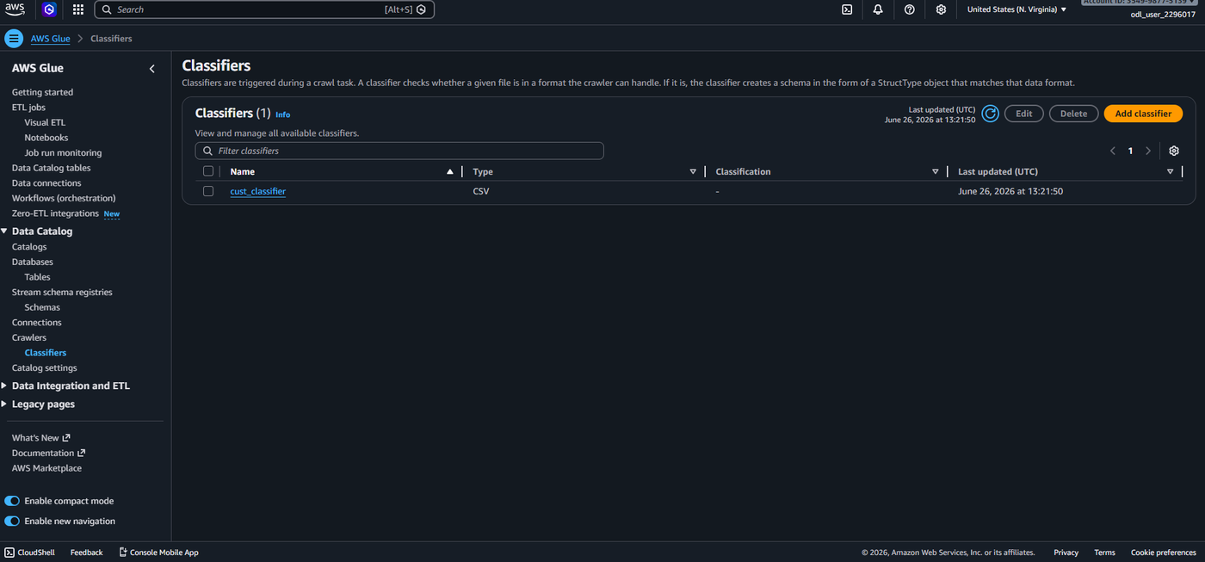
Figure 7.14: AWS Glue — Classifiers Page Showing cust_classifier Created

7.10 Step 10: Create Transaction CSV Classifier
Step 10: Create the txn_classifier CSV Classifier
Objective: Create a second custom CSV classifier for the Transactions dataset.
Explanation:
Following the same classifier creation process, a second classifier named txn_classifier is created with identical configuration: type CSV, column delimiter Comma (,), quote symbol Double-quote ("), column headings set to "Has headings". This classifier is specifically intended for use with the transaction-crawler. The Classifiers page subsequently shows Classifiers (2) listing both cust_classifier and txn_classifier, both of type CSV. The second classifier was created at 13:22:31 UTC.
Why This Step Is Required: Creating a dedicated classifier for the Transactions dataset allows the transaction-crawler to independently parse the transactions.csv file with its specific format. Although both files are standard CSVs in this project, maintaining separate classifiers provides flexibility for future format changes and ensures clear separation of crawler configurations.
Expected Output: The Classifiers page shows two classifiers: cust_classifier and txn_classifier, both of type CSV.

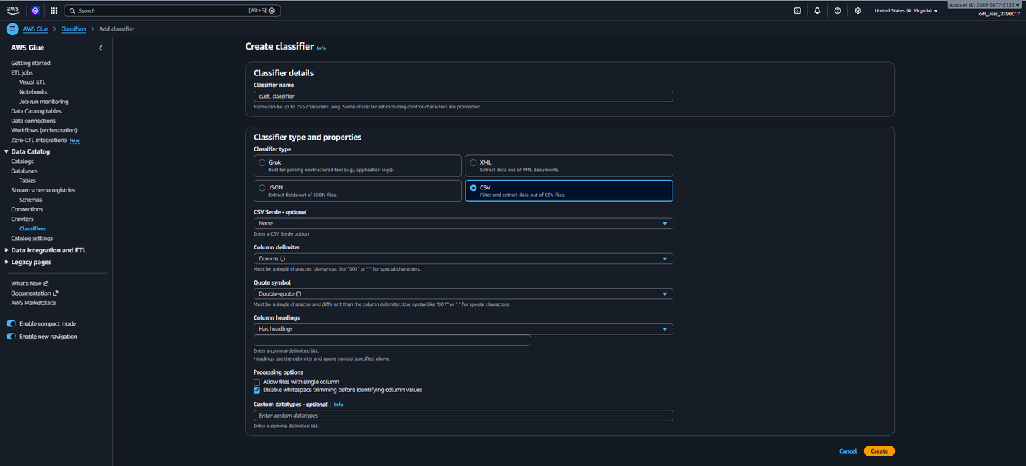
Figure 7.15: AWS Glue — Create CSV Classifier (txn_classifier) for Transaction Data
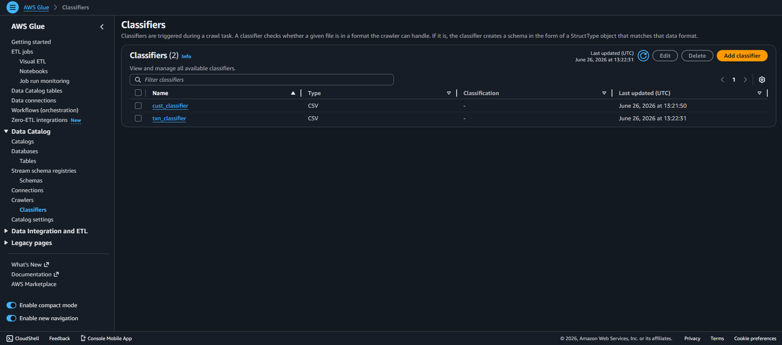
Figure 7.16: AWS Glue — Classifiers Page Showing Both Classifiers

7.11 Step 11: Create IAM Role — GlueETLRole
Step 11: Create GlueETLRole in AWS IAM
Objective: Create an IAM role that grants AWS Glue the necessary permissions to access S3 and execute ETL operations.
Explanation:
Navigating to IAM > Roles > Create Role, Step 1 asks to "Select trusted entity". The trusted entity type is set to "AWS service" and the use case is configured for "Glue". This allows AWS Glue to assume this role. In Step 2 (Add Permissions), the managed policies AmazonS3FullAccess and AWSGlueServiceRole are attached to grant Glue full access to S3 buckets and all required Glue service permissions. In Step 3 (Name, Review, and Create), the role is named GlueETLRole. After creation, the IAM Roles page displays a green banner confirming "Role GlueETLRole created." The role appears in the roles list with trusted entity as "AWS Service: glue".
Why This Step Is Required: AWS Glue requires an IAM role to authenticate and authorise its access to other AWS services. Without the GlueETLRole, the crawlers cannot read from S3, the Glue job cannot read catalog tables, and no ETL operations can be executed. The role must have both S3 access and Glue service permissions.
Expected Output: IAM Roles page shows a success banner "Role GlueETLRole created" and the role appears in the list with Trusted entity: AWS Service: glue.

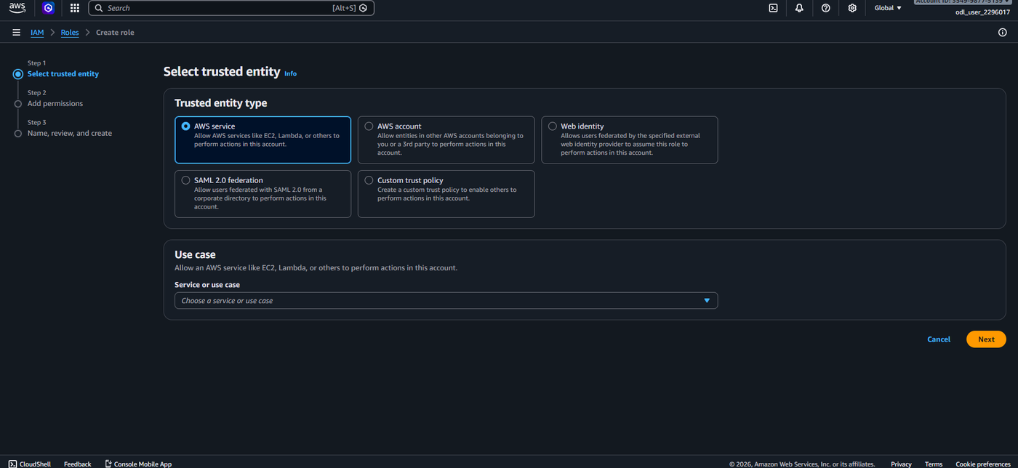
Figure 7.17: AWS IAM — Create Role — Select Trusted Entity (Glue Service)
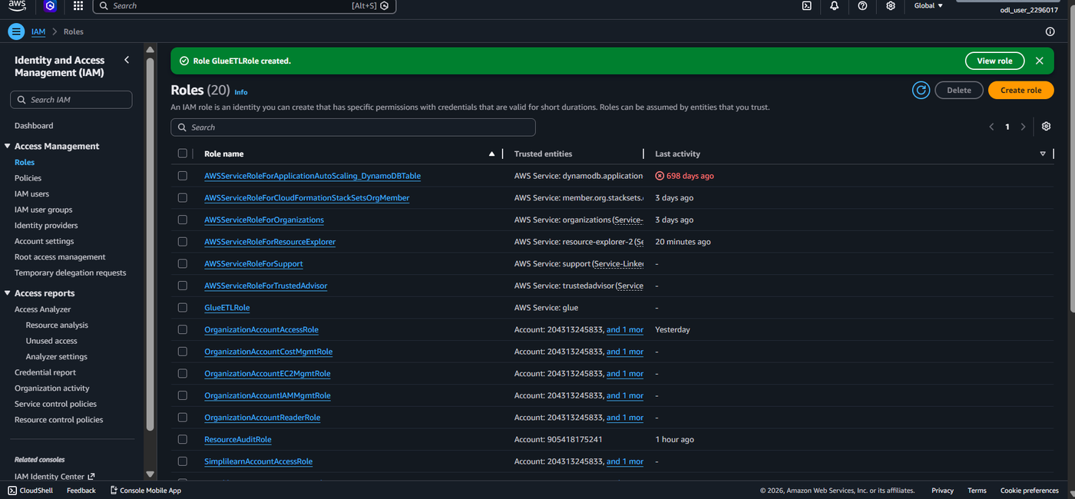
Figure 7.18: AWS IAM — GlueETLRole Successfully Created

7.12 Step 12: Create and Configure Product Crawler
Step 12: Create the product-crawler
Objective: Create an AWS Glue Crawler to automatically discover and catalogue the schema of the Product Details dataset.
Explanation:
From Glue > Crawlers, clicking "Create crawler" initiates a five-step wizard. Step 1 (Set crawler properties): The crawler is named product-crawler. Step 2 (Choose data sources and classifiers): "Not yet" is selected as the data is not already mapped. Under "Add a data source", Data source is set to S3, Location is "In this account", and the S3 path is set to s3://etl-cep-01-2296017/product-files/ by browsing the S3 bucket. Step 3 (Configure security settings): The IAM role is configured with GlueETLRole. Step 4 (Set output and scheduling): The target database is set to abc-retail, table name prefix is product_, and the frequency is On demand. Step 5 (Review and create): The complete configuration is reviewed showing all four settings. Clicking "Create crawler" creates the product-crawler.
Why This Step Is Required: The product-crawler automates the process of schema discovery for the Product Details CSV. Instead of manually defining table columns and data types, the crawler reads the file structure and automatically creates a table definition (product_product_details_csv) in the abc-retail database. This is a critical step that enables the Visual ETL job to reference the product data as a catalogued source.
Expected Output: The product-crawler page shows "One crawler successfully created. The following crawler is now created: product-crawler" with state READY.

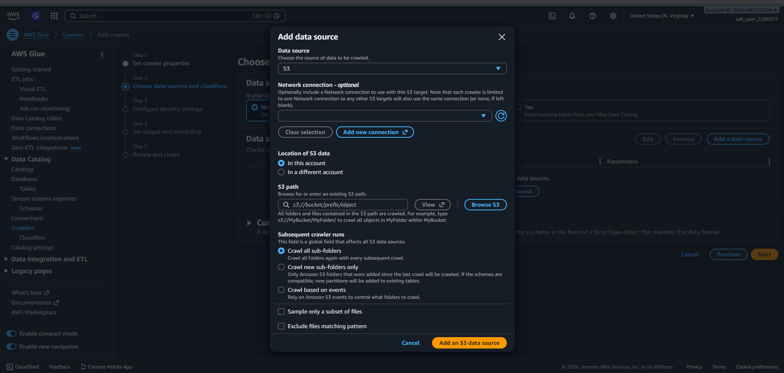
Figure 7.19: AWS Glue — Crawler Step 2: Add S3 Data Source (product-files Path)
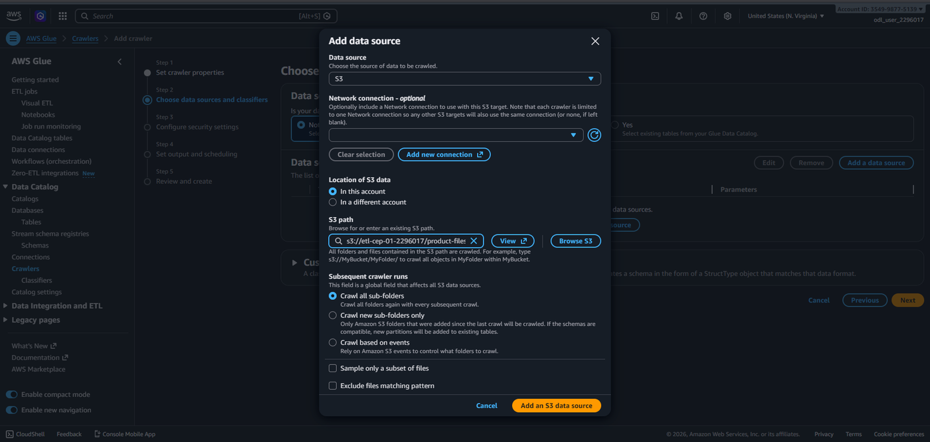
Figure 7.20: AWS Glue — Crawler Step 2: S3 Path Configured for Product Files
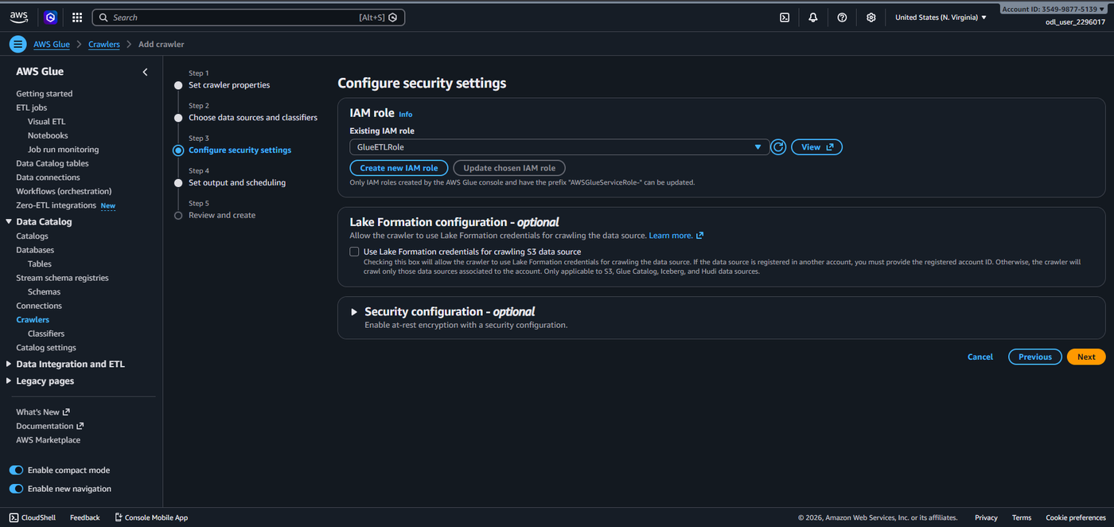
Figure 7.21: AWS Glue — Crawler Step 3: Security Settings with GlueETLRole
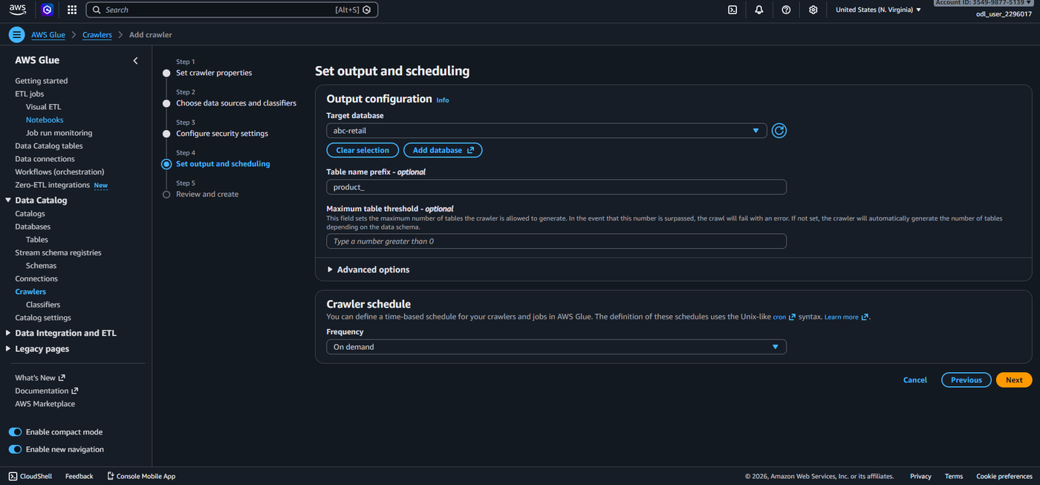
Figure 7.22: AWS Glue — Crawler Step 4: Output Configuration with abc-retail Database
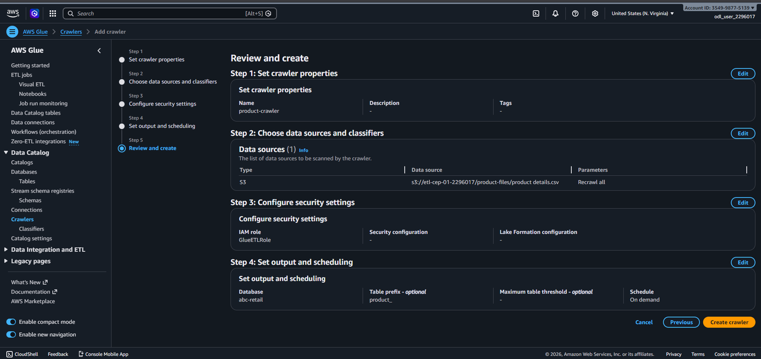
Figure 7.23: AWS Glue — Crawler Step 5: Review and Create — product-crawler Configuration
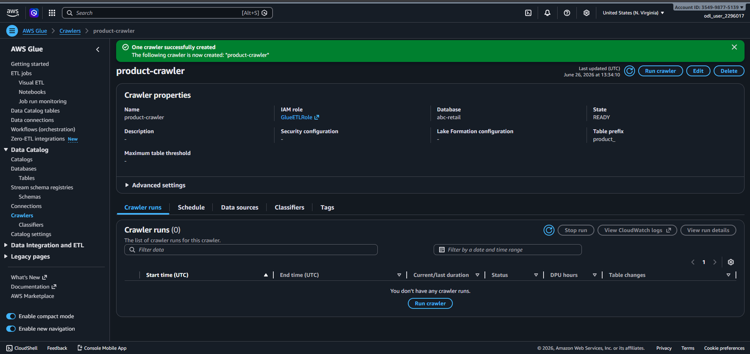
Figure 7.24: AWS Glue — product-crawler Successfully Created

7.13 Step 13: Run Product Crawler
Step 13: Execute the product-crawler
Objective: Run the product-crawler to discover the schema of the Product Details CSV and populate the Glue Data Catalog.
Explanation:
From the product-crawler detail page, clicking "Run crawler" initiates the crawl. The crawler connects to the S3 path s3://etl-cep-01-2296017/product-files/, reads the product details.csv file, and infers the schema based on the cust_classifier configuration. The crawler run is logged in the Crawler runs section. After approximately 54 seconds, the run completes with status "Completed" and the table changes column shows "1 table change, 0 partition changes", confirming that one new table definition (product_product_details_csv) was created in the abc-retail database.
Why This Step Is Required: Running the crawler performs the actual schema discovery. Until the crawler runs, the Glue Data Catalog has no knowledge of the product data structure. The 54-second run time reflects Glue spinning up the necessary compute resources, connecting to S3, sampling the CSV file, inferring column names and data types, and writing the table metadata to the catalog.
Expected Output: Crawler runs section shows status "Completed" with 1 table change, 0 partition changes. Duration: 54 seconds.

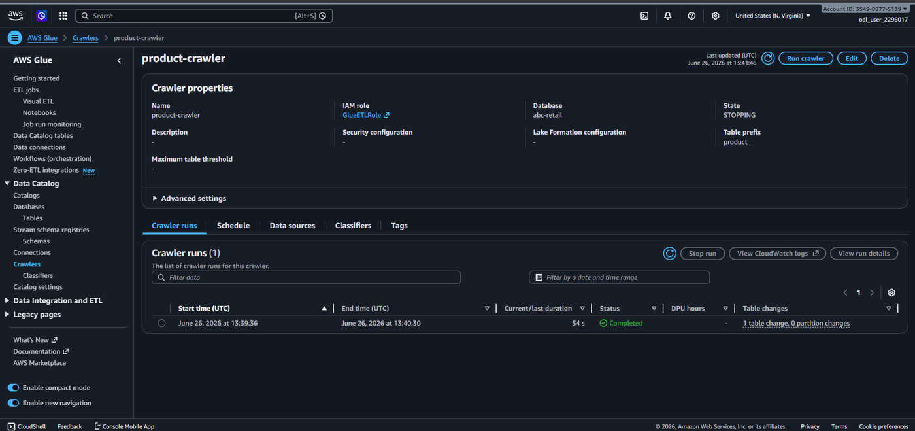
Figure 7.25: AWS Glue — product-crawler Run Completed Successfully (1 Table Created)

7.14 Step 14: Create and Configure Transaction Crawler
Step 14: Create the transaction-crawler
Objective: Create an AWS Glue Crawler to discover and catalogue the schema of the Transactions dataset.
Explanation:
The same five-step crawler creation process is followed for the Transactions dataset. The crawler is named transaction-crawler. The S3 data source is set to s3://etl-cep-01-2296017/transaction-files/transactions.csv. The IAM role is GlueETLRole. The target database is abc-retail with table prefix txn_. The Review and Create page confirms: Name: transaction-crawler, Data source: S3 (s3://etl-cep-01-2296017/transaction-files/transactions.csv), IAM role: GlueETLRole, Database: abc-retail, Table prefix: txn_, Schedule: On demand. The transaction-crawler detail page confirms successful creation with the same settings visible.
Why This Step Is Required: A separate transaction-crawler is required to independently process the larger Transactions CSV file (4.8 MB). By targeting the transaction-files/ folder specifically and using the txn_ prefix for table naming, the crawler creates a clearly named table (txn_transactions_csv) that is distinguishable from the product table in the Data Catalog. This separation is essential for the join configuration in the Visual ETL job.
Expected Output: Transaction-crawler page shows "Some crawlers successfully created. The following crawlers are now created: transaction-crawler, product-crawler" with state READY.

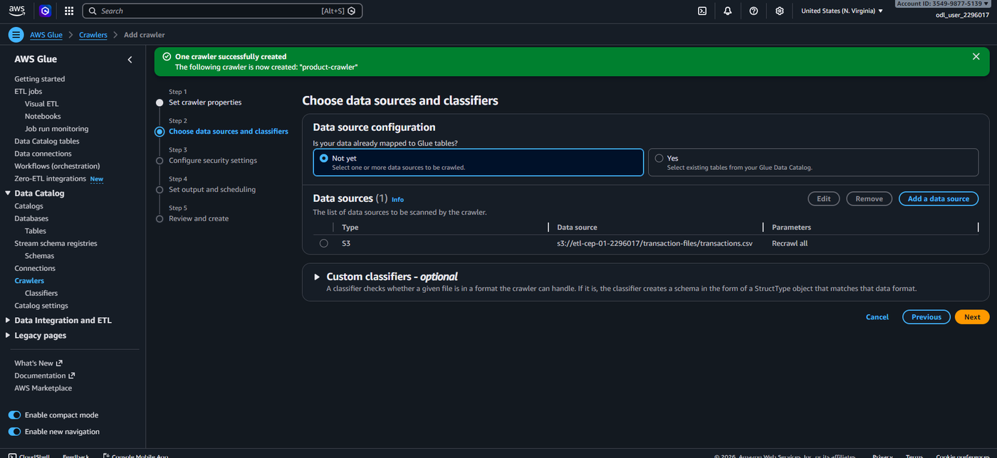
Figure 7.26: AWS Glue — Transaction Crawler Step 2: Data Source Configured
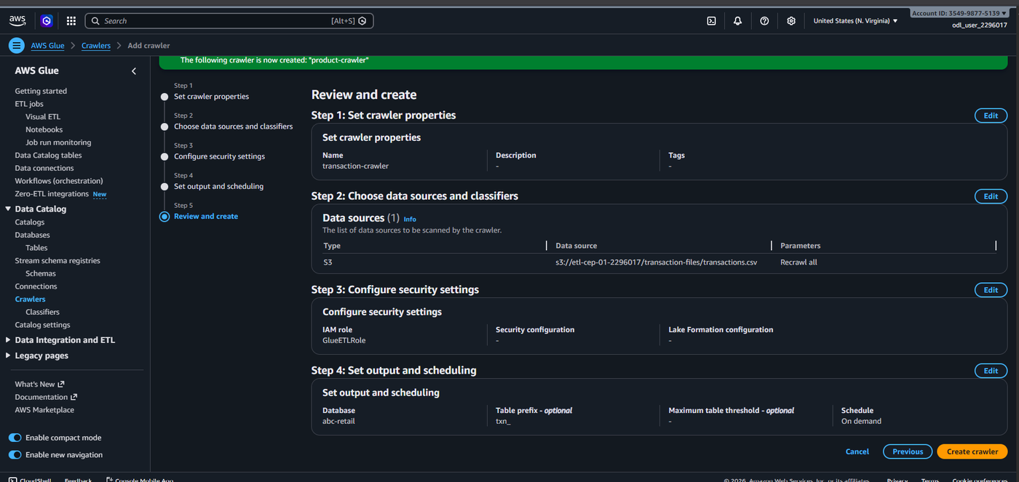
Figure 7.27: AWS Glue — Transaction Crawler Step 5: Review and Create
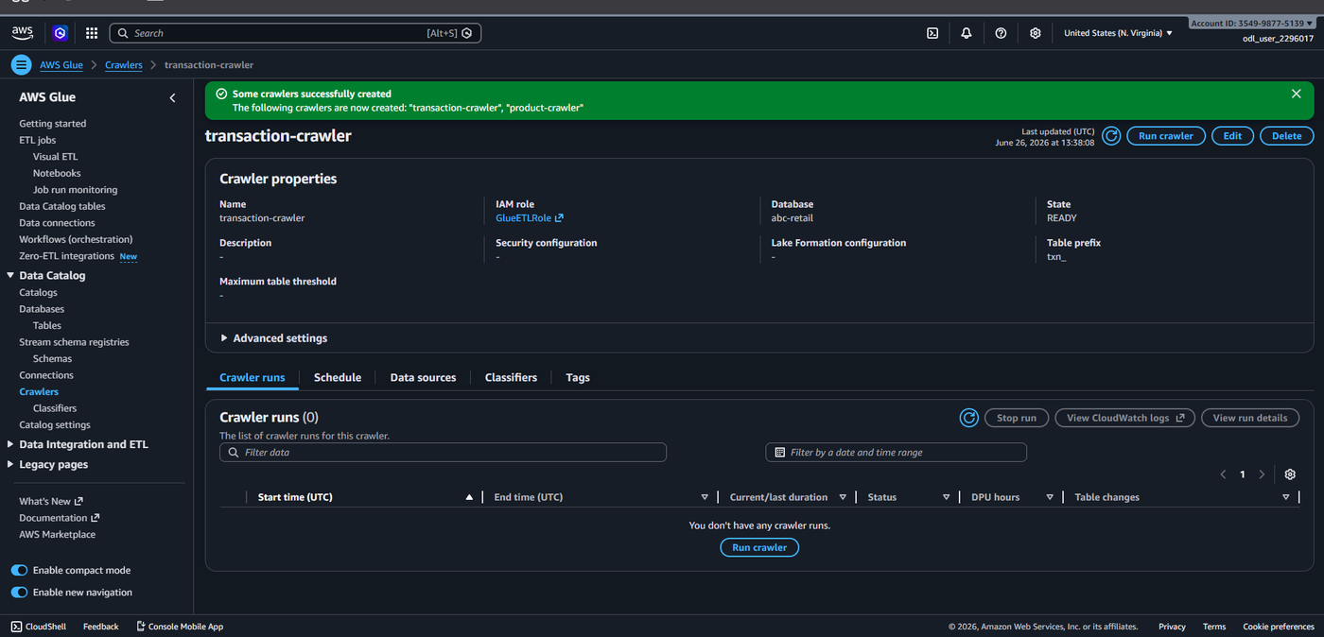
Figure 7.28: AWS Glue — transaction-crawler Successfully Created

7.15 Step 15: Run Transaction Crawler
Step 15: Execute the transaction-crawler
Objective: Run the transaction-crawler to discover the schema of the Transactions dataset.
Explanation:
Clicking "Run crawler" on the transaction-crawler page initiates the crawl. A success banner confirms "Crawler successfully starting. The following crawler is now starting: transaction-crawler." The Crawler runs section shows the run in progress with status "Running" at 05 seconds duration. The crawler processes the 4.8 MB transactions.csv file from the transaction-files/ S3 path. Upon completion, the Both Crawlers list page shows both product-crawler and transaction-crawler in Ready state with Last run status Succeeded. The product-crawler created 1 table (Last run timestamp: 13:39:36) and the transaction-crawler also completed successfully (Last run timestamp: 13:40:36).
Why This Step Is Required: Running the transaction-crawler completes the data discovery phase of the pipeline. After this step, both datasets are catalogued in the abc-retail database, making them available as data sources for the Visual ETL job. The larger file size means the transaction-crawler may take slightly longer, but it operates in a fully serverless manner with no infrastructure management required.
Expected Output: Crawlers list shows both product-crawler and transaction-crawler with state Ready and Last run status Succeeded.

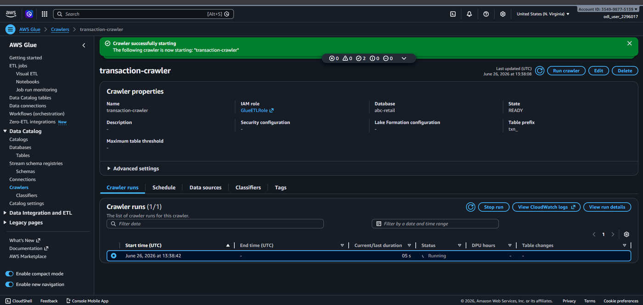
Figure 7.29: AWS Glue — transaction-crawler Running (Status: Running)
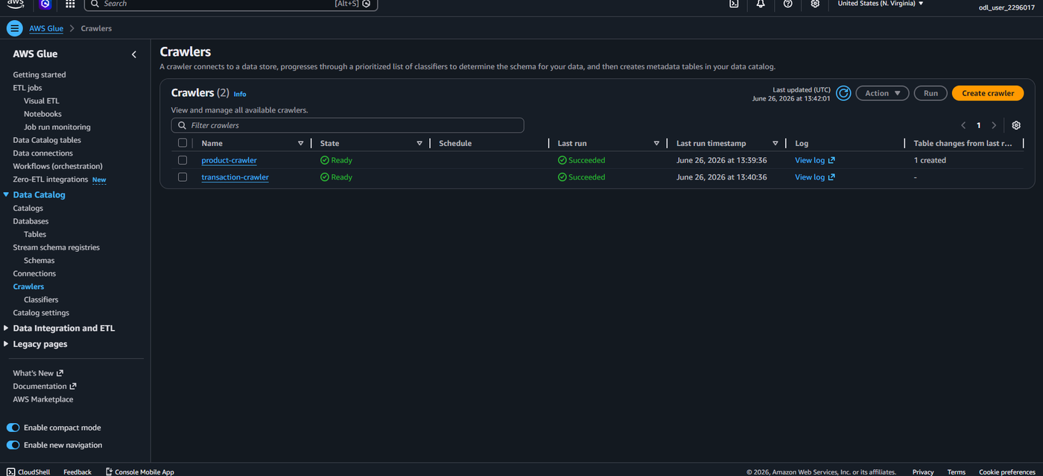
Figure 7.30: AWS Glue — Both Crawlers Completed Successfully

7.16 Step 16: Verify Glue Tables
Step 16: Verify the Glue Data Catalog Tables
Objective: Confirm that both table definitions have been created correctly in the abc-retail Glue database.
Explanation:
Navigating to Data Catalog > Tables and selecting the abc-retail database, the Tables page shows Tables (2) in the catalog. The two tables are: product_product_details_cs (with location s3://etl-cep-01-2296017/p… and classification CSV) and txn_transactions_csv (with location s3://etl-cep-01-2296017/t… and classification CSV). Both tables are associated with the abc-retail database. Options for "Table data", "View data quality", and "View statistics" are available. The presence of both tables confirms that both crawlers successfully inferred the schemas and registered the metadata in the Glue Data Catalog.
Why This Step Is Required: Verifying the Glue tables is a critical checkpoint before proceeding to build the Visual ETL job. If either table is missing, the ETL job cannot reference it as a data source. This step confirms that the entire data ingestion and discovery phase completed successfully and that the pipeline is ready for the transformation stage.
Expected Output: The Glue Tables page shows two tables: product_product_details_cs and txn_transactions_csv, both in the abc-retail database with CSV classification.

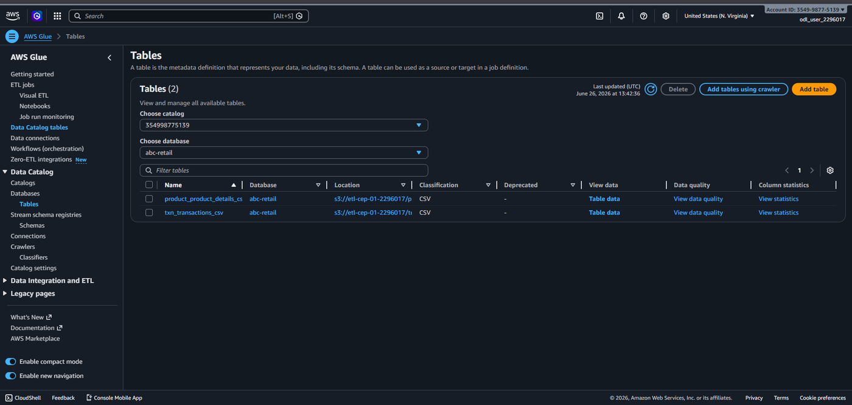
Figure 7.31: AWS Glue — Data Catalog Tables Showing Both Discovered Tables

7.17 Step 17: Create Visual ETL Job
Step 17: Create a New Visual ETL Job in AWS Glue Studio
Objective: Open the AWS Glue Studio Visual ETL editor to design the ETL transformation pipeline.
Explanation:
Navigating to ETL jobs > Visual ETL in the AWS Glue left panel opens the AWS Glue Studio homepage. The Create job section offers three authoring options: Visual ETL (author in a visual interface focused on data flow), Notebook (interactive code notebook), and Script editor (code with a script editor). Clicking the highlighted "Visual ETL" option opens the Visual ETL canvas — a blank graph editor for designing the ETL pipeline. The "Add nodes" panel on the left shows tabs for Sources, Transforms, Targets, and Popular. A sidebar is also provided for searching data sources.
Why This Step Is Required: The Visual ETL interface in AWS Glue Studio allows non-developers and data engineers alike to design ETL workflows without writing Spark code. This drag-and-drop interface abstracts the underlying PySpark/Scala execution and enables rapid pipeline development. The visual representation makes it easy to understand data flow and debug configurations.
Expected Output: The Visual ETL canvas opens with an "Add nodes" panel, showing Sources (AWS Glue Data Catalog, Amazon S3, etc.), Transforms, and Targets options.

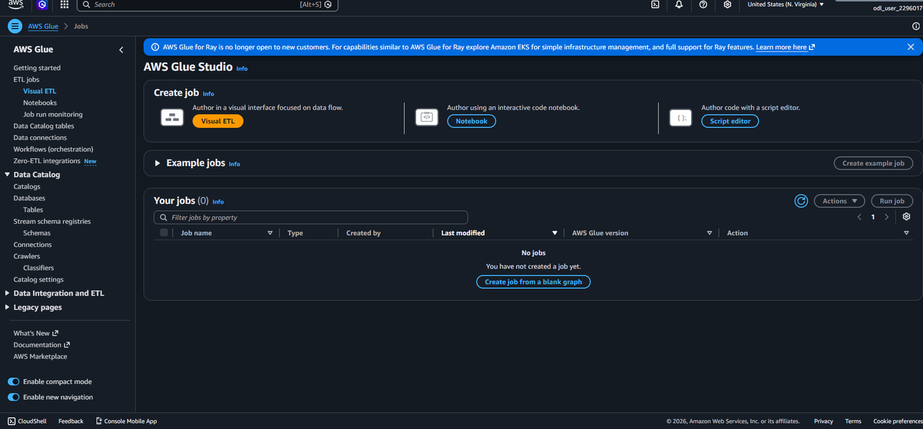
Figure 7.32: AWS Glue Studio — Create Job Page with Visual ETL Option
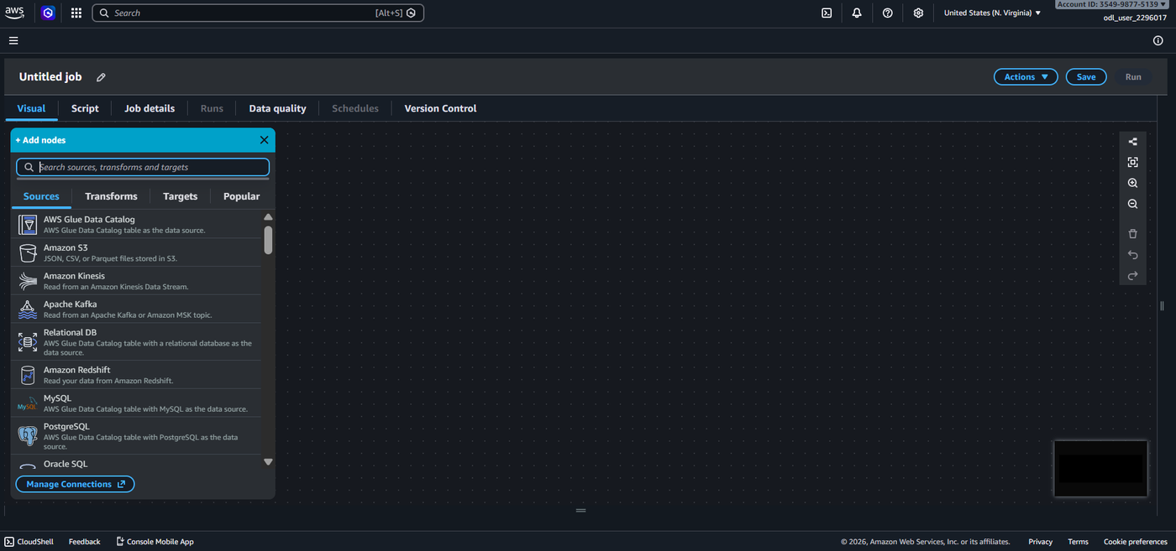
Figure 7.33: AWS Glue Studio — Visual ETL Canvas with Add Nodes Panel

7.18 Step 18: Add Product Data Source
Step 18: Configure the Product Details Data Catalog Source Node
Objective: Add and configure the first data source node pointing to the product_product_details_csv table.
Explanation:
In the Visual ETL canvas, clicking "+ Add nodes" and selecting "AWS Glue Data Catalog" under Sources adds the first data source node. The right-side properties panel shows Data source properties — Data Catalog. The name is set to "AWS Glue Data Catalog". The Database dropdown is set to abc-retail. The Table dropdown is configured to product_product_details_csv — the table created by the product-crawler. A green tick mark on the node confirms the source is correctly configured. The Output schema tab at the bottom would show the inferred columns: ProductID, Product, Product Category.
Why This Step Is Required: Adding the product data source node is the first step in constructing the ETL data flow graph. This node tells the Glue job to read data from the product_product_details_csv table in the abc-retail Data Catalog when the job runs. Without this source node, the pipeline has no product data to join with transaction records.
Expected Output: The Visual ETL canvas shows one Data Catalog source node with a green tick. The properties panel confirms Database: abc-retail, Table: product_product_details_csv.

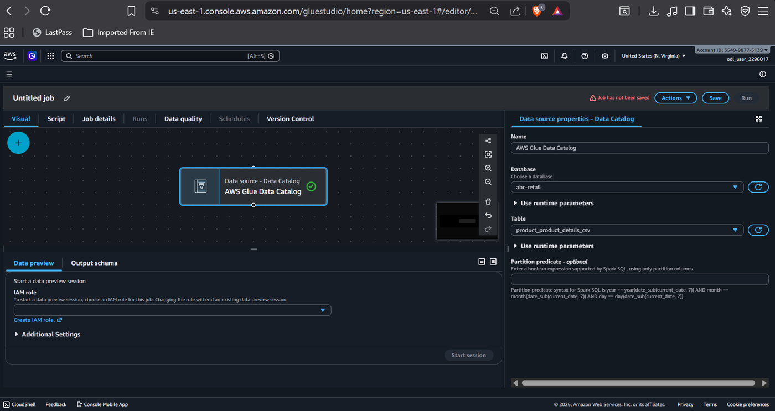
Figure 7.34: AWS Glue Studio — Product Data Source Node Configured

7.19 Step 19: Add Transaction Data Source
Step 19: Configure the Transactions Data Catalog Source Node
Objective: Add and configure the second data source node pointing to the txn_transactions_csv table.
Explanation:
A second "AWS Glue Data Catalog" source node is added to the canvas. In the properties panel, the Database is set to abc-retail and the Table is configured to txn_transactions_csv — the table created by the transaction-crawler. The canvas now shows two side-by-side data source nodes: the left node (product source, with green tick) and the right node (transaction source, selected, with green tick). The properties panel on the right confirms the transaction table selection. These two nodes represent the two data streams that will be joined in the next step.
Why This Step Is Required: Adding the transaction source node completes the data ingestion layer of the Visual ETL graph. Both source nodes are required before a Join transform can be added, as the Join operation requires exactly two parent source nodes to merge. This node instructs the Glue job to read the full transactions dataset from the Data Catalog.
Expected Output: The canvas shows two Data Catalog source nodes side by side. The right node properties panel confirms Table: txn_transactions_csv.

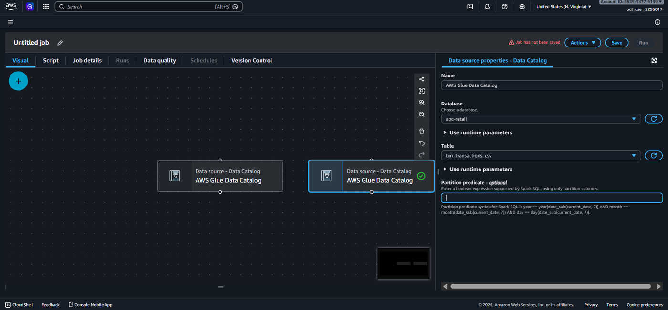
Figure 7.35: AWS Glue Studio — Transaction Data Source Node Configured

7.20 Step 20: Add and Configure the Join Transform
Step 20: Add a Join Transform to Merge Product and Transaction Data
Objective: Add a Join transform node and connect both data source nodes to it.
Explanation:
From the Add nodes panel, under the Transforms tab, the "Join" transform is added to the canvas. The Join node appears below and connected to both source nodes via connector lines. In the Transform properties panel, the Name is set to "Join" and the Join type is configured as "Inner join" (Select all rows from both datasets that meet the join condition). The Node parents section shows both "AWS Glue Data Catalog" (Catalog - DataSource) nodes selected as parent inputs. The Join conditions section shows "Add condition" button. Initially, warnings indicate that both source nodes must be fully connected and join keys must be specified.
Why This Step Is Required: The Join transform is the core transformation step of this ETL pipeline. It performs a relational inner join between the product and transaction datasets, enriching each transaction record with the corresponding product name and category from the product master data. This produces a single, comprehensive dataset that can be used for retail analytics.
Expected Output: The Visual ETL canvas shows two source nodes connected to a Join transform node. The properties panel shows Join type: Inner join with two parent nodes selected.

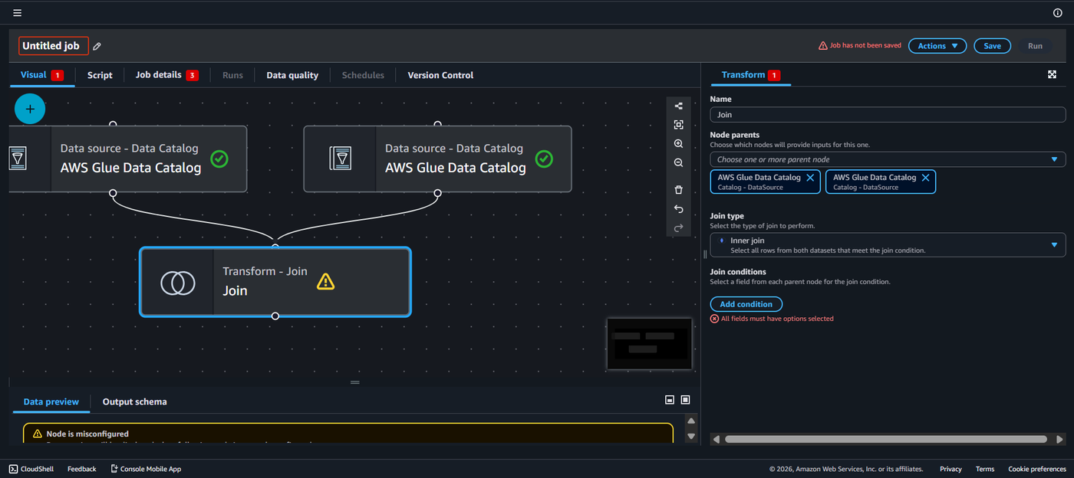
Figure 7.36: AWS Glue Studio — Join Transform with Both Source Nodes Connected

7.21 Step 21: Configure Join Keys
Step 21: Set the Join Condition Keys (ProductID = Product ID)
Objective: Configure the join keys to match products to transactions on the product identifier field.
Explanation:
In the Join conditions section of the Transform properties panel, clicking "Add condition" opens the join key dropdowns. The left dropdown (for the product source) is set to "productid" — the ProductID column from the product dataset. The right dropdown (for the transaction source) is set to the corresponding product ID field from the transactions table. Once both join keys are selected, the warning "All fields must have options selected" is resolved and the Join node displays a configuration-complete state. This inner join configuration ensures that only transactions with matching product records are included in the output, eliminating orphan records.
Why This Step Is Required: The join key configuration is the most critical parameter in the ETL transformation. Selecting the wrong fields would produce incorrect results — either no output, duplicate records, or mismatched data. The ProductID-to-ProductID join ensures referential integrity between the two datasets and produces a meaningful enriched output.
Expected Output: Join conditions show productid = product_id configured. The Join node warning is resolved and the node is correctly configured.

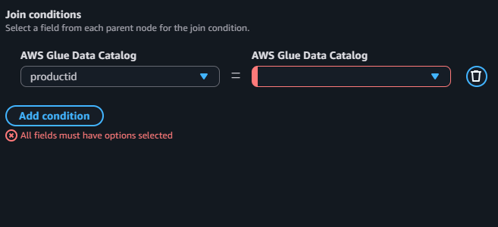
Figure 7.37: AWS Glue Studio — Join Key Configuration (productid selected for left source)

7.22 Step 22: Configure Amazon S3 Target
Step 22: Add and Configure the S3 Output Target Node
Objective: Add an Amazon S3 target node to define where the transformed data will be written.
Explanation:
After the Join node is configured, an S3 target node is added from the Targets tab in the Add nodes panel. The target node is connected to the output of the Join transform. In the S3 target properties, the format is set to Parquet or CSV, and the S3 URL is configured to point to the etl-cep-output-01-2296017 output bucket. The compression type and partition key settings are left at defaults. This node defines the write destination for all enriched retail records produced by the join operation.
Why This Step Is Required: The S3 target node completes the ETL pipeline graph. Without specifying a write target, the transformed data would have nowhere to persist after the job completes. Writing to the dedicated output bucket ensures clean separation of processed data from raw input data and enables downstream services such as Amazon Athena or Amazon Redshift to query the results.
Expected Output: An S3 target node is connected to the Join transform output. The properties panel shows the output bucket path configured.

7.23 Step 23: Configure Job Details
Step 23: Configure ETL Job Properties
Objective: Set the IAM role, Glue version, and worker configuration for the ETL job.
Explanation:
Clicking the "Job details" tab at the top of the Visual ETL editor opens the job configuration settings. The IAM role is set to GlueETLRole — the same role created in Step 11. The Glue version is set to Glue 4.0 (Spark 3.3, Python 3). The job type is Spark. Worker type is configured as G.1X (standard compute). The number of workers is set to 2 for this demonstration. The job timeout is set to 2880 minutes. The maximum concurrency is 1. The job bookmark is disabled for an initial run. These settings balance cost and performance for a small-scale ETL workload.
Why This Step Is Required: Job details configuration determines the compute resources, execution environment, and security context for the ETL job. The IAM role must match the one used by the crawlers to ensure consistent access permissions. The Glue version determines which Spark and Python versions are available. Worker settings directly impact cost and execution time.
Expected Output: The Job details tab shows GlueETLRole selected, Glue 4.0 version, G.1X worker type, and 2 workers configured.

7.24 Step 24: Save and Name the ETL Job
Step 24: Save the Visual ETL Job
Objective: Save the configured ETL job with a descriptive name.
Explanation:
Clicking the "Save" button in the top-right corner of the Visual ETL editor triggers the job save operation. The job is named using the pencil edit icon next to "Untitled job". A meaningful name such as retail-etl-job is assigned. The save action persists the job definition including the full visual graph (two source nodes, one Join transform, one S3 target) and all configuration settings to the Glue service. After saving, the "Job has not been saved" warning banner disappears and the job name appears confirmed in the title bar.
Why This Step Is Required: Saving the job persists its configuration and makes it available for execution, scheduling, and monitoring. Without saving, any navigator action away from the editor would lose all configurations. The job name should be descriptive enough to identify its purpose in a production environment with multiple pipelines.
Expected Output: The job is saved with the configured name. The "Job has not been saved" warning is cleared and the job definition is persisted.

7.25 Step 25: Run the ETL Job
Step 25: Execute the Visual ETL Job
Objective: Run the ETL job to process the join and write output to the S3 output bucket.
Explanation:
Clicking the "Run" button in the top-right of the Visual ETL editor triggers job execution. AWS Glue allocates the configured G.1X worker resources, initialises the Spark execution environment, reads from both Data Catalog tables, performs the inner join on ProductID, and writes the enriched output to the designated S3 output bucket. The Runs tab shows the job run with a start time and status updating from "Starting" to "Running" to "Succeeded". The DPU usage and data processing metrics are visible in the run monitoring dashboard.
Why This Step Is Required: Running the job executes the actual ETL workload. This is where all the prior configuration (S3 setup, crawlers, classifiers, IAM role, Visual ETL design) comes together to produce the final enriched dataset. A successful run confirms that the entire pipeline is correctly configured end-to-end.
Expected Output: The job run appears in the Runs tab with status transitioning to Succeeded, confirming the ETL transformation completed without errors.

7.26 Step 26: Verify ETL Output
Step 26: Verify the Transformed Data in the S3 Output Bucket
Objective: Navigate to the S3 output bucket to confirm the ETL job has written the output files.
Explanation:
After the job completes, navigating to the etl-cep-output-01-2296017 S3 bucket confirms the presence of output files. The bucket previously showed "No objects" but now contains the transformed output data written by the Glue ETL job. The output files are stored in the format specified in the S3 target node configuration. The presence of these files confirms the complete end-to-end functioning of the ETL pipeline: from raw CSV ingestion through S3, schema discovery via crawlers, data transformation via the Join, and final persistence in the output bucket.
Why This Step Is Required: Output verification is the final confirmation that the ETL pipeline executed correctly. Checking the output bucket ensures the data was written successfully and in the expected format. This step is critical before handing off the pipeline to any downstream analytics team.
Expected Output: The S3 output bucket contains newly created output files from the ETL job, confirming successful execution of the complete pipeline.

8. Common Errors Encountered
During the implementation of this ETL pipeline, several errors were encountered. Each error provided a learning opportunity and was resolved through investigation and corrective action. The following errors are documented with their causes and resolutions.

8.1 Error 1: Invalid Security Token
Error: UnrecognizedClientException — Invalid Security Token (Status 400)
Why It Happened: This error occurred when attempting to access the Glue Data Catalog Databases page after a period of inactivity. The AWS sandbox environment uses time-limited temporary credentials (STS tokens) that expire after a fixed session duration. The error message stated: "The security token included in the request is invalid" with HTTP status 400. The credentials embedded in the session had expired, rendering all authenticated API calls invalid.
How It Was Resolved: The session was refreshed by logging out and logging back into the AWS Management Console, which obtained new temporary credentials from AWS STS. After re-authentication, the Glue Data Catalog was accessible again. In production environments, this is handled by configuring IAM roles with appropriate session duration or using long-lived credentials with proper rotation policies.

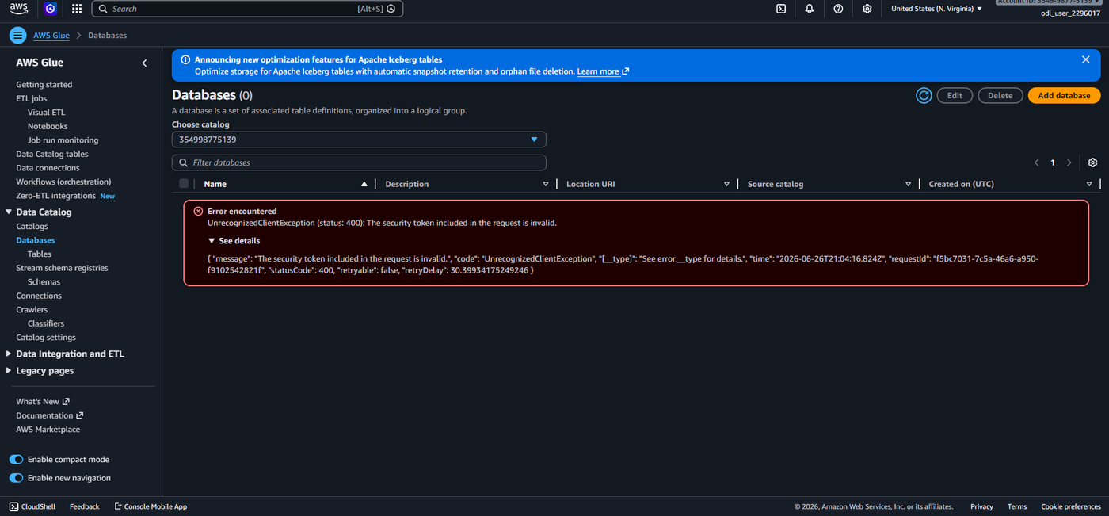
Figure 8.1: AWS Glue — Error: Invalid Security Token (Session Expired)

8.2 Error 2: Insufficient Source Nodes
Error: Insufficient Source Nodes — Join Transform Requires Two Parent Nodes
Why It Happened: This error appeared in the Visual ETL editor when a Join transform was added but only one data source node was connected as a parent. The error message read: "The Join transform requires two parent source nodes with selected tables." This occurred because the Join node was added before the second (transaction) source node was added and connected, leaving the Join node with only one parent input.
How It Was Resolved: The resolution was to add the second "AWS Glue Data Catalog" source node to the canvas, configure it with the txn_transactions_csv table, and then connect it as a second parent to the Join node using the node parents dropdown in the Transform properties panel. Once both source nodes were selected as parents, the "Insufficient source nodes" error was cleared.

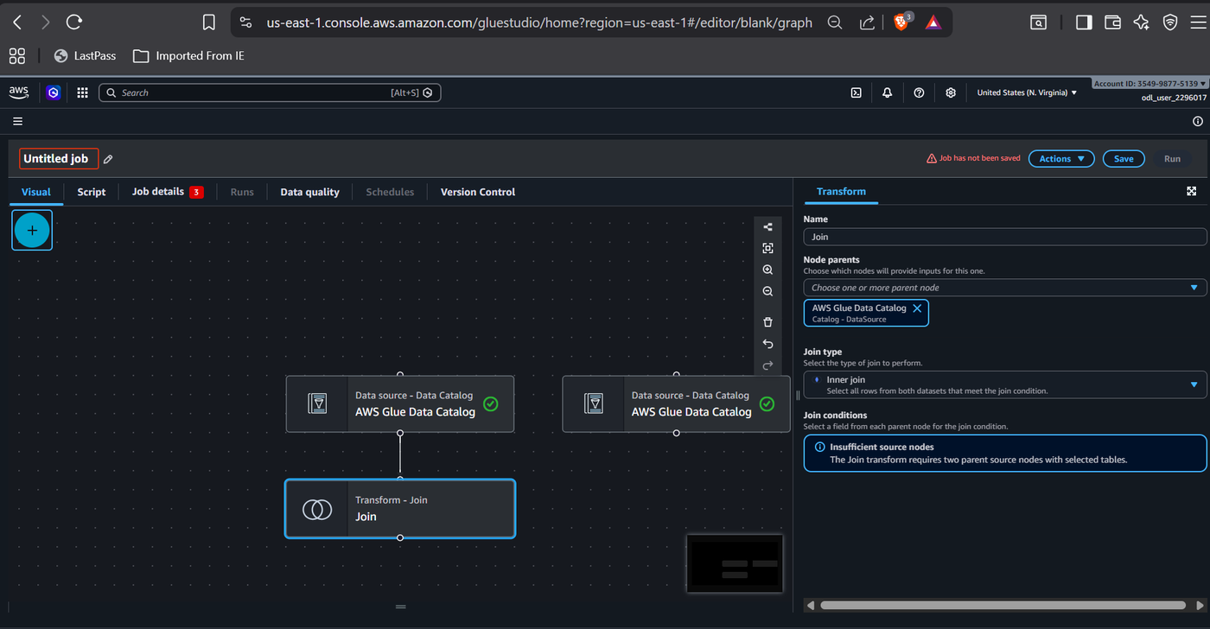
Figure 8.2: AWS Glue Studio — Error: Insufficient Source Nodes on Join Transform

8.3 Error 3: No Source Key / All Fields Must Have Options Selected
Error: No Source Key — Join Condition Fields Not Fully Configured
Why It Happened: After connecting both source nodes to the Join transform, the Join conditions panel showed "No source key" in the right dropdown of the join condition row. Additionally, the warning "All fields must have options selected" was displayed in red. This occurred because the left join key (productid) was selected from the product source dropdown, but the corresponding right key (Product ID) from the transaction source was not yet selected — it showed "No source key" as the only option in the dropdown.
How It Was Resolved: This error was caused by the transaction table not having its schema fully loaded in the dropdown at the time of selection. The resolution involved refreshing the join condition dropdowns by clicking away and re-opening the Join node properties panel, then re-selecting both join keys. After correctly selecting productid from the product source and the corresponding product ID field from the transaction source, the warning was cleared and the Join node was correctly configured with a valid join condition.

Figure 8.3a: AWS Glue Studio — Join Condition: productid Selected but Right Key Missing
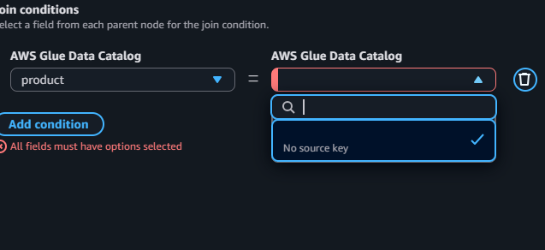
Figure 8.3b: AWS Glue Studio — Error: No Source Key Available in Right Dropdown

9. Result
The AWS Glue ETL pipeline was successfully designed and implemented. The following results were achieved:

Outcome | Detail
S3 Input Bucket | etl-cep-01-2296017 created with product-files/ and transaction-files/ folders
S3 Output Bucket | etl-cep-output-01-2296017 created for ETL job output
Product CSV Uploaded | 1.2 KB product details.csv uploaded to product-files/
Transactions CSV Uploaded | 4.8 MB transactions.csv uploaded to transaction-files/
Glue Database | abc-retail database created in the Data Catalog
Classifiers Created | cust_classifier and txn_classifier (both CSV type)
IAM Role Created | GlueETLRole with AmazonS3FullAccess and AWSGlueServiceRole
Crawlers Executed | product-crawler and transaction-crawler both completed with status Succeeded
Glue Tables Created | product_product_details_cs and txn_transactions_csv in abc-retail database
Visual ETL Job | Two-source Inner Join pipeline designed and saved in AWS Glue Studio

10. Conclusion
This project successfully demonstrated the design and implementation of a fully serverless AWS Glue ETL pipeline for retail data management. Beginning with raw CSV datasets stored in Amazon S3, the pipeline leveraged AWS Glue Crawlers for automated schema discovery, the Glue Data Catalog for centralised metadata management, and the Visual ETL interface in AWS Glue Studio for no-code pipeline construction.
The inner join performed between the Product Details and Transactions datasets produced an enriched output that combines product catalogue information with order-level transactional data. This kind of data enrichment is a foundational operation in retail analytics, enabling metrics such as category-wise revenue, product-level profitability, and shipping performance analysis.
The pipeline design follows AWS well-architected framework principles: data is isolated between input and output buckets, IAM roles enforce the principle of least privilege through scoped permissions, crawlers automate otherwise manual schema management tasks, and the Visual ETL interface ensures the pipeline logic is transparent and maintainable without deep programming expertise.
Three significant errors were encountered and resolved during implementation — an expired security token, an insufficient source nodes warning, and a join key configuration issue — each providing practical insight into real-world cloud engineering challenges. These experiences reinforce the importance of understanding AWS session management, visual ETL graph construction rules, and Data Catalog schema availability timing.

11. Learning Outcomes
Through the implementation of this project, the following technical and professional competencies were developed:

- Proficiency in creating and managing Amazon S3 buckets, folder hierarchies, and object uploads for structured data lake organisation.
- Hands-on experience with the AWS Glue Data Catalog, including database creation, table management, and metadata versioning.
- Understanding of AWS Glue Classifiers and their role in custom CSV schema detection and format specification.
- Ability to design and configure AWS Glue Crawlers with IAM role integration, S3 data source targeting, and output database configuration.
- Practical knowledge of AWS IAM role creation, trusted entity configuration, and managed policy attachment for cross-service access.
- Experience with the AWS Glue Studio Visual ETL interface, including adding data source nodes, configuring join transforms, and setting S3 output targets.
- Familiarity with common AWS Glue errors and their resolutions, including session token expiry, join node misconfiguration, and source key selection issues.
- Understanding of ETL pipeline architecture principles including source-target separation, schema cataloguing, and serverless compute orchestration.
- Exposure to real-world retail data including product master data and transactional datasets, and the analytical value of joining these for business intelligence.

— End of Report —

From AKETI RAGHAVENDRA VARMA
EMAIL: aketiraghavendravarma@gmail.com

