**BASAVARAJESWARI GROUP OF INSTITUTIONS**

# Ballari Institute of Technology & Management

**AUTONOMOUS INSTITUTE UNDER VISVESVARAYA TECHNOLOGICAL UNIVERSITY JNANA SANGAMA, BELAGAVI 590018**

**INTERNSHIP Report On**

**API SANDBOX ENVIRONMENT**

Submitted in partial fulfillment of the requirements for the award of degree of

# Bachelor of Engineering In

### COMPUTER SCIENCE AND ENGINEERING

**Submitted by**

**RAGHAVENDRA**

**3BR21CS125**

### Internship Carried Out By

**EZ TRAININGS & TECHNOLOGIES PVT.LTD**

**HYDERABAD**

**Internal Guide External Guide**

**Mrs. VARADA ALEKHYA Er. Y V D CHANDRA SEKHAR**

**ASST. PROF, CSE Sr. Technical Trainer**

**Mrs. STEFFI NIVEDITA**

**ASST. PROF, CSE**

**BALLARI INSTITUTE OF TECHNOLOGY & MANAGEMENT**

NACC Accredited Institution*

**(Recognized by Govt. of Karnataka, approved by AICTE, New Delhi & Affiliated to Visvesvaraya Technological University, Belagavi)**

**"Jnana Gangotri" Campus, No.873/2, Ballari-Hospet Road, Allipur, Ballar1-583 104 (Karnataka) (India)**

**Ph: 08392 – 237100 / 237190, Fax: 08392 – 237197**

### 2023-2024

**BASAVARAJESWARI GROUP OF INSTITUTIONS**

### BALLARI INSTITUTE OF TECHNOLOGY & MANAGEMENT

**Autonomous institute under VISVESVARAYA TECHNOLOGICAL UNIVERSITYJNANA SANGAMA, BELAGAVI 590018**

NACC Accredited Institution*

**(Recognized by Govt. of Karnataka, approved by AICTE, New Delhi & Affiliated to Visvesvaraya Technological University, Belagavi)**

**"JnanaGangotri" Campus, No.873/2, Ballari-HospetRoad, Allipur, Ballar1-583 104 (Karnataka)(India)**

**Ph: 08392 – 237100 / 237190, Fax: 08392 –237197**

### DEPARTMENT OF COMPUTER SCIENCE AND ENGINEERING

**CERTIFICATE**

This is to certify that the Internship project entitled **“API SANDBOX ENVIRONMENT”** has been successfully completed by **RAGHAVENDRA** bearing USN **3BR21CS125** a bonafide student of Ballari Institute of Technology and Management, Ballari. For the partial fulfillment of the requirements for the **Bachelor’s Degree in COMPUTER SCIENCE AND ENGINEERING** of the VISVESVARAYA TECHNOLOGICAL UNIVERSITY, Belagavi during the academic year 2023-2024.

**Signature of Internship Co-ordinator**

**Mrs. Varada Alekhya**

**Asst. prof, CSE**

**Mrs. Steffi Nivedita**

**Asst. prof, CSE**

**Signature of HOD**

**Dr. R N Kulkarni**

**HOD, CSE**

**Organization Certificate:**

Department of Computer Science Engineering

Certificate

This is to certify that Mr./Ms. RAGHAVENDRA bearing USN: 3BR21CS125 has completed Internship – 2 entitled “**Python Programming Language**” during **30th Oct 2023** to **28th Nov 2023** for the partial fulfilment of requirements for the award of bachelor’s degree in COMPUTER SCIENCE AND ENGINEERING of Visvesvaraya Technological University, Belagavi.

Signature of Internal Guide Signature of External Guide

Signature of HOD Signature of Principal





**DECLARATION**

I, **RAGHAVENDRA** second year student of Computer Science and Engineering, Ballari Institute of Technology, Ballari, declare that Internship entitled **“PYTHON PROGRAMMING LANGUAGE”** is a part of Internship Training successfully carried out by **EZ TECHNOLOGIES & TRAININGS PVT.LTD, Hyderabad** at “**BITM, BALLARI”.** This report is submitted in partial fulfillment of the requirements for the award of the degree, Bachelor of Engineering in Computer Science and Engineering of the Visvesvaraya Technological University, Belagavi.

**Date: Signature of the Student**

**Place:**

**ACKNOWLEDGEMENT**

The satisfactions that a company the successful completion of my internship on “API SANDBOX ENVIRONMENT” would be incomplete without the mention of people who made it possible, whose noble gesture, affection, guidance, encouragement and support crowned my efforts with success. It is my privilege to express my gratitude and respect to all those who inspired me in the completion of my internship.

I am grateful to our respective coordinator “**Varada Alekhya, Steffi Nivedita**” for his noble

gesture, support co-ordination and valuable suggestions given to me in the completion of Internship.

I also thank **DR. R N KULKARNI,** H.O.D. Department of **COMPUTER SCIENCE AND ENGINEERING** for extending all his valuable support and encouragement.

## Table of Contents

|  |  |  |
| --- | --- | --- |
| **Chapter No.** | **Chapter Name** | **Page No.** |
| **1** | **Company Profile** | **07** |
| **2** | **Day to day activity (student diary extract)** | **08** |
| **3** | **Abstract** | **09** |
| **4** | **Introduction of the project** | **10** |
| **5** | **Description** | **11** |
| **6** | **Algorithm** | **12-13** |
| **7** | **Output** | **14-15** |
| **8** | **Conclusion** | **16** |
| **9** | **References** | **17** |

**Company profile**

**EZ Trainings and Technologies Pvt. Ltd.**

**Introduction:**

EZ Trainings and Technologies Pvt. Ltd. is a dynamic and innovative organization dedicated to providing comprehensive training solutions and expert development services. Established with a vision to bridge the gap between academic learning and industry requirements, we specialize in college trainings for students, focusing on preparing them for successful placements.

Additionally, we excel in undertaking development projects, leveraging cutting-edge

technologies to bring ideas to life.

**Mission:**

Our mission is to empower the next generation of professionals by imparting relevant skills and knowledge through specialized training programs. We strive to be a catalyst in the career growth of students and contribute to the technological advancement of businesses through our development projects.

**Services:**

**College Trainings:**

* Tailored training programs designed to enhance the employability of students.
* Industry-aligned curriculum covering technical and soft skills.
* Placement assistance and career guidance.

**Development Projects:**

* End-to-end development services, from ideation to execution.
* Expertise in diverse technologies and frameworks.
* Custom solutions to meet specific business needs.

**Locations:** Hyderabad | Delhi NCR

At EZ Trainings and Technologies Pvt. Ltd., we believe in transforming potential into excellence.

**Day to day Activities**

**Abstract**

An API sandbox environment for student data management functions as a controlled, secure space dedicated to testing and refining API operations related to student information. This simulated environment allows developers to interact with endpoints for creating, retrieving, updating, and deleting student records within a protected setting. It ensures data isolation from live systems, offering a safe platform to experiment with API functionalities, validate integrations, test various scenarios, and refine applications without affecting real student data.

**Introduction of the project**

* API sandboxes play a crucial role in ensuring the quality and reliability of student data management systems. By providing a controlled testing environment, they help developers to
* Developers can test individual API endpoints, ensuring that they return the expected data in the correct format and handle various error scenarios.
* Developers can validate that the data retrieved from the API is accurate, consistent, and complete.
* By testing with different inputs and scenarios, developers can uncover potential security vulnerabilities that could be exploited to access or modify sensitive student data.
* Developers can test how their applications interact with the student data management APIs, ensuring seamless integration and data exchange.

**Description**

1. Student Information Retrieval:

- Endpoint: `/students`

- Description: Retrieves a list of students with details such as name, ID, contact

information, courses enrolled, grades, etc.

2. Single Student Information Retrieval:

- Endpoint: `/students/{student_id}`

- Description: Retrieves detailed information about a specific student identified by their

ID.

3. Student Creation:

- Endpoint: `POST /students`

- Description: Allows the creation of a new student record by providing necessary

information like name, contact details, enrolled courses, etc.

4. Student Update:

- Endpoint: `PUT /students/{student_id}`

- Description: Updates the information of an existing student using their ID. Allows

modification of details like name, contact information, enrolled courses, etc.

5. Student Deletion:

- Endpoint: `DELETE /students/{student_id}`

- Description: Deletes a student record identified by their ID from the system.

Authentication and Authorization:

- Token-based Authentication:

- Mechanism: login for valid users and adminstratives

- Description: Ensures secure access to the API endpoints by generating and validating

Username and password for authorized users or applications.

**Algorithm**

**Create (Insert)**

complexity:

1. Input: Student details (e.g., USN, name, year, branch)

2. Algorithm:

- Accept input data for a new student. 1

- Validate the input data. 1

- Create a new record for the student in the database: 1

- Assign a unique identifier (e.g., USN) to the student. 1

- Store the student's details in the database. 1

- Confirm successful insertion or handle any errors. 1

**Read (Retrieve)**

1. Input: Student identifier (e.g., USN) or criteria for fetching students

2. Algorithm:

- Accept input to identify the student(s) to retrieve. 1

- Fetch student information from the database: 1

- Use the identifier to find a specific student or apply criteria to

retrieve multiple students. n

- Display the retrieved student information or handle cases where

no data is found. 1

**Update (Modify)**

1. Input: Student identifier (e.g., USN) and updated information

(e.g., name, year, branch)

2. Algorithm:

- Accept input for the student identifier and updated information. 1

- Check if the student exists in the database: n

- If found, update the student's details based on the provided information. 1

- If not found, display an error message. 1

- Update the database with the modified student information. 1

- Confirm the successful update or handle errors. 1

**Delete (Remove)**

1. Input: Student identifier (e.g., USN)

2. Algorithm:

- Accept input for the student identifier to be deleted. 1

- Check if the student exists in the database: n

- If found, remove the student record from the database. 1

- If not found, display an error message. 1

- Confirm the successful deletion or handle errors. 1

**Time complexity:**

Overall time complexity to perform CRUD operation:

= 3n + 18

= n

Complexity for worst case : O(n)

Complexity for best case : Ω(1)

Complexity for average case : θ(n+1/2)

**Output**

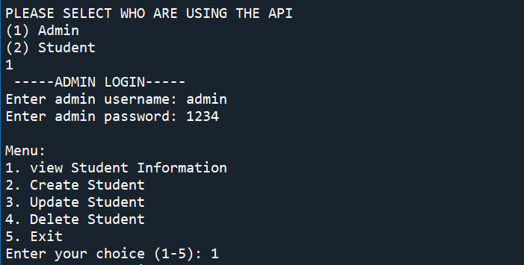

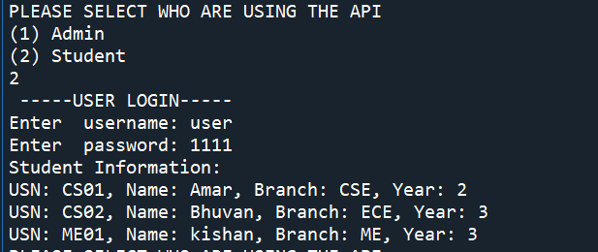

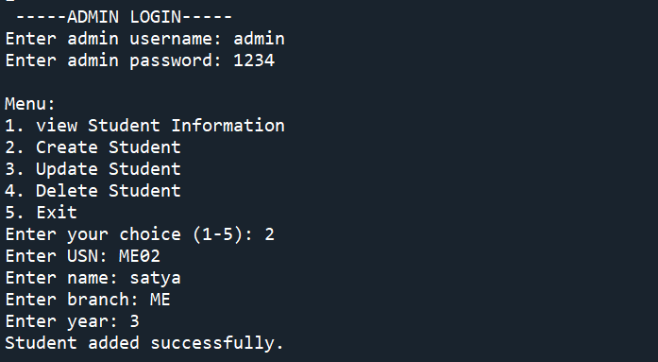

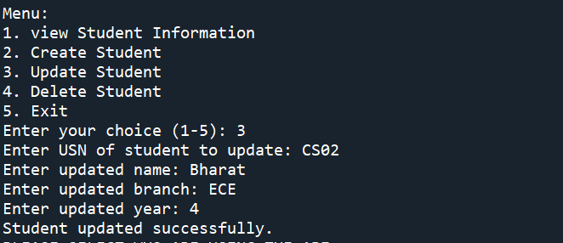

**Conclusion**

The API sandbox for student data is like a safe ground for developers. It lets them test how their tools handle student information without risking any real data. By imitating the real system, they can see if everything works as expected, fix any problems they find, and make sure it’s good before using it with actual student records. This sandbox is crucial it helps ensure that when the tools go live, they'll handle student data properly and securely, without any errors.

**Reference**

1. [https://smartbear.com/learn/api-sandbox](https://smartbear.com/learn/api-sandbox/)
2. <https://developers.bri.co.id>