# CHAPTER 1: INTRODUCTION

A student database management system is an essential software tool utilized by educational institutions to efficiently manage and organize student-related information. It serves as a centralized platform for storing comprehensive student profiles, including personal details, contact information, academic records, and demographic data. This centralized repository enables administrators and educators to easily access and update student information as needed. Additionally, the system facilitates the enrollment process by managing student registrations for courses, handling class schedules, and ensuring course availability. It plays a crucial role in academic records management by tracking and managing students' academic progress, including grades, transcripts, credits earned, and other pertinent records.

# CHAPTER 2: OBJECTIVES

# 1. Accurate Record-Keeping: The primary objective is to maintain accurate and up-to-date records of all students enrolled in the institution. This includes personal information, academic history, grades, attendance, and any other relevant data.

# 2. Efficient Data Management: Implementing systems and processes to efficiently manage student data, ensuring easy access, retrieval, and updating of information as needed.

# 3. Security and Privacy: Ensuring the security and privacy of student data by implementing appropriate measures such as access controls, encryption, and compliance with data protection regulations like GDPR or FERPA.

# 4. Integration and Interoperability: Integrating the student database with other institutional systems such as learning management systems (LMS), finance systems, and academic advising platforms to facilitate seamless data exchange and workflow automation.

# 5. Enhanced Communication: Facilitating effective communication between students, faculty, staff, and administrators through the student database, including features like messaging, notifications, and alerts.

# 6. Supporting Decision-Making: Providing administrators and academic staff with access to timely and accurate data to support decision-making processes related to student enrollment, academic planning, resource allocation, and student support services.

# 7. Monitoring and Reporting: Generating reports and analytics to monitor student progress, identify trends, and assess institutional performance. This includes tracking retention rates, graduation rates, academic performance, and other key metrics.

# 8. Supporting Student Services: Enhancing student services by providing tools and resources within the database for tasks such as course registration, academic advising, financial aid management, and career services.

# 9. Facilitating Research and Analysis: Supporting research initiatives by providing access to anonymized student data for academic research, institutional assessment, and program evaluation purposes.

# 10. Continuous Improvement: Continuously evaluating and improving the student database management system based on feedback from stakeholders, technological advancements, and changes in institutional needs and regulations.

# CHAPTER 3: PROBLEM STATEMENT

A student management system stores and tracks student details through computerized method which is difficult to store n number of student details manually.

# CHAPTER 4: SCOPE OF PROJECT

# A student database management system serves as a comprehensive platform for educational institutions to efficiently manage and organize student-related information. It encompasses various key functionalities aimed at streamlining administrative processes and enhancing communication among stakeholders. The system's scope includes managing student information, such as personal details and contact information, enrollment and registration processes, academic records management, attendance tracking, communication tools for teachers, students, parents, and administrators, reporting and analysis capabilities to support decision-making, and robust security measures to protect sensitive data. Furthermore, the system is designed to be scalable and customizable to accommodate the evolving needs of educational institutions while ensuring compliance with data protection regulations. By addressing these aspects, the system contributes to the overall efficiency, transparency, and effectiveness of educational operations, ultimately supporting student success and institutional growth.

# CHAPTER 5: SOFTWARE AND HARDWARE REQUIREMENTS

# 5.1 SOFTWARE REQUIREMENTS

Operating system : Windows versions 10 and above

Programming language: Python

# HARDWARE REQUIREMENTS

Processor : Intel i5 processor RAM : 1GB or more

HDD : 40GB

Keyboard : Normal Mouse : Normal

# CHAPTER 6: ALGORITHM

# 1. Create (Insert):

# 1. Input: Student details (e.g., USN, name, year, branch, mobile_no)

2. Algorithm:

- Accept input data for a new student.

- Validate the input data.

- Create a new record for the student in the database:

- Assign a unique identifier (e.g., USN) to the student.

- Store the student's details in the database.

- Confirm successful insertion or handle any errors.

**2. Read (Retrieve):**

1. Input: Student identifier (e.g., USN) or criteria for fetching students

2. Algorithm:

- Accept input to identify the student(s) to retrieve.

- Fetch student information from the database:

- Use the identifier to find a specific student or apply criteria to

retrieve multiple students.

- Display the retrieved student information or handle cases where

no data is found.

**3. Update (Modify)**

1. Input: Student identifier (e.g., USN) and updated information

(e.g., name, year, branch,mobile_no)

2. Algorithm:

- Accept input for the student identifier and updated information.

- Check if the student exists in the database:

- If found, update the student's details based on the provided

information.

- If not found, display an error message.

- Update the database with the modified student information.

- Confirm the successful update or handle errors.

**4.Delete (Remove)**

1. Input: Student identifier (e.g., USN)

2. Algorithm:

- Accept input for the student identifier to be deleted.

- Check if the student exists in the database:

- If found, remove the student record from the database.

- If not found, display an error message.

- Confirm the successful deletion or handle errors.

# CHAPTER 7: MODULES DESCRIPTION

1. Student Information Retrieval:

- Endpoint: `/students`

- Description: Retrieves a list of students with details such as name, ID, contact

information, courses enrolled, grades, etc.

2. Student Information Retrieval:

- Endpoint: `/students/{student_id}`

- Description: Retrieves detailed information about a specific student identified by their ID.

3. Student Enrollment:

- Endpoint: `POST /students`

- Description: Allows the creation of a new student record by providing necessary

information like name, contact details, enrolled courses, etc.

4. Student Update:

- Endpoint: `PUT /students/{student_id}`

- Description: Updates the information of an existing student using their ID. Allows

modification of details like name, contact information, enrolled courses, etc.

5. Student Deletion:

- Endpoint: `DELETE /students/{student_id}`

- Description: Deletes a student record identified by their ID from the system.

Authentication and Authorization:

- Token-based Authentication:

- Mechanism: login for valid users and administrative

- Description: Ensures secure access to the API endpoints by generating and validating

Username and password for authorized users or applications.

# CHAPTER 8: RESULTS

-LOGIN

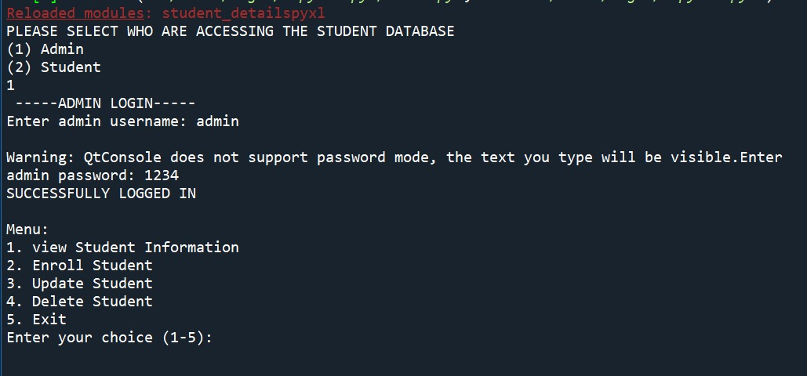

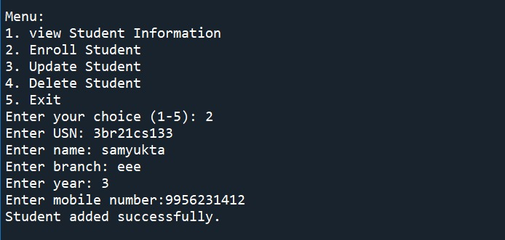

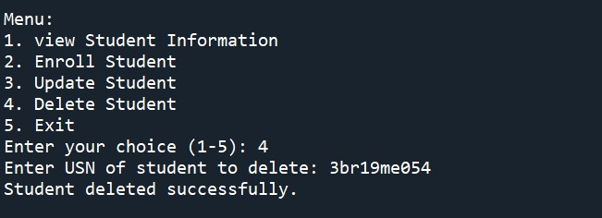

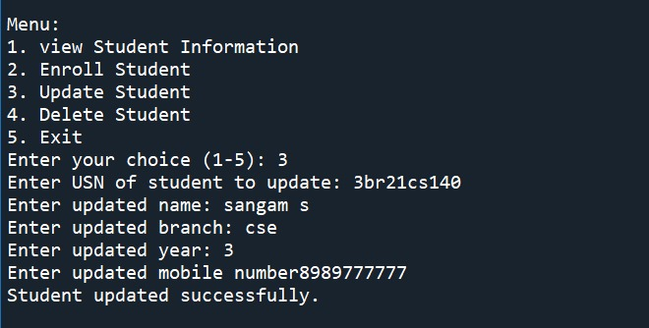

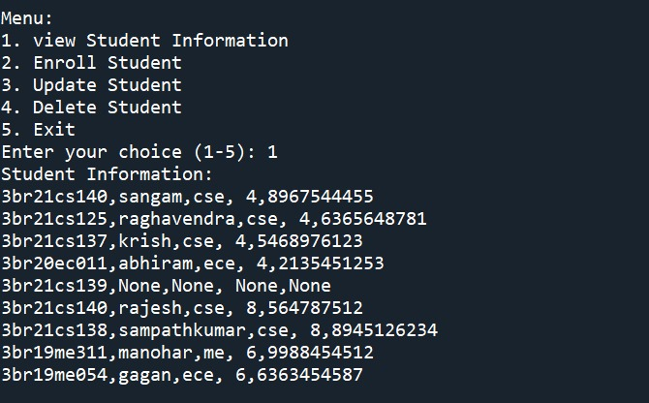

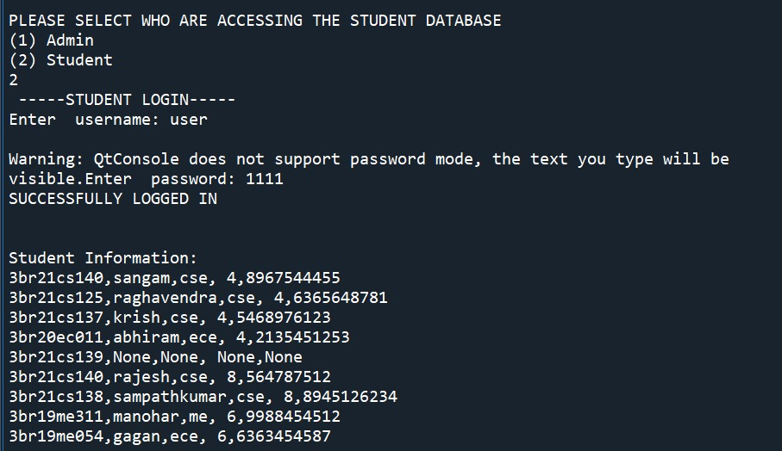

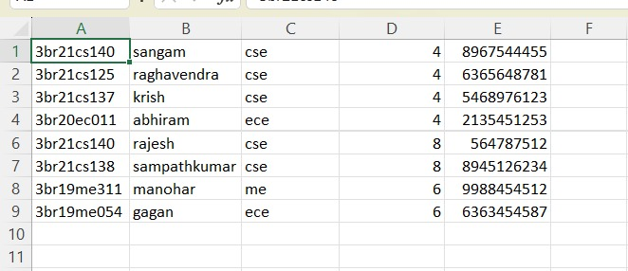

# CHAPTER 9: CONCLUSION

The implementation of a student database management system (DBMS) offers numerous advantages for educational institutions, students, and administrative staff alike. By centralizing student data, such a system enhances efficiency, accuracy, and accessibility of information. It streamlines administrative tasks, such as enrollment, grading, and record-keeping, allowing staff to focus more on strategic initiatives and student support. Additionally, students benefit from improved communication channels, easier access to academic resources, and a more personalized learning experience.

**CHAPTER 10: REFERENCES**

1. https://[www.scribd.com/doc/69760208/STUDENT MANAGEMENT SYSTEM-](http://www.scribd.com/doc/69760208/STUDENT%20MANAGEMENT%20SYSTEM-)
2. [https://stackoverflow.com/questions/52646045/ student](https://stackoverflow.com/questions/52646045/%20student) database management -system