TE CONNECTIVITY | STANDARD

CLPS Enterprise Technical Documentation Prompt — Clean .md Reference Guide
October 16, 2026
Document Owner | H R, Raghavendra
Generated by | TELme
Date | October 16, 2026
Version | 1.0
Classification | TE Internal

Contents
[Update table of contents: right-click → Update Field]

CLPS Enterprise Technical Documentation Prompt — Clean .md Reference Guide
This reference guide is a reusable, team-facing prompt template for generating enterprise-grade technical documentation for any CLPS (Manufacturing and Label Tracking System). It is designed to be shared across engineering, architecture, and delivery teams so that every documentation engagement follows a consistent, evidence-based, and professionally structured approach. The guide covers everything from how to prepare your repository context through to the full 19-section master prompt and a quick-reference card for selective use.
❗ IMPORTANT
All documentation generated using this prompt must be evidence-based. Every finding must reference a specific file, class, and method from the source code. Do not assert assumptions as facts — if something cannot be confirmed from the codebase, mark it explicitly as unknown.

1. Purpose and Scope
This document serves two distinct purposes. First, it is an operational guide that explains how team members should prepare, execute, and interpret the master prompt. Second, it is a prompt library — a curated, structured set of instructions that, when provided to an AI assistant alongside a repository, produces a complete technical document covering architecture, security, database design, API specification, deployment, and production readiness.
The scope covers any .NET-based CLPS application that manages label tracking (LT) generation, batch management, print master retrieval, order validation, machine validation, site resolution, and label printing workflows. The prompt is technology-stack-aware and will adapt its output based on what it discovers in the repository.

2. How to Use This Guide

2.1 Step 1 — Prepare Your Repository Context
Before running the master prompt, ensure you have access to all of the following artefacts. The quality of the generated documentation is directly proportional to the completeness of the repository context you provide.
- Source code repository (Git, Azure DevOps, or GitHub)
- Solution file (.sln) and all project files (.csproj)
- Configuration files: appsettings.json, appsettings.{Environment}.json, Dockerfile, Kubernetes YAML manifests
- Database artefacts: EF Core migrations, stored procedures, raw SQL scripts, seed data scripts
- Pipeline definitions: Azure DevOps YAML pipelines, GitHub Actions workflows
- Test projects: unit tests, integration tests, and any test fixture files
⚠ WARNING
If configuration files containing secrets (connection strings, API keys) are present in the repository, ensure you are working in a secure, access-controlled environment before attaching them to any AI assistant session.

2.2 Step 2 — Paste the Master Prompt
Copy the entire Master Prompt section (Section 4 of this guide) and paste it as the first message in your AI assistant session (TELme or equivalent). The prompt is self-contained and includes role assignment, repository analysis requirements, section-by-section documentation instructions, and output format rules.

2.3 Step 3 — Attach Repository Files
Attach or reference the repository path so the AI assistant can scan the source code. If your assistant supports file uploads, attach the solution folder as a ZIP or provide a direct repository URL. If working with a context-window-limited assistant, prioritise attaching the following files in order of importance:
- Program.cs / Startup.cs — application bootstrap and DI registration
- All *Controller.cs files — API surface area
- All *Service.cs and *InternalService.cs files — business logic
- All *Repository.cs files — data access layer
- appsettings.json — configuration and infrastructure references
- EF Core DbContext and migration files — database schema
- Dockerfile and Kubernetes YAML — deployment topology

2.4 Step 4 — Expected Output
The AI will generate a structured document covering all 19 sections defined in the master prompt. The output will be in clean Markdown (.md) format, with Mermaid diagrams for all architecture visuals, tables for structured data, and inline code references throughout. The document is immediately usable in VS Code, GitHub, GitLab, Obsidian, or Typora.

3. Quick Reference Card
Not every engagement requires the full 19-section document. Use the table below to identify which sections of the master prompt to include for targeted documentation tasks.
Documentation Goal | Sections to Include | Typical Use Case
Full technical document | All 19 sections | New project onboarding, architecture review, audit preparation
Architecture diagrams only | Sections 3, 13, 14 | Design review, stakeholder presentation
Security review only | Section 10 | Penetration test preparation, compliance audit
API documentation only | Section 8 | Developer onboarding, integration partner handoff
Database design only | Section 7 | DBA review, schema migration planning
Recommendations only | Section 19 | Sprint planning, technical debt backlog grooming
Deployment guide only | Section 15 | DevOps handoff, environment provisioning
Production readiness only | Section 18 | Go-live checklist, release gate review

4. Master Prompt — Full Text
ℹ NOTE
Copy everything from this section and paste it into your AI assistant. Replace placeholder values (marked with angle brackets) with your actual system name and context where applicable.

4.1 System Context Block
This application belongs to a manufacturing and label tracking system (CLPS).

Pay special attention to:
- LT (Label Tracking) generation lifecycle
- Batch management lifecycle
- Print Master retrieval
- Order validation workflow
- Machine validation workflow
- Site resolution workflow
- Label printing workflow
- Database transaction boundaries
- Concurrency control mechanisms
- Manufacturing traceability requirements

Produce a dedicated section called:
"LT Creation End-to-End Workflow Analysis"

Show exactly how:
CreateLTController → CreateLTService → CreateLTContextBuilder → CreateLTInternalService

...executes, including:
- Validations
- Database updates
- Transaction flow
- Error handling

4.2 Role Assignment Block
Act as a:
- Principal Software Architect
- Enterprise Architect
- Solution Architect
- Security Architect
- Technical Lead
- Technical Writer

Analyze the entire repository and generate comprehensive enterprise-grade technical documentation.

4.3 Repository Analysis Requirements
1. Scan the complete solution:
- Solution (.sln) and all .csproj files
- Controllers, Services, Interfaces, Repositories
- Models, DTOs, Validators
- Middleware, Background Services
- Database Access Layer, Entity Framework Models
- Migrations, SQL Scripts
- Configuration Files (appsettings.json, Program.cs, Startup.cs)
- Docker Files, Kubernetes Files, YAML Pipelines
- Unit Tests, Integration Tests

2. Build a complete architectural understanding of:
- Business functionality
- Application architecture
- Data architecture
- Integration architecture
- Security architecture
- Deployment architecture

3. Do NOT make assumptions.
Every statement must be based on source code evidence.

4. For every finding provide:
- File name
- Class name
- Method name (if applicable)
- Evidence from source code

5. Clearly identify:
- Confirmed findings
- Unknowns
- Assumptions avoided

5. Documentation Sections — Detailed Specifications
The following 19 sections define the complete structure of the generated technical document. Each section includes the AI instruction block, template structures, and Mermaid diagram templates where applicable.

5.1 Section 1 — Executive Summary
Provide:
- Application purpose
- Business objectives
- Target users
- Business capabilities
- Key workflows
- High-level architecture summary

5.2 Section 2 — System Overview
Document:
- Functional overview
- Major modules
- User interactions
- Data lifecycle
- Non-functional requirements discovered

5.3 Section 3 — High Level Design
Identify architecture style (explain why):
- Monolithic / Layered / N-Tier / Clean Architecture
- Hexagonal / Microservices / Event Driven / CQRS

Generate Mermaid diagrams:
- Context Diagram
- System Architecture Diagram
- Component Diagram

The following Mermaid diagram templates are provided as starting points. The AI will populate these with actual component names discovered from the repository.
Context Diagram — shows the system boundary and external actors:
```mermaid
graph TD
U[User / Operator] -->|HTTP Request| API[CLPS API Layer]
API --> DB[(SQL Database)]
API --> EXT[External Systems]
API --> PRINT[Label Printer]
```

System Architecture Diagram — shows the internal layered structure:
```mermaid
graph LR
Client -->|REST/JSON| Controller
Controller --> Service
Service --> Repository
Repository --> Database
Service --> ExternalAPI
```

Component Diagram — shows the LT creation component chain:
```mermaid
graph TD
CreateLTController --> CreateLTService
CreateLTService --> CreateLTContextBuilder
CreateLTService --> CreateLTInternalService
CreateLTInternalService --> Repository
Repository --> Database
```

5.4 Section 4 — Solution Structure
For every project document:
- Project name
- Project type (API / Library / Test)
- Responsibility
- Dependencies

For every major folder document:
- Purpose
- Key classes

Create folder hierarchy documentation.

Reference folder hierarchy (the AI will adapt this to the actual repository structure):
/CLPS.API
/Controllers
- CreateLTController.cs
- BatchController.cs
/Services
- CreateLTService.cs
- CreateLTInternalService.cs
/Builders
- CreateLTContextBuilder.cs
/Repositories
- LabelRepository.cs
/Models
/DTOs
/Validators
/Middleware
/CLPS.Core
/Interfaces
/Entities
/CLPS.Infrastructure
/Database
/Migrations
/CLPS.Tests
/Unit
/Integration

5.5 Section 5 — Technology Stack
Identify:
- .NET version
- ASP.NET Core version
- C# version
- ORM (Entity Framework / Dapper / ADO.NET)
- Database (SQL Server / Oracle / PostgreSQL)
- Logging frameworks (Serilog / NLog / ILogger)
- Caching technologies (Redis / In-Memory)
- Authentication frameworks (JWT / Azure AD / OAuth)
- API frameworks (REST / gRPC / GraphQL)

Create a complete NuGet package inventory.

NuGet Package Inventory — the AI will populate this table from .csproj files:
Package Name | Version | Purpose
Microsoft.AspNetCore | x.x.x | Web framework
EntityFrameworkCore | x.x.x | ORM
Serilog | x.x.x | Structured logging
FluentValidation | x.x.x | Request validation
AutoMapper | x.x.x | Object-to-object mapping
Polly | x.x.x | Resilience and retry policies

5.6 Section 6 — Low Level Design
For each component document:
- Responsibility
- Interfaces implemented
- Concrete implementations
- Dependencies injected
- Public methods with signatures
- Data flow (input → processing → output)

Generate dependency diagrams using Mermaid.

LT Creation Component Detail — reference template:
Component | Interface | Responsibility
CreateLTController | ICreateLTController | HTTP entry point and request routing
CreateLTService | ICreateLTService | Business orchestration layer
CreateLTContextBuilder | ICreateLTContextBuilder | Context assembly and validation
CreateLTInternalService | ICreateLTInternalService | Core LT creation logic and database writes

5.7 Section 7 — Database Design
Analyze:
- Entities and DbContexts
- Migrations
- Tables, Stored Procedures, Views

Document:
- Primary Keys
- Foreign Keys
- Constraints
- Indexes

Generate Mermaid ER Diagram.

ER Diagram Template — the AI will extend this with all discovered entities:
```mermaid
erDiagram
LABEL_TRACKING {
int LT_ID PK
string LT_Number
int BatchID FK
int OrderID FK
datetime CreatedAt
string Status
}
BATCH {
int BatchID PK
string BatchNumber
int SiteID FK
datetime BatchDate
}
ORDER {
int OrderID PK
string OrderNumber
string MachineID
string Status
}
LABEL_TRACKING ||--o{ BATCH : belongs_to
LABEL_TRACKING ||--o{ ORDER : linked_to
```

5.8 Section 8 — API Documentation
For every endpoint provide:
- Route
- HTTP Verb (GET / POST / PUT / DELETE)
- Controller
- Service called
- Request Model
- Response Model
- Validation rules
- Authentication required
- Authorization (roles/claims)
- Error handling

Generate API reference tables.

API Reference Table — the AI will populate this from all discovered controllers:
Route | Verb | Controller | Service | Auth | Description
/api/lt/create | POST | CreateLTController | CreateLTService | JWT | Create new Label Tracking record
/api/batch/{id} | GET | BatchController | BatchService | JWT | Retrieve batch details by ID
/api/order/validate | POST | OrderController | OrderValidationService | JWT | Validate manufacturing order
/api/site/resolve | GET | SiteController | SiteResolutionService | JWT | Resolve site configuration

5.9 Section 9 — Business Logic Analysis
Identify:
- Business rules
- Validation rules
- Decision points
- Workflow logic
- Manufacturing logic
- Processing rules

Provide code references (file → class → method).

LT Creation Business Rules Register — the AI will populate this from service and validator classes:
Rule ID | Rule Description | Component | Code Reference
BR-001 | Order must be in ACTIVE status before LT creation | CreateLTContextBuilder | ValidateOrder()
BR-002 | Machine must be registered and operational | CreateLTContextBuilder | ValidateMachine()
BR-003 | Site must be resolved before batch assignment | CreateLTService | ResolveSite()
BR-004 | Batch must not exceed maximum label count | CreateLTInternalService | ValidateBatchCapacity()
BR-005 | LT number must be globally unique | CreateLTInternalService | GenerateLTNumber()
BR-006 | Print Master must exist for label template | CreateLTInternalService | RetrievePrintMaster()

5.10 Section 10 — Security Review
Analyze:
- Authentication mechanism (JWT / Azure AD / OAuth)
- Authorization (roles, claims, policies)
- JWT token validation
- Secrets management (Azure Key Vault / env vars)
- Encryption at rest and in transit
- Data protection (PII handling)

Identify vulnerabilities and rate severity:
- Critical / High / Medium / Low

Provide remediation recommendations for each finding.

❗ IMPORTANT
The Security VulnerabilityRegister is a mandatory output of the security review. Every finding must include a severity rating and a concrete remediation recommendation. Do not omit findings simply because they are low severity.

ID | Vulnerability | Severity | Location | Recommendation
SEC-001 | SQL Injection risk in raw queries | Critical | Repository layer | Use parameterized queries or EF Core exclusively
SEC-002 | JWT token expiry not enforced | High | Auth middleware | Set short expiry window and implement refresh token rotation
SEC-003 | Connection strings stored in appsettings.json | High | appsettings.json | Migrate all secrets to Azure Key Vault
SEC-004 | Missing CSRF protection on state-changing endpoints | Medium | API Controllers | Add AntiForgery token validation
SEC-005 | Verbose error messages exposed in API responses | Medium | Global error handler | Sanitize all error responses before returning to client
SEC-006 | No rate limiting on LT creation endpoint | Low | CreateLTController | Implement API throttling using ASP.NET Core rate limiting middleware

5.11 Section 11 — Integration Analysis
Document all integrations:
- External APIs
- Databases
- Message Queues
- File Processing
- Third-Party Systems

For each integration provide:
- Purpose
- Protocol (REST / SOAP / gRPC / MQ)
- Authentication method
- Failure handling strategy

Integration Inventory Table — the AI will populate this from HttpClient registrations, configuration files, and service dependencies discovered in the repository:
System | Type | Protocol | Auth Method | Failure Handling Strategy
SQL Server | Database | ADO.NET / EF Core | Windows Auth or SQL Auth | Retry policy with exponential backoff and circuit breaker
Label Printer | Hardware integration | TCP/IP | API Key | Fallback to print queue with dead-letter handling
ERP System | External API | REST/JSON | OAuth 2.0 Client Credentials | Dead letter queue with alerting on repeated failure
Azure Active Directory | Identity provider | OAuth 2.0 / OIDC | Client Secret or Certificate | Token refresh with silent re-authentication

5.12 Section 12 — Logging and Error Handling
Analyze:
- Logging framework used (Serilog / NLog / ILogger)
- Log levels (Trace / Debug / Info / Warning / Error / Fatal)
- Global exception middleware
- Structured logging patterns
- Retry mechanisms (Polly policies)
- Resilience patterns (Circuit Breaker / Fallback)

Logging Standards Reference — the AI will validate actual log level usage against this standard and flag deviations:
Log Level | When to Use | Example Message
Information | Normal workflow steps completing successfully | "LT created successfully: LT-00123"
Warning | Non-critical issues that do not halt processing | "Batch capacity at 90% — approaching limit"
Error | Handled exceptions with known recovery path | "Order validation failed for OrderID: 456"
Critical | System-level failures requiring immediate intervention | "Database connection lost — all transactions halted"
Debug | Detailed diagnostic information for development use | "Entering ValidateOrder() with OrderID: 789"
Trace | Granular step-by-step execution tracing | "SQL query executed in 42ms for LT lookup"

5.13 Section 13 — Sequence Diagrams
Generate Mermaid sequence diagrams for:
1. User authentication flow
2. LT creation main transaction flow
3. Database transaction flow
4. External API interaction flow

LT Creation End-to-End Sequence Diagram — this is the primary sequence diagram for the CLPS system and must be generated with full fidelity to the actual code flow:
```mermaid
sequenceDiagram
participant Client
participant CreateLTController
participant CreateLTService
participant CreateLTContextBuilder
participant CreateLTInternalService
participant Repository
participant Database

Client->>CreateLTController: POST /api/lt/create (Request)
CreateLTController->>CreateLTController: Validate request model
CreateLTController->>CreateLTService: CreateLT(request)
CreateLTService->>CreateLTContextBuilder: BuildContext(request)
CreateLTContextBuilder->>Repository: ValidateOrder(orderID)
Repository->>Database: SELECT Order WHERE ID=orderID
Database-->>Repository: Order record
Repository-->>CreateLTContextBuilder: Order validated
CreateLTContextBuilder->>Repository: ValidateMachine(machineID)
Repository->>Database: SELECT Machine WHERE ID=machineID
Database-->>Repository: Machine record
Repository-->>CreateLTContextBuilder: Machine validated
CreateLTContextBuilder->>CreateLTService: Context built
CreateLTService->>CreateLTInternalService: CreateLTInternal(context)
CreateLTInternalService->>Database: BEGIN TRANSACTION
CreateLTInternalService->>Repository: InsertLT(ltData)
Repository->>Database: INSERT INTO LabelTracking
CreateLTInternalService->>Repository: UpdateBatch(batchData)
Repository->>Database: UPDATE Batch SET Count++
CreateLTInternalService->>Database: COMMIT TRANSACTION
CreateLTInternalService-->>CreateLTService: LT created (ltID)
CreateLTService-->>CreateLTController: Success response
CreateLTController-->>Client: 201 Created (LT details)
```

5.14 Section 14 — Data Flow Diagrams
Generate Mermaid diagrams for:
- Request flow (Client → Controller → Service → DB)
- Processing flow (Validation → Context Build → LT Creation)
- Response flow (DB → Service → Controller → Client)

Request Processing Flow Diagram — illustrates every decision gate from authentication through to final response:
```mermaid
flowchart TD
A[Client Request] --> B{Authentication Check}
B -->|Fail| C[401 Unauthorized]
B -->|Pass| D{Request Validation}
D -->|Fail| E[400 Bad Request]
D -->|Pass| F[Build LT Context]
F --> G{Order Valid?}
G -->|No| H[422 Order Invalid]
G -->|Yes| I{Machine Valid?}
I -->|No| J[422 Machine Invalid]
I -->|Yes| K{Site Resolved?}
K -->|No| L[422 Site Not Found]
K -->|Yes| M[Create LT Record]
M --> N{DB Transaction OK?}
N -->|Fail| O[500 Transaction Failed]
N -->|Success| P[201 LT Created]
```

5.15 Section 15 — Deployment Architecture
Analyze hosting model:
- IIS / Docker / Kubernetes / Azure / AWS

Generate deployment diagram.

Document environments:
- Development
- Test / QA
- UAT
- Production

Include:
- Infrastructure components
- Network topology
- Load balancing
- Database clustering
- Secrets management

Environment Configuration Matrix — the AI will validate actual environment configurations against this template using appsettings.{Environment}.json and Kubernetes manifest files:
Environment | Hosting | Database | Auth Provider | Logging Destination
Development | Local IIS or Docker Desktop | Local SQL Server instance | Dev Azure AD tenant | Console output and local file sink
Test / QA | Docker Compose | Shared SQL Server | Test Azure AD tenant | Centralised log aggregation
UAT | Kubernetes cluster | Managed Azure SQL | Azure AD | Azure Monitor and Log Analytics
Production | Azure Kubernetes Service (AKS) | Azure SQL with high availability | Azure AD with MFA enforced | Application Insights and Azure Monitor

5.16 Section 16 — Performance Analysis
Identify:
- Hot paths (most frequently called endpoints)
- Database bottlenecks (slow queries, missing indexes)
- Memory concerns (large object allocations)
- N+1 query risks (lazy loading pitfalls)
- Lock contention (concurrent LT creation)
- Caching opportunities

Provide optimization recommendations for each finding.

Performance Risk Register — the AI will populate this from query patterns, EF Core navigation property usage, and caching configuration discovered in the repository:
Risk ID | Area | Issue Identified | Business Impact | Recommended Remediation
PERF-001 | LT Creation | No caching for PrintMaster retrieval | High database load on every LT creation request | Cache PrintMaster records in Redis with appropriate TTL
PERF-002 | Batch Query | N+1 query pattern in batch loading | Slow response times under concurrent load | Replace lazy loading with eager loading using Include()
PERF-003 | LT Insert | Missing unique index on LT_Number column | Slow uniqueness check on every insert | Add a unique non-clustered index on LT_Number
PERF-004 | Site Resolution | Site configuration queried per request | Repeated unnecessary database round-trips | Cache site configuration at application startup or in distributed cache
PERF-005 | Concurrent LT Creation | Potential row-level lock contention on Batch table | Throughput degradation under high concurrency | Implement optimistic concurrency with row version tokens

5.17 Section 17 — Technical Debt Assessment
Identify:
- Code smells (God classes, magic numbers, dead code)
- High complexity methods (cyclomatic complexity > 10)
- Tight coupling (direct instantiation instead of DI)
- Code duplication
- SOLID violations
- Maintainability risks

Create a Technical Debt Register.

Technical Debt Register — the AI will populate this from static analysis of the codebase, flagging each item with severity and estimated remediation effort:
Debt ID | Debt Type | Location | Description | Severity | Estimated Effort
TD-001 | God Class | CreateLTService | Single class handles more than 15 distinct responsibilities | High | Large — requires decomposition into focused services
TD-002 | Tight Coupling | Repository layer | Direct DbContext instantiation instead of injected abstraction | Medium | Medium — introduce IDbContextFactory or unit-of-work pattern
TD-003 | Code Duplication | Validator classes | Order validation logic duplicated across three separate validators | Medium | Small — extract to shared OrderValidationRule
TD-004 | Magic Numbers | CreateLTInternalService | Hardcoded batch capacity limits with no named constants | Low | Small — replace with named configuration constants
TD-005 | SOLID — SRP Violation | CreateLTContextBuilder | Class simultaneously builds context, performs validation, and writes logs | Medium | Medium — separate concerns into dedicated classes
TD-006 | Dead Code | Multiple service files | Commented-out code blocks and unused private methods present | Low | Small — remove during next code review cycle

5.18 Section 18 — Production Readiness Review
Assess each dimension and assign score out of 10:
- Reliability (error handling, retries, failover)
- Scalability (horizontal scaling, load balancing)
- Security (auth, encryption, vulnerability coverage)
- Maintainability (code quality, documentation)
- Observability (logging, tracing, metrics)
- Monitoring (dashboards, health checks)
- Alerting (threshold alerts, on-call routing)
- Disaster Recovery (backup, RTO, RPO)

Production Readiness Scorecard — scores are assigned by the AI based on evidence found in the repository. The template below shows the scoring framework; actual scores will vary per codebase:
Dimension | Score /10 | Status | Key Gaps to Address
Reliability | ?/10 | To be assessed | Error handling completeness, retry policy coverage, failover configuration
Scalability | ?/10 | To be assessed | Horizontal scaling readiness, stateless service design, load balancer configuration
Security | ?/10 | To be assessed | Authentication enforcement, secrets management, vulnerability remediation status
Maintainability | ?/10 | To be assessed | Code quality metrics, inline documentation, test coverage percentage
Observability | ?/10 | To be assessed | Structured logging completeness, distributed tracing, correlation ID propagation
Monitoring | ?/10 | To be assessed | Health check endpoints, dashboard coverage, synthetic monitoring
Alerting | ?/10 | To be assessed | Alert threshold definitions, on-call routing, escalation policies
Disaster Recovery | ?/10 | To be assessed | Backup frequency, documented RTO and RPO targets, recovery runbooks
OVERALL | ?/80 | To be assessed | Aggregate score across all dimensions
ℹ NOTE
Score Guide — 🟢 8–10: Production Ready | 🟡 5–7: Needs Improvement Before Go-Live | 🔴 0–4: Critical Risk — Do Not Deploy to Production

5.19 Section 19 — Recommendations
Provide prioritized recommendations across 4 time horizons:

IMMEDIATE ACTIONS (0–30 days)
- Critical security fixes
- Production-blocking bugs
- Missing error handling

SHORT-TERM IMPROVEMENTS (1–3 months)
- Performance optimizations
- Code quality improvements
- Test coverage gaps

MEDIUM-TERM IMPROVEMENTS (3–6 months)
- Architectural refactoring
- Technical debt paydown
- Observability enhancements

LONG-TERM MODERNIZATION ROADMAP (6–12+ months)
- Microservices migration (if applicable)
- Cloud-native adoption
- CI/CD pipeline maturity

Recommendations Register — the AI will populate this register with findings drawn directly from Sections 10 through 18, ensuring every recommendation is traceable to a specific identified risk or debt item:
ID | Timeline | Priority | Recommendation | Primary Benefit | Source Section
REC-001 | 0–30 days | Critical | Remediate all SQL injection vulnerabilities in repository layer | Security — eliminates Critical risk SEC-001 | Section 10
REC-002 | 0–30 days | High | Migrate all connection strings and secrets to Azure Key Vault | Security — eliminates High risk SEC-003 | Section 10
REC-003 | 0–30 days | High | Enforce JWT token expiry and implement refresh token rotation | Security — eliminates High risk SEC-002 | Section 10
REC-004 | 1–3 months | High | Implement Redis caching for PrintMaster and site configuration | Performance — addresses PERF-001 and PERF-004 | Section 16
REC-005 | 1–3 months | High | Replace N+1 query patterns with eager loading across batch queries | Performance — addresses PERF-002 | Section 16
REC-006 | 1–3 months | Medium | Increase unit and integration test coverage to a minimum of 80% | Quality — reduces regression risk | Section 17
REC-007 | 1–3 months | Medium | Add unique index on LT_Number column in LabelTracking table | Performance and data integrity — addresses PERF-003 | Section 16
REC-008 | 3–6 months | Medium | Decompose CreateLTService God class into focused, single-responsibility services | Maintainability — addresses TD-001 | Section 17
REC-009 | 3–6 months | Medium | Introduce distributed tracing with correlation ID propagation across all services | Observability — addresses monitoring gaps | Section 18
REC-010 | 3–6 months | Medium | Implement optimistic concurrency on Batch table to resolve lock contention | Performance — addresses PERF-005 | Section 16
REC-011 | 6–12 months | Low | Evaluate extraction of LT module into an independently deployable service | Scalability — enables independent scaling of high-throughput LT creation path | Section 18
REC-012 | 6–12 months | Low | Mature CI/CD pipeline with automated security scanning and quality gates | Quality and Security — reduces deployment risk | Section 15

6. Output Format Instructions
The following instructions must be appended to the master prompt to ensure the AI produces output in the correct format for team consumption. These rules govern document structure, diagram format, table usage, and evidence standards.
Generate the final document with these top-level sections:

1. Executive Summary
2. High Level Design (HLD) — with Mermaid diagrams
3. Low Level Design (LLD) — with dependency diagrams
4. Database Design — with ER diagram
5. API Specification — with reference tables
6. Security Review — with vulnerability register
7. Integration Analysis — with integration inventory
8. Deployment Guide — with environment matrix
9. Technical Debt Assessment — with debt register
10. Production Readiness Assessment — with scorecard
11. Recommendations — with prioritized roadmap

Format requirements:
- Use professional architecture terminology throughout
- Use Markdown (.md) format for the entire document
- Include Mermaid diagrams for all architecture visuals
- Use tables for all structured data (APIs, risks, packages, environments)
- Reference source code by file → class → method for every finding
- Assign risk ratings (Critical / High / Medium / Low) to all identified issues
- All findings must be evidence-based — no assumptions permitted
- Mark any item that cannot be confirmed from source code as: [UNCONFIRMED — requires code review]

7. Markdown Viewing and Rendering Tools
The generated document is delivered in clean .md format. The table below lists recommended tools for viewing, editing, and sharing the output, including Mermaid diagram rendering support for each tool.
Tool | How to Open .md File | Mermaid Diagram Support | Best Used For
VS Code | Open file, press Ctrl+Shift+V for preview | Yes — requires Markdown Preview Mermaid Support extension | Local development and editing
GitHub / GitLab | Upload file to repository and view in browser | Yes — native rendering | Team sharing and version control
Mermaid Live Editor | Paste diagram code at mermaid.live | Yes — diagrams only | Iterating on individual diagrams
Typora | Open .md file directly | Yes — inline live preview | Writing and reviewing full documents
Obsidian | Import as a note into vault | Yes — with Mermaid plugin enabled | Knowledge base and long-term documentation storage
Dillinger.io | Paste content into online editor | Partial — limited Mermaid support | Quick online preview without local tooling
Azure DevOps Wiki | Upload or create wiki page | Yes — native rendering | Team wikis and project documentation portals
Confluence | Use Markdown macro or import | Partial — requires Mermaid plugin | Enterprise documentation management
ℹ NOTE
For the richest rendering experience including full Mermaid diagram support, GitHub or GitLab are recommended as the primary sharing platforms. Simply commit the generated .md file to your repository and view it in the browser.

8. Governance and Maintenance

8.1 Document Ownership
This prompt guide is owned and maintained by the DMS India team. The designated maintainer is Raghavendra H R (Analyst, Enterprise Systems). All proposed changes to the master prompt, section templates, or diagram standards should be submitted to the maintainer for review before being merged into the canonical version of this guide.

8.2 When to Re-Run the Master Prompt
The master prompt should be re-executed against the repository whenever any of the following conditions are met:
- A major feature or module is added to the CLPS application
- A significant architectural change is made (new service layer, new database, new integration)
- A security audit or penetration test is scheduled and up-to-date documentation is required
- A new team member joins and requires a comprehensive system orientation document
- A production incident reveals a gap in the existing documentation
- A quarterly architecture review is due

8.3 Version Control for Generated Documents
Every generated document should be committed to the repository under a /docs folder with a versioned filename following the convention CLPS-TechDoc-v{major}.{minor}-{YYYY-MM-DD}.md. This ensures the team always has a traceable history of the system's architectural state at any point in time.
/docs
/architecture
CLPS-TechDoc-v1.0-2025-01-15.md
CLPS-TechDoc-v1.1-2025-04-02.md
/security
CLPS-SecurityReview-v1.0-2025-03-10.md
/api
CLPS-APISpec-v1.0-2025-01-15.md
/database
CLPS-DBDesign-v1.0-2025-01-15.md

8.4 Version History
Version | Date | Author | Changes Made
v1.0 | 2025 | Raghavendra H R | Initial prompt template created and published to DMS India team

9. Frequently Asked Questions

9.1 Can this prompt be used for systems other than CLPS?
Yes. The master prompt is designed to be adaptable. Replace the CLPS-specific context in the System Context Block (Section 4.1) with the relevant domain terminology for your target system. The 19-section structure, diagram templates, and output format instructions are system-agnostic and apply to any enterprise .NET application.

9.2 What if the AI cannot access the repository directly?
If your AI assistant does not support direct repository access, paste the most critical source files inline into the chat session in the following priority order: Program.cs, all controller files, all service files, all repository files, appsettings.json, and the EF Core DbContext. While this approach is more manual, it will still produce high-quality output for the sections that depend on those files.

9.3 How long does the generated document typically run?
For a medium-complexity CLPS application with 10–20 controllers, 20–40 services, and a database of 30–60 tables, the generated document typically runs between 8,000 and 15,000 words across all 19 sections, including diagrams and tables. Larger systems with extensive integration landscapes or complex deployment topologies may produce documents exceeding 20,000 words.

9.4 Should the generated document be reviewed before sharing?
Yes, always. While the prompt enforces evidence-based findings and prohibits assumptions, the generated document should be reviewed by at least one team member with direct knowledge of the system before being shared with stakeholders. Pay particular attention to the Security Vulnerability Register (Section 10) and the Production Readiness Scorecard (Section 18), as these sections carry the highest risk if inaccuracies are present.
⚠ WARNING
Never share the generated Security Review section externally (outside your organisation) without first redacting specific vulnerability details, file paths, and class names. This information could be exploited if it reaches unintended recipients.

9.5 Can individual sections be regenerated without re-running the full prompt?
Yes. Refer to the Quick Reference Card in Section 3 of this guide. Each section of the master prompt is self-contained and can be extracted and run independently. For example, if only the API documentation needs to be refreshed after a new endpoint is added, run Section 8 of the master prompt in isolation with the updated controller files attached.

10. End of Guide
ℹ NOTE
This prompt guide is maintained by the DMS India team. For updates, corrections, or improvements, contact Raghavendra H R (Analyst, Enterprise Systems). When submitting a proposed change, include the section number, the current text, the proposed replacement text, and the rationale for the change.

Data Visualizations
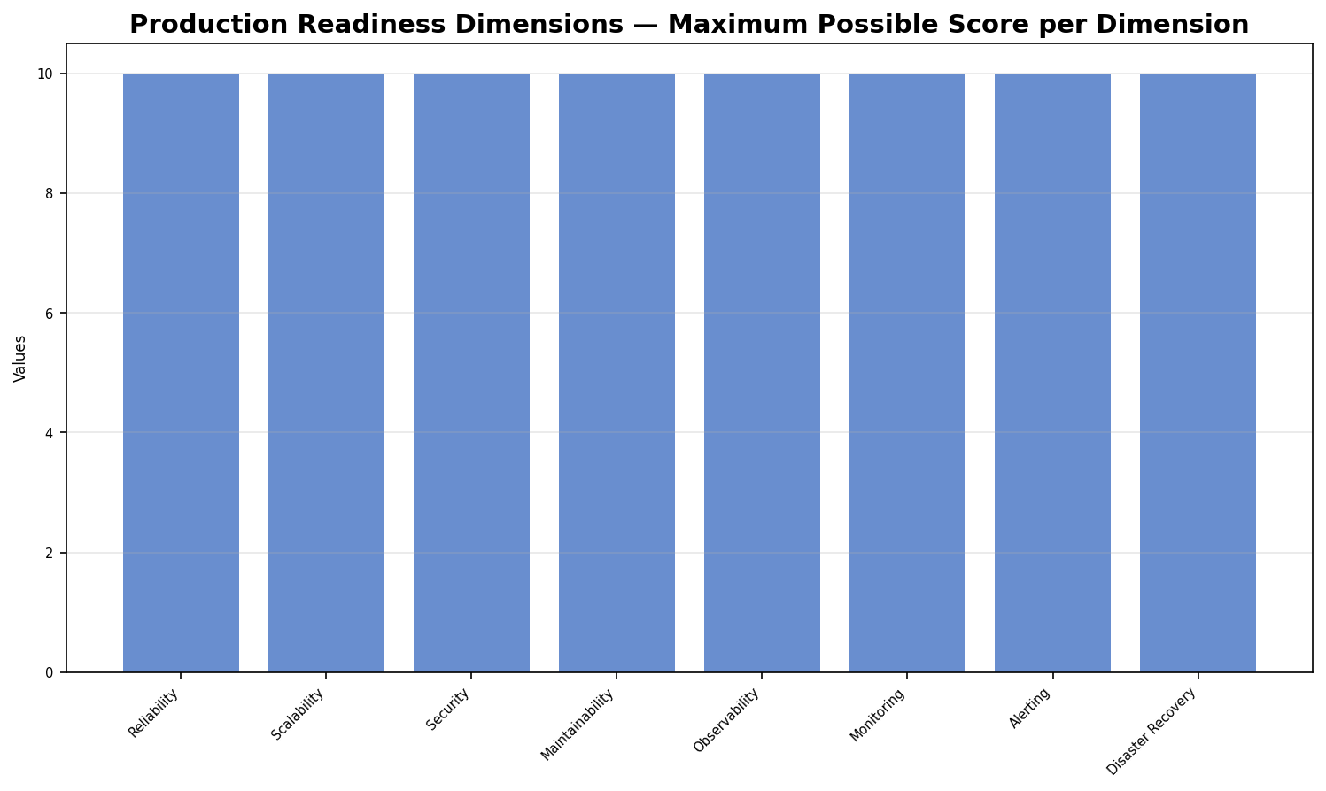

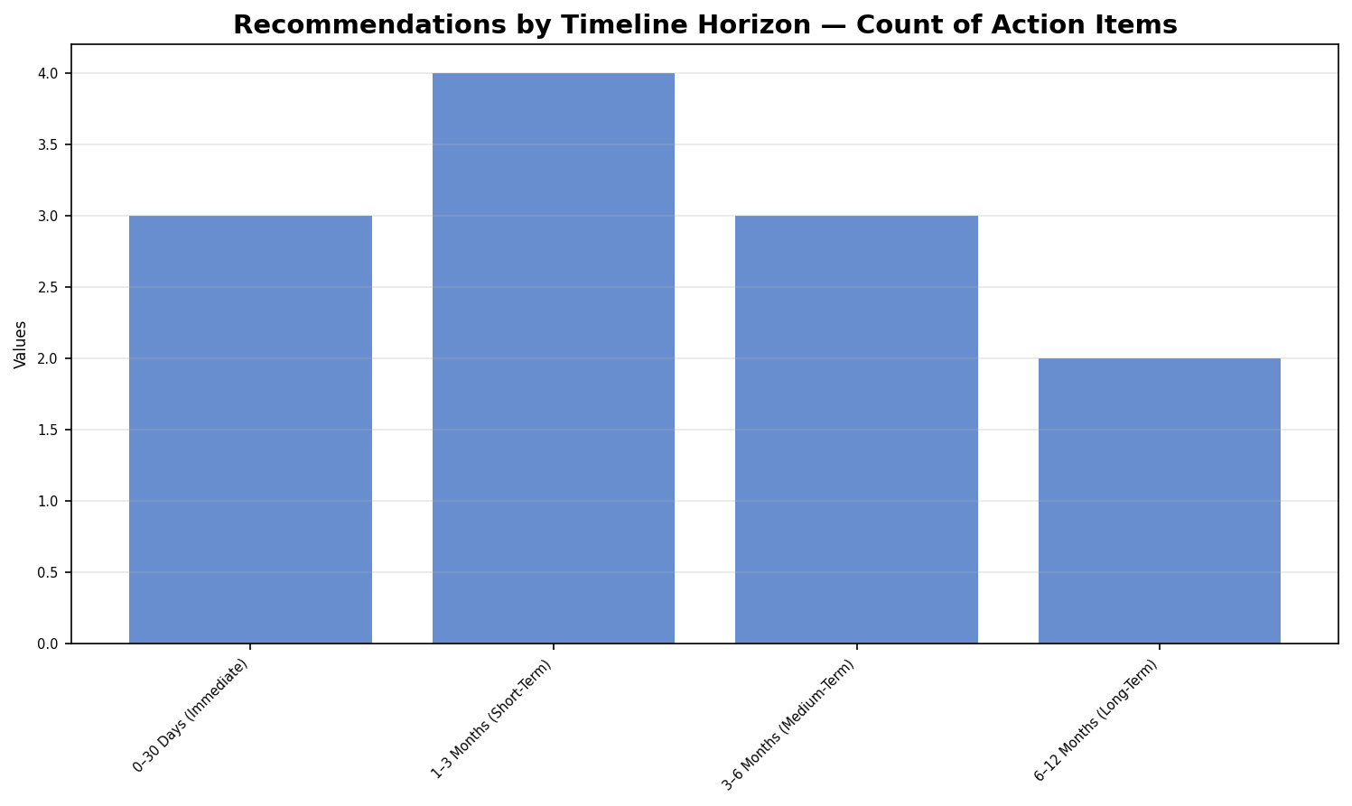

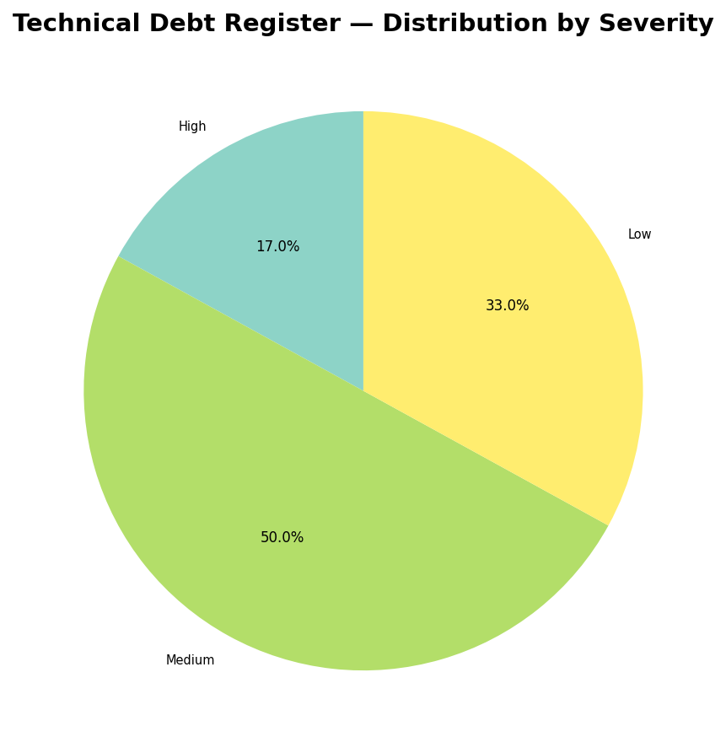

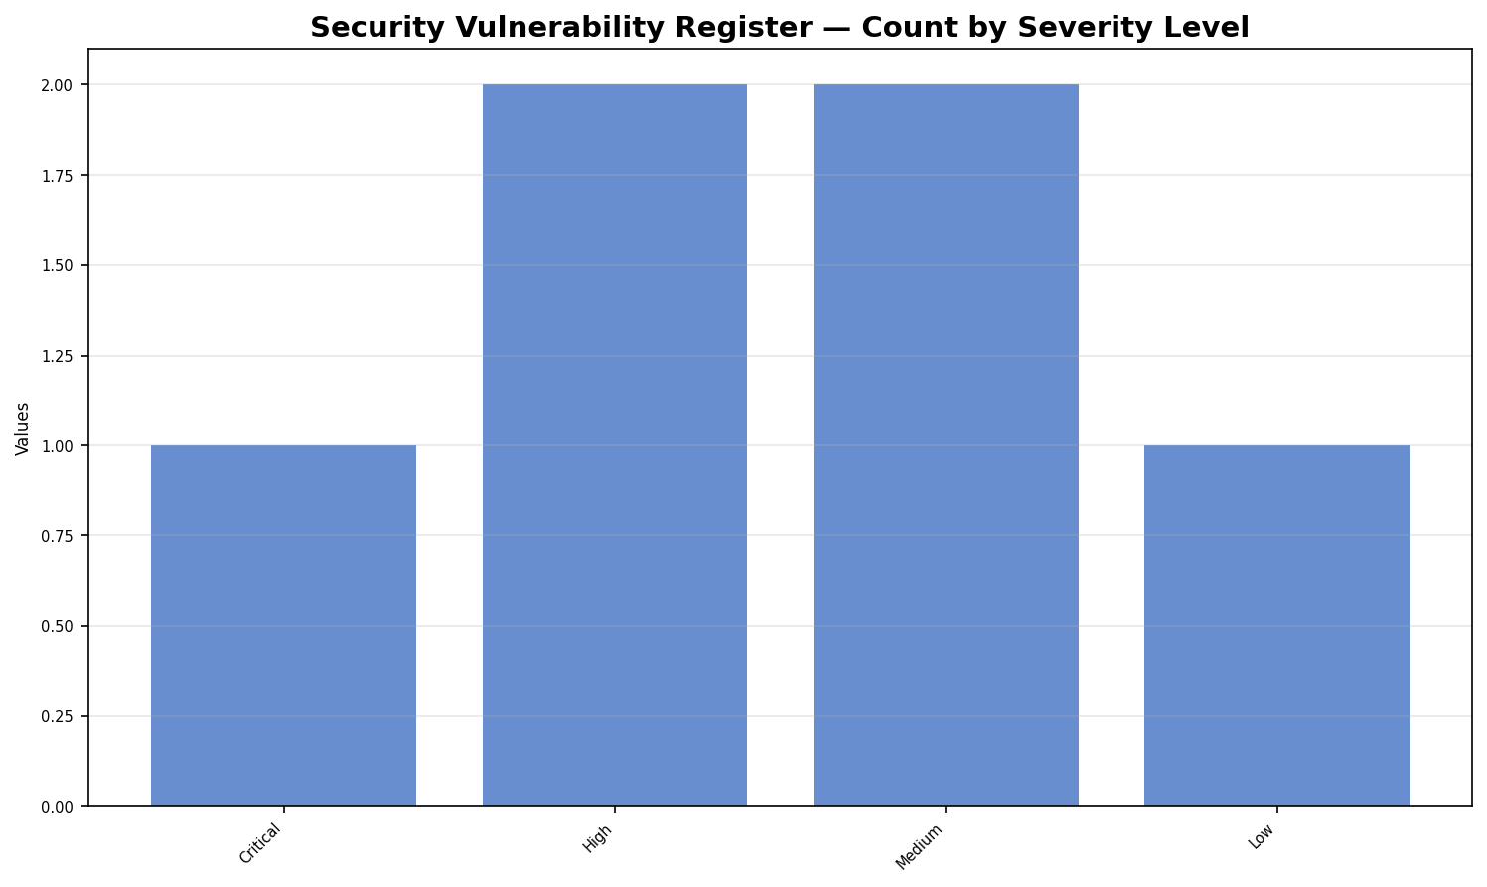

References
[1] Microsoft ASP.NET Core Documentation — https://learn.microsoft.com/en-us/aspnet/core/
Official Microsoft documentation for ASP.NET Core — referenced for controller, middleware, and DI patterns described in the prompt
[2] Entity Framework Core Documentation — https://learn.microsoft.com/en-us/ef/core/
Official Microsoft EF Core documentation — referenced for DbContext, migrations, and query patterns described in Sections 7 and 16
[3] Mermaid Diagram Syntax Reference — https://mermaid.js.org/intro/
Official Mermaid documentation — referenced for all diagram syntax templates included in Sections 3, 7, 13, and 14
[4] Serilog Structured Logging for .NET — https://serilog.net/
Official Serilog documentation — referenced for logging framework guidance in Section 12
[5] FluentValidation Documentation — https://docs.fluentvalidation.net/
Official FluentValidation documentation — referenced for validation patterns described in Sections 6 and 9
[6] Polly Resilience and Transient Fault Handling — https://github.com/App-vNext/Polly
Official Polly GitHub repository — referenced for retry and circuit breaker patterns in Sections 11 and 12
[7] Azure Key Vault Documentation — https://learn.microsoft.com/en-us/azure/key-vault/
Official Microsoft Azure Key Vault documentation — referenced for secrets management recommendations in Section 10
[8] OWASP Top Ten Security Risks — https://owasp.org/www-project-top-ten/
OWASP foundation — referenced as the basis for security vulnerability classification and severity ratings in Section 10
[9] Microsoft Azure Kubernetes Service (AKS) Documentation — https://learn.microsoft.com/en-us/azure/aks/
Official Microsoft AKS documentation — referenced for Kubernetes deployment architecture guidance in Section 15

