Express.js
Express.js tutorial provides basic and advanced concepts of Express.js. Our Express.js tutorial is designed for beginners and professionals both.
Express.js is a web framework for Node.js. It is a fast, robust and asynchronous in nature.
Our Express.js tutorial includes all topics of Express.js such as Express.js installation on windows and linux, request object, response object, get method, post method, cookie management, scaffolding, file upload, template etc.

What is Express.js
Express is a fast, assertive, essential and moderate web framework of Node.js. You can assume express as a layer built on the top of the Node.js that helps manage a server and routes. It provides a robust set of features to develop web and mobile applications.
Let's see some of the core features of Express framework:
- It can be used to design single-page, multi-page and hybrid web applications.
- It allows to setup middlewares to respond to HTTP Requests.
- It defines a routing table which is used to perform different actions based on HTTP method and URL.
- It allows to dynamically render HTML Pages based on passing arguments to templates.

Why use Express
- Ultra fast I/O
- Asynchronous and single threaded
- MVC like structure
- Robust API makes routing easy

How does Express look like
Let's see a basic Express.js app.

File: basic_express.js
var express = require('express');
var app = express();
app.get('/', function (req, res) {
res.send('Welcome to Merida Tech Minds!');
});
var server = app.listen(8000, function () {
var host = server.address().address;
var port = server.address().port;
console.log('Example app listening at ', port);
});

This is the Output for the above code :
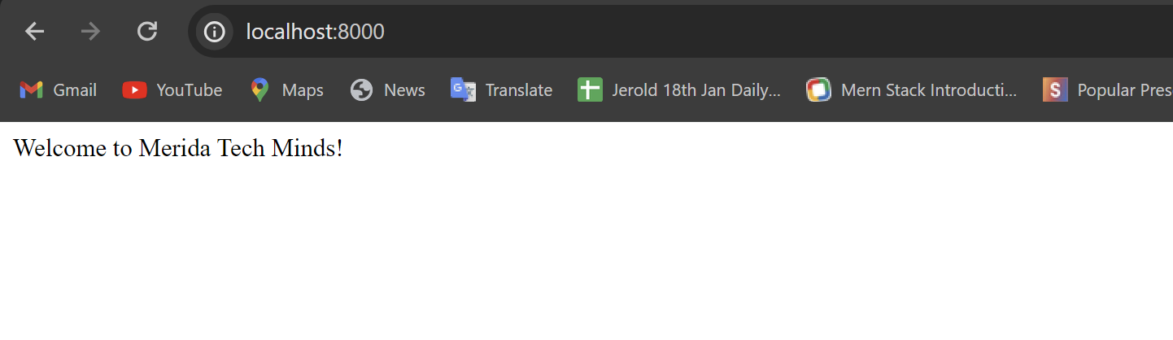

Install Express.js
Firstly, you have to install the express framework globally to create web application using Node terminal. Use the following command to install express framework globally.
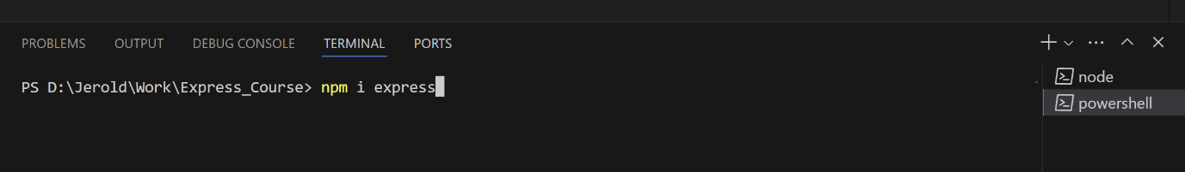
The above command install express in node_module directory and create a directory named express inside the node_module. You should install some other important modules along with express. Following is the list:
- body-parser: This is a node.js middleware for handling JSON, Raw, Text and URL encoded form data.
- cookie-parser: It is used to parse Cookie header and populate req.cookies with an object keyed by the cookie names.
- multer: This is a node.js middleware for handling multipart/form-data.

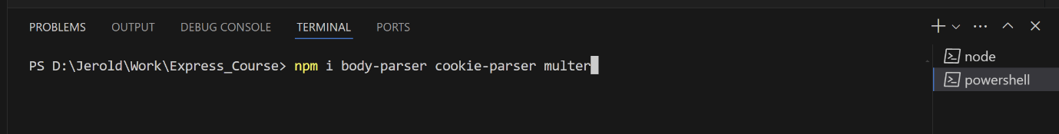

Express.js Request Object
Express.js Request and Response objects are the parameters of the callback function which is used in Express applications.
The express.js request object represents the HTTP request and has properties for the request query string, parameters, body, HTTP headers, and so on.
Syntax :
app.get('/', function (req, res) {
// This the normal syntax
});

Express.js Request Object Properties
The following table specifies some of the properties associated with request object.
Index | Properties | Description
1. | req.app | This is used to hold a reference to the instance of the express application that is using the middleware.
2. | req.baseurl | It specifies the URL path on which a router instance was mounted.
3. | req.body | It contains key-value pairs of data submitted in the request body. By default, it is undefined, and is populated when you use body-parsing middleware such as body-parser.
4. | req.cookies | When we use cookie-parser middleware, this property is an object that contains cookies sent by the request.
5. | req.fresh | It specifies that the request is "fresh." it is the opposite of req.stale.
6. | req.hostname | It contains the hostname from the "host" http header.
7. | req.ip | It specifies the remote IP address of the request.
8. | req.ips | When the trust proxy setting is true, this property contains an array of IP addresses specified in the ?x-forwarded-for? request header.
9. | req.originalurl | This property is much like req.url; however, it retains the original request URL, allowing you to rewrite req.url freely for internal routing purposes.
10. | req.params | An object containing properties mapped to the named route ?parameters?. For example, if you have the route /user/:name, then the "name" property is available as req.params.name. This object defaults to {}.
11. | req.path | It contains the path part of the request URL.
12. | req.protocol | The request protocol string, "http" or "https" when requested with TLS.
13. | req.query | An object containing a property for each query string parameter in the route.
14. | req.route | The currently-matched route, a string.
15. | req.secure | A Boolean that is true if a TLS connection is established.
16. | req.signedcookies | When using cookie-parser middleware, this property contains signed cookies sent by the request, unsigned and ready for use.
17. | req.stale | It indicates whether the request is "stale," and is the opposite of req.fresh.
18. | req.subdomains | It represents an array of subdomains in the domain name of the request.
19. | req.xhr | A Boolean value that is true if the request's "x-requested-with" header field is "xmlhttprequest", indicating that the request was issued by a client library such as jQuery

Request Object Methods
Following is a list of some generally used request object methods:

req.accepts (types)
This method is used to check whether the specified content types are acceptable, based on the request's Accept HTTP header field.
Examples:
app.get('/', function (req, res) {
if (req.accepts('html')) {
res.send('Client accepts HTML');
} else if (req.accepts('text/html')) {
res.send('Client accepts text/html');
} else {
res.send('Client does not accept HTML');
}
});

req.get(field)
This method returns the specified HTTP request header field.
app.post('/', function (req, res) {
// Retrieve the Content-Type header
const contentType = req.get('Content-Type'); // or req.get('content-type')

// Retrieve a custom header 'Something'
const somethingHeader = req.get('Something');

res.send(`
Content-Type: ${contentType || 'undefined'}<br>
Something: ${somethingHeader || 'undefined'}
`);
});

req.is(type)
This method returns true if the incoming request's "Content-Type" HTTP header field matches the MIME type specified by the type parameter.
app.post('/', function (req, res) {
// Check if Content-Type matches 'html'
const isHtml = req.is('html'); // true if Content-Type is 'text/html'

// Check if Content-Type matches 'text/html'
const isTextHtml = req.is('text/html'); // true if Content-Type is exactly 'text/html'

// Check if Content-Type matches 'text/*'
const isTextWildcard = req.is('text/*'); // true if Content-Type is 'text/*'

res.send(`
req.is('html'): ${isHtml}<br>
req.is('text/html'): ${isTextHtml}<br>
req.is('text/*'): ${isTextWildcard}
`);
});

req.param(name [, defaultValue])
This method is used to fetch the value of param name when present.
app.get('/user/:name', function (req, res) {
const name = req.param('name'); // from route
res.send(`Route param name: ${name}`);
});

Express.js Response Object
The Response object (res) specifies the HTTP response which is sent by an Express app when it gets an HTTP request.
- It sends response back to the client browser.
- It facilitates you to put new cookies value and that will write to the client browser (under cross domain rule).
- Once you res.send() or res.redirect() or res.render(), you cannot do it again, otherwise, there will be uncaught error.

Response Object Properties
Let's see some properties of response object.
Index | Properties | Description
1. | res.app | It holds a reference to the instance of the express application that is using the middleware.
2. | res.headersSent | It is a Boolean property that indicates if the app sent HTTP headers for the response.
3. | res.locals | It specifies an object that contains response local variables scoped to the request

Response Object Methods
Following are some methods:

Response Append method
Syntax:
res.append(field [, value])
Example :
app.get('/', function (req, res) {
// Append a single value to the 'Set-Cookie' header
res.append('Set-Cookie', 'name=sasha');

// Append another value to the 'Set-Cookie' header
res.append('Set-Cookie', 'language=javascript');

// Append multiple values to the 'Link' header
res.append('Link', ['<http://localhost>; rel="home"', '<http://localhost/about>; rel="about"']);

res.send('Headers have been appended!');
});

This method appends the specified value to the HTTP response header field. That means if the specified value is not appropriate then this method redress that.

Response Attachment method
Syntax:
res.attachment([filename])

Example :
app.get('/', function (req, res) {
// Set the Content-Disposition header to attachment with filename 'example.txt'
res.attachment('example.txt');

// Send a response with content
res.send('This is an example file for download.');
});

Response Cookie method
Syntax:
res.cookie(name, value [, options])

This method is used to set a cookie name to value. The value can be a string or object converted to JSON.
Examples:
app.get('/', function (req, res) {
// Set a cookie named 'name' with value 'Aryan', restricted to the '.xyz.com' domain, accessible only at '/admin', and transmitted over HTTPS
res.cookie('name', 'Aryan', { domain: '.xyz.com', path: '/admin', secure: true });

// Set a cookie named 'Section' with an object value, containing an array
res.cookie('Section', { Names: ['Aryan', 'Sushil', 'Priyanka'] });

// Set a cookie named 'Cart' with an object value, containing an array, with a maximum age of 15 minutes (900000 milliseconds)
res.cookie('Cart', { items: [1, 2, 3] }, { maxAge: 900000 });

res.send('Cookies have been set!');
});

Response ClearCookie method
Syntax:
res.clearCookie(name [, options])
As the name specifies, the clearCookie method is used to clear the cookie specified by name.
Examples:
To set a cookie
res.cookie('name', 'Aryan', { path: '/admin' });

To clear a cookie:
res.clearCookie('name', { path: '/admin' });

Response Download method
Syntax:
res.download(path [, filename] [, fn])

Example :
app.get('/', function (req, res) {
// Send the file 'report-12345.pdf' as an attachment
res.download('/report-12345.pdf', 'report.pdf', function(err){
if (err) {
// Handle error, for example:
console.error('Error downloading file:', err);
res.status(500).send('Internal Server Error');
} else {
console.log('File sent successfully');
}
});
});

Response End method
Syntax:
res.end([data] [, encoding])
This method is used to end the response process.
Example :
app.get('/', function (req, res) {
// End the response without any data
res.end();
});

Response Format method
Syntax:
res.format(object)
This method performs content negotiation on the Accept HTTP header on the request object, when present.
Example :
app.get('/greet', (req, res) => {
res.format({
'text/plain': function() {
res.send('hey');
},
'text/html': function() {
res.send('<p>hey</p>');
},
'application/json': function() {
res.send({ message: 'hey' });
},
'default': function() {
// log the request and respond with 406
console.log('Not Acceptable - No matching content type');
res.status(406).send('Not Acceptable');
}
});
});

Response JSON method:
Syntax:
res.json([body])
This method returns the response in JSON format.
Example :
res.json(null)
res.json({ name: 'ajeet' })

Response Links method
Syntax:
res.links(links)
This method populates the response?s Link HTTP header field by joining the links provided as properties of the parameter.
Example :
app.get('/users', (req, res) => {
// Simulate fetching user data from a database or other source
const users = [
{ id: 1, name: 'Alice' },
{ id: 2, name: 'Bob' },
{ id: 3, name: 'Charlie' }
// ... more user data
];

// Set pagination links
res.links({
next: 'http://api.rnd.com/users?page=5',
last: 'http://api.rnd.com/users?page=10'
});

// Respond with the user data
res.json(users);
});

Response Location method
Syntax:
res.location(path)
This method is used to set the response location HTTP header field based on the specified path parameter.
Examples:
app.post('/items', (req, res) => {
// Simulate creating a new resource
const newItem = { id: 1, name: req.body.name };

// Set the location header to the URL of the new resource
res.location(`http://xyz.com/items/${newItem.id}`);

// Respond with 201 Created and the new item
res.status(201).json(newItem);
});

Response Redirect method
Syntax:
res.redirect([status,] path)
This method redirects to the URL derived from the specified path, with specified HTTP status. The res.redirect() method in Express.js is used to redirect the client to a different URL. It sets the Location HTTP header and sends a 302 Found status by default, although you can specify a different status code if needed.
Examples:
app.get('/old-path', (req, res) => {
// Redirect the client to a new URL
res.redirect('http://example.com');
});

Response Render method

Syntax:
res.render(view [, locals] [, callback])
Example :
The res.render() method in Express.js is used to render a view template and send the HTML response to the client. This method integrates with view engines like EJS, Pug, Handlebars, etc., to dynamically generate HTML based on template files.
Here’s how you can use res.render() in different scenarios, including passing local variables to the view and handling rendering errors.
// Define a route to render the index view
app.get('/', (req, res) => {
res.render('index'); // Renders the index.ejs template
});

Response Send method
Syntax:
res.send([body])
The res.send() method in Express.js is versatile and can be used to send different types of responses to the client, such as strings, buffers, JSON objects, or even HTML.
app.get('/html', (req, res) => {
res.send({ some: 'json' });
res.send(Buffer.from('whoop'));
res.send(`
<!DOCTYPE html>
<html>
<head>
<title>Some HTML</title>
</head>
<body>
<h1>Some HTML content</h1>
<p>.....some html content</p>
</body>
</html>
`); // Sending an HTML response
});

Express.js GET Request
GET and POST both are two common HTTP requests used for building REST API's. GET requests are used to send only limited amount of data because data is sent into header while POST requests are used to send large amount of data because data is sent in the body.
Express.js facilitates you to handle GET and POST requests using the instance of express.

Express.js GET Method Example 1
Fetch data in JSON format:
Get method facilitates you to send only limited amount of data because data is sent in the header. It is not secure because data is visible in URL bar.
Let's take an example to demonstrate GET method.
File: index.html
app.get('/index.html', function (req, res) {
res.sendFile( __dirname + "/" + "index.html" );
})

Express.js POST Request
GET and POST both are two common HTTP requests used for building REST API's. POST requests are used to send large amount of data.
Express.js facilitates you to handle GET and POST requests using the instance of express.

Express.js POST Method
Post method facilitates you to send large amount of data because data is send in the body. Post method is secure because data is not visible in URL bar but it is not used as popularly as GET method. On the other hand GET method is more efficient and used more than POST.

Let's take an example to demonstrate POST method.

app.post('/process_post', urlencodedParser, function (req, res) {
// Prepare output in JSON format
response = {
first_name:req.body.first_name,
last_name:req.body.last_name
};
console.log(response);
res.end(JSON.stringify(response));
})

Express.js Routing
Routing is made from the word route. It is used to determine the specific behavior of an application. It specifies how an application responds to a client request to a particular route, URI or path and a specific HTTP request method (GET, POST, etc.). It can handle different types of HTTP requests.
Let's take an example to see basic routing.
var express = require('express');
var app = express();
app.get('/', function (req, res) {
console.log("Got a GET request for the homepage");
res.send('Welcome to JavaTpoint!');
})
app.post('/', function (req, res) {
console.log("Got a POST request for the homepage");
res.send('I am Impossible! ');
})
app.delete('/del_student', function (req, res) {
console.log("Got a DELETE request for /del_student");
res.send('I am Deleted!');
})
app.get('/enrolled_student', function (req, res) {
console.log("Got a GET request for /enrolled_student");
res.send('I am an enrolled student.');
})
// This responds a GET request for abcd, abxcd, ab123cd, and so on
app.get('/ab*cd', function(req, res) {
console.log("Got a GET request for /ab*cd");
res.send('Pattern Matched.');
})

Express.js Cookies Management

What are cookies
Cookies are small piece of information i.e. sent from a website and stored in user's web browser when user browses that website. Every time the user loads that website back, the browser sends that stored data back to website or server, to recognize user.

Install cookie
You have to acquire cookie abilities in Express.js. So, install cookie-parser middleware through npm by using the following command:

Import cookie-parser into your app.

var express = require('express');
var cookieParser = require('cookie-parser');
var app = express();
app.use(cookieParser());

Define a route:
Cookie-parser parses Cookie header and populate req.cookies with an object keyed by the cookie names.
Let's define a new route in your express app like set a new cookie:
app.get('/cookie',function(req, res){
res.cookie('cookie_name' , 'cookie_value').send('Cookie is set');
});
app.get('/', function(req, res) {
console.log("Cookies : ", req.cookies);
});

Express.js Cookies Example
File: cookies_example.js
var express = require('express');
var cookieParser = require('cookie-parser');
var app = express();
app.use(cookieParser());
app.get('/cookieset',function(req, res){
res.cookie('cookie_name', 'cookie_value');
res.cookie('company', MeridaTech);
res.cookie('name', 'sonoo');

res.status(200).send('Cookie is set');
});
app.get('/cookieget', function(req, res) {
res.status(200).send(req.cookies);
});
app.get('/', function (req, res) {
res.status(200).send('Welcome to Merida!');
});
var server = app.listen(8000, function () {
var host = server.address().address;
var port = server.address().port;
console.log('Example app listening at http://%s:%s', host, port);
});

Output :
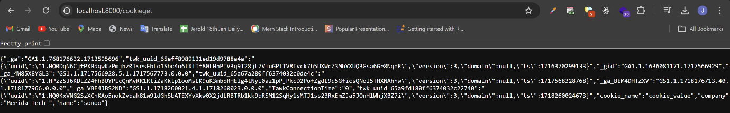

Express.js Middleware
Express.js Middleware are different types of functions that are invoked by the Express.js routing layer before the final request handler. As the name specified, Middleware appears in the middle between an initial request and final intended route. In stack, middleware functions are always invoked in the order in which they are added.
Middleware is commonly used to perform tasks like body parsing for URL-encoded or JSON requests, cookie parsing for basic cookie handling, or even building JavaScript modules on the fly.

What is a Middleware function
Middleware functions are the functions that access to the request and response object (req, res) in request-response cycle.

A middleware function can perform the following tasks:
- It can execute any code.
- It can make changes to the request and the response objects.
- It can end the request-response cycle.
- It can call the next middleware function in the stack.

Express.js Middleware
Following is a list of possibly used middleware in Express.js app:
- Application-level middleware
- Router-level middleware
- Error-handling middleware
- Built-in middleware
- Third-party middleware
Let's take an example to understand what middleware is and how it works.
Let's take the most basic Express.js app:

Use of Express.js Middleware
If you want to record every time you a get a request then you can use a middleware.
See this example:
File: simple_middleware.js
app.use(function(req, res, next) {
console.log('%s %s', req.method, req.url);
next();
});
This is the normal middleware which will take the request’s method and the url. It will trigger every time the application get a Requests.
Example : If u open the Application at localhost:8000/

Then making one more request for the different page : localhost:8000/cookieget
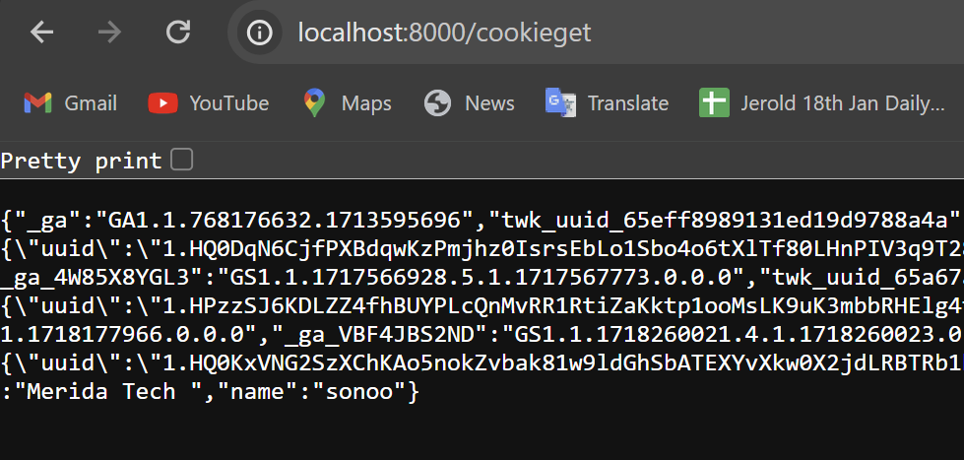
This is how it will work , here u can check the request which are made in the server. Middleware can be used for the various purpose also.
