Phase 4: Development Part 2

Smart Parking System using IOT

**Connecting ESP32 with firebase:**

* The esp32 was connected to firebase using urequests module which is a built-in module in wokwi micropython.
* The necessary requirements to connect the firebase database are the firebase url and the security key**.**
* Whenever the ultrasonic sensor detects an object it sends signal to the ESP32, it sends data to be updated in the to the firebase.

**Connecting app to firebase:**

* The app to display the slots available is created using MIT app inventor.
* The app gets the data in the firebase using the firebase link and checks if the slots is occupied then the color of the slot changes red and if the slot is available then it changes to green.
* The admin can login in and can handle the slots.

**Structure of the realtime database:**

{

  "ibmnm": [

    null,

    "Occupied",

    "Available",

    "Available"

  ]

}

**Wokwi link:**

<https://wokwi.com/projects/379932606462682113>

In this you can refer to the code and I have also posted the code in my GitHub also.

**Screenshots:**

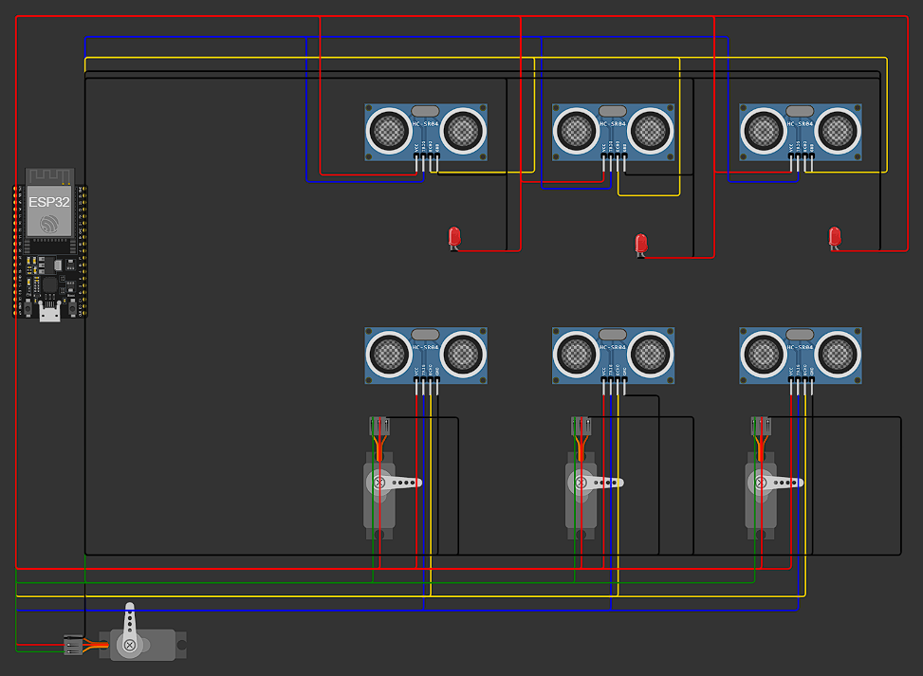

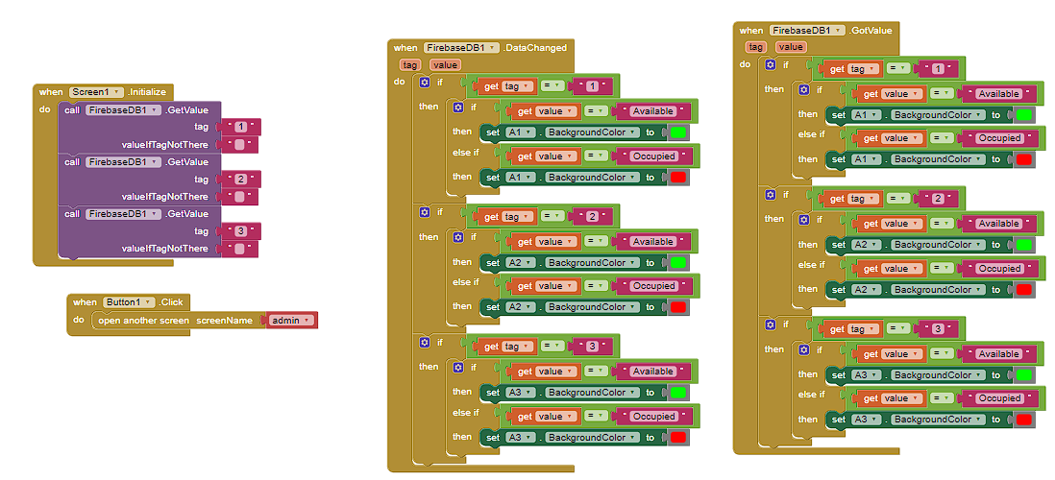

I have also attached:

* Esp32 required codes
* Export from MIT app inventor.