The two most discussed scaling methods are Normalization and Standardization. **Normalization**typically means rescales the values into a range of [0,1]. **Standardization**typically means rescales data to have a mean of 0 and a standard deviation of 1 (unit variance).

Normalization is a technique often applied as part of data preparation for machine learning. The goal of normalization is to change the values of numeric columns in the dataset to a common scale, without distorting differences in the ranges of values. For machine learning, every dataset does not require normalization. It is required only when features have different ranges.

For example, consider a data set containing two features, age(x1), and income(x2). Where age ranges from 0–100, while income ranges from 0–20,000 and higher. Income is about 1,000 times larger than age and ranges from 20,000–500,000. So, these two features are in very different ranges. When we do further analysis, like multivariate linear regression, for example, the attributed income will intrinsically influence the result more due to its larger value. But this doesn’t necessarily mean it is more important as a predictor.

Min_max

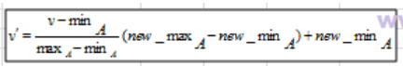

Z_score: / standard scalar

