**Principal Component Analysis(PCA)**

As the number of features or dimensions in a dataset increases, the amount of data required to obtain a statistically significant result increases exponentially. This can lead to issues such as overfitting, increased computation time, and reduced accuracy of machine learning models this is known as the curse of dimensionality problems that arise while working with high-dimensional data.

As the number of dimensions increases, the number of possible combinations of features increases exponentially, which makes it computationally difficult to obtain a representative sample of the data. It becomes expensive to perform tasks such as clustering or classification because the algorithms need to process a much larger feature space, which increases computation time and complexity. Additionally, some [machine learning](https://www.geeksforgeeks.org/machine-learning/) algorithms can be sensitive to the number of dimensions, requiring more data to achieve the same level of accuracy as lower-dimensional data.

To address the [curse of dimensionality](https://www.geeksforgeeks.org/videos/curse-of-dimensionality-in-machine-learning/), [Feature engineering](https://www.geeksforgeeks.org/what-is-feature-engineering/)techniques are used which include feature selection and feature extraction. [Dimensionality reduction](https://www.geeksforgeeks.org/dimensionality-reduction/) is a type of feature extraction technique that aims to reduce the number of input features while retaining as much of the original information as possible.

## What is Principal Component Analysis(PCA)?

[Principal Component Analysis](https://www.geeksforgeeks.org/principal-component-analysis-with-python/)(PCA) technique was introduced by the mathematician **Karl Pearson** in 1901**.** It works on the condition that while the data in a higher dimensional space is mapped to data in a lower dimension space, the variance of the data in the lower dimensional space should be maximum.

* **Principal Component Analysis (PCA)**is a statistical procedure that uses an orthogonal transformation that converts a set of correlated variables to a set of uncorrelated variables.PCA is the most widely used tool in exploratory data analysis and in machine learning for predictive models. Moreover,
* Principal Component Analysis (PCA) is an [unsupervised learning](https://www.geeksforgeeks.org/supervised-unsupervised-learning/) algorithm technique used to examine the interrelations among a set of variables. It is also known as a general factor analysis where regression determines a line of best fit.
* The main goal of Principal Component Analysis (PCA) is to reduce the dimensionality of a dataset while preserving the most important patterns or relationships between the variables without any prior knowledge of the target variables.

Principal Component Analysis (PCA) is used to reduce the dimensionality of a data set by finding a new set of variables, smaller than the original set of variables, retaining most of the sample’s information, and useful for the [regression and classification](https://www.geeksforgeeks.org/regression-classification-supervised-machine-learning/) of data.

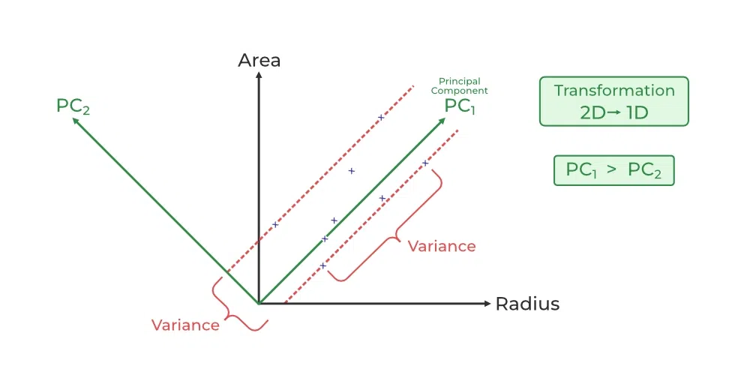

1. Principal Component Analysis (PCA) is a technique for dimensionality reduction that identifies a set of orthogonal axes, called principal components, that capture the maximum variance in the data. The principal components are linear combinations of the original variables in the dataset and are ordered in decreasing order of importance. The total variance captured by all the principal components is equal to the total variance in the original dataset.
2. The first principal component captures the most variation in the data, but the second principal component captures the maximum [variance](https://www.geeksforgeeks.org/python-statistics-variance/) that is [orthogonal](https://www.geeksforgeeks.org/orthogonal-and-orthonormal-vectors-in-linear-algebra/) to the first principal component, and so on.
3. Principal Component Analysis can be used for a variety of purposes, including data visualization, feature selection, and data compression. In data visualization, PCA can be used to plot high-dimensional data in two or three dimensions, making it easier to interpret. In feature selection, PCA can be used to identify the most important variables in a dataset. In data compression, PCA can be used to reduce the size of a dataset without losing important information.
4. In Principal Component Analysis, it is assumed that the information is carried in the variance of the features, that is, the higher the variation in a feature, the more information that features carries.

Overall, PCA is a powerful tool for data analysis and can help to simplify complex datasets, making them easier to understand and work with.



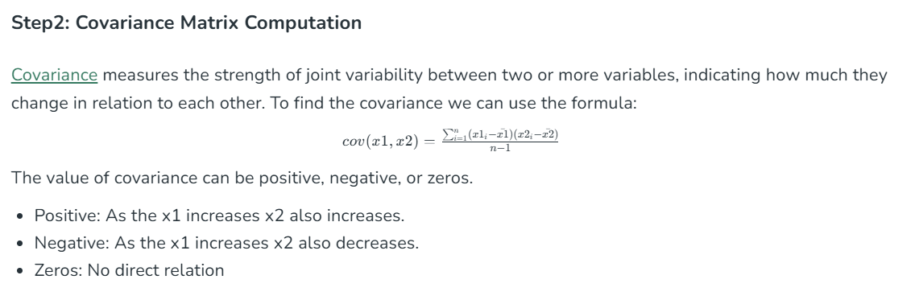

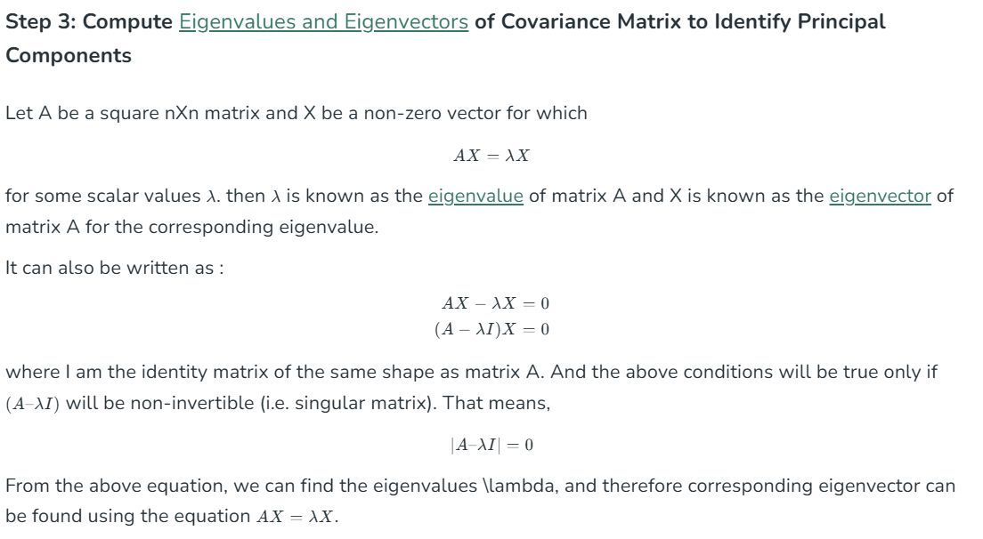

## How Principal Component Analysis(PCA) works?

Hence, PCA employs a linear transformation that is based on preserving the most variance in the data using the least number of dimensions. It involves the following steps:

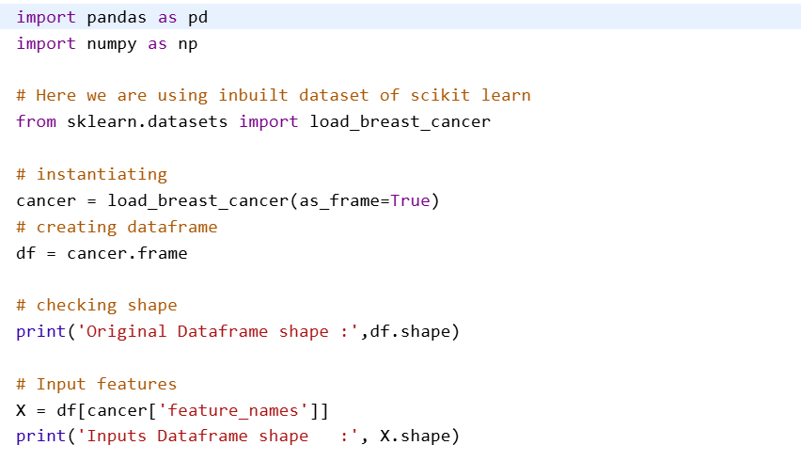

**Output**:

Original Dataframe shape : (569, 31)  
Inputs Dataframe shape : (569, 30)

