**Description of a Crop Recommendation System with Soil Data**

A **crop recommendation system** helps farmers select the best crops to grow based on the specific properties of their soil. This system uses soil characteristics and environmental factors to determine the crops that are most likely to thrive. Recommendations are provided to improve crop yield, optimize resource use, and ensure sustainable farming practices.

**Core Components for Recommendations**

The system should consider the following **soil parameters** and **external factors** to make accurate recommendations:

1. **Soil Nutrients:**
   * **Nitrogen (N):** Promotes leafy growth; ideal for crops like spinach, lettuce, and wheat.
   * **Phosphorus (P):** Essential for root development; crucial for legumes, peas, and root vegetables like carrots.
   * **Potassium (K):** Enhances disease resistance and fruit quality; important for fruiting plants like tomatoes, bananas, and potatoes.
2. **Soil pH:**
   * Indicates soil acidity or alkalinity.
   * Neutral pH (6.5-7.5) supports most crops like rice, wheat, and maize.
   * Acidic soil (<6.5) favors crops like tea and coffee.
   * Alkaline soil (>7.5) supports crops like barley and asparagus.
3. **Organic Matter:**
   * High organic content improves water retention and nutrient availability.
   * Crops like vegetables and fruits benefit from rich organic matter.
4. **Moisture Level:**
   * Determines irrigation needs and crop suitability.
   * High moisture crops: Paddy, sugarcane.
   * Low moisture crops: Millet, sunflower.
5. **Temperature:**
   * Warm crops: Maize, rice, and cotton.
   * Cool crops: Wheat, barley, and cabbage.
6. **Rainfall:**
   * Rain-fed crops (e.g., rice) thrive in high rainfall areas.
   * Drought-resistant crops (e.g., millets) perform well in low-rainfall zones.
7. **Geographical Factors:**
   * Altitude, latitude, and local climate conditions.
   * Example: Coffee grows well in high altitudes, while coconut thrives in coastal regions.

**How to Update Recommendations**

1. **Dynamic Soil Profiles:**
   * Use **real-time soil testing** data to determine nutrient levels, pH, and moisture.
   * Example: If the nitrogen level is low, recommend nitrogen-fixing crops like legumes.
2. **Crop Rotation Insights:**
   * Suggest crop rotations to maintain soil health.
   * Example: After a nitrogen-depleting crop like wheat, recommend a nitrogen-fixing crop like lentils.
3. **Fertilizer Suggestions:**
   * Provide recommendations for fertilizers based on deficiencies.
   * Example: If phosphorus is low, suggest adding rock phosphate.
4. **Weather and Climate Integration:**
   * Include real-time weather data like rainfall forecasts and temperature trends.
   * Example: Recommend drought-tolerant crops during dry seasons.
5. **Regional Crop Suitability:**
   * Use regional data to match crops with local soil and climate.
   * Example: Recommend paddy in water-rich regions like Punjab, and millet in arid regions like Rajasthan.

**Sample Output for Crop Recommendations**

Based on soil and environmental data:

* **Soil Parameters:**
  + pH: 6.8 (neutral)
  + Nitrogen: Medium
  + Phosphorus: Low
  + Potassium: High
  + Moisture: Moderate
* **Recommendations:**
  + **Primary Crops:** Wheat, Maize, Barley.
  + **Secondary Crops (Improving Soil Health):** Lentils, Chickpeas (for nitrogen fixation).
  + **Fertilizer Recommendation:** Use phosphorus-rich fertilizers (e.g., DAP).

**How to Present Recommendations**

* Use a **dashboard or mobile app** for farmers.
* Show clear visualizations of soil test results and matched crops.
* Include:
  + Top recommended crops.
  + Fertilizer and irrigation tips.  
    -``

**Problem Setup**

We are given environmental factors, such as moisture content, temperature, humidity, precipitation, etc. The goal of the agent is to decide whether the soil will be **Wet** or **Dry** based on these factors. The agent will learn from its environment by taking actions and receiving rewards based on its predictions (Wet or Dry).

**Q-learning in a Soil Wet/Dry Environment**

Let's assume that the state of the soil is determined by the following environmental factors:

* **Moisture Content** (percentage)
* **Temperature** (in °C)
* **Humidity** (percentage)
* **Precipitation** (mm)
* **Soil pH**
* **Soil Texture** (categorical: Loam, Sandy, Clay)

The agent's actions can be:

1. **Action 1**: Predict "Wet"
2. **Action 2**: Predict "Dry"

The reward is given based on the correctness of the prediction:

* If the prediction is correct (i.e., the soil is actually Wet when the agent predicts Wet, or Dry when it predicts Dry), the agent gets a positive reward.
* If the prediction is incorrect, the agent gets a negative reward.

**Step-by-Step Explanation of Q-learning for this Problem**

We can implement **Q-learning** using the following steps:

**1. Define the State Space**

In this problem, the **state space** is defined by the environmental factors like moisture, temperature, humidity, etc. We assume that the state is a vector of these features.

For example:

state = [Moisture Content, Temperature, Humidity, Precipitation, Soil pH, Soil Texture]

This state vector will be used to decide which action (prediction) the agent should take.

**2. Define the Action Space**

The **action space** consists of two actions:

1. **Action 1**: Predict "Wet"
2. **Action 2**: Predict "Dry"

The agent needs to learn which action to take based on the current state.

**3. Initialize the Q-table**

The Q-table will have dimensions for all possible states and actions. Since the state is a vector of environmental features, we will have a separate Q-value for each combination of state-action pair. The Q-table stores the expected future rewards for each state-action combination.

Q = np.zeros((num_states, num_actions)) # num_states depends on the number of distinct state combinations

Initially, the Q-values are set to zero, indicating that the agent does not know anything about the environment.

**4. Define the Learning Parameters**

We'll define the following parameters:

* **Learning rate** (α\alphaα): How much new information overrides the old information. (e.g., 0.1)
* **Discount factor** (γ\gammaγ): How much future rewards are considered when updating the Q-value. (e.g., 0.9)
* **Exploration rate** (ϵ\epsilonϵ): The probability that the agent will explore (take a random action) rather than exploit (take the best-known action). Starts high to encourage exploration and decays over time. (e.g., 1.0)
* **Episodes**: The number of iterations the agent will go through to learn from the environment.

**5. Implement the Q-learning Algorithm**

Now, let's break down the Q-learning loop:

1. **Initialize the environment** (i.e., the dataset of states and correct actions).
2. **For each episode**:
   * Start in a random state (random environmental features).
   * Choose an action using the **epsilon-greedy** policy: either explore or exploit based on ϵ\epsilonϵ.
   * Take the action, observe the reward (whether the prediction was correct or incorrect), and move to the next state.
   * Update the Q-value for the state-action pair using the **Bellman equation**.
   * Update ϵ\epsilonϵ (decay it to reduce exploration over time).

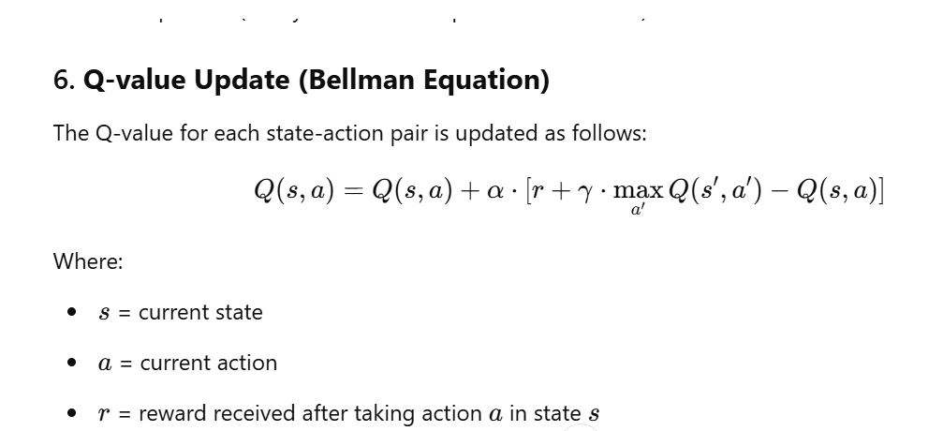

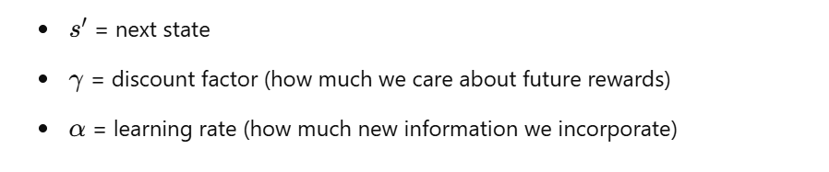

**Step-by-Step Code Implementation**

Let's break this down into code, assuming the agent learns whether the soil is **Wet** or **Dry** based on environmental data:

import numpy as np

import random

# Environmental data example (you can expand with more data)

data = {

'Moisture Content': [12, 5, 18, 2, 22],

'Temperature': [25, 30, 22, 35, 20],

'Humidity': [60, 50, 65, 45, 70],

'Soil pH': [6.5, 7.0, 6.8, 6.0, 6.5],

'Precipitation': [5, 0, 2, 0, 10],

'Soil Texture': ['Loam', 'Sandy', 'Clay', 'Sandy', 'Loam'],

'Label': ['Wet', 'Dry', 'Wet', 'Dry', 'Wet']

}

# Encode categorical features

soil_texture_mapping = {'Loam': 0, 'Sandy': 1, 'Clay': 2}

data['Soil Texture'] = [soil_texture_mapping[t] for t in data['Soil Texture']]

data['Label'] = [1 if label == 'Wet' else 0 for label in data['Label']]

# Convert the data into a numpy array for easier handling

states = np.array([[

data['Moisture Content'][i],

data['Temperature'][i],

data['Humidity'][i],

data['Soil pH'][i],

data['Precipitation'][i],

data['Soil Texture'][i]

] for i in range(len(data['Label']))])

# Initialize Q-table

num_states = len(states)

num_actions = 2 # 0 = Dry, 1 = Wet

Q = np.zeros((num_states, num_actions))

# Learning parameters

alpha = 0.1 # Learning rate

gamma = 0.9 # Discount factor

epsilon = 1.0 # Exploration rate

epsilon_min = 0.1 # Minimum exploration rate

epsilon_decay = 0.995 # Epsilon decay rate

episodes = 1000 # Number of training episodes

# Reward function: positive for correct prediction, negative for wrong prediction

def get_reward(prediction, actual):

if prediction == actual:

return 10 # Positive reward for correct prediction

else:

return -10 # Negative reward for incorrect prediction

# Training loop

for episode in range(episodes):

total_reward = 0

for i in range(num_states):

# Choose action using epsilon-greedy policy

if random.uniform(0, 1) < epsilon:

action = random.choice(range(num_actions)) # Explore

else:

action = np.argmax(Q[i]) # Exploit the best-known action

# Get reward based on prediction

reward = get_reward(action, data['Label'][i])

# Update Q-table using Bellman equation

next_state = i # In this case, we stay in the same state

max_future_q = np.max(Q[next_state]) # Max Q-value of the next state

Q[i, action] = Q[i, action] + alpha * (reward + gamma * max_future_q - Q[i, action])

total_reward += reward

# Decay epsilon for exploration vs. exploitation trade-off

if epsilon > epsilon_min:

epsilon *= epsilon_decay

# Optionally print the total reward for each episode to monitor training

if (episode + 1) % 100 == 0:

print(f"Episode {episode + 1}/{episodes}, Total Reward: {total_reward}, Epsilon: {epsilon:.2f}")

# Testing the trained Q-values

print("\nTesting learned Q-values:")

for i in range(num_states):

predicted_action = np.argmax(Q[i]) # Predict Wet (1) or Dry (0)

print(f"State {i} - Predicted action: {'Wet' if predicted_action == 1 else 'Dry'}, Actual label: {'Wet' if data['Label'][i] == 1 else 'Dry'}")

**Explanation:**

1. **Data Preprocessing**:
   * We map categorical features like **Soil Texture** to numeric values and map the **Label** (Wet or Dry) to binary values (1 for Wet, 0 for Dry).
   * The state space is constructed from environmental features, including **Moisture Content**, **Temperature**, **Humidity**, **Soil pH**, **Precipitation**, and **Soil Texture**.
2. **Q-table**:
   * We initialize a Q-table of size (num_states, num_actions) where num_states is the number of data points, and num_actions is 2 (Wet or Dry).
3. **Reward**:
   * The reward function gives a positive reward (10) if the action (prediction) is correct, and a negative reward (-10) if the prediction is incorrect.
4. **Q-learning Loop**:
   * The agent chooses an action based on an **epsilon-greedy** policy (balance between exploration and exploitation).
   * The Q-values are updated based on the **Bellman equation**.
   * **Epsilon** decays after each episode to reduce exploration over time.
5. **Testing**:
   * After training, we test the learned Q-values to see how well the agent predicts whether the soil is Wet or Dry for each state.

**Key Points:**

* **Exploration vs Exploitation**: The agent explores more at the beginning (high epsilon) and exploits learned values as it gets better.
* **Q-table Update**: The Q-table is updated using the Bellman equation based on the reward the agent receives.
* **Reward System**: The agent is rewarded for correct predictions (Wet or Dry), which helps it learn optimal actions.