Introduction

ABSTRACT:
Heart related diseases or Cardiovascular Diseases (CVDs) are the main reason for a huge number of death in the world over the last few decades and has emerged as the most life-threatening disease, not only in India but in the whole world. So, there is a need of reliable, accurate and feasible system to diagnose such diseases in time for proper treatment. Machine Learning algorithms and techniques have been applied to various medical datasets to automate the analysis of large and complex data. Many researchers, in recent times, have been using several machine learning techniques to help the health care industry and the professionals in the diagnosis of heart related diseases. This paper presents a survey of various models based on such algorithms and techniques and analyze their performance. K-Nearest Neighbour (KNN), Logistic models are found very popular among the researchers.

  - Background and Basics

Heart disease is considered as one of the major causes of death throughout the world. It cannot be easily predicted by the medical practitioners as it is a difficult task which demands expertise and higher knowledge for prediction. An automated system in medical diagnosis would enhance medical efficiency and also reduce costs. We will design a system that can efficiently discover the rules to predict the risk level of patients based on the given parameters about their health.
The goal is to extract hidden patterns by applying data mining techniques, which are noteworthy to heart diseases and to predict the presence of heart disease in patients where the presence is valued on a scale. The prediction of heart disease requires a huge size of data which is too complex and massive to process and analyze by conventional techniques. Our objective is to find out the suitable machine learning technique that is computationally efficient as well as accurate for the prediction of heart disease.
Data mining combines statistical analysis, machine learning and database technology to extract hidden patterns and relationships from large databases. The implementation of work is done on Cleveland heart diseases dataset from the University of California Irvine (UCI) machine learning repository to test on different data mining techniques.

  - Literature Survey

1.2.1 Intelligent Heart Disease Prediction System Using Data Mining Techniques
Authors: Sellappan Palaniappan, Rafiah Awang

The healthcare industry collects huge amounts of healthcare data which, unfortunately, are not “mined”to discover hidden information for effective decision making. Discovery of hidden patterns and relationships often goes unexploited. Advanced data mining techniques can help remedy this situation. This research has developed a prototype Intelligent Heart Disease Prediction System (IHDPS) using data mining techniques, namely, Decision Trees, Naive Bayes and Neural Network.

1.2.2 Smartphone Based Ischemic Heart Disease (Heart Attack) Risk Prediction using
Clinical Data and Data Mining Approaches, a Prototype Design
Authors: M. Raihan, Saikat Mondal, Arun More, Md. Omar Faruqe Sagor, Gopal Sikder, Mahbub Arab Majumder, Mohammad Abdullah Al Manjur andKushal Ghosh

An Android based prototype software has been developed by integrating clinical data obtained from patients admitted with IHD(Ishchemic Heart Disease.The clinical data from 787 patients has been analyzed and correlated with the risk factors like Hypertension, Diabetes, Dyslipidemia (Abnormal cholesterol), Smoking, Family History, Obesity, Stress and existing clinical symptom which may suggest underlying non detected IHD. The data was mined with data mining technology and a score is generated. Risks are classified into low, medium and high for IHD.

1.2.3 Analysis of Data Mining Techniques for Heart Disease Prediction
Authors: Marjia Sultana, Afrin Haider and Mohammad ShorifUddin

Heart disease is considered as one of the major causes of death throughout the world. It cannot be easily predicted by the medical practitioners as it is a difficult task which demands expertise and higher knowledge for prediction. This paper addresses the issue of prediction of heart disease according to input attributes on the basis of data mining techniques. We have investigated the heart disease prediction using KStar, J48, SMO, Bayes Net and Multilayer Perceptron through Weka software. The performance of these data mining techniques is measured by combining the results of predictive accuracy, ROC curve and AUC value using a standard data set as well as a collected data set. Based on performance factor SMO and Bayes Net techniques show optimum performances than the performances of KStar, Multilayer Perceptron and J48 techniques.

1.2.4 Machine Learning Application to Predict the Risk of Coronary Artery Atherosclerosis
Authors:Soodeh Nikan, Femida Gwadry-Sridhar, and Michael Bauer

Coronary artery disease is the leading cause of death in the world. In this research, we propose an algorithm based on the machine learning techniques to predict the risk of coronary artery atherosclerosis. A ridge expectation maximization imputation (REMI) technique is proposed to estimate the missing values in the atherosclerosis databases. A conditional likelihood maximization method is used to remove irrelevant attributes and reduce the size of feature space and thus improve the speed of the learning. The STULONG and UCI databases are used to evaluate the proposed algorithm. The performance of heart disease prediction for two classification models is analyzed and compared to previous work. Experimental results show the improved accuracy percentage of risk prediction of our proposed method compared to other works. The effect of missing value imputation on the prediction performance is also evaluated and the proposed REMI approach performs significantly better than conventional techniques

1.3 Project Undertaken

1.3.1 Problem Definition
Heart disease is considered as one of the major causes of death throughout the world. It cannot be easily predicted by the medical practitioners as it is a difficult task which demands expertise and higher knowledge for prediction. An automated system in medical diagnosis would enhance medical efficiency and also reduce costs. We will design a system that can efficiently discover the rules to predict the risk level of patients based on the given parameters about their health. The goal is to extract hidden patterns by applying data mining techniques, which are noteworthy to heart diseases and to predict the presence of heart disease in users and patients.

1.3.2 Scope Statement
Comparative study of different Machine Learning algorithms will be done. The most efficient algorithm of them will be found and used. Create a Machine Learning program trained with a different data set. Develop a User-interactive application for Heart Disease Prediction.

1.4 Organization of Project Report
The overall report revolves around the objective of prediction of heart disease based on user’s data.
First chapter deals with introduction of Prediction of Heart disease using Machine Learning and its need. In that we have included background and basics, literature survey and Project Undertaken.
Second chapter deals with project planning and managements. In that we include details of System Requirements Specification (SRS), Project Process Modeling, Cost and Effort Estimates and finally Project scheduling.
Third chapter deals with Analysis and Design. In this we include Idea Matrix, Mathematical Model, Feasibility Analysis and UML Diagrams.
Fourth chapter deals with testing section.
In fifth chapter, there is final conclusion regarding to the topic including references.
In this way we complete the report in the given sequence of chapters.

Project Planning and Management

2.1 Detail System Requirement Specification (SRS)

This chapter covers the project planning and management details. It also covers System Requirement specifications. SRS is considered as the base for the effort estimations and project scheduling.

2.1.1 System Overview

It is a web-based machine learning application which is trained by a UCI dataset. The user inputs it’s specific medical details to get the prediction of heart disease for that user. The algorithm will calculate the probability of presence of heart disease. The result will be displayed on the webpage itself. Thus minimizing the cost and time required to predict the disease.

2.1.2 Functional Requirements

Format of data plays crucial part in this application. At the time of uploading the user data application will check its proper file format and if it not as per need then ERROR dialog box will be prompted.

There will be the following three algorithms implemented:
- KNN
- LOGISTIC

The working of these algorithms has been explained in the sections ahead.
The algorithms have been trained using the data set obtained from University of California, Irvine.
75% of the entries in the data set have been used for training and the remaining 25% for testing the accuracy of the algorithm. Furthermore, some steps have been taken for optimizing the algorithms thereby improving the accuracy. These steps include cleaning the dataset and data preprocessing.
The algorithms were judged based on their accuracy and it was observed that the SVM was the most accurate out of the three with 64.4% efficiency. Hence, it was selected for the main application.
The main application is a web application which accepts the various parameters from the user as input and computes the result. The result is displayed along with the accuracy of prediction.
Inputs: Data set, User Data
Outputs: Result, Accuracy.

2.1.3 Non-Functional Requirements

Performance Requirements
- .
- The system needs to be reliable.
- If unable to process the request then appropriate error message will be displayed.

Security Requirements
- Data will not be shared to other organizations.
- Data will be safe and secure.

2.1.4 Deployment Environment

Software/Hardware Specifications
Software specifications

IDE: Anaconda python

Operating systems: Windows 7/10
Coding language: Python

Hardware Specifications
System : i5 Processor
Hard Disk : 500 GB.
Input Devices : Keyboard, Mouse
Ram : 4GB

Maintainability
Application code will be cohesive and have easily recognizable functionality. Classes will be abstract enough to facilitate changes in data structures. Class and function modularity should be implemented to avoid the need for major refactoring.

2.2 Project Process Modeling
2.2.1 Incremental Model
The incremental model is a method of software development where the product is designed, implemented and tested incrementally until the product is finished. It involves both development and maintenance. This process goes on until it satisfies all of its requirements of the user/client. This model is the combination of the elements of the waterfall model with the iterative philosophy of prototyping. The product is decomposed into a number of components, each of which is designed and built separately. Each component is delivered to the client/user when it is complete. This allows partial utilization of the product and avoids a long development time. It also avoids a large initial capital outlay and subsequent long waiting period.

Characteristics of Incremental Model
- System is broken down into many small development projects.
- Partial systems are built to produce the final system.
- Highest priority requirements are tackled first.
- The requirement of a portion is frozen once the incremented portion is developed.

Advantages
- After each iteration, regression testing should be conducted. During this testing, faulty elements of the software can be quickly identified because few changes are made within any single iteration.
- It is generally easier to test and debug than other methods of software development because relatively smaller changes are made during each iteration. This allows for more targeted and rigorous testing of each element within the overall product.
- Customer can respond to features and review the product for any needed or useful changes.
- Initial product delivery is faster and also lowers the initial delivery cost.

2.3 Cost Effective Estimates
Cost of the project will be the cost of hardware (mainly CPU) plus the cost of work that is put in.

2.3.1 Basic COCOMO
- Project class
However it determines that the project fits in the characteristics of organic Mode as project is college level and requirements are rigid and less than rigid.
- Number of code Lines
The project will have approximately 1000 Delivered Source instructions. So, the Basic COCOMO model equations are as follows:
Effort Applied (E) = ab (KLOC) bb [man months]
Development Time (D) =cb (E) db [months]
People Required (P) = E/D [count] Where: KLOC (Kilo lines of code) is the estimated
number of delivered lines (in thousands) of code for project. E is the effort applied per
person per month. D is the development time in consecutive months. The coefficients
ab; bb; cb; db
are predetermined according to Semi-detached mode project class.
For Semi-detached mode:
ab = 1.0
bb = 1:12
cb = 2:5
db = 0:35

- Calculations
So, this project comes under the organic mode.
Effort Applied (E) = 3.0* (1) (1.12) [man-months]
E = 3.36
Development Time (D) = 2.5* (3.36) (0.35) [months]
D = 2.94
People Required (P) = 22.31/2.94 [count]
P = 7.5

Analysis and Design

3.1 Introduction
This chapter covers the analysis and design of the considered system.

3.2 IDEA Matrix

An IDEA matrix is a concept that evaluate various effects that the idea has. This tells us almost everything about the project.
The letters in the word idea are the initials of the components analyzed regarding the project.
It is represented in a tabular form. Along with the component name, its description is written beside it in another column.
Fig. (3.1) I
Fig. (3.2) D
Fig. (3.3) E

Fig. (3.4) A

3.3 Mathematical Model

- Let ’S’ be the System set of Heart Disease Prediction
S = fI , F , O , Sc , Fl g
I - Input
F - Functions
O - Output
Sc - Success
Fl – Failure

- Input ( I )
I = {I1; I2; I3; I4; I5; I6; I7; I8; I9; I10; I11; I12}
I1 - Age in years
I2 - Sex
I3 - Chest Pain Type :
value1 : typical angina;
value2 : atypical angina;
value3 : non - anginapain;
value4 : asymptomatic pain:
I4 - Resting blood pressure in mm Hg
I5 - Fasting blood sugar in mg=dl
I6 - Resting electrographic result
I7 - Cholesterol in mg=dl
I8 - Maximum Heart Rate Achieved
I9 - Exercise Induced Angina where 1 is yes and 0 is no
I10 - Slope of the peak exercise ST segment
I11 - ST depresion induced by exercise
I12 - Number of Major vessels colored by fluroscopy

- Functions( F )

F = { F1; F2}
F1 - Function to insert user data into dataset
F2 - Function to display result

- Output ( O )

O = {O1}
O1 - Display Result

- Success ( Sc )

Sc = {Sc1}
Sc1 - Result displayed successfully

- Failure ( Fl )

Fl = { Fl1; Fl2}
Fl1 - Incorrect Data Entered
Fl2 - Incorrect result displayed

3.4 Feasibility Analysis

3.4.1 Algorithm

1. Start
2. Input the details
i. Check the format of details
ii. Process the details
iii. Ignore Spaces as Delimiters
3. Train Dataset
4. Prediction of the result using Support Vector Machine algorithm
5. Display result
END

3.5 Architecture Design

Result
Prediction
User Interface
Build Model

User
Input
Set of values

Train Dataset

Fig(3.5) Architecture Diagram

3.6 UML Diagrams

3.6.2 Activity Diagram

Fig. (3.7) Activity
Diagram

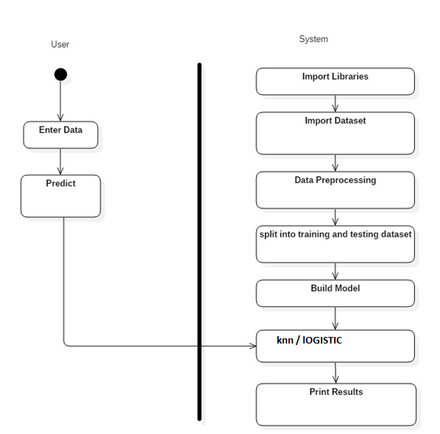

3.6.3 Sequence Diagram

GUI
Fig. (3.8) Sequence Diagram

Input parameters
Classifier
Graphical User Interface

Output Prediction

Fig (3.9) Interface Diagram

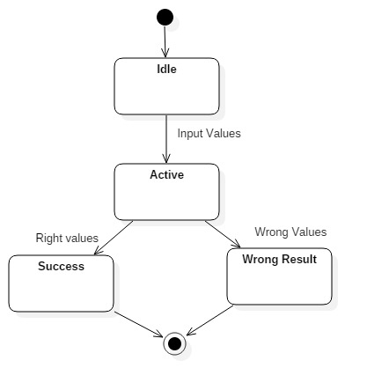

Fig (3.11) State Machine Diagram

Implementation and Coding

4.1 Introduction

This chapter covers the role of various subsystems/modules/classes along with implementation details listing of the code for the major functionalities.
4.2 Database schema
Table (4.1) Database Description
Field | Description | Range and Values
Age | Age of the patient | 0-100 in years
Sex | Gender of the patient | 0-1 (1:Male 0:Female)
Chest Pain | Type of chest pain | 1-4 (1: Typical Angina, 2: Atypical Angina, 3: Non-anginal, 4: Asymptotic )
Resting Blood Pressure | Blood pressure during rest | mm Hg
Cholesterol | Serum Cholesterol | mg / dl
Fasting Blood Sugar | Blood sugar content before food intake if >120 mg/dl | 0-1 (0: False, 1: True)
ECG | Resting Electrocardiographic results | 0-1 (0: Normal, 1: Having ST-T wave)
Max Heart Rate | Maximum heart beat rate. | Beats/min
Exercise Induced Angina | Has pain been induced by exercise | 0-1 (0: No, 1: Yes)
Old Peak | ST depression induced by exercise relative to rest | 0-4
Slope of Peak Exercise | Slope of the peak exercise ST segment | 1-3 (1: Up sloping, 2: Flat, 3: Down sloping)
Ca | Number of vessels colored by fluoroscopy | 0-3
Thal |  | 3- normal  6-Fixed Defect  7- Reversible Defect
Num | Diagnostics of Heart Disease | - (0: <50% Narrowing  1: >50% Narrowing)

4.3 Operational Details

- Data Cleaning
NA values in the dataset were the major setback for us as it was reducing the accuracy of the prediction profoundly so, we removed the fields which had NA value. We substituted it with the mean value of the column. This way, we removed all the NA values in the data set.
- Feature Scaling
Since the range of values of raw data varies widely, in some machine learning algorithms, objective functions will not work properly without feature scaling. For example, the majority of classifiers calculate the distance between two points by the Euclidean distance. If one of the features has a broad range of values, the distance will be governed by this particular feature. Therefore, the range of all features should be scaled so that each feature contributes approximately proportionately to the final distance. So we scaled the various fields in order to get them closer in terms of values.
Eg. Age had just two values i.e. 0,1 and cholesterol had high values like 100. So, in order to get them closer to each other, they were scaled to a value between -1, and 1.
- Factorization
In this section, we assigned a meaning to the values so that the algorithm doesn’t confuse between them. For example, assigning meaning to 0 and 1 in the age section so that the algorithm doesn’t consider 1 as greater than 0 in that section.
Fig. (4.1) Graph

The KNN Algorithm
Load the data
Initialize K to your chosen number of neighbors
3. For each example in the data
3.1 Calculate the distance between the query example and the current example from the data.
3.2 Add the distance and the index of the example to an ordered collection
4. Sort the ordered collection of distances and indices from smallest to largest (in ascending order) by the distances
5. Pick the first K entries from the sorted collection
6. Get the labels of the selected K entries
7. If regression, return the mean of the K labels
8. If classification, return the mode of the K labels

Choosing the right value for K
To select the K that’s right for your data, we run the KNN algorithm several times with different values of K and choose the K that reduces the number of errors we encounter while maintaining the algorithm’s ability to accurately make predictions when it’s given data it hasn’t seen before.
Here are some things to keep in mind:
As we decrease the value of K to 1, our predictions become less stable. Just think for a minute, imagine K=1 and we have a query point surrounded by several reds and one green (I’m thinking about the top left corner of the colored plot above), but the green is the single nearest neighbor. Reasonably, we would think the query point is most likely red, but because K=1, KNN incorrectly predicts that the query point is green.
Inversely, as we increase the value of K, our predictions become more stable due to majority voting / averaging, and thus, more likely to make more accurate predictions (up to a certain point). Eventually, we begin to witness an increasing number of errors. It is at this point we know we have pushed the value of K too far.
In cases where we are taking a majority vote (e.g. picking the mode in a classification problem) among labels, we usually make K an odd number to have a tiebreaker.
Advantages
The algorithm is simple and easy to implement.
There’s no need to build a model, tune several parameters, or make additional assumptions.
The algorithm is versatile. It can be used for classification, regression, and search (as we will see in the next section).
Disadvantages
The algorithm gets significantly slower as the number of examples and/or predictors/independent variables increase.
KNN in practice
KNN’s main disadvantage of becoming significantly slower as the volume of data increases makes it an impractical choice in environments where predictions need to be made rapidly. Moreover, there are faster algorithms that can produce more accurate classification and regression results.
However, provided you have sufficient computing resources to speedily handle the data you are using to make predictions, KNN can still be useful in solving problems that have solutions that depend on identifying similar objects. An example of this is using the KNN algorithm in recommender systems, an application of KNN-search.

Logistic Regression
Logistic Regression is a Machine Learning algorithm which is used for the classification problems, it is a predictive analysis algorithm and based on the concept of probability.
Logistic Function
Logistic regression is named for the function used at the core of the method, the logistic function.

The logistic function, also called the sigmoid function was developed by statisticians to describe properties of population growth in ecology, rising quickly and maxing out at the carrying capacity of the environment. It’s an S-shaped curve that can take any real-valued number and map it into a value between 0 and 1, but never exactly at those limits.

1 / (1 + e^-value)

Where e is the base of the natural logarithms (Euler’s number or the EXP() function in your spreadsheet) and value is the actual numerical value that you want to transform. Below is a plot of the numbers between -5 and 5 transformed into the range 0 and 1 using the logistic function.

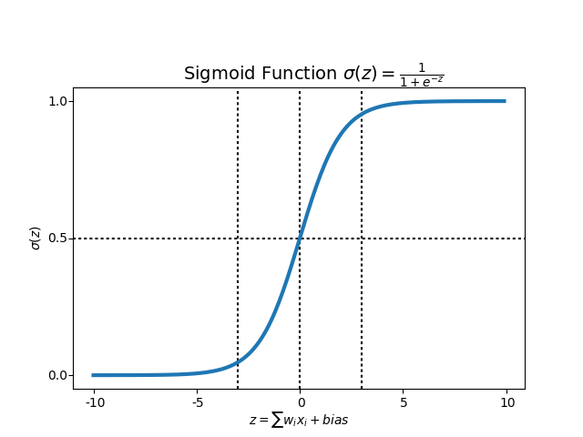

We expect our classifier to give us a set of outputs or classes based on probability when we pass the inputs through a prediction function and returns a probability score between 0 and 1.

Coding and Results

Sample coding:

from sklearn.model_selection import train_test_split
X_train, X_test, y_train, y_test = train_test_split(X, y, test_size=tsize, random_state=seed)
from sklearn.linear_model import LogisticRegression
# instantiate the model (using the default parameters)
logreg = LogisticRegression()

# fit the model with data
logreg.fit(X_test,y_test)

import matplotlib.pyplot as plt
import numpy as np
def plot_confusion_matrix(cm, title='Confusion matrix', cmap=plt.cm.Blues):
target_names=['yes','no']
plt.imshow(cm, interpolation='nearest', cmap=cmap)
plt.title(title)
plt.colorbar()
tick_marks = np.arange(len(target_names))
plt.xticks(tick_marks, target_names, rotation=45)
plt.yticks(tick_marks, target_names)
plt.tight_layout()
plt.ylabel('True label')
plt.xlabel('Predicted label')

from sklearn.neighbors import KNeighborsClassifier
knn=KNeighborsClassifier(n_neighbors=12)
knn.fit(X_test, y_test)

from sklearn.metrics import confusion_matrix
y_pred=knn.predict(X_test)
cm=confusion_matrix(y_test, y_pred)
print('Confusion matrix, without normalization')
print(cm)
plot_confusion_matrix(cm)

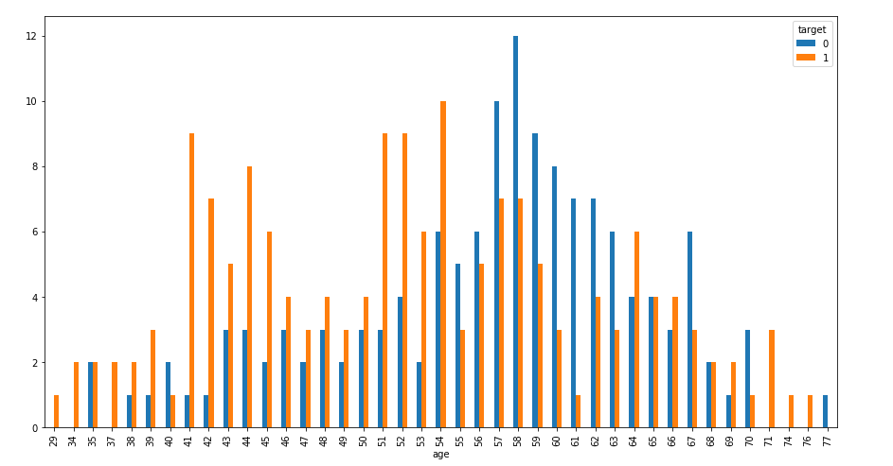

Age wise Disease/Non disease patients

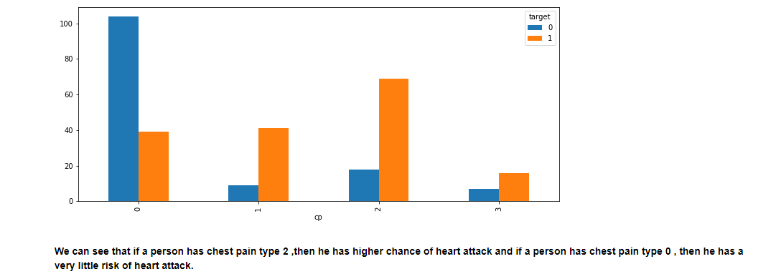

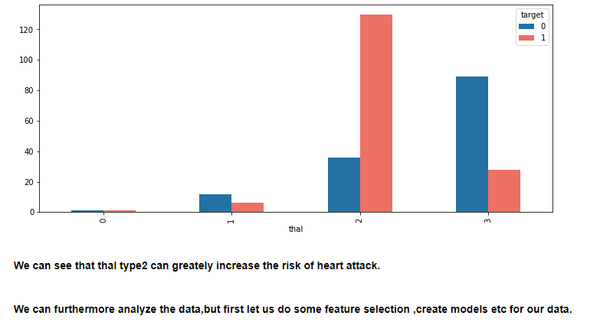

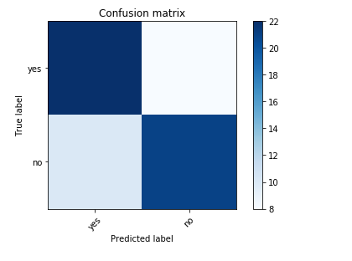
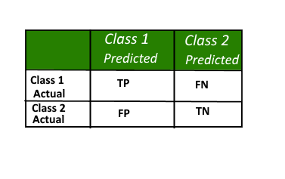
Here,
• Class 1 : Positive
• Class 2 : Negative

Definition of the Terms:
• Positive (P) : Observation is positive (for example: is an apple).
• Negative (N) : Observation is not positive (for example: is not an apple).
• True Positive (TP) : Observation is positive, and is predicted to be positive.
• False Negative (FN) : Observation is positive, but is predicted negative.
• True Negative (TN) : Observation is negative, and is predicted to be negative.
• False Positive (FP) : Observation is negative, but is predicted positive.

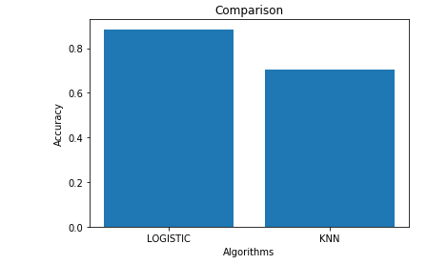

At first, the two algorithms were implemented. Datasets were trained for all the algorithms individually. After this, all of them were tested. The most efficient algorithm was to be selected based on various criteria. We found out that logistic algorithm was the most efficient out of the three with an accuracy of 83.4%. This would help the end users get a preliminary prediction about the condition of their heart. Since heart diseases are a major killer in India and throughout the world, application of a promising technology like machine learning to the initial prediction of heart diseases will have a profound impact on the society.
This will tell the user if they are at a risk and if they need to visit the doctor. This will help reduce the death rate due to heart attacks.
Hence by using the above approach successful analysis of heart diseases of the individual was performed and the result was obtained which predicted the risk of heart disease based on the parameters provided by the user.

Predictions by input:
Logistic Algorithm:

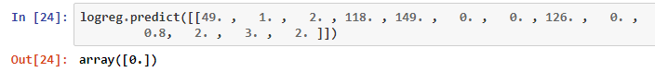

Knn Algorithm:

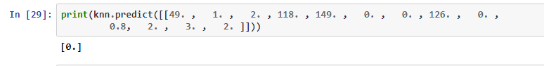

Future Work

Using the machine learning concept newly trained dataset can be used for an even more accurate prediction system. Accounts can be created for each user and then by referring the past choice history of user’s heart condition can be monitored to tell if there is any improvement or if the condition has deteriorated.

