Question **1** of **60**

1. Question

Which SOQL query successfully returns the Accounts grouped by name?

*  SELECT type,Max(CreatedDate)  FROM Account GROUP BY NAME
* ** SELECT Name,Max(CreatedDate) FROM Account GROUP BY Name**

##### 2. Question

For which three items can trace flag be configured? (Choose three)

* ** Apex Trigger**
* ** Apex Class**
*  Process Builder
* ** User**
*  Visualforce

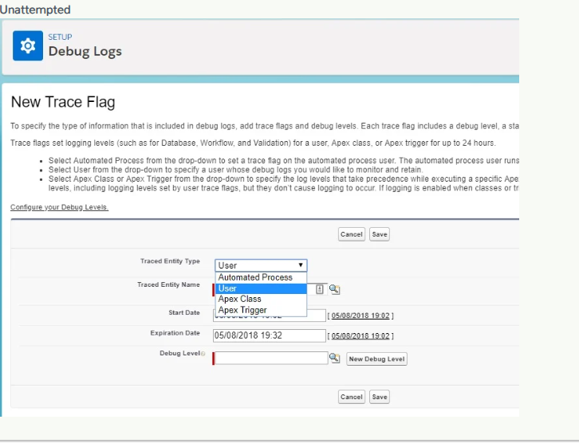

Question **3** of **60**

3. Question

Which of the following is a best practice when writing test classes? Choose 1 answer

* ** Use System.assert() methods to verify test results**
*  Use SeeAllData=true
*  Use System.debug() method to verify test results
*  Use @future annotation

**Unattempted**

Salesforce Apex Test Class Best Practices

1)Do not put (seeAllData = true) in test class otherwise, use it for exceptional cases.

2) Use @isTest at the Top for all the test classes.

3) Test in bulk: Test to see if your code can run on 200 records at once. This is the maximum number of records that can be evaluated in a single trigger by Salesforce.

4)Avoid Using Hard Coding Ids anywhere in test Class or any apex class.

5) Use System.assertEquals() to see if your code has the expected outcomes.

6) Use Test.startTest() and Test.stopTest() statement to increase Governor Limits of your test code.

4. Question

Which of the following ways can be used to throw a custom exception? Choose 3 answers

* ** throw new myCustomException(e)**
* ** throw new myCustomException('Error Message Here');**
*  throw new myCustomException().addError('Error Message Here');
* ** throw new myCustomException();**
*  throw new myCustomException().setMessage('Error Message Here');

**Unattempted**

You have to create your own Exception class like this:

public class applicationException extends Exception {}

Then you can throw that:

throw new applicationException(You can’t do that here’);

Question **5** of **60**

5. Question

Which of the following statements about the IF-ELSE statement are true? Choose 2 answers

*  The IF-ELSE statement provides a secondary path of execution when an IF clause evaluates to true.
* ** An IF statement can be followed by a discretionary ELSE statement, which executes when the Boolean expression is false**
*  An IF-ELSE statement can have a number of possible execution paths
* ** The IF-ELSE statement permits a choice to be made between two possible execution paths**

6. Question

Which static methods can be used in a test class to test governor limits? Choose 1 answer

*  Test.runAs() and Test.getLimits()
* ** Test.startTest() and Test.stopTest()**
*  Test.setFixedSearchResults()
*  Test.isTest() and Test.isnotTest()

**Unattempted**

Test.startTest/Test.stopTest

There are two additional system static methods provided by Apex. These methods, Test.startTest and Test.stopTest, are used when testing governor limits. Or in other words, executing test scenarios with a larger data set.

The Test.startTest method marks the point in your test code when your test actually begins. Each test method is allowed to call this method only once. All of the code before this method should be used to initialize variables, populate data structures, and so on, allowing you to set up everything you need in order to run your test. After you call this method, you get a fresh set of governor limits for the remainder of the test until you call Test.stopTest.

The Test.stopTest method marks the point in your test code when your test ends. Use this method in conjunction with thestartTest method. Each test method is allowed to call this method only once. After calling this method, any post assertions are done in the original context

@isTest

public class sampleTestMethodCls  
{  
private static testMethod void testAccountTrigger()  
{  
//First, prepare 200 contacts for the test data  
Account acct = new Account(name=’test account’);

insert acct;

Contact[] contactsToCreate = new Contact[]{};

for(Integer x=0; x<200;x++)  
{  
Contact ct = new Contact(AccountId=acct.Id,lastname='test');  
contactsToCreate.add(ct);  
}

//Now insert data causing an contact trigger to fire.

Test.startTest();

insert contactsToCreate;

Test.stopTest();  
}  
}

##### 7. Question

Cool Air Conditioners has been using Service cloud to manage cases, but are now considering using it to manage field service jobs. They would like to track field service activity and assignment to technicians. What is the recommended solution to meet these requirements? Choose 1 answer

*  Install an AppExchange product that provides Field Service functionality
*  Extend the Service Cloud configuration to handle Field Service cases
* ** Utilize the standard objects Work Order and Work Order Line Items**
*  Use real time API integration to connect Salesforce with an external field service application

Question **8** of **60**

8. Question

Which iteration components can be used to display a table of data in a Visualforce page? Choose 2 answers

* ** <apex:dataTable>**
*  <apex:outputTable>
*  <apex:table>
* ** <apex:pageBlockTable>**

**Unattempted**

apex:dataTable

An HTML table that’s defined by iterating over a set of data, displaying information about one item of data per row.

apex:pageBlockTable

A list of data displayed as a table within either an  or  component, similar to a related list or list view in a standard Salesforce page. Like an , an is defined by iterating over a set of data, displaying information about one item of data per row. The set of data can contain up to 1,000 items, or 10,000 items when the page is executed in read-only mode.

9. Question

A developer is required to create a trigger that every time the Type field on Request object is updated, the Owner field should be changed as well, either to a User or Queue. What trigger event should the developer use? Choose 1 answer

*  After Update
* ** Before Update**
*  Before Delete
*  After Merge

**Unattempted**

What is Triggers in Salesforce?

A trigger is an Apex script that executes before or after data manipulation language (DML) events occur. Apex triggers enable you to perform custom actions before or after events to record in Salesforce, such as insertions, updates, or deletions. Just like database systems support triggers, Apex provides trigger support for managing records.

Syntax:

Trigger on

Question **10** of **60**

10. Question

A developer needs to create a newContact record in his Apex Trigger. What DML statement should be used in the code? Choose 1 answer

*  Merge
* ** Insert**
*  Upsert
*  Create

**Unattempted**

Apex DML Statements

Use Data Manipulation Language (DML) statements to insert, update, merge, delete, and restore data in Salesforce.

The following Apex DML statements are available:

Insert Statement

The insert DML operation adds one or more sObjects, such as individual accounts or contacts, to your organization’s data. insert is analogous to the INSERT statement in SQL.

Account newAcct = new Account(name = ‘Acme’);  
try {  
insert newAcct;  
} catch (DmlException e) {  
// Process exception here  
}

Update Statement

The update DML operation modifies one or more existing sObject records, such as individual accounts or contactsinvoice statements, in your organization’s data. update is analogous to the UPDATE statement in SQL.

Account a = new Account(Name=’Acme2′);  
insert(a);

Account myAcct = [SELECT Id, Name, BillingCity FROM Account WHERE Id = :a.Id];  
myAcct.BillingCity = ‘San Francisco’;

try {  
update myAcct;  
} catch (DmlException e) {  
// Process exception here  
}

Upsert Statement

The upsert DML operation creates new records and updates sObject records within a single statement, using a specified field to determine the presence of existing objects, or the ID field if no field is specified.

Delete Statement

The delete DML operation deletes one or more existing sObject records, such as individual accounts or contacts, from your organization’s data. delete is analogous to the delete() statement in the SOAP API.

Account[] doomedAccts = [SELECT Id, Name FROM Account  
WHERE Name = ‘DotCom’];  
try {  
delete doomedAccts;  
} catch (DmlException e) {  
// Process exception here  
}

Question **11** of **60**

11. Question

A developer would like to relate an external data object (Social Media Posts) to the contacts object in Salesforce to track every post the contact has made in the external platform. How can the developer achieve this? Choose 1 answer

*  Create an external lookup relationship using a custom field with External ID and Unique attributes
* ** Create an indirect lookup relationship using a custom field with External ID and Unique attributes**

Question **12** of **60**

12. Question

Which of the following field types can a Roll-Up Summary field calculate? Choose 1 answer

* ** Number**
*  Text
*  Checkbox
*  Picklist

**Correct**

A roll-up summary field calculates values from related records, such as those in a related list. You can create a roll-up summary field to display a value in a master record based on the values of fields in a detail record. The detail record must be related to the master through a master-detail relationship.

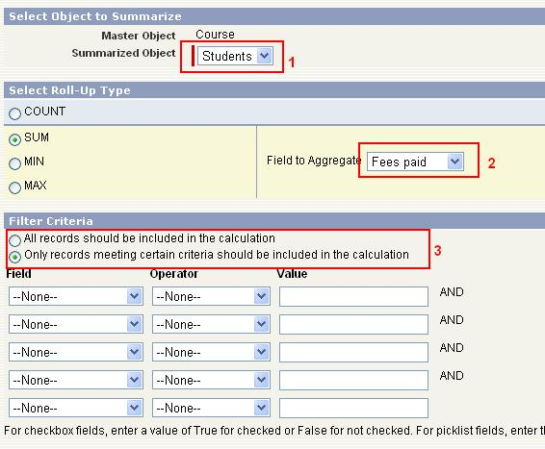

13. Question

Which of the following are capabilities of Schema Builder ? Choose 3 answers

* ** Creating a custom object**
* ** Deleting a custom object**
* ** Creating lookup and master-detail relationships**
*  Exporting schema definition
*  Importing schema definition

**Unattempted**

Schema Builder is a tool within Salesforce.com that is used to view and manage objects, fields, and relations between objects in a graphical interface.

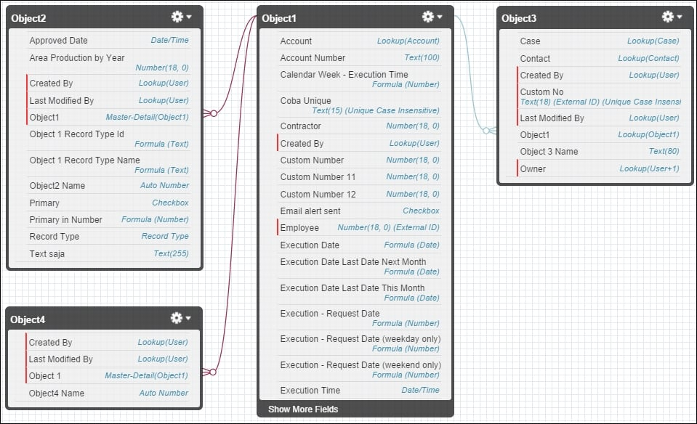

Here are a few actions you can perform with Schema Builder:

-Create and delete custom objects

-Edit custom object properties

-Create and delete custom fields

-Edit custom field properties

-Manage custom field permissions

##### 14. Question

Which of the following statements are true about controller extensions? Choose 3 answers

* ** A controller extension is an Apex class that extends the functionality of a standard or custom controller**
*  Only one controller extension can be defined for a single page
* ** The extension is associated with the page using the 'extensions' attribute of the component.**
* ** If an extension works in conjunction with a standard controller, the standard controller methods will also be available**
*  A standard or custom controller is an extension of the controller extension

Question **15** of **60**

15. Question

What options are available to run unit tests in an org? Choose 3 answers

*  Run all methods in a specific class that does not contain test methods
* ** Run all unit tests in an org**
* ** Run a test suite**
* ** Run all methods in a specific class**

##### 16. Question

The Salesforce developer of Cosmic Solutions would like to override the standard ‘New’ button for creating an Account in Salesforce Classic. How can this be done? Choose 1 answer

*  Create a new custom object with a custom button because standard buttons cannot be modified
*  Override the standard button with a new Lightning Component
*  Clone the standard button to be able to modify the look and feel of the page.
* ** Override the standard button with a new Visualforce page**

##### 18. Question

Which of the following best describe the Lightning Component Framework? Choose 2 answers

* ** It has an event-driven architecture**
* ** It is device-aware and supports cross-browser compatibility**
*  It automatically upgrades all pre-existing Visualforce pages and components
*  It require the Aura Components model to build Lightning components

##### 9. Question

A developer needs to access a list of data on a Visualforce page and represent the data as a table. However, the developer would also like to customize the look and feel and not use the standard Salesforce styling. What Visualforce components can the developer use? Choose 3 answers

*  <apex:listTable>
* ** <apex:dataTable>**
* ** <apex:dataList>**
* ** <apex:repeat>**
*  <apex:table>

Question **20** of **60**

20. Question

A developer is creating a Training application to track training courses and the enrollment of the candidates. Each candidate can enroll in multiple training courses at a time. How can the developer achieve this? Choose 1 answer

* ** Create a junction object to relate many candidates to many training courses through master-detail relationships.**
*  Create a master-detail relationship between Candidate and Training Course
*  Create a lookup relationship between Candidate and Training Course
*  Create a junction object to related Candidates to Training Courses and use lookup relationships to relate the junction object to Candidates and Training Courses

Question **21** of **60**

21. Question

A developer requires a variable numberOfStudents with a constant value of 25 that is accessible only within the Apex class in which it is defined. Which of the following is the best variable declaration? Choose 1 answer

*  protected final Integer numberOfStudents =25;
*  global static Integer numberOfStudents =25;
* ** private static final Integer numberOfStudents=25;**
*  public Integer numberOfStudents =25;

##### 22. Question

A junior developer frequently experiences governor limit errors when running Apex Triggers. As a senior developer, which of the following are best practices that you could advise? Choose 2 answers

* ** Use a combination of collections (e.g. maps, lists) and streamlined queries.**
*  Use an Apex handler class for multiple triggers
* ** Use lists to perform DML operations on multiple records**
*  Use SOQL queries only within FOR loops

##### 23. Question

The Stage field of all related Opportunity records should be updated to [Closed Lost] when the associated Account record become Inactive. What could be used for this? Choose 1 answer

*  Flow
*  Approval Process
* ** Process Builder**
*  Workflow Rule

##### 24. Question

Which of the following use cases are valid for declarative customization ? Choose 3 answers

* ** Determining a lead rating, based on checking the value of 3 lead fields**
* ** Displaying the number of employees of the account related to an opportunity, on the opportunity page layout**
*  Calculating the sales tax applicable to a quote, that is a complex calculation and based on various factors such as product, state, quantity
* ** Calculating the number of days until an opportunity closes and displaying on a report**

##### 25. Question

A developer needs to create a trigger that will throw an error whenever the user tries to delete a contact that is not associated to an account. What trigger event should the developer use? Choose 1 answer.

* ** Before Delete**
*  After Insert
*  After Delete
*  Before Insert

##### 26. Question

Which of the following are capabilities of Visual Studio Code? Choose 3 answers.

*  Creating Change Sets
* ** Running Apex Tests**
* ** Deploying metadata components from org to another**
*  Create a test suite for running tests
* ** Executing SOQL queries**

Which of the following are part of the model layer in the MVC model? Choose 3 answers

* ** Fields**
* ** Objects**
*  Tabs
*  Page Layouts
* ** Relationships**

##### 28. Question

Which standard objects in the following list are not supported by DML operations? Choose 2 answers

* ** Record Type**
* ** Profile**
*  User
*  Opportunity Line Item

Question **29** of **60**

29. Question

When writing an Apex Trigger,what should a developer keep in mind?Choose 2 answers

*  An Apex Trigger should not cause another trigger to be fired
*  An Apex Trigger should use @future annotation in performing DML operations
* ** A single Apex Trigger is all you need for each object**
* ** An Apex Trigger should be logic-less and delegate the logic responsibilities to a handler class**

**Unattempted**

Best Practices to follow using Triggers:

Best Practice #1: Bulkify your Code

Bulkifying Apex code refers to the concept of making sure the code properly handles more than one record at a time. When a batch of records initiates Apex, a single instance of that Apex code is executed, but it needs to handle all of the records in that given batch.

Best Practice #2: Avoid SOQL Queries or DML statements inside FOR Loops

There is a governor limit that enforces a maximum number of SOQL queries. There is another that enforces a maximum number of DML statements (insert, update, delete, undelete). When these operations are placed inside a for loop, database operations are invoked once per iteration of the loop making it very easy to reach these governor limits.

Instead, move any database operations outside of for loops. If you need to query, query once, retrieve all the necessary data in a single query, then iterate over the results. If you need to modify the data, batch up data into a list and invoke your DML once on that list of data.

Best Practice #3: Using Collections, Streamlining Queries, and Efficient For Loops

It is important to use Apex Collections to efficiently query data and store the data in memory. A combination of using collections and streamlining SOQL queries can substantially help writing efficient Apex code and avoid governor limits.

Best Practice #4: Streamlining Multiple Triggers on the Same Object

Best Practice #5: Querying Large Data Sets

The total number of records that can be returned by SOQL queries in a request is 50,000. If returning a large set of queries causes you to exceed your heap limit, then a SOQL query for loop must be used instead. It can process multiple batches of records through the use of internal calls to query and queryMore.

Best Practice #6: Use of the Limits Apex Methods to Avoid Hitting Governor Limits

Apex has a System class called Limits that lets you output debug messages for each governor limit.There are two versions of every method: the first returns the amount of the resource that has been used in the current context, while the second version contains the word limit and returns the total amount of the resource that is available for that context.

##### 30. Question

Before code can be deployed to production,which of the following must be true? Choose 2 answers

*  At least 75% of Apex code in triggers must be covered by unit tests
* ** At least 75% of Apex code must be  covered by unit tests**
* ** All classes and triggers must compile successfully**
*  Test methods and test classes must be counted as part of code coverage

##### 31. Question

When would a full copy sandbox be required ? Choose 2 answers

* ** Performance and Load Testing**
*  Integration Testing
* ** Staging**
*  Training

Full Sandbox

Full sandboxes copy your entire production organization and all its data, including standard and custom object records, documents, and attachments. You can refresh a Full sandbox every 29 days.

Sandbox templates allow you to pick specific objects and data to copy to your sandbox, so you can control the size and content of each sandbox. Sandbox templates are only available for Partial Data or Full sandboxes.

REFRESH LIMIT :- 29 Days

DATA LIMIT :- Same as Production

A Full sandbox is intended to be used as a testing environment. Only Full sandboxes support performance testing, load testing, and staging.

##### 32. Question

What method can be used to obtain metadata information about all the sObjects in an organization and their fields? Choose 1 answer

*  describeObjects()
* ** getGlobalDescribe()**
*  getGlobalSObjects()
*  describeSObjects()

##### 33. Question

Which data type is appropriate for a numerical value of 726.234 stored in the variable totalCost? Choose 1 answer

*  Numeric totalCost;
*  Long totalCost;
* ** Decimal totalCost;**
*  Integer totalCost;

34. Question

What are valid use cases for using a custom controller in a Visualforce page? Choose 2 answers

*  A Visualforce page needs to add new actions to a standard controller
* ** A Visualforce page needs to run in system mode**
* ** A Visualforce page should replace the functionality of the standard controller**
*  A Visualforce page should override the save action of the standard controller

**Unattempted**

When we have standard controller and extensions feature in visualforce what is the need of custom controller?

A custom controller is an Apex class that implements all of the logic for a page without leveraging a standard controller. Use custom controllers when you want your Visualforce page to run entirely in system mode, which does not enforce the permissions and field-level security of the current user.

##### 35. Question

What is true regarding projects in Visual Studio Code? Choose 2 answers

* ** Projects can work in online or offline modes**
* ** Each developer can define the metadata components to be included in a local project**
*  Each developer will have the same set of files in their project
*  Compiling of Apex code is done locally

36. Question

A company would like to send record information to a legacy system when a criteria is met. A developer can accomplish this requirement by using: Choose 1 answer

* ** Workflow Rule with Outbound Message**
*  Visual Workflow
*  Outbound Notification Rule
*  Assignment Rule

**Unattempted**

Workflow rules can help automate the following types of actions based on your organization’s processes:

Tasks: Assign a new task to a user, role, or record owner.

Email Alerts: Send an email to one or more recipients you specify.

Field Updates: Update the value of a field on a record.

Outbound Messages: Send a secure, configurable API message (in XML format) to a designated listener.

##### 37. Question

How would a developer write a query to return the number of leads for each source? Choose 1 answer

* ** SELECT LeadSource,COUNT(Name) FROM Lead GROUP BY LeadSource**

38. Question

What trigger context variable will return a map of IDs to the old versions of the sObject records? Choose 1 answer

*  newMap
* ** oldMap**
*  updateMap
*  insertMap

**Unattempted**

Here is List of Trigger Context Variables

isExecuting: Returns true if the current context for the Apex code is a trigger, not a Visualforce page, a Web service, or an executeanonymous() API call.

isInsert: Returns true if this trigger was fired due to an insert operation, from the Salesforce user interface, Apex, or the API.

isUpdate: Returns true if this trigger was fired due to an update operation, from the Salesforce user interface, Apex, or the API.

isDelete: Returns true if this trigger was fired due to a delete operation, from the Salesforce user interface, Apex, or the API.

isBefore: Returns true if this trigger was fired before any record was saved.

isAfter: Returns true if this trigger was fired after all records were saved.

isUndelete: Returns true if this trigger was fired after a record is recovered from the Recycle Bin (that is, after an undelete operation from the Salesforce user interface, Apex, or the API.)

new: Returns a list of the new versions of the sObject records. This sObject list is only available in insert, update, and undelete triggers, and the records can only be modified in before triggers.

newMap: A map of IDs to the new versions of the sObject records. This map is only available in before update, after insert, after update, and after undelete triggers.

old : Returns a list of the old versions of the sObject records. This sObject list is only available in update and delete triggers.

oldMap: A map of IDs to the old versions of the sObject records. This map is only available in update and delete triggers.

size: The total number of records in a trigger invocation, both old and new.

39. Question

What does a Helper in a Lightning component contain? Choose 1 answer

*  A description, sample code, and one or multiple references to example components
*  Custom icon resource for components used in the LightningApp Builder or Community Builder
*  Styles for the component
* ** Controller functions that can be called from any part of the controller in a component bundle**

**Unattempted**

What is helper in lightning?

Put functions that you want to reuse in the component’s helper. Helper functions also enable specialization of tasks, such as processing data and firing server-side actions. A helper function can be called from any JavaScript code in a component’s bundle, such as from a client-side controller or renderer.

Question **40** of **60**

40. Question

Which of the following actions can be performed in the Before Update trigger? Choose 2 answers

* ** Create a validation before accepting own field changes**
*  Modifying trigger.old values
*  Delete trigger.new values to avoid changes
* ** Changes its own field values using trigger.new**

Question **41** of **60**

41. Question

How can a developer start and monitor debug logs via the Salesforce UI? Choose 1 answer

* ** Setup > Debug Logs >New**
*  Setup > Profile > Choose Profile > Enable Debug Logs
*  Setup > User > Debug Logs > New
*  Setup  > Company Information > Enable Debug Logs

**Unattempted**

Turning on debug logs in Salesforce.com

Debug logs are a valuable tool to any system administrator. When you move to the world of web applications, they become essential. Salesforce.com has provided a nice and easy way to create, view and delete debug log information for users within Salesforce.com setup.

In order to create a debug log in Salesforce.com, simply follow the steps below:

Step 1 – Login as a System Administrator to Salesforce.com and click on the Setup link.

Step 2 – On the left side navigation under “Administration Setup”, expand the Monitoring section.

Step 3 – Click on the “Debug Logs” option (shown below)

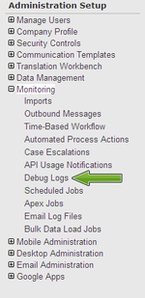

Step 4 – If no debug logs have been created you will see a basic screen with no rows in either of the two tables (Shown below). Click the “New” button.

Step 5 – Select the user(s) that you want to start the debug log for. Click the “Save” button when you are finished.

Step 6 – You’ve now created a debug log. You can now go to this same screen to view the events that are logged. In addition, you can download the log if you need to send it over to your development team. To clean things up you can delete individual logs or delete all logs from this screen as well.

42. Question

What is the procedure for unit testing ? Choose 1 answer

*  Create test data, run all tests, delete any records created, and verify the results
* ** Create test data, call the method being tested, verify results**
*  Create test data, run all tests, verify results, delete any records created
*  Create test data, call the method being tested, verify results, delete any records created

**Unattempted**

What Are Apex Unit Tests?

To facilitate the development of robust, error-free code, Apex supports the creation and execution of unit tests. Unit tests are class methods that verify whether a particular piece of code is working properly. Unit test methods take no arguments, commit no data to the database, and send no emails. Such methods are flagged with the @isTest annotation in the method definition. Unit test methods must be defined in test classes, that is, classes annotated with @isTest.

For example:

@isTest  
private class myClass {  
@isTest static void myTest() {  
// code_block  
}  
}

This example of a test class contains two test methods.  
@isTest  
private class MyTestClass {

// Methods for testing  
@isTest static void test1() {  
// Implement test code  
}

@isTest static void test2() {  
// Implement test code  
}

}

##### 43. Question

Universal Insurance uses Salesforce for managing claims. Claim is a custom object. If an email sent from a claimant regarding an existing claim, it should be checked for a unique reference number and if found, attached to the related claim record, an the status of the claim record updated. What feature would be most appropriate for this requirement? Choose 1 answer

*  Email to Custom Object
*  Email-to-Case
* ** Custom Email Handler**
*  Process Builder

##### 44. Question

The developer executes the code below and an error is returned indicating that a variable is not properly declared.  
String str= new String();  
public void stringDisplay(){  
str=’Hello’;  
System.debug(str);  
}  
What is the proper way of declaring a String data type variable? Choose 1 answer

*  Text str;
*  String new=str String();
*  String=str;
* ** String str;**

‘

Question **45** of **60**

45. Question

A developer created a lookup relationship between the standard object Account and a custom object Feedback. Which statement is correct? Choose 1 answer

* ** If a feedback record is deleted, the account will not be deleted**
*  Any user that can view the account records can also view the feedback records
*  If a feedback record is deleted, the account will also be deleted
*  The owner of the account record will be the owner its feedback record

**Unattempted**

Difference between Master Detail and Lookup Relationship:

Master–Detail Relationship :

We cannot create master – detail relationship type fields directly if records already exists. Instead we have to first create Look up fields then fill all the records with that lookup filed. After that we can convert the lookup fields to master – detail relationship.

If we delete master records then detail (Child) records are deleted.

It creates the parent(master) child(Detail) relationship between objects.

Lookup relationship :

Look up relationship creates relations between two objects.

If we delete any object then other object is not deleted.

##### 46. Question

What will be the result if the code below is executed when the variable testRawScore is 75?  
if(testRawScore >=90){  
gradeEqual=’A’;  
} else if(testRawScore >=80){  
gradeEqual=’B’;  
} else if(testRawScore >=70){  
gradeEqual=’C’;  
} else if(testRawScore >=60) {  
gradeEqual=’D’;  
}  
System.debug(gradeEqual);  
Choose 1 answer

*  A
*  B
* ** C**
*  D

47. Question

A PageReference is a reference to an instantiation of a page. Which of the following are valid means of instantiating a PageReference? Choose 2 answers

* ** PageReference pageRef=new PageReference('URL');**
* ** Page.existingPageName**
*  ApexPages.Page().existingPageName
*  PageReference.page('URL')

**Unattempted**

PageReference Class

A PageReference is a reference to an instantiation of a page. Among other attributes, PageReferences consist of a URL and a set of query parameter names and values.

PageReference pageRef = new PageReference(‘partialURL’);

Question **48** of **60**

48. Question

What feature can be used to find the latest news and information about the account and contacts you are interested in ? Choose 1 answer

* ** Social Accounts, Contacts and Leads**
*  Global Search
*  News Search
*  Twitter Search

**Unattempted**

Social Accounts and Contacts

The Social Accounts, Contacts, and Leads feature adds social network information from Twitter and YouTube to your records. To use it, you must have an account on each social network that you’re using, and you have to link the account or contact record to a user profile on each social network.

##### 49. Question

A developer has created the following trigger to update the description of existing Contract records:  
List getContracts=new List();  
for(Opportunity opp:(List)Trigger.New){  
Contract con=[SELECT Id FROM Contract where Id=:opp.ContractId];  
con.Description =’This is the contract for Opportunity’+ opp.Name;  
getContracts.add(con);  
}  
update getContracts;

How many Contract records will be updated when a developer loads 2000 Opportunity records? Choose 1 answer

*  2000
*  100
*  1
* ** 0**

Question **50** of **60**

50. Question

How can the relationship between different accounts be recorded and viewed? Choose 2 answers

* ** Using the View Hierarchy link**
*  Using the Generate Relationship
* ** Using the Parent Account field**
*  Using the Related Account field

**Unattempted**

##### 51. Question

A Licensed_Professional__c custom object exists in the system with two Master-Detail fields for the following objects: Certification__c and Contact. Users with the “Certification Representative“ role can access the Certification records they own and view the related Licensed Professionals records, however users with the “Sales Representative“ role report they cannot view any Licensed Professional records even though they own the associated Contact record.  
What are two likely causes of users in the “Sales Representative“ role not being able to access the Licensed Professional records?  
Choose 2 answers.

*  The organization recently modified the Sales Representative role to restrict Read access to Licensed_Professional__c.
*  The organization has a private sharing model for Certification__c, and Contact is the primary relationship in the Licensed_Professional__c object.
* ** The organization recently modified the Sales Representative role to restrict Read/Write access to Licensed_Professional__c.**
* ** The organization has a private sharing model for Certification__c. and Certification__c is the primary relationship in the Licensed_Professional__c object.**

52. Question

Which action causes a before trigger to fire by default for Accounts?

*  Renaming or replacing picklists.
*  Converting Leads to Contact accounts.
* ** Importing data using the Data Loader and the Bulk API.**
*  Updating addresses using the Mass Address update tool.

**Unattempted**

This question is related to the concept of Operations That Don‘t Invoke Triggers.  
Some operations dont invoke triggers. riggers are invoked for data manipulation language (DML) operations that the Java application server initiates or processes. Therefore, some system bulk operations don‘t invoke triggers.  
The correct answer is Importing data using the Data Loader and the Bulk API because it causes before triggers to fire by default.  
The below answers are incorrect:  
Renaming or replacing picklists is NOT correct because renaming or replacing picklists will not invoke triggers.  
Updating addresses using the Mass Address update tool is NOT correct because Mass address updates dont invoke triggers.  
Converting Leads to Contact accounts is NOT correct because the before triggers associated with these operations are fired during lead conversion only if validation and triggers for lead conversion are enabled in the organization.  
There is a checkbox Require Validation for Converted Leads which decides that Apex Trigger will fire or not.  
Please find the below screenshot:

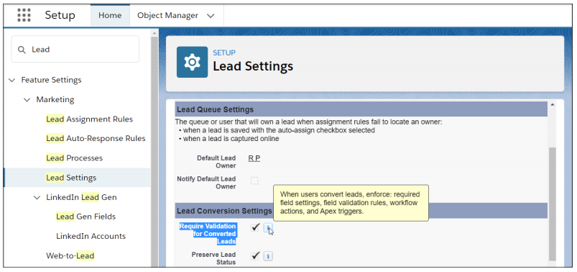

53. Question

What are three capabilities of the <1tng:require> tag when loading JavaScript resources in Aura components?  
Choose 3 answers.

* ** One-time loading for duplicate scripts.**
*  Loading files from Documents.
* ** Specifying loading order.**
* ** Loading scripts in parallel.**
*  Loading externally hosted scripts.

**Unattempted**

This question is related to using external JavaScript Libraries in Lightning Components.  
To reference a JavaScript library, upload it as a static resource and use a tag in your .cmp or .app markup. The frameworks content security policy mandates that external JavaScript libraries must be uploaded to Salesforce static resources.  
Syntax of using external JavaScript in Aura Component:

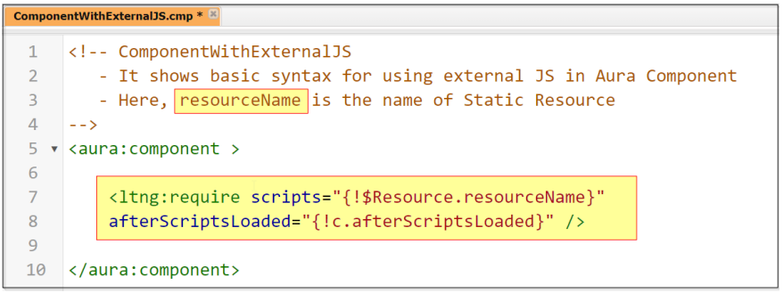  
Important Points to NOTE:

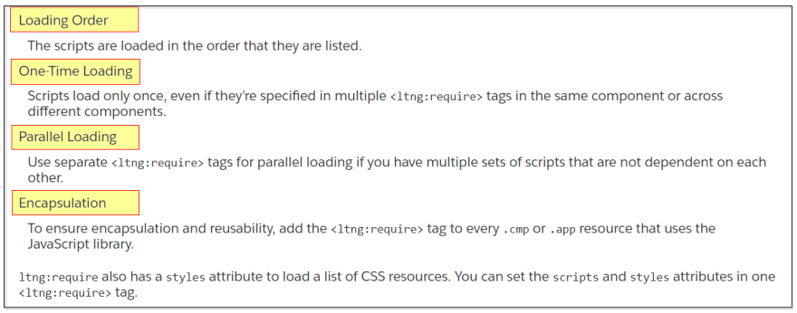  
With this explanation and important points,  
The first correct answer is:  
One-time loading for duplicate scripts because Script only loads once, even if they are specified in multiple <1tng:require> tags.  
The second correct answer is:  
Specifying loading order because the scripts are loaded in the order they are listed.  
The third correct answer is:  
Loading scripts in parallel because we can use separate <1tng:require> tags to parallelly load multiple sets of scripts.  
Reference:  
<https://developer.salesforce.com/docs/atlas.en-us.lightning.meta/lightning/js_libs_platform.htm>

##### 54. Question

Which three resources in an Aura Component can contain JavaScript functions?  
Choose 3 answers.

*  Design
*  Style
* ** Renderer**
* ** Controller**
* ** Helper**

##### 55. Question

A developer needs to have records with specific field values in order to test a new Apex class.  
What should the developer do to ensure the data is available for the test?

*  Use Test.loadData() and reference a CSV file.
*  Use SOQL to query the org for the required data.
*  Use Anonymous Apex to create the required data.
* ** Use Test.loadData() and reference a static resource.**

57. Question

Universal Containers has a support process that allows users to request support from its engineering team using a custom object, Engineering_Support_c.  
Users should be able to associate multiple Engineering_Support_c records to a single Opportunity record. Additionally, aggregate information about the Engineering_Support_c records should be shown on the Opportunity record.  
What should a developer implement to support these requirements?

*  Master-detail field from Opportunity to Engineering_Support_c
*  Lookup field from Engineering_Support_c to Opportunity
* ** Master-detail field from Engineering_Support_c to Opportunity**
*  Lookup field from Opportunity to Engineering_Support_c

**Unattempted**

This question is more of an Administrator‘s knowledge than a Platform Developer 1 knowledge.  
Let us understand it thoroughly.  
We have Engineering_Support cases for the opportunity. Let‘s say we are offering some service/product to end-user and before that opportunity gets materialized/converted to Closed-Won. We need to address some support queries of the customer.  
It means One opportunity record will have multiple Support records.  
So, Opportunity is parent, and Engineering support is a child object.  
With this, we either have to create either a Lookup or Master-Detail (MD) relationship field on the Engineering Support object.  
So that Engineering support will have a lookup field and Opportunity will have a related list.  
Now the second requirement mentions that we need to show aggregate information about the Engineering support records.  
We can achieve it through the Roll-up summary field.  
And in order to apply the Roll-up summary field, we need to compulsory create an MD relationship on the Engineering support object.  
Hence, the “Master-detail field from Engineering_Support_c to Opportunity“ is the correct answer selection.  
You can gather more information about the MD relationship and Roll-up summary on the below reference links.  
As these are Administrator concepts I am not elaborating them here in further detail.  
Reference:  
<https://help.salesforce.com/s/articleView?id=sf.fields_defining_summary_fields.htm&type=5>  
Trailhead Module:  
<https://trailhead.salesforce.com/content/learn/modules/point_click_business_logic/roll_up_summary_fields>  
<https://trailhead.salesforce.com/content/learn/modules/data_modeling/object_relationships>

##### 58. Question

A PrimeryId_c custom field exists on the Candidate_c custom object. The field is used to store each candidates Id number and is marked as Unique in the schema definition.  
As part of a data enrichment process, Universal Containers has a CSV file that contains updated data for all candidates in the system. The file contains each candidates primary Id as a data point. Universal Containers wants to upload this information into Salesforce, while ensuring all data rows are correctly mapped to a candidate in the system.  
Which technique should a developer implement to streamline the data upload?

*  Create a before insert trigger to correctly map the records.
*  Create a Process Builder on the Candidate_c object to map the records.
* ** Update the PrimaryId__c field definition to mark it as an External Id.**
*  Upload the CSV into a custom object related to Candidate_c.

59. Question

Which two settings must be defined in order to update a record of a junction object?  
Choose 2 answers.

*  Read/Write access on the junction object.
*  Read access on the primary relationship.
* ** Read/Write access on the secondary relationship.**
* ** Read/Write access on the primary relationship.**

**Unattempted**

In order to understand the answer let us first gather the understanding of Junction Object.  
Junction objects help associate two objects. They are custom objects in Salesforce that allow building a master-detail relationship established between two different data objects.  
You can use master-detail relationships to model many-to-many relationships between any two objects. A many-to-many relationship allows each record of one object to be linked to multiple records from another object and vice versa.  
Junction objects establish many-to-many relationships between two objects and are created with two master-detail relationships.  
Now to understand the answer selection please follow the below steps.  
1) Create a user and assign it a custom profile.  
2) Create three custom objects.  
i) PrimaryRelationshipObj  
ii) SecondaryRelationshipObj  
iii) JunctionObj  
3) Create first MD relationship on JunctionObj with PrimaryRelationshipObj (That will become primary relationship)  
4) Create a second MD relationship on JunctionObj with SecondaryRelationshipObj (That will become primary relationship)  
5) Make sure to create a tab for all three objects and make sure to assign Read, Create, Edit, and Delete.  
6) From Sharing settings first mark PrimaryRelationshipObj and SecondaryRelationshipObj with Private “Default Internal access“. (You will not observe JunctionObj there because its access is controlled by Primary and Secondary objects. (And hence, “Read/Write access on the junction object.“ is totally incorrect option.  
7) Now through Admin, a user creates 2-3 records under junction object.  
8) Login with the user created in the first step.  
Observation: The user will not be able to even view any records under the JunctionObj tab.  
9) Now change the sharing setting options with the other three options.  
Observation: The user will be able to edit the records under JunctionObj only when “Read/Write access on the primary relationship.“ and “Read/Write access on the secondary relationship.“

  
The rest of the answer options are incorrect:  
“Read/Write access on the junction object“ is incorrect as already explained above.  
If you keep “Read access on the primary relationship“ and try to modify the records of JunctionObj then it will show the below error.

60. Question

A developer created a weather app that contains multiple Lightning web components.  
One of the components, called Toggle, has a toggle for Fahrenheit or Celsius units. Another component, called Temperature, displays the current temperature in the unit selected in the Toggle component.  
When a user toggles from Fahrenheit to Celsius or vice versa in the Toggle component, the information must be sent to the Temperature so the temperature can be converted and displayed.  
What is the recommended way to accomplish this?

*  Use an application event to communicate between the components.
* ** The Toggle component should call a method in the Temperature component.**
*  Use Lightning Message Service to communicate between the components.
*  Create a custom event to handler the communication between components.

**Unattempted**

This question is a scenario-based question and it is related to Lightning Web Component.  
Lets understand the scenario step by step:  
1.  Component 1 named Toggle is used to toggle between Fahrenheit or Celsius and vice versa.  
2.  Component 2 named Temperature is used to show the current temperature in the selected unit.  
3.  The important point is When a user toggles from Fahrenheit to Celsius or vice versa in the Toggle component, the information must be sent to the Temperature so the temperature can be converted and displayed.  
4.  As per the scenario, the Lightning Components can be placed as below:  
   Toggle component can act as the parent component  
    Temperature component can act as a child component  
    When the toggle button is used, the selected unit information should be passed to the Temperature (child) component.  
So, here the point to focus on is: When the toggle button is used, the selected unit information should be passed from Toggle (Parent) component to the Temperature (child) component.  
Please Note: To communicate down the containment hierarchy, owner and parent components can call JavaScript methods on child components. To expose a public method, decorate it with @api.  
That means in our scenario, we can create a method in the child component which can be called from the parent component.  
With this explanation, the correct answer is  
The Toggle component should call a method in the Temperature component.  
Lets see below code example:  
Screenshot  Temperature (Child Component) – html file

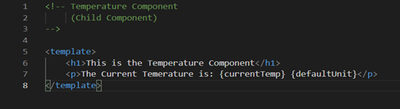  
Screenshot  Temperature (Child Component) – javascript file

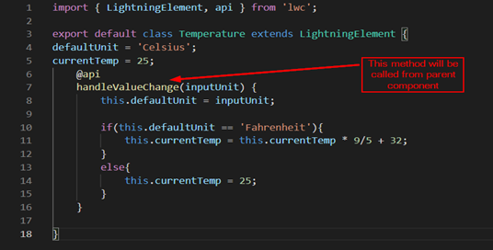  
Screenshot  Toggle (Parent Component) – html file

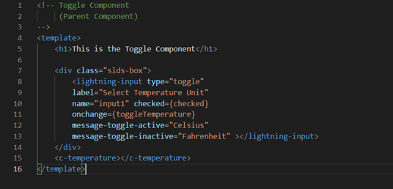  
Screenshot  Toggle (Parent Component) – javascript file

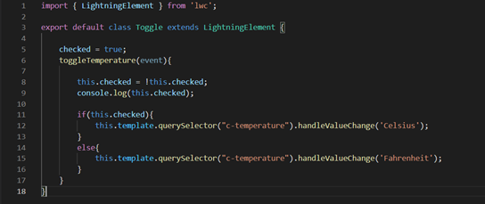  
Screenshot  UI Showing Toggle and Temperature

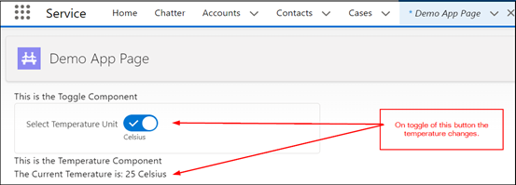  
References:  
<https://developer.salesforce.com/docs/component-library/documentation/en/lwc/create_javascript_methods>  
<https://salesforcediaries.com/2019/08/21/lwc-communication-part-3-call-methods-on-child-components/>

1. 1. Question

In a single record, a user selects multiple values from a multi-select picklist. How are the selected values represented in Apex?

* +  As a String with each value separated by a comma
  +  As a Set with each value as an element in the set
  + ** As a String with each value separated by a semicolon**
  +  As a List with each value as an element in the list Previous

**Unattempted**

In a single record, a user selects multiple values from a multi – select pick list and the selected values are represented in apex as a string with each value separated by semi colon.

1. 2. Question

Which trigger event allows a developer to update fields in the Trigger.new list without using an additional DML statement? Choose 2 answers

* + ** Before Insert**
  + ** Before Update**
  +  After Update
  +  After Insert

**Unattempted**

Before triggers: used to update or validate record values before they’re saved to the database.

After triggers: used to access field values that are set by the system (such as a record’s Id or LastModifiedDate field) and to effect changes in other records. The records that fire the after trigger are read-only.

We cannot use After trigger if we want to update a record because it causes read only error. This is because after inserting or updating, we cannot update a record.

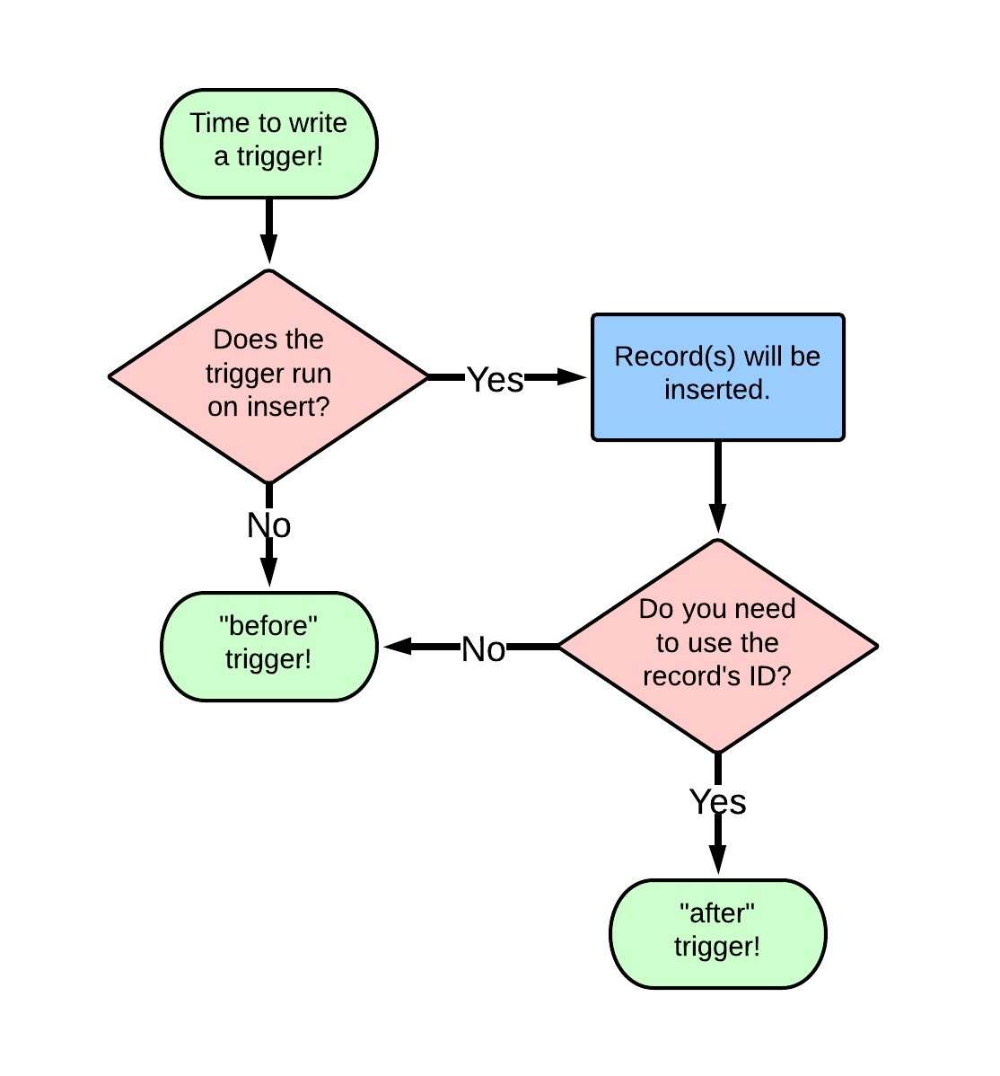

1. 3. Question

Which statement would a developer use when creating test data for products and price books?

* + ** Id pricebookId= Test.getStandardPricebookId();**
  +  Pricebook pb= new Pricebook();
  +  IsTest(SeeAllData= false);
  +  List objList=Test.loadData(Account.sObjectType,'myResource');

**Unattempted**

The tag PricebookId tells the system to filter product search results by a single price book ID. Developers can therefore create price book entries for standard and custom price books in Apex tests.

This method allows the system to pull the standard price book ID and then uses that ID to create a price book entry for a product that has a standard price. A custom price book can then be created based on this entry, with its own ID.

1. 4. Question

Where would a developer build a managed package?

* +  Developer Sandbox
  +  Unlimited Edition
  +  Partial Copy Sandbox
  + ** Developer Edition**

**Unattempted**

The correct answer to this question is Developer Edition. This edition, used in the cloud based software, Salesforce is used to test and develop applications. The data in this edition is not critical to the business. Developer editions are free and they take up less storage.

They also have less users than other editions. There is no limit on how many developer editions one can sign up for and it is primarily used as the Initial stage of development. Using developer edition allows one to create an application, which can be used in any production environment on the Salesforce software.

A managed package is a collection of application components that are posted as a unit on AppExchange, and are associated with a namespace and a License Management Organization.

You must use a Developer Edition organization to create and work with a managed package.

Difference between managed and unmanaged package in Salesforce:

Unmanaged Package

Unmanaged packages are typically used to distribute open-source projects or application templates to provide developers with the basic building blocks for an application.

Once the components are installed from an unmanaged package, the components can be edited in the organization they are installed in.

Managed Package

Managed packages are typically used by salesforce.com partners to distribute and sell applications to customers.

Once the components are installed from a managed package, the components cannot be edited in the organization they are installed in.

1. 5. Question

Which statement results in an Apex compiler error?

* +  Map lmap=new Map([select ID from Lead Limit 8]);
  +  Date d1=Date.Today(), d2=Date.ValueOf('2018-01-01');
  +  Integer a=5,b=6,c,d=7;
  + ** List s=List {'a','b','c');**

**Unattempted**

Lists

A list is an ordered collection of elements that are distinguished by their indices. List elements can be of any data type—primitive types, collections, sObjects, user-defined types, and built-in Apex types.

To declare a list, use the List keyword followed by the primitive data, sObject, nested list, map, or set type within <> characters. For example:

// Create an empty list of String  
List my_list = new List();  
// Create a nested list  
List<list<set>> my_list_2 = new List<list<set< integer="" style="box-sizing: inherit;">>>();</list<set<></list<set

1. 6. Question

What are two benefits of the Lightning Component framework? (Choose two)

* +  It simplifies complexity when building pages, but not applications.
  + ** It provides an event-driven architecture for better decoupling between components.**
  + ** It promotes faster development using out-of-box components that are suitable for desktop and mobile devices.**
  +  It allows faster PDF generation with Lightning components.

**Unattempted**

Why Use the Lightning Component Framework?

There are many benefits of using the Lightning Component framework to build components and apps.

Out-of-the-box Components

Comes with an out-of-the-box set of components to kick start building apps. You don’t have to spend your time optimizing your apps for different devices as the components take care of that for you.

Rich Component Ecosystem

Create business-ready components and make them available in the Salesforce app, Lightning Experience, and Communities. Salesforce app users access your components via the navigation menu. Customize Lightning Experience or Communities using drag-and-drop components on a Lightning Page in the Lightning App Builder or using Experience Builder. Additional components are available for your org in the AppExchange. Similarly, you can publish your components and share them with other users.

Fast Development

Empowers teams to work faster with out-of-the-box components that function seamlessly with desktop and mobile devices. Building an app with components facilitates parallel design, improving overall development efficiency.

Components are encapsulated and their internals stay private, while their public shape is visible to consumers of the component. This strong separation gives component authors freedom to change the internal implementation details and insulates component consumers from those changes.

Device-aware and Cross Browser Compatibility

Apps use responsive design and support the latest in browser technology such as HTML5, CSS3, and touch events.

1. 7. Question

A method is passed a list of generic sObjects as a parameter. What should the developer do to determine which object type (Account,Lead or Contact for example) to cast each sObject?

* +  Use the first three characters of the sObject ID to determine the sObject type.
  + ** Use the getSObjectType method on each generic sObject to retrieve the sObject token**
  +  Use the getSObjectName method on the sObject class to get the sObject name
  +  Use a try-catch construct to cast the sObject into one of the three sObject types

**Unattempted**

SObject Class: SObject methods are all instance methods: they are called by and operate on an sObject instance such as an account or contact. The following are the instance methods for sObjects.

getSObjectType()  
Returns the token for this SObject. This method is primarily used with describe information.

Account acc = new Account(name = ‘Acme’, description = ‘Acme Account’);  
Schema.SObjectType expected = Schema.Account.getSObjectType();  
System.assertEquals(expected, acc.getSObjectType());

1. 8. Question

What should a developer use to implement an automatic Approval Process submission for Cases?

* +  An Assignment Rule
  +  Scheduled Apex
  + ** Process Builder**
  +  A Workflow Rule

**Unattempted**

Process Builder is a point-and-click tool that lets you easily automate if/then business processes and see a graphical representation of your process as you build.

The Components of a Process

Every process consists of a trigger, at least one criteria node, and at least one action. You can configure immediate actions or schedule actions to be executed at a specific time.

Here’s an example of a simple process.

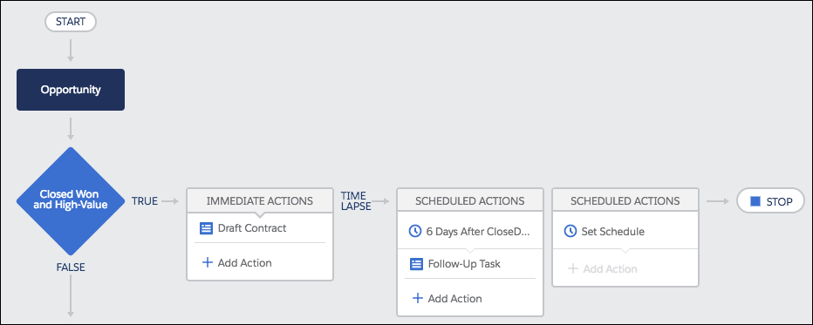

Trigger: Identify When the Process Should Run

The trigger identifies when the process should run. For record change processes, the trigger determines which object and which of the following changes the process should pay attention to.

Only when a record is created

Anytime a record is created or edited

Criteria: Determine Whether or Not to Execute Actions

While a process gets one trigger, you can add as many criteria nodes as your heart desires. Each criteria node controls whether or not the process executes the associated actions. If the record doesn’t meet the criteria, the process skips those actions and moves on to the next criteria node in the process.

In each criteria node, you can:

Set filter conditions.

Enter a custom formula. Like in validation rules, the formula must resolve to true or false.

Opt out of criteria and always execute the associated actions.

Actions: What the Process Should Do

When a criteria node evaluates to true, the process executes the associated actions or waits to execute them at a scheduled time.

Each immediate action is executed as soon as the criteria evaluates to true.

Each scheduled action is executed at the specified time, such as 10 days before the record’s close date or 2 days from now. At the specified time, Salesforce makes sure that the associated criteria node still evaluates to true. If so, the scheduled action is executed. You can schedule actions based on either:A specific date/time field on the record that started the process. For example, a month before an account’s service contract expires.The time that the process ran. For example, 3 days from now.

Regardless of when the actions execute, here are some of the things you can do with a process action.

-Create records.

-Update the record that started the process or any related record.

-Submit that record for approval.

-Update one or more related records.

-Send emails using a specified email template.

-Post to a Chatter feed.

1. 9. Question

When viewing a Quote, the sales representative wants to easily see how many discounted items are included in the Quote Line items. What should a developer do to meet this requirement?

* +  Create a trigger on the Quote object that queries the Quantity field on discounted Quote Line Items
  +  Create a Workflow Rule on the Quote Line Item object that updates a field on the parent Quote when the item is discounted.
  + ** Create a roll-up summary field on the Quote object that performs a SUM on the quote Line Item Quantity field, filtered for only discounted Quote Line Items**
  +  Create a formula field on the Quote object that performs a SUM on the Quote Line Item Quantity field, filtered for only discounted Quote Line Items.

**Unattempted**

1. 10. Question

Which two Apex data types can be used to reference a Salesforce record ID dynamically? (Choose two )

* +  ENUM
  + ** sObject**
  +  External ID
  + ** String**

**Unattempted**

sObject and String are the two apex date types used for reference a Salesforce record ID dynamically.

Explanation:The sObject type defines an object’s existence in force.com, a generic and a unique data type that can be used in either standard or custom objects. The real purpose of the sObject is that it takes the actual meaning for portrayal of any object that it is designated to it. For example: Fruit is a generic type whereas pineapple, guava, orange is all concrete types of sObject fruit. And strings similar to other programming languages, is also used to store characters of infinite length.

1. 11. Question

Where can a developer identify the time taken by each process in a transaction using Developer Console log inspector?

* +  Performance Tree tab under Stack Tree panel
  +  Execution Tree tab under Stack Tree panel
  + ** Timeline tab under Execution Overview panel**
  +  Save Order tab under Execution Overview panel

**Unattempted**

Log Inspector

The Log Inspector is a context-sensitive execution viewer in the Developer Console. It shows the source of an operation, what triggered the operation, and what occurred next. Use this tool to inspect debug logs that include database events, Apex processing, workflow, and validation logic.

The panels displayed in the Log Inspector depend on the selected perspective. To switch perspectives, select Debug | Switch Perspective.

Some features in the Log Inspector, such as filtering and searching, are available only after a debug log has finished loading and processing. To access a log that is still processing, select File | Open Raw Log.

Log Panels

The Log Inspector can contain the following panels:

-Stack Tree

-Execution Stack

-Execution Log

-Source

-Variables

-Execution Overview

Execution Overview: Save Order, Limits, Timeline, and Executed Units

The Execution Overview panel at the bottom of the Log Inspector contains four tabs:

The Save Order tab displays a color-coded timeline of DML actions. For each DML action taken, save order elements are shown as boxcars in the timeline.

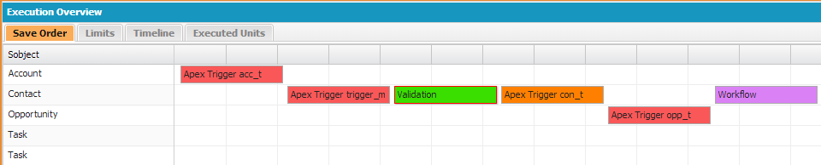

The Timeline tab provides a visual representation of the time taken by each process. Select the Scale option that results in the most useful view.

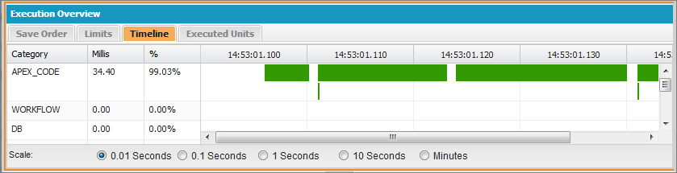

The Timeline tab contains this information:

COLUMN               DESCRIPTION

Category                Type of process.

Millis                       Milliseconds of time taken by the process.

%                            Percent the process took of the entire request.

1. 12. Question

Which two platform features align to the Controller portion of MVC architecture? (Choose two)

* + ** Process Builder actions**
  + ** Workflow rules**
  +  Standard objects
  +  Date fields

**Unattempted**

Model View Controller (MVC)

Model view controller (MVC) is a software architecture pattern which separates the representation of information from the user’s interaction with it

In addition to dividing the application into three kinds of components, the MVC design defines the interactions between them.

A controller can send commands to its associated view to change the view’s presentation of the model (e.g., by scrolling through a document). It can also send commands to the model to update the model’s state (e.g., editing a document).

A model notifies its associated views and controllers when there has been a change in its state. This notification allows the views to produce updated output, and the controllers to change the available set of commands. A passive implementation of MVC omits these notifications, because the application does not require them or the software platform does not support them.

A view requests from the model the information that it needs to generate an output representation.

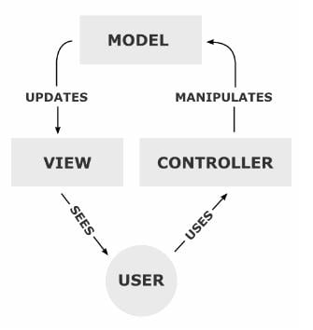

Model: What schema and data does salesforce uses to represent the system completely. In salesforce, we can say that sObjects are the model as every entity in salesforce is mapped to some sObject.

View: How the schema and data is represented. Visualforce is used to present the data to users.

Controller: How the interface actions. Controllers are used to perform the actions whenever users interact with visual force.

In SFDC

1. Visual Force pages, Page Layouts, Tabs comes under View Layer of Model View controller .

2. Workflows, Apex Classes, Triggers comes under Controller part in Model View controller .

3. Objects, Fields, Relationships comes under Model Layer of Model View Controller .

1. 13. Question

A developer needs to test an Invoicing system integration. After reviewing the number of transactions required for the test, the developer estimates that the test data will total about 2GB of data storage. Production data is not required for the integration testing. Which two environments meet the requirements for testing ? Choose two

* +  Developer Sandbox
  + ** Full Sandbox**
  +  Developer Edition
  + ** Partial Sandbox**
  +  Developer Pro Sandbox

**Unattempted**

Developer Sandbox  
A Developer sandbox is intended for development and testing in an isolated environment. A Developer Sandbox includes a copy of your production org’s configuration (metadata).

Developer Pro Sandbox  
A Developer Pro sandbox is intended for development and testing in an isolated environment and can host larger data sets than a Developer sandbox. A Developer Pro sandbox includes a copy of your production org’s configuration (metadata). Use a Developer Pro sandbox to handle more development and quality assurance tasks and for integration testing or user training.

Partial Copy Sandbox  
A Partial Copy sandbox is intended to be used as a testing environment. This environment includes a copy of your production org’s configuration (metadata) and a sample of your production org’s data as defined by a sandbox template. Use a Partial Copy sandbox for quality assurance tasks such as user acceptance testing, integration testing, and training.

Full Sandbox  
A Full sandbox is intended to be used as a testing environment. Only Full sandboxes support performance testing, load testing, and staging. Full sandboxes are a replica of your production org, including all data, such as object records and attachments, and metadata.

1. 14. Question

A developer working on a time management application wants to make total hours for each timecard available to application users. A timecard entry has a Master-Detail relationship to a timecard. Which approach should the developer use to accomplish this declaratively?

* +  A visualforce page that calculates the total number of hours for a timecard and displays it on the page.
  + ** A Roll-up summary field on the Timecard Object that calculates the total hours from timecard entries for that timecard**
  +  A process builder process that updates a field on the timecard when a timecard entry is created
  +  An Apex trigger that uses an Aggregate Query to calculate the hours for a given timecard and stores it in a custom field.

**Unattempted**

Roll-up summary field

A roll-up summary field calculates values from related records, such as those in a related list. You can create a roll-up summary field to display a value in a master record based on the values of fields in a detail record. The detail record must be related to the master through a master-detail relationship. For example, you want to display the sum of invoice amounts for all related invoice custom object records in an account’s Invoices related list. You can display this total in a custom account field called Total Invoice Amount.

You can perform different types of calculations with a roll-up summary field. You can count the number of detail records related to a master record. Or, you can calculate the sum, minimum value, or maximum value of a field in the detail records.

1. 15. Question

A developer encounters APEX heap limit errors in a trigger. Which two methods should the developer use to avoid this error? (Choose two)

* + ** Use the transient keyword when declaring variables**
  +  Query and store fields from the related object in a collection when updating related objects.
  +  Remove or set collections to null after use
  + ** Use SOQL for loops instead of assigning large queries results to a single collection and looping through the collection**

**Unattempted**

We can use transient keyword with apex class’s instance variables when we want that values of those variables should not be transferred as part of the view state of visualforce page. This helps us reducing the view state of visualforce page. As we all know that, there is a limit of 135KB of view state and many times this “Transient” keyword helps us to reduce the view state.

There are certain points that we should consider while using the transient keyword:

The value of transient variable is only transferred from controller to visualforce page but not as part of view state. As the value is not part of view state, the changed value of that variable is not transferred back from visualforce page to controller when a new request is made by clicking a button or link.

We should use the transient keyword mostly in case where we have read only Visualforce page and data doesn’t need to be sent back to controller in further requests. A common use case for the transient keyword is a field on a Visualforce page that is needed only for the duration of a page request, but should not be part of the page’s view state and would use too many system resources to be recomputed many times during a request.

1. 16. Question

Which approach should be used to provide test data for a test class?

* +  Query for existing records in the database.
  +  Execute anonymous code blocks that create data
  + ** Use a test data factory class to create test data.**
  +  Access data in @TestVisible class variables.

**Unattempted**

Data Factories are apex classes that are responsible for generating data. They primarily generate Salesforce records in various ways. By far, test classes use Data Factories the most to generate their data.  
//service provider

public abstract class TestDataFactory {

//Account creation  
public static List createAccounts( Integer numberOfAccounts) {  
List accounts = new List();  
for ( Integer i = 0 ; i < numberOfAccounts ; i++ ) { Account account = new Account( firstname = 'Test Account' + Math.random(), lastname = 'Account', PersonEmail = 'noreplay@email.com',Home_Phone__c= '(415) 419-8873',PersonMailingStreet = '5353 W.Test Rd', PersonMailingCity = 'Testdale', PersonMailingState = 'CA', PersonMailingPostalCode = '94803'); accounts.add( account); } return accounts; } } // Consumer class @isTest private class TestDataFactoryTest { static Account account; //test for creating Accounts static testMethod void createAccountsTest() { account = TestDataFactory.createAccounts(1)[0]; insert account; system.debug('Account Id'+account.id); account = [select firstname, lastname,personmailingpostalcode,personEmail from account where id = :account.id]; system.assertEquals(account.lastname, 'Account'); system.assertEquals(account.personmailingpostalcode, '94803'); system.debug('Account Firstname'+ account.FirstName); } }

1. 17. Question

Which approach should a developer take to automaically add a ” Maintenance Plan” to each Opportunity that includes an “Annual Subscription” when an opportunity is closed?

* +  Build a OpportunityLineItem trigger that adds a PriceBookEntry record.
  +  Build an OpportunityLineItem trigger to add an OpportunityLineItem record
  +  Build an Opportunity trigger that adds a PriceBookEntry record.
  + ** Build an Opportunity trigger that adds an OpportunityLineItem record.**

**Unattempted**

1. 18. Question

What is the requirement for a class to be used as a custom Visualforce Controller?

* +  Any top-level Apex class that has a constructor that returns a PageReference
  +  Any top-level Apex class that extends a PageReference.
  + ** Any top-level Apex class that has a default, no-argument constructor**
  +  Any top-level Apex class that implements the controller interface

**Unattempted**

1. 19. Question

A visualforce page is required for displaying and editing Case records that includes both standard and custom functionality defined in an Apex class called myControllerExtension. The visualforce page should include attribute(s) to correctly implement controller functionality?

* +  controller="Case" and extensions="myControllerExtension"
  +  extensions="myControllerExtension"
  +  controller="myControllerExtension"
  + ** standardController="Case" and extensions="myControllerExtension"**

**Unattempted**

What is visualforce controller extension ?

Visualforce controller Extension :-If we want to use both custom controller functionality and standard controller functionality we use extension controllers. Extension Controllers begins with Standard controller and extended or overridden with custom controller with custom apex code.

Syntax :-

1. 20. Question

A newly hired developer discovers that there are multiple triggers on the case object. What should the developer consider when working with triggers?

* +  Developers must dictate the order of trigger execution
  +  Trigger execution order is based on creation date and time
  +  Unit tests must specify the trigger being tested
  + ** Trigger execution order is not guaranteed for the same sObject.**

**Unattempted**

1. 21. Question

How should a developer prevent a recursive trigger?

* +  Use a "one trigger per object" pattern
  +  Use a static Boolean variable
  +  Use a trigger handler
  + ** Use a private Boolean variable**

**Unattempted**

What is a Recursive Trigger :

A recursive trigger is one that performs an action, such as an update or insert, which invokes itself owing to, say something like an update it performs.

How to avoid Recursive Trigger:

To avoid recursive triggers you can create a class with a static Boolean variable with default value true. In the trigger, before executing your code keep a check that the variable is true or not. Once you check make the variable false.

Example:

public Class checkRecursive{  
private static boolean run = true;  
public static boolean runOnce(){  
if(run){  
run=false;  
return true;  
}else{  
return run;  
}  
}  
}

1. 22. Question

Which three options can be accomplished with formula fields?Choose three

* + ** Generate a link using the HYPERLINK function to a specific record**
  +  Display the previous value for a field using the PRIORVALUE function
  + ** Determine if a datetime field value has passed using the NOW function**
  +  Return and display a field value from another object using the VLOOKUP function
  + ** Determine which of three different images to display using the IF function**

**Unattempted**

1. 23. Question

What is a capability of the tag that is used for loading external Javascript libraries in Lightning Component? (Choose three)

* +  Loading files from Documents
  + ** One-time loading for duplicate scripts**
  + ** Specifying loading order**
  + ** Loading scripts in parallel**
  +  Loading externally hosted scripts

**Unattempted**

[https://developer.salesforce.com/docs/atlas.en-us.lightning.meta/lightning/js_libs_platform.htm#](https://developer.salesforce.com/docs/atlas.en-us.lightning.meta/lightning/js_libs_platform.htm)!

1. 24. Question

A Platform Developer needs to write an Apex method that will only perform an action if a record is assigned to a specific Record Type. Which two options allow the developer to dynamically determine the ID of the required Record Type by its name ? Choose two

* +  Make an outbound web services call to the SOAP API
  +  Hardcode the ID as a constant in an Apex class
  + ** Use the getRecordTypeInfosByName() method in the DescribeSObjectResult class**
  + ** Execute a SOQL query on the RecordType object**

**Unattempted**

getRecordTypeInfosByName()

Returns a map that matches record labels to their associated record type. The current user is not required to have access to a record type to see it in this map.

1. 25. Question

A developer has the controller class below:  
public with sharing class myFooController {  
public integer prop {get; private set; }  
}  
Which code block will run successfully in an execute anonymous window?

* +  myFooController m=new myFooController(); System.assert(m.prop != null);
  +  myFooController m= new myFooController(); System.assert(m.prop==0)
  + ** myFooContoller m =new myFooContoller(); System.assert(m.prop ==null);**
  +  myFooController m= new myFooController(); System.assert(m.prop ==1)

**Unattempted**

1. 26. Question

A developer writes the following code:  
List acc=[select id from Account Limit 10];  
Delete acc;  
Database.emptyRecycleBin(acc);  
System.debug(Limits.getDMLStatements() +’, ‘+Limits.getLimitDMLStatements());  
What is the result of the debug statement?

* +  1100
  +  1150
  + ** 2150**
  +  2200

**Unattempted**

1. 27. Question

Given:  
Map accountMap=new Map([Select id,Name from Account]);  
What are three valid Apex loop structures for iterating through items in the collection ? (Choose three)

* + ** for (ID accountID: accountMap.keySet()) {...}**
  + ** for (Account accountRecord: accountMap.values() ) {...}**
  + ** for(Integer i=0; I<="" label="" style="box-sizing: inherit;">**
  +  for (ID accountID: accountMap) {...}
  +  for (Account accountRecord: accountMap.keySet()) {...}

**Unattempted**

1. 28. Question

Universal Containers wants Opportunities to be locked from editing when reaching the Closed/Won stage. Which two strategies should a developer use to accomplish this ? Choose two

* +  Use a Visual Workflow
  + ** Use a validation rule**
  +  Use the Process Automation Settings
  + ** Use a Trigger**

**Unattempted**

1. 29. Question

How should a developer make sure that a child record on a custom object, with a lookup to the Account object, has the same sharing access as its associated account?

* +  Create a Sharing Rule comparing the custom object owner to the account owner.
  +  Create a validation rule on the custom object comparing the record owners on both records
  +  Include the sharing related list on the custom object page layout
  + ** Ensure that the relationship between the objects is Master-Detail**

**Unattempted**

1. 30. Question

Which approach should a developer use to add pagination to a Visualforce page?

* +  A StandardController
  +  The Action attribute for a page
  +  The extensions attribute for a page
  + ** A StandardSetController**

**Unattempted**

1. 31. Question

A developer is asked to create a PDF quote document formatted using the company’s branding guidelines and automatically save it to the Opportunity record. Which two ways should a developer create this functionality? (Choose two)

* + ** Install an application from the AppExchange to generate documents**
  + ** Create a Visualforce page with custom styling**
  +  Create an email template and use it in Process Builder
  +  Create a visual flow that implements the company's formatting.

**Unattempted**

1. 32. Question

Which tool allows a developer to send requests to the Salesforce REST APIs and view the responses?

* +  REST resource path URL
  + ** Workbench REST Explorer**
  +  Developer Console REST tab
  +  Force.com IDE REST Explorer tab

**Unattempted**

How to open REST Explorer?

1) Log in to your developer organization.

2) Open a new browser tab and navigate to https://workbench.developerforce.com/login.php. and login after click on I agree button.

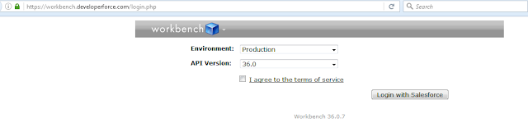

3) Then Open REST Explorer. Click Utilities | REST Explorer.

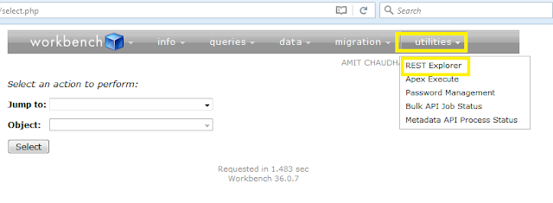

4) If you want to see REST Explorer service then use below URL and click on execute button

URL:- /services/data/v36.0

Method :- Get

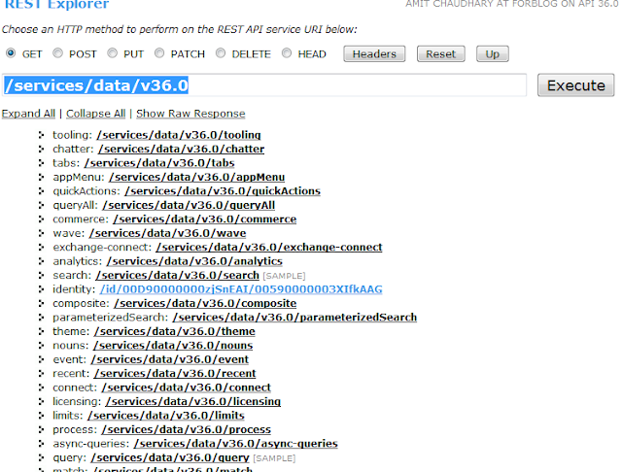

1. 33. Question

A developer created a Visualforce page and a custom controller with methods to handle different buttons and events that can occur on the page. What should the developer do to deploy to production?

* +  Create a test class that provides coverage of the Visualforce page
  +  Create a test page that provides coverage of the Visualforce page
  +  Create a test page that provides coverage of the custom controller
  + ** Create a test class that provides coverage of the custom controller**

**Unattempted**

1. 34. Question

What is  a benefit of using an after insert trigger over using a before insert trigger?

* +  An after insert trigger allows a developer to bypass validation rules when updating fields on the new record.
  + ** An after insert trigger allows a developer to insert other objects that reference the new record.**
  +  An after insert trigger allows a developer to make a callout to an external service
  +  An after insert trigger allows a developer to modify fields in the new record without a query

**Unattempted**

1. 35. Question

An org has a single account named ‘NoContacts’ that has no related contacts. Given the query:  
List accounts=[Select Id,(select Id, Name from Contacts) from Account where Name=’NoContacts’];  
What is the result of running this Apex?

* +  accounts[0].contacts is invalid Apex
  + ** accounts[0].contacts is an empty Apex**
  +  accounts[0].contacts is Null
  +  A QueryException is thrown

**Unattempted**

1. 36. Question

A platform developer at Universal Containers needs to create a custom button for the Account object that, when clicked will perform a series of calculations and redirect the user to a custom Visualforce page. Which three attributes need to be defined with values in the tag to accomplish this ? Choose three

* + ** action**
  + ** renderAs**
  + ** standardController**
  +  readOnly
  +  extensions

**Unattempted**

1. 37. Question

Using the Schema Builder, a developer tries to change the API name of a field that is referenced in an Apex test class. What is the end result?

* +  The API name is not changed and there are no other impacts.
  +  The API name of the field and the reference in the test class is changed
  + ** The API name of the field is changed, and a warning is issued to update the class.**
  +  The API name of the field and the reference in the test class is updated

**Unattempted**

1. 38. Question

When is an Apex Trigger required instead of a Process Builder Process?

* +  When a record needs to be created
  +  When multiple records related to the triggering record need to be updated
  +  When a post to Chatter needs to be created
  + ** When an action needs to be taken on a delete or undelete, or before a DML operation is executed.**

**Unattempted**

Process Builders cannot handle before DML It executes after a record has been created or updated. Whereas Apex triggers can handle both before and after DML operations.

Process Builder cannot handle delete and undelete DML. Whereas Apex triggers can handle all DML operations.

An error reported in Process Builder is more generic which makes it difficult to find the origin of the error. With Apex triggers, exception handling can be made more specific.

1. 39. Question

A developer needs to join data received from an integration with an external system with parent records in Salesforce. The data set  does not contain the Salesforce IDs of the parent records, but it does have a foreign key attribute that can be used to identify the parent. Which action will allow the developer to relate records in the data model without knowing the Salesforce ID?

* +  Create and populate a custom field on the parent object marked as Unique.
  +  Create a custom field on the child object of type External Relationship
  +  Create and populate a custom field on the parent object marked as an External ID
  + ** Create a custom field on the child object of type Foreign Key**

**Unattempted**

1. 40. Question

A developer created a Lightning component to display a short text summary for an object and wants to use it with multiple Apex classes. How should the developer design the Apex classes?

* +  Have each class define method getObject() that returns the sObject that is controlled by the Apex class.
  +  Extend each class from the same base class that has a method getTextSummary() that returns the summary
  + ** Have each class implement an interface that defines method getTextSummary() that returns the summary**
  +  Have each class define method getTextSummary() that returns the summary

**Unattempted**

1. 41. Question

The operation manager at a construction company uses a custom object called Machinery to manage the usage and maintenance of its cranes and other machinery. The manager wants to be able to assign machinery to different construction jobs, and track the dates and costs associated with each job. More than one piece of machinery can be assigned to one construction job. What should a developer do to meet these requirements?

* + ** Create a lookup field on the Construction job object to the Machinery object**
  +  Create a lookup field on the Machinery object to the Construction Job object
  +  Create a Junction object with Master-Detail relationship to both the Machinery object and the Construction Job object
  +  Create a junction object with Master-Detail relationship to both the Machinery object and the Construction Job object

**Unattempted**

What is Lookup Relationship in Salesforce?

Lookup relationship is a one type of relationship which form loose bond relationship between Parent object and Child object.

In lookup Child record need not be associated to a parent.

No Cascade record deletion happens.

Lookup field is not required on the page layouts of the detail object.

No Rollup summary fields can be created in Lookup relationship.

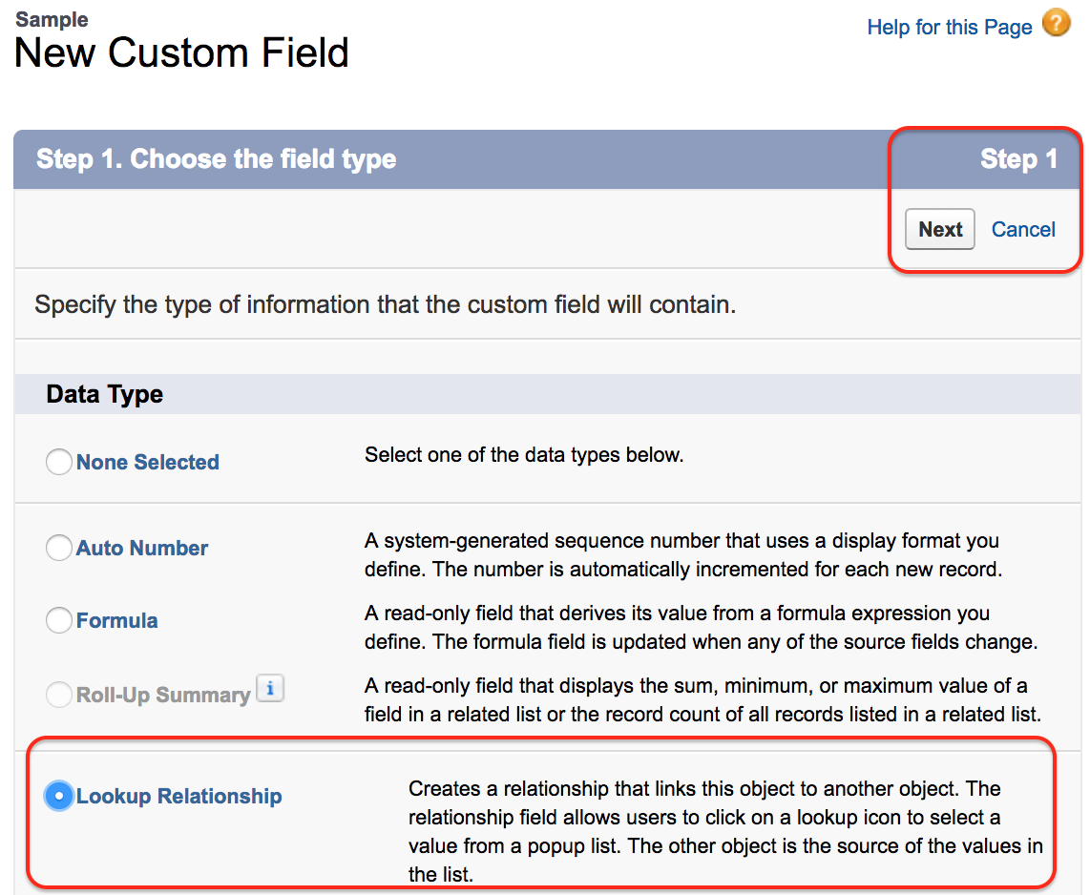

1. 42. Question

Which two strategies should a developer use to avoid hitting governor limits when developing in a multi-tenant environment? Choose two

* +  Use collections to store all fields from a related object and not just minimally required fields
  + ** Use methods from the "Limits" class to monitor governor limits.**
  + ** Use SOQL for loops to iterate data retrieved from queries that return a high number of rows**
  +  Use variables within Apex classes to store large amounts of data

**Unattempted**

The Limits methods return the specific limit for the particular governor, such as the number of calls of a method or the amount of heap size remaining.

Because Apex runs in a multitenant environment, the Apex runtime engine strictly enforces a number of limits to ensure that runaway Apex doesn’t monopolize shared resources.

None of the Limits methods require an argument. The format of the limits methods is as follows:

myDMLLimit = Limits.getDMLStatements();

1. 43. Question

Which set of roll-up types are available when creating a roll-up summary field?

* + ** COUNT, SUM, MIN, MAX**
  +  AVERAGE,SUM,MIN, MAX
  +  SUM, MIN, MAX
  +  AVERAGE, COUNT, SUM, MIN, MAX

**Unattempted**

Note : Roll up summary field can only be defined on the master object.

The Roll up Summary field is basically of 4 types:

Count

Sum

Min

Max

1. 44. Question

Which three tools can deploy metadata to production? (Choose three)

* +  Change Set from Developer Org
  + ** Force.com IDE**
  +  Data Loader
  + ** Change Set from Sandbox**
  + ** Metadata API**

**Unattempted**

1. 45. Question

How should a developer avoid hitting the governor limits in test methods?

* +  Use @TestVisible on methods that create records
  +  Use Test.loadData() to load data from a static resource
  +  Use @isTest (SeeAllData=true) to use existing data
  + ** Use Test.startTest() to reset governor limits**

**Unattempted**

Set up your test data in @testSetup. To avoid using your test governor limits, start with Test.startTest()  
@isTest class MyUnitTestClass {  
@testSetup static void testSetup() {  
Test.startTest();  
// Do your DML operations here  
Test.stopTest();  
}  
@isTest static void test() {

Test.startTest();  
// Test your business logic here  
Test.stopTest();  
}  
}

1. 46. Question

Which three declarative fields are correctly mapped to variable types in Apex? (Choose three)

* + ** Number maps to Decimal**
  +  Number maps to Integer
  +  TextArea maps to List of type String
  + ** Data/Time maps to Dateline**
  + ** Checkbox maps to Boolean**

**Unattempted**

1. 47. Question

A developer is asked to set a picklist field to ‘Monitor’ on any new Leads owned by a subnet of Users. How should the developer implement this request?

* +  Create an after insert Lead trigger
  +  Create a before insert Lead trigger
  + ** Create a Lead Workflow Rule Field Update**
  +  Create a Lead formula field

**Unattempted**

1. 48. Question

A developer executes the following query in Apex to retrieve a list of contacts for each account:  
List accounts=[Select ID,Name,(Select ID,Name from Contacts) from Account];  
Which two exceptions may occur when it executes? Choose two

* +  CPU limit exception due to the complexity of the query
  +  SOQL query row limit exception due to the number of contacts
  + ** SOQL query limit exception due to the number of contacts**
  + ** SOQL query row limit exception due to the number of accounts**

**Unattempted**

1. 49. Question

Why would a developer consider using a custom controller over a controller extension?

* +  To increase the SOQL query governor limits
  + ** To implement all of the logic for a page and bypass default Salesforce functionality**
  +  To leverage built-in functionality of a standard controller
  +  To enforce user sharing settings and permissions

**Unattempted**

Controller extension leverages the built-in-functionality of Standard Controller, but overrides one or more actions.

Where as, Custom Controller replaces the functionality of Standard Controller without leveraging it.

1. 50. Question

A developer needs to display all of the available fields for an object. In which two ways can the developer retrieve the available fields if the variable myObject represents the name of the object? Choose two

* +  Use myObject.sObjectType.getDescribe().fieldSet() to return a set of fields
  + ** Use mySObject.myObject.fields.getMap() to return a map of fields**
  + ** Use Schema.describeSObjects(new String[] {myObject})[0].fields.getMap() to return a map of fields.**
  +  Use getGlobalDescribe().get(myObject).getDescribe().fields.getMap() to return a map of fields

**Unattempted**

1. 51. Question

A developer wants to override a button using Visualforce on an object. What is the requirement?

* +  The controller or extension must have a PageReference method
  + ** The standardController attribute must be set to the object**
  +  The action attribute must be set to a controller method
  +  The object record must be instantiated in a controller or extension

**Unattempted**

When a developer wants to override a button using visualforce on an object, the standardController attribute must be set to the object. In general, a controller is an Apex class which developers use to implement many of the positive features of visualforce, such as its logic.

Standard controllers are often used in coding to provide guidelines for standard functions like delete, save, and create records.

1. 52. Question

How should a developer create a new custom exception class?

* + ** public class CustomException extends Exception{}**
  +  CustomException ex=new (CustomException) Exception();
  +  public class CustomException implements Exception {}
  +  (Exception)CustomException ex=new Exception();

**Unattempted**

Create Custom Exceptions

You can’t throw built-in Apex exceptions. You can only catch them. But with custom exceptions, you can throw and catch them in your methods. Custom exceptions enable you to specify detailed error messages and have more custom error handling in your catch blocks.

Exceptions can be top-level classes, that is, they can have member variables, methods and constructors, they can implement interfaces, and so on.

To create your custom exception class, extend the built-in Exception class and make sure your class name ends with the word Exception, such as “MyException” or “PurchaseException”. All exception classes extend the system-defined base class Exception, and therefore, inherits all common Exception methods.

This example defines a custom exception called MyException.

public class MyException extends Exception {}

1. 53. Question

Which two number expressions evaluate correctly? Choose two

* + ** Double d=3.14159;**
  +  Integer I=3.14159;
  + ** Decimal d=3.14159;**
  +  Long l=3.14159;

**Unattempted**

1. 54. Question

How can a developer set up a debug log on a specific user?

* +  It is not possible to setup debug logs for users other than yourself
  +  Ask the user for access to their account credentials, log in as the user and debug the issue
  +  Create Apex code that logs code actions into a custom object
  + ** Set up a trace flag for the user,and define a logging level and time period for the trace**

**Unattempted**

1. 55. Question

A developer needs to create a Visualforce page that displays Case data. The page will be used by both support reps and support managers. The support Rep profile does not allow visibility  of the Customer_Satisfaction__c field, but the Support Manager profile does. How can the developer create the page to enforce Field Level Security and keep future maintenance to a minimum?

* +  Create one Visualforce Page for use by both profiles
  +  Use a new Support Manager permission set
  +  Create a separate Visualforce page for each profile
  + ** Use  a custom controller that has the with sharing keywords**

**Unattempted**

1. 56. Question

When an Account’s custom picklist field called customer Sentiment is changed to a value of “Confused”, a new related Case should automatically be created. Which two methods should a developer use to create this case ? Choose two

* + ** Process Builder**
  + ** Apex Trigger**
  +  Custom Button
  +  Workflow Rule

**Unattempted**

1. 57. Question

What are three characteristics of static methods? Choose three

* + ** Initialized only when a class is loaded**
  +  A static variable outside of the scope of an Apex transaction
  + ** Allowed only in outer classes**
  +  Allowed only in inner classes
  + ** Excluded from the view state for a Visualforce page**

**Unattempted**

A static method or variable doesn’t require an instance of the class in order to run.

Static methods, variables, or initialization code are associated with a class, and are only allowed in outer classes. When you declare a method or variable as static, it’s initialized only once when a class is loaded. Static variables aren’t transmitted as part of the view state for a Visualforce page.

1. 58. Question

What are two uses for External IDs?  Choose two

* + ** To create relationships between records imported from an external system.**
  +  To create a record in a development environment with the same Salesforce ID as in another environment
  +  To identify the sObject type in Salesforce
  + ** To prevent an import from creating duplicate records using Upsert**

**Unattempted**

1. 59. Question

A developer wrote a unit test to confirm that a custom exception works properly in a custom controller, but the test failed due to an exception being thrown. Which step should the developer take to resolve the issue  and properly test the exception?

* + ** Use try/catch within the unit test to catch the exception**
  +  Use the finally block within the unit test to populate the exception
  +  Use the database methods with all or none set to FALSE
  +  Use Test.isRunningTest() within the custom controller

**Unattempted**

1. 60. Question

Which statement generates a list of Leads and Contacts that have a field with the phrase ACME?

* + ** List> searchList = [FIND “*ACME*“ IN ALL FIELDS RETURNING Contact, Lead);**
  +  List searchList = [FIND “*ACME*“ IN ALL FIELDS RETURNING Contact, Lead];
  +  List> searchList = [SELECT Name, ID FROM Contact, Lead WHERE Name like ACME‘];
  +  Map searchList = [FIND “ACME*“ IN ALL FIELDS RETURNING Contact, Lead];

**Unattempted**

This question is related to the concept of SOSL Query in Salesforce.  
Salesforce Object Search Language (SOSL) is a Salesforce search language that is used to perform text searches in records. Use SOSL to search fields across multiple standard and custom object records in Salesforce.  
Basic SOSL Syntax:  
FIND ‘SearchQuery‘ [IN SearchGroup] [RETURNING ObjectsAndFields]  
In above SOSL query syntax:  
   SearchQuery is the text to search for (a single word or a phrase)  
   SearchGroup is optional. It is the scope of the fields to search. If not specified, the default search scope is all fields. SearchGroup can take one of the following values.  
     o ALL FIELDS  
     o NAME FIELDS  
     o EMAIL FIELDS  
     o PHONE FIELDS  
   ObjectsAndFields is optional. It is the information to return in the search resulta list of one or more sObjects and, within each sObject, list of one or more fields, with optional values to filter against. If not specified, the search results contain the IDs of all objects found.  
Please Note: Return Type of SOSL is List of List of sObjects.  
The correct answer is List> searchList = [FIND “*ACME*“ IN ALL FIELDS RETURNING Contact, Lead); because as per above explanation it has correct return type List of List of sObjects and also the correct query syntax.  
The other answers are not correct:  
Option List> searchList = [SELECT Name, ID FROM Contact, Lead WHERE Name like ACME‘]; is NOT correct because the SOSL syntax is wrong. It cannot start with Select keyword.  
Option Map searchList = [FIND “ACME*“ IN ALL FIELDS RETURNING Contact, Lead]; is NOT correct because the return type is NOT List of List of sObject.  
Option List searchList = [FIND “*ACME*“ IN ALL FIELDS RETURNING Contact, Lead]; is NOT correct because the return type is NOT List of List of sObject.

1. 1. Question

Do Apex Classes or Interfaces create different implementations of methods based on a specific application? The implementing class provides a method definition.

* +  Both
  + ** Interfaces**
  +  Classes
  +  Neither

**Unattempted**

1. 2. Question

Can a user change his personal information after logging in?

* +  No
  +  Only in Lightning
  + ** Yes**
  +  Only in Classic

**Unattempted**

1. 3. Question

Will changing the products on an Opportunity record be reflected on the synched Quote? And vice-versa?

* +  No to Both
  +  Only Opportunity to Quote
  + ** Yes to Both**
  +  Only Quote to Opportunity

**Unattempted**

1. 4. Question

Which loop would you use if you wanted to execute code block based on condition at least once?

* + ** Do-While Loop**
  +  SOQL Loop
  +  While Loop
  +  List/Set Iteration Loop
  +  Traditional Loop

**Unattempted**

1. 5. Question

SOSL, SOQL or DML: Which one uses the IN clause to specify search fields?

* +  DML
  + ** SOSL and SOQL**
  +  SOQL Only
  +  SOSL Only

**Unattempted**

1. 6. Question

Generally speaking, which of these two field criteria is more restricting?

* + ** Number**
  +  Text
  +  Both are equally restricting.

**Unattempted**

1. 7. Question

In which menu in the Developer Console can users select to skip the test coverage option?

* +  My Tests
  +  Test Manager
  + ** New Run**
  +  Test Classes

**Unattempted**

1. 8. Question

Which one is NOT one of the three tools for creating Apex Classes?

* +  Visual Studio Code
  +  Developer Console
  +  Apex Classes Page
  + ** Salesforce Setup**

**Unattempted**

1. 9. Question

Which of the following requires two Master-Child rRelationships to a single object in the child side?

* +  Master Detail
  +  Grandchild Relationship
  + ** Many to Many**
  +  External Lookup

**Unattempted**

1. 10. Question

Which component must be used to embed a website into a Visualforce page?

* +  apex:visualforce
  + ** apex:iframe**
  +  apex:getsite
  +  apex:inputhtml

**Unattempted**

1. 11. Question

Can the task created via Workflow be used to assign said task to other Salesforce object that is not a user?

* + ** Yes**
  +  No

**Unattempted**

1. 12. Question

Can Visualforce be used in a Standard Page Layout?

* +  No
  +  Only for Custom objects
  +  Only for Standard Objects
  + ** Yes**

**Unattempted**

1. 13. Question

Up to how many record types can be managed before performance issues emerge?

* +  50
  + ** 200**
  +  30
  +  100

**Unattempted**

1. 14. Question

The expression syntax is used to bind components in a Visualforce page to what?

* +  The method employed
  +  The apex class
  + ** The data set in the controller**

**Unattempted**

1. 15. Question

Which one is NOT one of the tools that can be used to generate test data for the test classes?

* +  Data from static Resources
  + ** Data Loader**
  +  SOQL Queries
  +  Apex

**Unattempted**

1. 16. Question

How are the components of a date variable represented in the syntax?

* +  (year, month, day, minute, second)
  +  (month, day)
  + ** (year, month, day)**
  +  (year, month, day, hour, minute, second)

**Unattempted**

1. 17. Question

Can External Objects be created from the Schema Builder?

* + ** No**
  +  Only in Classic
  +  Yes
  +  Only in Lightning

**Unattempted**

1. 18. Question

Which non-primitive data type requires a specific order of its components?

* +  Set
  +  Enum
  + ** List**
  +  Map

**Unattempted**

1. 19. Question

SOSL, SOQL or DML: Which one can use wildcards with the LIKE operator?

* + ** SOQL Only**
  +  SOSL Only
  +  DML
  +  SOSL and SOQL

**Unattempted**

1. 20. Question

If the overall code coverage of a test which only performs specific tests on classes does not go over 75% will the entire transaction be rolled back, also for those classes with over 75%?

* + ** Yes**
  +  No

**Unattempted**

1. 21. Question

SOSL, SOQL or DML: Which one can Filter search results using the WHERE clause?

* + ** SOSL and SOQL**
  +  SOSL Only
  +  SOQL Only
  +  DML

**Unattempted**

1. 22. Question

From where can Users be created?

* +  From the Users Tab
  +  From the FSL Setup
  + ** From Setup**
  +  From the Users Lightning Component

**Unattempted**

1. 23. Question

Which service can be used to allow Visualforce pages, Lightning Components and Aura components to talk and update one another?

* + ** Lightning Message**
  +  Application Events

**Unattempted**

1. 24. Question

Can the Skip Test Coverage option be selected in the Apex Test Execution page in Setup?

* + ** Yes**
  +  No

**Unattempted**

1. 25. Question

What is true regarding cascading execution of triggers? Choose 1 answer

* +  Each trigger will start a new execution context
  +  There is a limit of 5 triggers that can be executed from a cascading execution
  + ** Cascading triggers are part of the same execution context with respect to governor limits**
  +  Cascading execution of triggers will cause an exception

**Unattempted**

1. 26. Question

Which of the following are true when using Test Setup methods? Choose 2 answers

* +  The testing framework executes the test setup method last and after any test method in the class
  +  Test Setup method are prefixed with the @SetupForTest annotation
  + ** Any changes to the records created in the @testSetup method will be rolled back after each test method finishes execution**
  + ** Test Setup method is used to create test records once and then access them in every test method in the test class.**

**Unattempted**

Using Test Setup Methods

Use test setup methods (methods that are annotated with @testSetup) to create test records once and then access them in every test method in the test class. Test setup methods can be time-saving when you need to create reference or prerequisite data for all test methods, or a common set of records that all test methods operate on.

Test setup methods can reduce test execution times especially when you’re working with many records. Test setup methods enable you to create common test data easily and efficiently. By setting up records once for the class, you don’t need to re-create records for each test method.

@isTest  
private class CommonTestSetup {

@testSetup static void setup() {  
// Create common test accounts  
List testAccts = new List();  
for(Integer i=0;i<2;i++) {  
testAccts.add(new Account(Name = 'TestAcct'+i));  
}  
insert testAccts;  
}

@isTest static void testMethod1() {  
// Get the first test account by using a SOQL query  
Account acct = [SELECT Id FROM Account WHERE Name='TestAcct0' LIMIT 1];  
// Modify first account  
acct.Phone = '555-1212';  
// This update is local to this test method only.  
update acct;

// Delete second account  
Account acct2 = [SELECT Id FROM Account WHERE Name='TestAcct1' LIMIT 1];  
// This deletion is local to this test method only.  
delete acct2;

// Perform some testing  
}  
}

1. 27. Question

Which are true regarding how to display data in a Visualforce page? Choose 2 answers

* + ** Data context is provided to controllers by the id parameter of the page**
  +  The component component can be used to display individual fields from a record
  +  Object data can be inserted but not global data
  + ** Expression syntax is used to bind components to the data set available in the page controller**

**Unattempted**

1. 28. Question

Which of the following can be used to execute specific Apex test methods in an organization? Choose 3 answers

* + ** SOAP API**
  + ** Developer Console**
  + ** Visual Studio Code**
  +  Change Sets
  +  Data Loader

**Unattempted**

1. 29. Question

What constitutes the Model part in the Model-View-Controller paradigm? Choose 2 answers

* + ** Custom Objects**
  +  Visualforce Pages
  + ** Standard Objects**
  +  Standard Pages

**Unattempted**

SFDC MVC pattern contains below three modules:

Model

View

Controller

Model: What schema and data does salesforce uses to represent the system completely. In salesforce, we can say that sObjects are the model as every entity in salesforce is mapped to some sObject.

View: How the schema and data is represented. Visualforce is used to present the data to users.

Controller: How the interface actions. Controllers are used to perform the actions whenever users interact with visual force.

In SFDC

1. Visual Force pages, Page Layouts, Tabs comes under View Layer of Model View controller .

2. Workflows, Apex Classes, Triggers comes under Controller part in Model View controller .

3. Objects, Fields, Relationships comes under Model Layer of Model View Controller .

1. 30. Question

A developer has to do a quick one-time load of 100 custom object records into a development environment. The data is in a csv file and each record contains 5 fields. Which tool would you recommend to use to load the data? Choose 1 answer

* +  Custom Object Import Wizard
  +  Data API Tool
  + ** Data Import Wizard**
  +  Data Loader

**Unattempted**

Data import wizard provides you load the data into salesforce . By using this wizard we can insert, update & upsert the records.

By using this we can can import up to 50,000 records. It won’t allow you to load duplicate records.

By using this you can load Accounts, Contacts, Leads, Solutions and Custom objects.

To navigate data import wizard go to Setup -> Administer -> Data Management -> Data import Wizard and click on Launch Wizard.

1. 31. Question

You are trying to decide whether to use a master-detail or lookup relationship between two objects. Which of the following considerations  are true? Choose 3 answers

* + ** Custom Objects on the detail side of a master-detail relationship cannot have queues**
  + ** In a master-detail relationship, if the master record is deleted, the detail records will all be deleted**
  +  Child records in master-detail relationships on custom objects cannot be reparented
  + ** A custom object cannot be on the master side of a relationship with a standard object**
  +  In a master-detail relationship, the master record will be deleted when the only child is deleted

**Unattempted**

What is a “Lookup Relationship”?

Up to 25 allowed for object

Parent is not a required field.

No impact on a security and access.

No impact on deletion.

Can be multiple layers deep.

Lookup field is not required.

What is “Master-Detail Relationship”?

Master Detail relationship is the Parent child relationship. In which Master represents Parent and detail represents Child. If Parent is deleted then Child also gets deleted. Rollup summary fields can only be created on Master records which will calculate the SUM, AVG, MIN of the Child records.

Up to 2 allowed to object.

Parent field on child is required.

Access to parent determines access to children.

Deleting parent automatically deletes child.

A child of one master detail relationship cannot be the parent of another.

Lookup field on page layout is required.

1. 32. Question

Sending and receiving change sets can be done between which of the following? Choose 2 answers

* + ** Sandbox to Sandbox**
  +  Developer Edition to Developer Edition
  + ** Developer Sandbox to Production**
  +  Developer Edition to Production

**Unattempted**

1. 33. Question

Which are true regarding the runAs() method? Choose 2 answers

* + ** runAs() can be used with existing users or a new user**
  + ** runAs() ignores user license limits**
  +  runAs() can be used in any APEX method
  +  runAs() enforces user permissions and field level permissions

**Unattempted**

Using the runAs Method

Generally, all Apex code runs in system mode, where the permissions and record sharing of the current user are not taken into account. The system method runAs enables you to write test methods that change the user context to an existing user or a new user so that the user’s record sharing is enforced. The runAs method doesn’t enforce user permissions or field-level permissions, only record sharing.

You can use runAs only in test methods. The original system context is started again after all runAs test methods complete.

The runAs method ignores user license limits. You can create new users with runAs even if your organization has no additional user licenses.

1. 34. Question

What will happen if a governor limit is hit from an Apex class that was called from an Apex controller class of a Visualforce page? Choose 2 answers

* + ** An exception will be thrown**
  +  It will save all changes made from the Apex class
  + ** It will rollback all changes made up to the error**
  +  It will save all changes made from the Apex controller class

**Unattempted**

The exception thrown by hitting a limit, System.LimitException is uncatchable and means that your script will be killed, even if it happens inside a try/catch block. There is a class, Limits, that contains a number of static methods that allow you to check your governor limit consumption

1. 35. Question

Which of the following is a standard controller action that aborts an edit operation? Choose 1 answer

* + ** Cancel**
  +  Delete
  +  Close
  +  Save

**Unattempted**

1. 36. Question

You have come across a situation where a consultant works on behalf of multiple organizations. How can you track this in Salesforce? Choose 1 answer

* +  Use the Account Teams feature
  +  Create multiple contact records and relate the consultant to each organization they consult for
  + ** Use the Contacts to Multiple Accounts feature**
  +  Use the Account Hierarchy feature

**Unattempted**

1. 37. Question

The Salesforce Administrator was given a requirement to display the total cost of products at the time they are added to an opportunity. The product cost is a custom field on the product object and is added as a formula field to the opportunity product object. How would the Salesforce Administrator meet this requirement? Choose 1 answer

* + ** Create a workflow rule that copies the product cost to a currency field and create a roll-up summary field based on the currency field**
  +  Create a trigger that queries the product cost values and update the opportunity
  +  Create a roll- up summary field on the opportunity based on the product cost formula field
  +  Create a trigger that copies the product cost to a currency field

**Unattempted**

1. 38. Question

Which features are available in Visual Studio Code? Choose 2 answers

* + ** Execute anonymous code**
  +  Process Builder
  +  Schema Builder
  + ** Code Editor**

**Unattempted**

1. 39. Question

New Horizon Satellites uses Salesforce for opportunity management for its data service products. There are many variables and complex combinations that can be configured when offering a data service. The company currently uses Excel to produce quotes but would like to use Salesforce instead. What would be the recommended solution? Choose 2 answers

* +  Use the standard Quote template functionality
  +  Create a Visualforce page that displays the quote and allows saving it as a PDF
  +  Create a custom button that allows exporting the opportunity details to Excel
  + ** Look for an AppExchange product that meets the requirement s**
  + ** Use Salesforce Quote-to-Cash functionality**

**Unattempted**

1. 40. Question

What is the discretionary clause that can be added to a SOSL query to specify the information to be returned in the text search result? Choose 1 answer

* +  LIMIT n
  + ** RETURNING**
  +  OFFSET n
  +  ORDER by

**Unattempted**

FIND {SearchQuery}  
[ IN SearchGroup ]  
[ RETURNING FieldSpec [[ toLabel(fields)] [convertCurrency(Amount)] [FORMAT()]] ]  
[ WITH DivisionFilter ]  
[ WITH DATA CATEGORY DataCategorySpec ]  
[ WITH SNIPPET[(target_length=n)] ]  
[ WITH NETWORK NetworkIdSpec ]  
[ WITH PricebookId ]  
[ WITH METADATA ]  
[ LIMIT n ]

[ UPDATE [TRACKING], [VIEWSTAT] ]  
RETURNING FieldSpec : Optional. Information to return in the search result. List of one or more objects and, within each object, list of one or more fields, with optional values to filter against. If unspecified, the search results contain the IDs of all objects found.

1. 41. Question

There are several escape sequences that can be used in queries so that user query can contain special characters. Which of the following are valid escape sequences? Choose 3 answers

* +  \c
  + ** \n**
  + ** \"**
  +  \a
  + ** \'**

**Unattempted**

1. 42. Question

There is a requirement to validate that the country code of an account field is a valid ISO code.There are over 200 codes. What could be used for this validation? Choose 1 answer

* + ** Validation Rule**
  +  Workflow Rule
  +  After Update trigger
  +  Before Update trigger

**Unattempted**

Validation rules verify that the data a user enters in a record meets the standards you specify before the user can save the record. A validation rule can contain a formula or expression that evaluates the data in one or more fields and returns a value of “True” or “False”.

1. 43. Question

Global Insurance has custom objects to represent policies and claims. A policy can have zero or many claims. A claim is always related to a policy. Claims are first assigned to a queue and then later assigned to different members of the claims team. What type of relationship would be used to relate the policy and claim objects? Choose 1 answer

* +  Direct relationship
  + ** Lookup relationship**
  +  Self relationship
  +  Master-detail relationship

**Unattempted**

1. 44. Question

Stock Symbol is a custom field on the Account object. What is the best way to make this field appear on Contact detail page layout? Choose 1 answer

* +  Roll-Up Summary Field
  +  Lookup field
  + ** Formula field**
  +  Requires Apex code
  +  Parent Field

**Unattempted**

1. 45. Question

Where can a developer use Visualforce in Lightning Experience? Choose 3 answers

* + ** Custom App**
  + ** Navigation Bar**
  + ** Standard Page Layout**
  +  Setup Home Page
  +  Chatter Feed

**Unattempted**

1. 46. Question

What is true about Custom Exceptions? Choose 3 answers

* +  They are not capable of re-throwing a caught exception
  +  Built-in and custom Apex exceptions behave the same in throwing and catching exceptions.
  + ** They are primarily useful if the method is called by another method and the exception handling is transferred to the other method**
  + ** They are capable of specifying detailed error messages and have additional custom error handling in catch blocks**
  + ** They are built by extending the built-in Exception class and should end with the word Exception**

**Unattempted**

Create Custom Exceptions

You can’t throw built-in Apex exceptions. You can only catch them. But with custom exceptions, you can throw and catch them in your methods. Custom exceptions enable you to specify detailed error messages and have more custom error handling in your catch blocks.

To create your custom exception class, extend the built-in Exception class and make sure your class name ends with the word Exception, such as “MyException” or “PurchaseException”. All exception classes extend the system-defined base class Exception, and therefore, inherits all common Exception methods.

This example defines a custom exception called MyException.

public class MyException extends Exception {}

1. 47. Question

Which of the following statements about triggers are true? Choose 3 answers

* + ** For the Attachment,ContentDocument and Note standard objects, a trigger cannot be created in the Salesforce user interface**
  +  Apex Triggers are always active and cannot be turned off
  + ** A developer can specify the version of Apex and API which can be used with the Trigger**
  + ** Trigger code is stored as metadata under the object which they are associated with**
  +  Triggers can be used to detect a before undelete event.

**Unattempted**

1. 48. Question

When catching exceptions, the default notification actions in uncaught exceptions will be lost,so developers are expected to formulate their own. Which of the following ways can a developer notify the user of the issue? Choose 2 answers

* +  Adding a @future method to create a record on a custom object that could catch the error details
  +  Sending an email that may add to the catch-block of a try-catch construct
  + ** Using ApexPages.message class to create an error message for display on a Visualforce page**
  + ** Using .addError method on errors that may occur in DML on Apex Triggers**

**Unattempted**

1. 49. Question

In the following line of code, why can the helloWorld() method be called directly instead of instantiating the myClass?

* +  myClass.helloWorld('Hello');
  +  Choose 1 answer
  +  myClass is defined as public
  +  myClass is defined as a static class
  +  helloWorld is defined as a void method
  + ** helloWorld is defined as a static method**

**Unattempted**

Static : Static methods, variables and initialization code have following characteristics.

They are associated with a class.

They’r allowed only in outer class.

They’r initialized only when the class is loaded.

They’r not transmitted as part of the view state for a VF page.

1. 50. Question

Because Apex runs in a multitenant environment, the Apex runtime engine enforces limits to ensure that Apex code or processes don’t monopolize shared resources. What are valid examples of these limits? Choose 3 answers

* +  Maximum execution time for a DML operation
  + ** Time executing a SOQL query**
  + ** CPU time per transaction**
  + ** Total number of records retrieved by SOQL queries**
  +  Maximum number of records that can be stored

**Unattempted**

What are Governor Limits?

As we know, Apex runs in multi-tenant environment, i.e., a single resource is shared by all the customers and organizations. So, it is necessary to make sure that no one monopolizes the resources and hence Salesforce.com has created the set of limits which governs and limits the code execution. Whenever any of the governor limits are crossed, it will throw error and will halt the execution of program.

From a Developer’s perspective, it is important to ensure that our code should be scalable and should not hit the limits.

All these limits are applied on per transaction basis. A single trigger execution is one transaction.

1. 51. Question

A developer would like to selectively include related lists on a detail page. Which component allows the developer to achieve this in the most straightforward way? Choose 1 answer

* +  <apex:dataList>
  +  <apex:dataTable>
  + ** <apex:relatedList>**
  +  <apex:repeat>

**Unattempted**

apex:relatedList

A list of Salesforce records that are related to a parent record with a lookup or master-detail relationship.

You’re looking at some related lists for {!account.name}:

Titles can be overriden with facets

1. 52. Question

Which of the following are valid use cases of Apex code? Choose 3 answers

* + ** Server-side calls from custom Lightning components**
  + ** Triggers**
  +  Visualforce pages with standard controllers
  +  Custom button with Javascript
  + ** Web Service**

**Unattempted**

1. 53. Question

What does Trigger.new contain? Choose 1 answer

* +  A list of new records and is available only in insert triggers
  + ** A list of new versions of records and is available in insert, update and undelete triggers**
  +  A set of new versions of records available in insert and update triggers
  +  A map of sObject ids and records that are new or modified and available in insert and update triggers

**Unattempted**

Trigger.new : Returns a list of the new versions of the sObject records. Note that this sObject list is only available in insert and update triggers, and the records can only be modified in before triggers.

Trigger.old : Returns a list of the old versions of the sObject records. Note that this sObject list is only available in update and delete triggers.

1. 54. Question

As per the order of execution, when will an email created from a workflow email alert be sent? Choose 1 answer

* +  Before entitlement rules execution
  + ** After all DML operations are committed to the database**
  +  When all before triggers are executed
  +  After workflow rule execution

**Unattempted**

1. 55. Question

Which of the following can be uploaded as a static resource and can be referenced in a Visualforce page using a global variable? Choose 3 answers

* + ** JavaScript File**
  + ** Archive**
  +  Apex Class
  +  Apex Trigger
  + ** Style Sheet**

**Unattempted**

Use static resource in Visualforce – Salesforce

Force.com platform provides us a facility to upload, manage and use the content that is static (not changing) for your organization, and it can be stored under “Static Resources“. It can be a Javascript file, CSS file, an image or even a zip file containing all the files required in one zip file.

Use a static resource to display an image on a visualforce page

In example we will cover, how to use a static resource to display an image on a visualforce page.

Below are the ways to use the static resources in our visualforce pages:

Suppose there is a single file like any single image or standalone css file, that you need to refer in your VF page, then you can directly use the “$Resource.resourceName” to refer the static resource where ‘$Resource‘ is a global variable to use any static resource within visualforce page. You need not to hard code the path of the static resource in VF page code. Below are some examples of the same.

Suppose you have an image file uploaded in static resource with name “**Z_test”** as shown below in the screenshot.

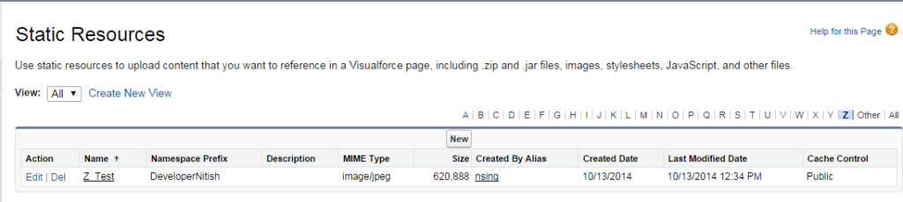

1. 56. Question

A developer is selecting and running the same set of test classes repeatedly. What feature can help with making this task more efficient? Choose 1 answer

* +  Defining a test set
  + ** Defining a test suite**
  +  Reducing the number of test classes
  +  Defining a master test class

**Unattempted**

A Test Suite is a collection of test classes that you can run together. If you are working on a specific set of test classes and running regularly, create a test suite with the list of test classes that you want to execute and run that test suite instead of running each class individually. And you can use this test suite regularly to run the list of test classes again and again. We can create test suites in the developer console.

How to create a Test Suite?

To create test Suite, go to developer console -> Select tab “Test” -> click New suite see the below image for reference.

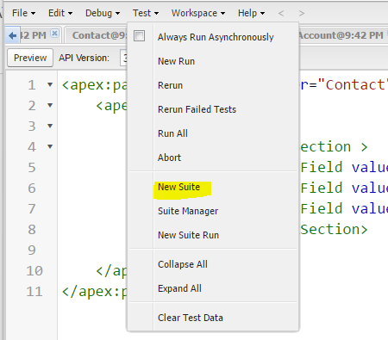

2. Enter Suite name and click on ok. See the below image for reference.

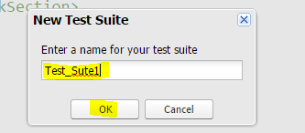

3. Add the classes, you want to execute, from available test classes section to selected test classes. See the below image for reference.

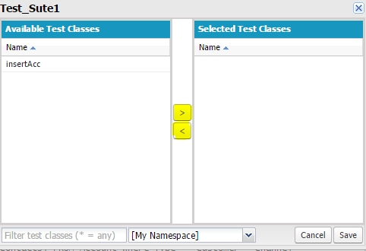

1. 57. Question

Universal Containers has tried the Schema Builder but has found that it has long loading times and objects are difficult to find because there are too many objects are difficult to find because there are too many objects and relationships displayed. What features would you suggest to help with this issue? Choose 3 answers

* + ** The filter can be used to only display objects of interest**
  + ** The map can be used to navigate to objects of interest**
  + ** If the 'Hide Relationships' option is selected, performance is improved**
  +  Fields can be hidden and only the objects displayed
  +  Activate lightweight mode in the Schema Builder Settings

**Unattempted**

Salesforce Schema Builder provides a dynamic surrounding to feature new custom objects, custom fields, and relationships to your schema. This eliminates the requirement to click from page to page to seek out the details of a master-detail relationship or to feature a brand new custom field to an object in your schema. For instance, if you’re using Schema Builder to look at the details of your schema, you’ll add a brand new custom object while not leaving Schema Builder in Salesforce. The drag-and-drop interface helps you to simply add a custom object or new field and saves the layout of your schema any time you move an object in Salesforce.

From Setup, search for and click Schema Builder in the Quick Find box.

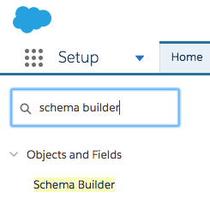

1. 58. Question

Which of the following action methods are supported by standard controllers? Choose 3 answers

* +  Select
  + ** Cancel**
  + ** Delete**
  +  Export
  + ** Quicksave**

**Unattempted**

The following table describes the action methods that are supported by all standard controllers.

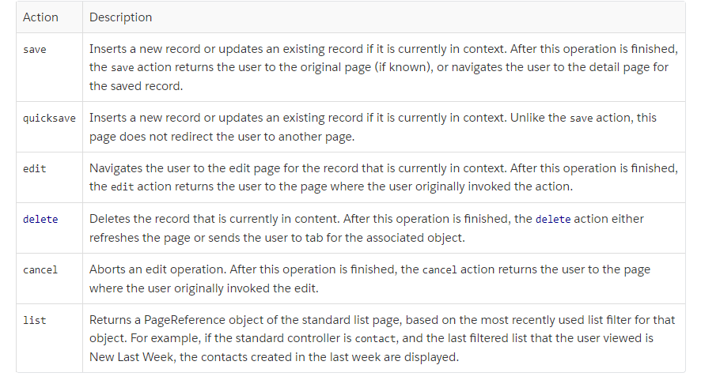

1. 59. Question

Which statement is true?

* +  A. Child records in mater-detail relationships have their own org-wide defaults.
  + ** B. Org-wide defaults can be set for both standard and custom objects.**
  +  C. Only read/write access can be granted through sharing rules.
  +  D. Sharing rules are used to restrict access to records.

**Unattempted**

1. 60. Question

A Lightning component has a wired property, searchresults, that stores a list of Opportunities.  
Which definition of the Apex method, to which the searchresults property is wired, should be used?

* + ** @AuraEnabled (cacheable=true)  
    Public static List search (String term) { /* implementation */ }**
  +  @AuraEnabled (cacheable=false)  
    Public List search (String term) { /* implementation */}
  +  @AuraEnabled (cacheable=true)  
    Public List search (String term) { /* implementation */ }
  +  @AuraEnabled(caceable=false)  
    Public static List search (String term) { /* implementation */}

**Unattempted**

This question is related to how to read Salesforce data with Lightning web components using wire service.  
The below answer is correct because to use @wire to call an Apex method, annotate the Apex method with @AuraEnabled(cacheable=true) and also Remember that the method must be static, and global or public  
To demonstrate this, we have written an Apex Class named OppController, a Lightning Web Component named searchOpp, and created an App Page in Salesforce to keep this Lightning Component. This component is used to search the existing opportunities in Salesforce by typing a search keyword.  
Apex Class:

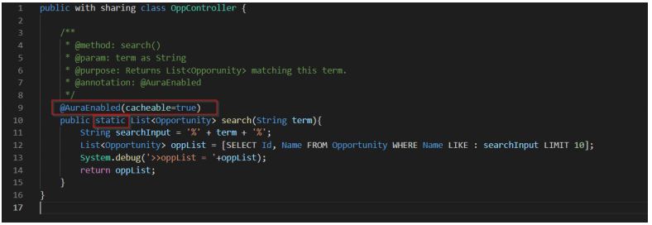  
Lightning Web Component (.html file)

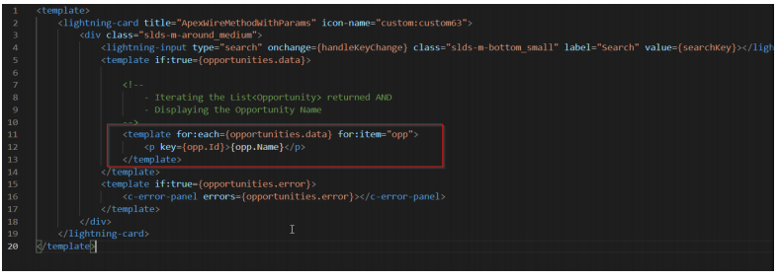  
Lightning Web Component (.js file)

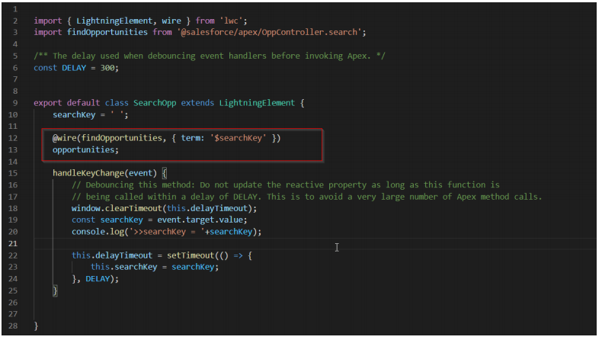  
App Page using the Lightning Web Component

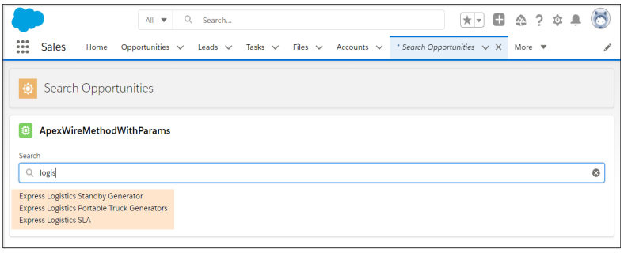  
The below answer is NOT correct because of cacheable=false  
@AuraEnabled(caceable=false)  
Public static List search (String term) { /* implementation */}  
The below answer is also NOT correct because of cacheable=false and method is Non Static  
@AuraEnabled (cacheable=false)  
Public List search (String term) { /* implementation */}  
The below answer is also NOT correct because method is Non-Static. It should be static.  
@Auraenabled (cacheable=true)  
Public List search (String term) { /* implementation */ }  
Platform Developer 1 Trailmix:  
<https://trailhead.salesforce.com/en/users/strailhead/trailmixes/prepare-for-your-salesforce-platform-developer-i-credential>

1. 1. Question

If a field is encrypted using Shield Platform Encryption can it be converted?

* +  Yes, all of them.
  +  Yes, to other data type similar to itself.
  + ** No**

**Unattempted**

1. 2. Question

Which Strategy Builder Action is defined here: “used to combine recommendations from multiple branches into a single branch.”

* +  Load
  +  Enhance
  +  Generate
  + ** Branch Merge**
  +  Branch Selector

**Unattempted**

1. 3. Question

Which one is NOT one of the three query-related statements that can be created and implemented in Salesforce?

* + ** SQL**
  +  SOQL
  +  SOSL
  +  DML

**Unattempted**

1. 4. Question

What is defined here: “The break statement can be used conditionally within a procedural loop statement to exit the entire loop. When encountered, any remaining loop iteration will not be executed.”

* +  While Loop
  + ** Break Loop Statement**
  +  Traditional Loop
  +  SOQL Loop
  +  Do-While Loop

**Unattempted**

1. 5. Question

Which of the following tools can NOT be used to execute specific apex test methods in an org?

* + ** Change Sets**
  +  Visual Studio Code
  +  SOAP API
  +  Developer Console

**Unattempted**

1. 6. Question

Do Visualforce Pages support edit actions?

* +  No
  + ** Yes**

**Unattempted**

1. 7. Question

For which of the following will a debug log NOT store any information?

* + ** Time-based Workflow Actions**
  +  HTTP Callouts
  +  Validation Rules
  +  Apex Errors

**Unattempted**

1. 8. Question

Can external Lookup Relationships or indirect Lookup Relationships be created directly from the canvas?

* +  Only in Classic
  + ** No**
  +  Only in Lightning
  +  Yes

**Unattempted**

1. 9. Question

What is a constructor?

* +  A constructor is code that is executed when an object of a class is deleted.
  +  A constructor is code that is executed when an object of a class is triggered
  + ** A constructor is code that is executed when an object of a class is created**
  +  A constructor is code that is executed when an object of a class is extended

**Unattempted**

1. 10. Question

What is defined here: “The continue statement can be used conditionally within a procedural loop statement to skip the current iteration and jump to the next iteration.”

* +  Break Loop Statement
  +  Traditional Loop
  +  While Loop
  +  Do-While Loop
  + ** Continue statement**

**Unattempted**

1. 11. Question

Which kind of variables, that can be referenced by Visualforce pages can be used to retrieve user data, such as his role and profile?

* +  Controller Variables
  + ** Global Variables**
  +  Neither
  +  Both

**Unattempted**

1. 12. Question

SOSL, SOQL or DML: Which one can use SELECT and From commands to query Data.

* +  DML
  +  SOSL
  + ** SOQL**
  +  Neither

**Unattempted**

1. 13. Question

If a developer wishes to share a developer environment with other developers, which one should be used?

* +  Neither
  +  A scratch org
  + ** A Sandbox**
  +  Either

**Unattempted**

1. 14. Question

Which non-primitive data type requires uniqueness across its elements?

* +  Enum
  + ** Set**
  +  List
  +  Map

**Unattempted**

1. 15. Question

What is defined here: “They are different ways to manage the flow of code execution.”

* +  SOQL queries
  + ** Control Flow statements**
  +  Procedural Loops
  +  SOSL queries

**Unattempted**

1. 16. Question

Which of the primitive data types responds to this definition? “Used to represent any data type in apex and applicable to many different Salesforce Objects.”

* +  Long
  +  Integer
  + ** Object**
  +  Date
  +  Double
  +  Decimal

**Unattempted**

1. 17. Question

During the setup of a many to many relationship, on which Object would the two Master-Detail Relationships be created?

* +  Child Object
  +  External Object
  + ** Junction Object**
  +  Master Object

**Unattempted**

1. 18. Question

Of the following code terms which one responds to the description? “Types of expressions can be a literal, sObject, List, Set, Map, SOQL, SOSL query, static or instance method invocation”

* +  Assignments
  +  Expressions
  + ** Variations**
  +  Operators

**Unattempted**

1. 19. Question

Which Formula Function can be used to summarize?

* +  MONTH
  +  ISPICKVAL
  +  MAX
  + ** PARENTGORUPVAL**

**Unattempted**

1. 20. Question

Which Strategy Builder Action is defined here: “generate recommendations based on apex code which can be called by the strategy builder if made @invocableMethod.”

* +  Branch Merge
  +  Branch Selector
  +  Load
  +  Enhance
  + ** Generate**

**Unattempted**

1. 21. Question

Which one is NOT one of the 4 access modifiers and can NOT be set for an Apex Class?

* +  Private
  +  Protected
  + ** Universal**
  +  Global
  +  Public

**Unattempted**

1. 22. Question

Which type of event should be used to reach an Aura component embedded in the innermost component of an app page?

* + ** Component Event**
  +  Application Event

**Unattempted**

1. 23. Question

Which of the following is not part of the standard Aura component bundle?

* +  Render
  + ** csv table**
  +  Documentation
  +  Helper

**Unattempted**

1. 24. Question

Which of the following can be created via Visualforce?

* +  App Pages
  + ** Charts**
  +  Custom Regions

**Unattempted**

1. 25. Question

Formula Fields can present values from fields in related objects, but, can they only show that 1 relationship away, or many relationships away?

* + ** Many**
  +  Just one

**Unattempted**

1. 26. Question

When writing a formula field and the user wants to join together fields and strings, what formula operator can be used?

* + ** &**
  +  WITH
  +  +
  +  INCLUDE

**Unattempted**

1. 27. Question

Which of the non-primitive data types responds to this definition? “Ordered collection of elements”

* +  Enum
  + ** List**
  +  Set
  +  Map

**Unattempted**

1. 28. Question

Good practice dictates that field types should be changed when they DO or DO NOT contain data?

* + ** Do not**
  +  Some do.
  +  Do

**Unattempted**

1. 29. Question

Which Salesforce standard object matches this description: “They are used to track customer’s requests for products and services.”

* +  Assets
  +  Contract
  + ** Orders**
  +  Work Order

**Unattempted**

1. 30. Question

Data models are most typically created for custom or standard Salesforce apps?

* +  Standard
  + ** Custom**
  +  Both

**Unattempted**

1. 31. Question

Can Cases be redirected to Support Agents with assignment rules?

* + ** Yes**
  +  No

**Unattempted**

1. 32. Question

Process Builder, Workflow or Flow: Which of them can NOT invoke apex code?

* +  Flow
  + ** Workflow**
  +  Process Builder

**Unattempted**

1. 33. Question

What is defined here: “a blueprint which contains functionality or logic in Apex. It contains variables and methods which can be used to specify the state and behavior of objects.”

* +  Apex Variable
  +  Apex Method
  + ** Apec Class**
  +  Apex Dynamic Query

**Unattempted**

1. 34. Question

Which is NOT a step of a unit test?

* +  Create Valid Test Data
  +  Verify expected results.
  +  Execute method to test.
  + ** Write deletion DML for resulting test data.**

**Unattempted**

1. 35. Question

Which one is NOT one of the two available tabs in the Schema Builder?

* + ** Relationships**
  +  Objects
  +  Elements

**Unattempted**

1. 36. Question

Can the Process Builder invoke Ape?

* +  No
  + ** Yes**

**Unattempted**

1. 37. Question

Which keyword can be used in a custom Visualforce controller to NOT allow all users to view all records, but instead restrict the viewing to those that have access via the sharing hierarchy?

* +  without sharing
  + ** with sharing**
  +  inherited sharing
  +  sharing context

**Unattempted**

1. 38. Question

What is defined here: “point-and-click process automation tool used with Einstein Next Best Action. It funnels recommendation records through your business logic to determine which recommendations are surfaced on your record pages.”

* +  Lightning Components
  + ** Strategy Builder**
  +  Flow Builder
  +  Next Best action

**Unattempted**

1. 39. Question

Can a Test Class be executed from the Test menu in the Developer Console?

* +  No
  + ** Yes**

**Unattempted**

1. 40. Question

Which relationship allows two objects to be related when a record from one object can be linked to multiple records from another object?

* +  Master Detail
  +  Lookup
  +  External Lookup
  + ** Many to Many**

**Unattempted**

1. 41. Question

What can be used to link Accounts in Salesforce to social network profiles and viewing activity feeds?

* +  Contacts
  +  Person Accounts
  + ** Social Accounts**
  +  Business Accounts

**Unattempted**

1. 42. Question

SOSL, SOQL or DML: Which one throws an exception when data manipulation fails?

* +  SOSL
  +  Neither
  + ** DML**
  +  SOQL

**Unattempted**

1. 43. Question

Which of the following is NOT required when creating an Apex Class?

* +  Access Modifier
  +  Class Name
  +  Extend/Implement
  + ** Password of user**

**Unattempted**

1. 44. Question

Is the Lightning Component Framework device aware and offer cross-browser compatibility?

* + ** Yes**
  +  No

**Unattempted**

1. 45. Question

Which loop would you use if you wanted to iterate through elements returned from a SOQL query?

* +  List/Set Iteration Loop
  +  While Loop
  +  Traditional Loop
  +  Do-While Loop
  + ** SOQL Loop**

**Unattempted**

1. 46. Question

Into what can Master-Detail Relationships be converted by editing them?

* + ** Lookup**
  +  Hierarchical
  +  External
  +  Indirect
  +  Many to Many

**Unattempted**

1. 47. Question

What Screen Flow output component can be used to showcase some text to guide the user in filling out the screen flow?

* + ** Display Text**
  +  Validate Input
  +  TEXTINBLOCK
  +  Screen Component

**Unattempted**

1. 48. Question

Which element must be enabled in the lightning app builder to allow the next best action component to invoked the flow again after a rejection?

* + ** The "Launch Flow on Rejection" checkbox must be ticked.**
  +  The "Execute Flow" checkbox must be ticked.

**Unattempted**

1. 49. Question

True or False? When triggering an apex class in the default System Context object permissions, field-level security, and sharing rules of the current user are ignored and the class can access all data in the org.

* + ** TRUE**
  +  FALSE

**Unattempted**

1. 50. Question

Is it possible to reset a user’s password? If so, from where?

* +  No, a new user has to be created.
  + ** YES, from the "Users" page in Setup.**
  +  YES, from the "Passwords and Security" page in Setup.
  +  YES, contacting Salesforce Support.

**Unattempted**

1. 51. Question

Can users turn the logs off in the Logs tab of the developer console?

* + ** Yes**
  +  No

**Unattempted**

1. 52. Question

Which one is NOT one of the declarative automation tools that can be used in those cases in which Rollup-Summary Fields fail?

* + ** Workflows**
  +  Flow
  +  Process Builder

**Unattempted**

1. 53. Question

Which Strategy Builder Action is defined here: “select recommendations based on a specified condition. For example, user’s profile.”

* +  Enhance
  +  Generate
  +  Branch Merge
  +  Load
  + ** Branch Selector**

**Unattempted**

1. 54. Question

What element must be added to a Flow for it to call an Apex class?

* + ** An Apex Action**
  +  An Apex Method
  +  An Apex Callout
  +  An Apex Class

**Unattempted**

1. 55. Question

Can Visual Studio Code execute SOQL queries?

* + ** Yes**
  +  No

**Unattempted**

1. 56. Question

Can Formula Fields reference fields in related objects?

* +  No
  + ** Yes**

**Unattempted**

1. 57. Question

Which of the primitive data types responds to this definition? “Store a particular Date without time.”

* +  Decimal
  +  Datetime
  +  Boolean
  + ** Date**
  +  Integer
  +  Blob

**Unattempted**

1. 58. Question

What can be referenced in a Visualforce page using a global variable?

* + ** Static resource**
  +  Apex Class

**Unattempted**

1. 59. Question

Can Google Charts be integrated into Visualforce?

* +  Only in lightning experience
  +  Only after the 4.00 version
  + ** Yes**
  +  No

**Unattempted**

1. 60. Question

Which one is NOT a Fundamental Functions of a Rollup-Summary Field?

* +  Max
  +  Count
  + ** Log**
  +  Sum
  +  Min

**Unattempted**

1. 61. Question

Which of the following packages CAN be modified?

* + ** Unmanaged**
  +  Managed

**Unattempted**

1. 62. Question

Will the view state of a Visualforce page hold in between user sessions?

* +  Yes
  + ** No**

**Unattempted**

1. 63. Question

Which of the primitive data types responds to this definition? “Used for a 64-bit number without decimal point”

* +  Boolean
  +  Double
  +  Date
  +  Decimal
  +  Integer
  + ** Long**

**Unattempted**

1. 64. Question

Which one is NOT one of the three standard fields that are included in EVERY Salesforce object, be it Custom or Standard?

* +  Created by
  +  Owner
  +  Name
  + ** Location**

**Unattempted**

1. 65. Question

What is described here: “an automation tool that can receive user input, execute logic, interact with Salesforce data and display output WITHOUT utilizing Apex Code.”

* + ** Flow**
  +  Process Builder
  +  Workflow
  +  Visualforce

**Unattempted**

1. 1. Question

What exclusive tool can be used for exporting reports?

* +  Import Knowledge Article tools
  +  Data Import Wizard
  + ** Report Export**
  +  Change Sets
  +  Data Loader

**Unattempted**

1. 2. Question

Which of the following can be used to prevent a SOQL injection atack?

* +  Dynamic Query with a bind variable
  +  Static Query without a bind variable.
  + ** Static Query with a bind variable**
  +  Dynamic Query without a bind variable.

**Unattempted**

1. 3. Question

What is the Javascript file in a component responsible for?

* + ** It defines how the component UI will react to client events.**
  +  To style the component and match a specific style.
  +  There is no CSS file on the lightning component bundle.

**Unattempted**

1. 4. Question

Which component must be used to embed a Visualforce page into a Lightning record page?

* + ** The Visualforce Lightning Component**
  +  A custom Lightning Component

**Unattempted**

1. 5. Question

Which is the best tool to quickly test apex code which calls a web service?

* +  Developer Console
  +  Workbench
  +  Annonymous Code
  + ** Apex Test Class**

**Unattempted**

1. 6. Question

Which service can be used to allow Visualforce pages, Lightning Components and Aura components to talk and update one another?

* +  Application Events
  + ** Lightning Message**

**Unattempted**

1. 7. Question

SOSL, SOQL or DML: Which one uses the merge statement to merge up to three records?

* + ** DML**
  +  SOSL
  +  SOQL
  +  Neither

**Unattempted**

1. 8. Question

What type of relationship can be created on the user object to related hierarchically a user to another?

* +  External Lookup
  +  Master Detail
  +  Many to Many
  + ** Hierarchical**

**Unattempted**

1. 9. Question

Can third party data tools be used for import and export of data into and out of Salesforce?

* + ** Yes**
  +  No

**Unattempted**

1. 10. Question

Can Auto-Response rules be set up so as to send email responses to lead submissions from Web-to-Lead forms?

* +  No
  + ** Yes**

**Unattempted**

1. 11. Question

How are the components of a date variable represented in the syntax?

* +  (year, month, day, minute, second)
  + ** (year, month, day)**
  +  (year, month, day, hour, minute, second)
  +  (month, day)

**Unattempted**

1. 12. Question

Of the following which one does not need to be specified in the destructiveChanges.xml file of the Ant Migration Tool?

* + ** Name of all sub-components**
  +  Name of the metadata component type
  +  Name of metadata component member

**Unattempted**

1. 13. Question

SOSL, SOQL or DML: Which one can use the FIND clause to search for a word or phrase.

* + ** SOSL**
  +  DML
  +  Neither
  +  SOQL

**Unattempted**

1. 14. Question

Which is the correct building structure of a debug log? that is which element is built of many of the following?

* + ** Execution Units are built of MANY Code Units which are built of MANY Log Lines**
  +  Code Units are built of MANY Execution Units which are built of MANY Log Lines

**Unattempted**

1. 15. Question

Can Visualforce be used in a Custom App?

* + ** Yes**
  +  No

**Unattempted**

1. 16. Question

Which one can NOT be created directly from the schema builder.

* + ** Custom Apps**
  +  Custom Fields
  +  Custom Objects
  +  Relationships

**Unattempted**

1. 17. Question

What can be set up to automatically escalate a case in the event of the agent not knowing what to do, or an entitlement milestone gets violated?

* + ** Escalation Rule**
  +  SOS Workflow
  +  Flow
  +  Assignment Rule

**Unattempted**

1. 18. Question

What can Custom Buttons be added to?

* +  Custom page layout
  + ** Both**
  +  Neither
  +  Standard page layout

**Unattempted**

1. 19. Question

Can you undelete and merge records with a DML statement?

* + ** Yes**
  +  No

**Unattempted**

1. 20. Question

Which relationship should be used if both objects must have independent security and sharing access?

* +  Many to Many
  + ** Lookup**
  +  Hierarchical
  +  Master Detail

**Unattempted**

1. 21. Question

Which Formula Function can be used to rework mathematically?

* +  MONTH
  +  PARENTGORUPVAL
  +  ISPICKVAL
  + ** ABS**

**Unattempted**

1. 22. Question

In Salesforce can Custom Objects be the parent in a Master-Detail Relationship where the detail are standard objects?

* + ** No**
  +  Yes
  +  Only if the Standard object uses a custom record type.

**Unattempted**

1. 23. Question

Can Validation Rules be used in Standard Fields, custom, or both?

* +  Standard only
  +  Custom only
  + ** Both**

**Unattempted**

1. 24. Question

Which component must be used to embed a website into a Visualforce page?

* +  apex:inputhtml
  +  apex:getsite
  +  apex:visualforce
  + ** apex:iframe**

**Unattempted**

1. 25. Question

Can unit tests tolerate uncaught exceptions?

* + ** No**
  +  Yes

**Unattempted**

1. 26. Question

Can Apex Classes or Interfaces be used for web service, email services, complex validation and business processes, custom logic, and batch operations?

* +  Neither
  + ** Classes**
  +  Both
  +  Interfaces

**Unattempted**

1. 27. Question

When a Salesforce attachment needs to be stored as a variable and it can be used to convert the attachment into a single object, which primitive variable should be used?

* + ** Blob**
  +  Long
  +  Integer
  +  Date
  +  Double

**Unattempted**

1. 28. Question

Can the task created via Workflow be used to assign said task to other Salesforce object that is not a user?

* +  No
  + ** Yes**

**Unattempted**

1. 29. Question

If a user wishes for a loop to end after the current iteration triggers a statement, which is required?

* + ** Break**
  +  Continue

**Unattempted**

1. 30. Question

Which of the primitive data types responds to this definition? “Used for a 64-bit number with a decimal point”

* +  Boolean
  +  Integer
  + ** Double**
  +  Date
  +  Decimal
  +  Blob

**Unattempted**

1. 31. Question

Can a record type that is referenced by apex code be deleted?

* +  Only if it is not the master rrecord type.
  +  Yes
  + ** No**

**Unattempted**

1. 32. Question

What are Resources in the Flow Builder?

* + ** Are containers that hold data values. Like variables.**
  +  They Define the behaviour of the flow, they are the building bocks for defining various actions.
  +  It is the start element which can in some flows be programed to regulate when the Flow should trigger.
  +  Are the paths defined between the various elements that represent the order of execution.

**Unattempted**

1. 33. Question

What can be used in a standard controller put in a child object to print its parent object’s fields in a Visualforce page?

* +  SOQL Queries
  +  A DML Statement
  +  SOSL Queries
  + ** Merge Field Syntax**

**Unattempted**

1. 34. Question

The JSENCODE is used to prevent XSS or SOQL injection?

* + ** XSS**
  +  SOQL Injection

**Unattempted**

1. 35. Question

Would you use Capture or Bubble when the component handler fires from inner component to outer component.

* + ** Bubble**
  +  Capture

**Unattempted**

1. 36. Question

What is the only field type that Text Area (Rich) can be converted to?

* +  Text
  + ** Text Area (long)**
  +  Currency
  +  Formula

**Unattempted**

1. 37. Question

Does the Ant Migration Tool have a graphical user interface?

* +  Yes
  + ** No**

**Unattempted**

1. 38. Question

Can a Workflow Rule delete records?

* +  Yes
  +  Only of Standard Objects
  +  Only of Custom Objects
  + ** No**

**Unattempted**

1. 39. Question

Can the new, view and edit buttons be all overriden by Visualforce in Classic, Lightning and Mobile from the same action override screen?

* +  No
  + ** Yes**

**Unattempted**

1. 40. Question

Which phase is described here: “When a component handler is fired from the outermost component to the innermost component i.e. the owner component handler first, then the container handler, and so on until it reaches the source component, which actually triggered the event, this phase is called the capture phase. To specify the capture phase we add the phase attribute to the handler and put the value as capture.”

* + ** Capture**
  +  Bubble

**Unattempted**

1. 41. Question

Can Visualforce pages be linked directly to a Tab?

* +  No
  + ** Yes**

**Unattempted**

1. 42. Question

Which of the following is NOT a procedural Loop?

* +  List/Set
  +  Traditional
  +  SOQL Loop
  +  While Loop
  + ** Set While Loop**

**Unattempted**

1. 43. Question

Do Constructors require an explicit return data type?

* +  Yes
  + ** No**

**Unattempted**

1. 44. Question

Can Visualforce tabs be displayed in the Salesforce app?

* +  No
  + ** Yes**

**Unattempted**

1. 45. Question

Would you use Capture or Bubble when both components are on the same level of the hierarchy?

* +  Bubble
  + ** Capture**

**Unattempted**

1. 46. Question

Apex Classes or Interfaces: for which one are access modifier, keyword and name required in its definition?

* +  Both
  +  Interfaces
  + ** Classes**
  +  Neither

**Unattempted**

1. 47. Question

Which of the following actions must be performed in a Full Copy Sandbox?

* + ** Load Testing**
  +  Quality Assurance
  +  Development

**Unattempted**

1. 48. Question

Which of the following methods can extend a test class to reach methods that have their access modifier defined as private?

* +  @IsTest
  + ** @TestVisible**
  +  @MakeVisible

**Unattempted**

1. 49. Question

Can the Schema Builder be accessed directly from the Force.com home page?

* +  No
  + ** Yes**

**Unattempted**

1. 50. Question

Which one is NOT one of the two data types used in Salesforce programming depending on their simplicity?

* + ** Modern**
  +  Primitive
  +  Non-primitive

**Unattempted**

1. 51. Question

What can the Test.startTest and Test.stopTest methods be used for?

* +  Regulate test performance
  + ** Validate how close apex code is to reach governor limits.**
  +  Both
  +  Neither

**Unattempted**

1. 52. Question

What object tracks the products that are sold in an Opportunity?

* + ** Products**
  +  Assets
  +  Quotes
  +  Price Books

**Unattempted**

1. 53. Question

Which phase is described here: “The handlers specified on each component are fired in this order i.e. from source to the owner. This phase where the event is handled from the innermost to the outermost component is called the bubble phase. It is also the default phase in lightning.”

* + ** Bubble**
  +  Capture

**Unattempted**

1. 54. Question

Of the following which one is NOT a primitive data type?

* +  Decimal
  + ** Set**
  +  Datetime
  +  Double

**Unattempted**

1. 55. Question

Can Formula Fields be used to showcase the value of a parent record in a child record?

* +  No
  + ** Yes**

**Unattempted**

1. 56. Question

Can the Tooling API be used to commit changes to a Salesforce org?

* + ** Yes**
  +  No

**Unattempted**

1. 57. Question

SOSL, SOQL or DML: Which one can use wildcards with the LIKE operator.

* +  SOSL Only
  +  SOSL and SOQL
  + ** SOQL Only**
  +  DML

**Unattempted**

1. 58. Question

Up to how many Master-Detail Relationships can a single object have?

* + ** 2**
  +  As many as required
  +  Only 1
  +  5

**Unattempted**

1. 59. Question

Would you use a Master-Detail or Lookup Relationship if you want to establish a loose link between two objects?

* +  Master Detail
  + ** Lookup**
  +  Both
  +  Neither

**Unattempted**

1. 60. Question

How many conditions can be checked with an IF-ELSE statement?

* +  0
  + ** 2**
  +  More than 2
  +  1

**Unattempted**

1. 61. Question

Of the following code terms which one responds to the description? “Can be used to join expressionswith one another to create compound expressions”

* +  Expressions
  +  Variations
  + ** Operators**
  +  Assignments

**Unattempted**

1. 62. Question

What is described here: “They are a mechanism to ensure data quality, that inspects the input information on a field and corroborates it against a set formula rule, if the result is true, then an error message is displayed.They are a mechanism to ensure data quality, that inspects the input information on a field and corroborates it against a set formula rule, if the result is true, then an error message is displayed.”

* +  Assignment Rules
  +  Data Quality Checker
  +  Workflow Rules
  + ** Valdiation Rules**

**Unattempted**

1. 63. Question

Which non-primitive data type needs to be used when a variable should only have one of a set of predefined values. For example, it can be used for specifying all the possible locations of a business?

* + ** Enum**
  +  List
  +  Set
  +  Map

**Unattempted**

1. 64. Question

Can Visualforce be used in the Setup home page?

* +  Only from the Developer Console
  + ** No**
  +  Yes

**Unattempted**

1. 65. Question

When sending an Outbound message with Workflow, in what format would data be sent?

* +  .pdf
  +  .csv
  + ** .xml**
  +  .sfdc

**Unattempted**

1. 1. Question

The Sales Management team hires a new intern. The intern is not allowed to view Opportunities, but needs to see the Most Recent Closed Date of all child Opportunities when viewing an Account record. What would a developer do to meet this requirement?

* +  A. Create a trigger on the Account object that queries the Close Date of the most recent Opportunities.
  +  B. Create a Workflow rule on the Opportunity object that updates a field on the parent Account.
  +  C. Create a formula field on the Account object that performs a MAX on the Opportunity Close Date field.
  + ** D. Create a roll-up summary field on the Account object that performs a MAX on the Opportunity Close Date field.**

**Unattempted**

1. 2. Question

Which trigger event allows a developer to update fields in the Trigger.new list without using an additional DML statement?Choose 2 answers

* + ** A. Before insert**
  + ** B. Before update**
  +  C. After update
  +  D. After insert

**Unattempted**

1. 3. Question

Which statement would a developer use when creating test data for products and pricebooks?

* + ** A. Id pricebookId = Test.getStandardPricebookId();**
  +  B. Pricebook pb = new Pricebook();
  +  C. IsTest(SeeAllData = false);
  +  D. List objList = Test.loadData(Account.sObjectType, 'myResource');

**Unattempted**

1. 4. Question

Where would a developer build a managed package?

* +  A. Developer Sandbox
  +  B. Unlimited Edition
  +  C. Partial Copy Sandbox
  + ** D. Developer Edition**

**Unattempted**

1. 5. Question

Which type of information is provided by the Checkpoints tab in the Developer Console? (Choose 2)

* + ** A. Namespace**
  + ** B. Time**
  +  C. Exception
  +  D. Debug Statement

**Unattempted**

1. 6. Question

A developer wrote a workflow email alert on case creation so that an email is sent to the case owner manager when a case is created. When will the email be sent?

* + ** A. After Committing to database.**
  +  B. Before Trigger execution.
  +  C. After Trigger execution.
  +  D. Before Committing to database.

**Unattempted**

1. 7. Question

What is a benefit of the lightning component framework?

* +  A. Better integration with Force.com sites
  +  B. Better performance for custom Salesforce1 Mobile Apps
  +  C. More Centralized control via server-side logic
  + ** D. More pre-built components to replicate the salesforce look and feel**

**Unattempted**

1. 8. Question

What is a valid source and destination pair that can send or receive change sets? (Choose 2)

* +  A. Developer Edition to Sandbox
  + ** B. Sandbox to Production**
  + ** C. Sandbox to Sandbox**
  +  D. Developer Edition to Production

**Unattempted**

1. 9. Question

A Visual force page displays two fields named Phone Number and Email.  
User1 has access to Phone Number, but not to Email.  
User2 has access to Email, but not Phone Number  
A developer needs to ensure that User1 can only see Phone Number, and User2 can only see Email.  
Which method can the developer use to achieve this?

* +  A. Schema isUpdateable() method.
  + ** B. Schema isAccessible() method.**
  +  C. Schema isReadable() method.
  +  D. Schema isCreateable() method.

**Unattempted**

1. 10. Question

What is an important consideration when developing in a multi-tenant environment?

* + ** A. Governor limits prevent tenants from impacting performance in multiple orgs on the same instance.**
  +  B. Unique domain names take the place of namespaces for code developed for multiple orgs on multiple instances.
  +  C. Polyglot persistence provides support for a global, multilingual user base in multiple orgs on multiple instances.
  +  D. Org-wide data security determines whether other tenants can see data in multiple orgs on the same instance.

**Unattempted**

1. 11. Question

Which resource can be included in a Lightning Component bundle? Choose 2 answers

* +  A. Apex class
  +  B. Adobe Flash
  + ** C. JavaScript**
  + ** D. Documentation**

**Unattempted**

1. 12. Question

A developer creates an Apex class that includes private methods. What can the developer do to ensure that the private methods can be accessed by the test class?

* +  A. Add the TestVisible attribute to the Apex class
  +  B. Add the SeeAllData attribute to the test methods.
  + ** C. Add the TestVisible attribute to the apex methods.**
  +  D. Add the SeeAllData attribute to the test class

**Unattempted**

1. 13. Question

What is a capability of formula fields? (Choose 3)

* + ** A. Generate a link using the HYPERLINK function to a specific record in a legacy system.**
  +  B. Display the previous values for a field using the PRIORVALUE function.
  +  C. Return and display a field value from another object using the VLOOKUP function.
  + ** D. Determine if a datetime field has passed using the NOW function.**
  + ** E. Determine which of three different images to display using the IF function.**

**Unattempted**

1. 14. Question

A developer has the following query: Contact c = [SELECT id, firstname, lastname, email FROM Contact WHERE lastname = ‘Smith’]; What does the query return if there is no Contact with the last name ‘Smith’?

* +  A. A contact initialized to null.
  + ** B. An error that no rows are found.**
  +  C. An empty List of Contacts.
  +  D. A Contact with empty values.

**Unattempted**

1. 15. Question

What is a capability of the Developer Console?

* + ** A. Execute Anonymous Apex code, Create/Edit code, view Debug Logs.**
  +  B. Execute Anonymous Apex code, Run REST API, create/Edit code.
  +  C. Execute Anonymous Apex code, Create/Edit code, Deploy code changes.
  +  D. Execute Anonymous Apex code, Run REST API, deploy code changes.

**Unattempted**

1. 16. Question

A developer needs to create a Visualforce page that will override the standard Account edit button. The page will be used to validate the account’s address using a SOQL query. The page will also allow the user to make edits to the address. Where would the developer write the Account address verification logic?

* +  A. In a Standard Extension.
  +  B. In a Standard Controller.
  +  C. In a Custom Controller.
  + ** D. In a Controller Extension.**

**Unattempted**

1. 17. Question

Which scenario is invalid for execution by unit tests?

* +  A. Executing methods for negative test scenarios
  +  B. Loading the standard Pricebook ID using a system method
  + ** C. Loading test data in place of user input for Flows.**
  +  D. Executing methods as different users.

**Unattempted**

1. 18. Question

How would a developer change the field type of a custom field on the Account object from string to an integer?

* +  A. Make the changes in the developer console, and then the change will automatically be reflected in the Apex code.
  +  B. Mate the change in the declarative UI, then update the field type to an integer field in the Apex code.
  +  C. Make the change in the declarative UI, an then the change will automatically be reflected in the Apex code.
  + ** D. Remove all references in the code, make the change in the declarative UI, and restore the references with the new type.**

**Unattempted**

1. 19. Question

Where can the custom roll-up summary fields be created using Standard Object relationships (Choose 3)

* + ** A. On Opportunity using Opportunity Product records.**
  +  B. On Account using Case records.
  +  C. On Quote using Order records.
  + ** D. On Campaign using Campaign Member records.**
  + ** E. On Account using Opportunity records.**

**Unattempted**

1. 20. Question

Which statement about change set deployments is accurate? (Choose 3)

* + ** A. They use an all or none deployment model.**
  + ** B. They require a deployment connection.**
  +  C. They ca be used to transfer Contact records.
  +  D. They can be used to deploy custom settings data.
  + ** E. They can be used only between related organizations.**

**Unattempted**

1. 21. Question

When loading data into an operation, what can a developer do to match records to update existing records? (Choose 2)

* +  A. Match an auto-generated Number field to a column in the imported file.
  + ** B. Match an external Id Text field to a column in the imported file.**
  +  C. Match the Name field to a column in the imported file.
  + ** D. Match the Id field to a column in the imported file.**

**Unattempted**

1. 22. Question

A developer needs to know if all tests currently pass in a Salesforce environment. Which feature can the developer use? (Choose 2)

* +  A. ANT Migration Tool
  +  B. Workbench Metadata Retrieval
  + ** C. Salesforce UI Apex Test Execution**
  + ** D. Developer Console**

**Unattempted**

1. 23. Question

What can a Lightning Component contain in its resource bundle?Choose 2 answers

* + ** A. Custom client side rendering behavior.**
  +  B. Build scripts for minification
  +  C. Properties files with global settings
  + ** D. CSS styles scoped to the component**

**Unattempted**

1. 24. Question

What is the proper process for an Apex Unit Test

* +  A. Query for test data using SeeAllData = true. Call the method being tested. Verify that the results are correct.
  +  B. Query for test data using SeeAllData = true. Execute runAllTests(). Verify that the results are correct.
  +  C. Create data for testing. Execute runAllTests(). Verify that the results are correct.
  + ** D. Create data for testing. Call the method being tested. Verify that the results are correct.**

**Unattempted**

1. 25. Question

When can a developer use a custom Visualforce page in a Force.com application? (Choose 2)

* + ** A. To generate a PDF document with application data**
  + ** B. To create components for dashboards and layouts**
  +  C. To deploy components between two organizations
  +  D. To modify the page layout settings for a custom object

**Unattempted**

1. 26. Question

A developer wants to create a custom object to track Customer Invoices.How should Invoices and Accounts be related to ensure that all Invoices are visible to everyone with access to an Account?

* +  A. The Account should have a Master-Detail relationship to the Invoice.
  + ** B. The Invoice should have a Master-Detail relationship to the Account**
  +  C. The Account should have a Lookup relationship to the Invoice
  +  D. The Invoice should have a Lookup relationship to the Account Previous

**Unattempted**

1. 27. Question

A developer writes a SOQL query to find child records for a specific parent. How many levels can be returned in a single query?

* + ** A. 1**
  +  B. 7
  +  C. 5
  +  D. 3

**Unattempted**

1. 28. Question

A developer in a Salesforce org with 100 Accounts executes the following code using the Developer console:Account myAccount = new Account(Name = ‘MyAccount’);Insert myAccount;For (Integer x = 0; x < 150; x++) {Account newAccount = new Account (Name='MyAccount' + x);try {Insert newAccount;} catch (Exception ex) {System.debug (ex) ;}}insert new Account (Name='myAccount');How many accounts are in the org after this code is run?

* +  A. 101
  + ** B. 100**
  +  C. 102
  +  D. 252

**Unattempted**

1. 29. Question

Which user can edit a record after it has been locked for approval? (Choose 2)

* +  A. Any user with a higher role in the hierarchy
  + ** B. A user who is assigned as the current approver**
  +  C. Any user who approved the record previously
  + ** D. An administrator**

**Unattempted**

1. 30. Question

A developer needs to confirm that an Account trigger is working correctly without changing the organization’s data.What would the developer do to test the Account trigger?

* + ** A. Use the Test menu on the developer Console to run all test classes for the account trigger.**
  +  B. Use the New button on the Salesforce Accounts Tab to create a new Account record.
  +  C. Use the Open Execute Anonymous feature on the Developer Console to run an insert Account DML statement.
  +  D. Use Deply from the Force.com IDE to deploy an insert Account Apex class.

**Unattempted**

1. 31. Question

Which data type or collection of data types can SOQL statements populate or evaluate to? (Choose 3)

* + ** A. A single sObject**
  + ** B. An integer**
  +  C. A string
  + ** D. A list of sObjects**
  +  E. A Boolean

**Unattempted**

1. 32. Question

A reviewer is required to enter a reason in the comments field only when a candidate is recommended to be hired. Which action can a developer take to enforce this requirement?

* +  A. Create a required Visualforce component.
  +  B. Create a formula field.
  +  C. Create a required comments field.
  + ** D. Create a validation rule.**

**Unattempted**

1. 33. Question

A developer creates a custom controller and custom Visualforce page by using the following code block:public class myController {public String myString;public String getMyString() {return ‘getmyString’;}public String getStringMethod1() {return myString;}public String getStringMethod2() {if (myString == null)myString = ‘Method2’;return myString;}}{!myString}, {!StringMethod1}, {!StringMethod2}, {!myString}What does the user see when accessing the custom page?

* + ** A. GetMyString , , Method2 , getMystring**
  +  B. , , Method2 , getMyString
  +  C. , , Method2,
  +  D. GetMyString , , ,

**Unattempted**

1. 34. Question

A developer has a block of code that omits any statements that indicate whether the code block should execute with or without sharing. What will automatically obey the organization-wide defaults and sharing settings for the user who executes the code in the Salesforce organization?

* +  A. Apex Triggers
  +  B. HTTP Callouts
  +  C. Apex Controllers
  + ** D. Anonymous Blocks**

**Unattempted**

1. 35. Question

Which action can a developer perform in a before update trigger? (Choose 2)

* + ** A. Display a custom error message in the application interface.**
  + ** B. Change field values using the Trigger.new context variable.**
  +  C. Delete the original object using a delete DML operation.
  +  D. Update the original object using an update DML operation.

**Unattempted**

1. 36. Question

A developer needs to create records for the object Property__c. The developer creates the following code block:List propertiesToCreate = helperClass.createProperties();try { // line 3 } catch (Exception exp ) { //exception handling }Which line of code would the developer insert at line 3 to ensure that at least some records are created, even if a few records have errors and fail to be created?

* + ** A. Database.insert(propertiesToCreate, false);**
  +  B. insert propertiesToCreate;
  +  C. Database.insert(propertiesToCreate, System.ALLOW_PARTIAL);
  +  D. Database.insert(propertiesToCreate);

**Unattempted**

1. 37. Question

A company wants a recruiting app that models candidates and interviews; displays the total number of interviews on each candidate record; and defines security on interview records that is independent from the security on candidate records. What would a developer do to accomplish this task? Choose 2 answers

* +  A. Create a roll -up summary field on the Candidate object that counts Interview records.
  +  B. Create a master -detail relationship between the Candidate and Interview objects.
  + ** C. Create a lookup relationship between the Candidate and Interview objects.**
  + ** D. Create a trigger on the Interview object that updates a field on the Candidate object.**

**Unattempted**

1. 38. Question

A Hierarchy Custom Setting stores a specific URL for each profile in Salesforce. Which statement can a developer use to retrieve the correct URL for the current user’sprofile and display this on a Visualforce Page?

* +  A. {!$Setup.Url_Settings__C.Instance[Profile.Id].URL__c}
  + ** B. {!$Setup.Url_Settings__C.URL__c}**
  +  C. {!$Setup.Url_Settings__C.[Profile.Id].URL__c}
  +  D. {!$Setup.Url_Settings__C.[$Profile.Id].URL__c}

**Unattempted**

1. 39. Question

Which statement should a developer avoid using inside procedural loops? (Choose 2)

* +  A. System.debug('Amount of CPU time (in ms) used so far: ' + Limits.getCpuTime() );
  + ** B. List contacts = [SELECT Id, Salutation, FirstName, LastName, Email FROM Contact WHERE AccountId = :a.Id];**
  +  C. If(o.accountId == a.id)
  + ** D. Update contactList;**

**Unattempted**

1. 40. Question

What is a valid way of loading external JavaScript files into a Visualforce page? (Choose 2) *For this question, replace ( ) with less/greater than symbols.

* + ** A. Using an (apex:includeScript)* tag. \>**
  +  B. Using an (apex:define)* tag.
  +  C. Using a (link)* tag.
  + ** D. Using a (script)* tag.**

**Unattempted**

1. 41. Question

What is a capability of a StandardSetController?Choose 2 answers

* + ** A. It allows pages to perform mass updates of records**
  + ** B. It allows pages to perform pagination with large record sets**
  +  C. It enforces field-level security when reading large record sets
  +  D. It extends the functionality of a standard or custom controller

**Unattempted**

1. 42. Question

A developer has the following code:try {List nameList;Account a;String s = a.Name;nameList.add(s);} catch (ListException le ) {System.debug(‘ List Exception ‘);} catch (NullPointerException npe) {System.debug(‘ NullPointer Exception ‘);} catch (Exception e) {System.debug(‘ Generic Exception ‘);} What message will be logged?

* +  A. List Exception
  + ** B. NullPointer Exception**
  +  C. Generic Exception
  +  D. No message is logged

**Unattempted**

1. 43. Question

Which type of code represents the Controller in MVC architecture on the Force.com platform? (Choose 2)

* +  A. JavaScript that is used to make a menu item display itself.
  +  B. A static resource that contains CSS and images.
  + ** C. Custom Apex and JavaScript coda that is used to manipulate data.**
  + ** D. StandardController system methods that are referenced by Visualforce.**

**Unattempted**

1. 44. Question

What is the minimum log level needed to see user-generated debug statements?

* + ** A. DEBUG**
  +  B. FINE
  +  C. INFO
  +  D. WARN

**Unattempted**

1. 45. Question

Which declarative method helps ensure quality data? (Choose 3)

* + ** A. Validation Rules**
  +  B. Workflow alerts
  +  C. Exception Handling
  + ** D. Lookup Filters**
  + ** E. Page Layouts**

**Unattempted**

1. 46. Question

A developer wants to list all of the Tasks for each Account on the Account detail page. When a task is created for a Contact, what does the developer need to do to display the Task on the related Account record?

* + ** A. Nothing. The task is automatically displayed on the Account page.**
  +  B. Nothing. The Task cannot be related to an Account and a Contact.
  +  C. Create a Workflow rule to relate the Task to the Contact's Account.
  +  D. Create an Account formula field that displays the Task information.

**Unattempted**

1. 47. Question

A developer is creating an application to track engines and their parts. An individual part can be used in different types of engines.What data model should be used to track the data and to prevent orphan records?

* + ** A. Create a junction object to relate many engines to many parts through a master-detail relationship**
  +  B. Create a lookup relationship to represent how each part relates to the parent engine object.
  +  C. Create a master-detail relationship to represent the one-to-many model of engines to parts.
  +  D. Create a junction object to relate many engines to many parts through a lookup relationship

**Unattempted**

1. 48. Question

Which option would a developer use to display the Accounts created in the current week and the number of related Contacts using a debug statement in Apex?

* + ** A. For(Account acc: [SELECT Id, Name,(SELECT Id, Name FROM Contacts) FROM Account WHERE CreatedDate = THIS_WEEK]) { List cons = acc.Contacts; System.debug(acc.Name +  has  + cons.size() + Contacts; }**
  +  B. For(Account acc: [SELECT Id, Name, (SELECT Id, Name FROM Contacts) FROM Account WHERE CreatedDate = CURRENT_WEEK]){ List cons = acc.Contacts; System.debug(acc.Name +  has  + cons.size() + Contacts); }
  +  C. For(Account acc:[SELECT Id, Name, Account.Contacts FROM Account WHERE CreatedDate = CURRENT_WEEK]) { List cons = acc.Account.Contacts; System.debug(acc.Name +  has  + cons.size() + Contacts); }
  +  D. For(Account acc: [SELECT Id, Name, Account.Contacts FROM Account WHERE CreatedDate = THIS_WEEK]){ List cons = acc.Account.Contacts; System.debug(acc.Name +  has  + cons.size() + Contacts }

**Unattempted**

1. 49. Question

A developer creates an Apex helper class to handle complex trigger logic. How can the helper class warn users when the trigger exceeds DML governor limits?

* +  A. By using PageReference.setRedirect() to redirect the user to a custom Visualforce page before the number of DML statements is exceeded.
  +  B. By using Messaging.sendEmail() to continue toe transaction and send an alert to the user after the number of DML statements is exceeded.
  +  C. By using AmexMessage.Messages() to display an error message after the number of DML statements is exceeded.
  + ** D. By using Limits.getDMLRows() and then displaying an error message before the number of DML statements is exceeded.**

**Unattempted**

1. 50. Question

A candidate may apply to multiple jobs at the company Universal Containers by submtting a single application per job posting. Once an application is submitted for a job posting, that application cannot be modified to be resubmitted to a different job posting.What can the administrator do to associate an application with each job posting in the schema for the organization?

* +  A. Create a master-detail relationship in the Job Postings custom object to the Applications custom object.
  + ** B. Create a master-detail relationship in the Application custom object to the Job Postings custom object.**
  +  C. Create a lookup relationship on both objects to a junction object called Job Posting Applications.
  +  D. Create a lookup relationship in the Applications custom object to the Job Postings custom object

**Unattempted**

1. 51. Question

How can a developer retrieve all Opportunity record type labels to populate a list collection?  
Choose 2 answers

* + ** A. Obtain describe object results for the Opportunity objct.**
  +  B. Write a for loop that extracts values from the Opportunity.RecordType.Name field.
  +  C. Use the global variable $RecordType and extract a list from the map.
  + ** D. Write a SOQL for loop that iterates on the RecordType object.**

**Unattempted**

1. 52. Question

How would a developer determine if a CustomObject__c record has been manually shared with the current user in Apex?

* +  A. By querying the role hierarchy.
  +  B. By calling the isShared() method for the record.
  + ** C. By querying CustomObject__Share.**
  +  D. By calling the profile settings of the current user.

**Unattempted**

1. 53. Question

How can a developer avoid exceeding governor limits when using an Apex Trigger?choose 2 answers

* +  A. By using a helper class that can be invoked from multiple triggers.
  +  B. By using the Database class to handle DML transactions.
  + ** C. By using Maps to hold data from query results.**
  + ** D. By performing DML transactions on lists of SObjects.**

**Unattempted**

1. 54. Question

What is the result of the following code block ?  
Integer  x = 1;  
Integer Y = 0;  
While(x < 10) { Y++; }

* + ** A. An error occurs**
  +  B. Y = 9
  +  C. Y = 10
  +  D. X = 0

**Unattempted**

1. 55. Question

The initial value for a number field on a record is 1. A user updated the value of the number field to 10. This action invokes a workflow field update, which changes the value of the number field to 11. After the workflow field update, an update trigger fires.  
What is the value of the number field of the object that is obtained from Trigger.old?

* +  A. Null
  +  B. 11
  + ** C. 1**
  +  D. 10

1. 1. Question

A company would like to send an offer letter to a candidate, have the candidate sign it electronically, and then send the letter back.  
What can a developer do to accomplish this?

* +  A. Create a visual workflow that will capture the candidates signature electronically
  +  B. Develop a Process Builder that will send the offer letter and allow the candidate to sign it electronically.
  + ** C. Install a managed package that will allow the candidate to sign documents electronically**
  +  D. Create an assignment rule that will assign the offer letter to the candidate

**Unattempted**

1. 2. Question

What is a benefit of the Lightning Component framework?Choose 3 answers

* +  A. It uses client-side Apex controllers for logic.
  + ** B. It uses a traditional publish-subscribe model.**
  + ** C. It uses an event-driven architecture**
  + ** D. It uses an MVC architectural design pattern.**
  +  E. It uses server-side JavaScript controller for logic.

**Unattempted**

1. 3. Question

Which Apex collection is used to ensure that all values are unique?

* + ** A. A Set**
  +  B. An Enum
  +  C. A List
  +  D. An sObject

**Unattempted**

1. 4. Question

A developer creates an Apex Trigger with the following code block:  
List customers = new List();  
For (Order__c o: trigger.new)  
{  
Account a = [SELECT Id, Is_Customer__c FROM Account WHERE Id = :o.Customer__c];  
a.Is_Customer__c = true;  
customers.add(a);  
}  
Database.update(customers, false);  
The developer tests the code using Apex Data Loader and successfully loads 10 Orders. Then, the developer loads 150 Orders.  
How many Orders are successfully loaded when the developer attempts to load the 150 Orders?

* + ** A. 0**
  +  B. 1
  +  C. 150
  +  D. 100

**Unattempted**

1. 5. Question

A developer executes the following code in the Developer Console:  
List fList = new List ();  
For(integer i= 1; I <= 200; i++) { fList.add(new Account ( Name = 'Universal Account ' + i)); } Insert fList; List sList = new List();  
For (integer I = 201; I <= 20000; i ++) { sList.add(new Account (Name = 'Universal Account ' + i)); } Insert sList; How many accounts are created in the Salesforce organization ?

* +  A. 20000
  + ** B. 0**
  +  C. 200
  +  D. 1000

**Unattempted**

1. 6. Question

Which actions can a developer perform using the Schema Builder?Choose 2 answers

* +  A. Create a custom field and automatically add it to an existing page layout.
  + ** B. Create a view containing only standard and system objects.**
  + ** C. Create a custom object and define a lookup relationship on that object**
  +  D. Create a view of objects and relationships without fields

**Unattempted**

1. 7. Question

What must the Controller for a Visualforce page utilize to override the Standard Opportunity view button?

* +  A. The StandardSetController to support related lists for pagination.
  + ** B. The Opportunity StandardController for pre -built functionality.**
  +  C. A callback constructor to reference the StandardController.
  +  D. A constructor that initializes a private Opportunity variable.

**Unattempted**

1. 8. Question

In which order does SalesForce execute events upon saving a record?

* + ** A. Before Triggers; Validation Rules; After Triggers; Assignment Rules; Workflow Rules; Commit**
  +  B. Validation Rules; Before Triggers; After Triggers; Workflow Rules; Assignment Rules; Commit
  +  C. Before Triggers; Validation Rules; After Triggers; Workflow Rules; Assignment Rules; Commit
  +  D. Validation Rules; Before Triggers; After Triggers; Assignment Rules; Workflow Rules; Commit

**Unattempted**

1. 9. Question

Why would a developer use Test. startTest( ) and Test.stopTest( )?

* +  A. To avoid Apex code coverage requirements for the code between these lines
  +  B. To start and stop anonymous block execution when executing anonymous Apex code
  +  C. To indicate test code so that it does not Impact Apex line count governor limits.
  + ** D. To create an additional set of governor limits during the execution of a single test class.**

**Unattempted**

1. 10. Question

A developer creates a method in an Apex class and needs to ensure that errors are handled properly.  
What would the developer use? (There are three correct answers.)

* +  A. ApexPages.addErrorMessage()
  + ** B. A custom exception**
  + ** C. .addError()**
  +  D. Database.handleException()
  + ** E. A try/catch construct**

**Unattempted**

1. 11. Question

Which requirement needs to be implemented by using standard workflow instead of Process Builder?  
Choose 2 answers

* +  A. Create activities at multiple intervals.
  + ** B. Send an outbound message without Apex code.**
  + ** C. Copy an account address to its contacts.**
  +  D. Submit a contract for approval.

**Unattempted**

1. 12. Question

What would a developer do to update a picklist field on related Opportunity records when a modification to the associated Account record is detected?

* + ** A. Create a process with Process Builder.**
  +  B. Create a workflow rule with a field update.
  +  C. Create a Lightning Component.
  +  D. Create a Visualforce page.

**Unattempted**

1. 13. Question

In the Lightning Component framework, where is client-side controller logic contained?

* +  A. Apex
  +  B. Visualforce
  +  C. HTML
  + ** D. JavaScript**

**Unattempted**

1. 14. Question

In an organization that has enabled multiple currencies, a developer needs to aggregate the sum of the Estimated_value__c currency field from the CampaignMember object using a roll-up summary field called Total_estimated_value__c on Campaign.

* + ** A. The values in Campaignmember.Estimated_value__c are converted into the currency of the Campaign record and the sum is displayed using the currency on the Campaign record.**
  +  B. The values in CampaignMember.Estimated_value__c are converted into the currency on the majority of the CampaignMember records and the sum is displayed using that currency.
  +  C. The values in CampaignMember.Estimated_value__c are summed up and the resulting Total_estimated_value__c field is displayed as a numeric field on the Campaign record.
  +  D. The values In CampaignMember.Estimated_value__c are converted into the currency of the current user, and the sum is displayed using the currency on the Campaign record.

**Unattempted**

1. 15. Question

An org has different Apex Classes that provide Account -related functionality.  
After a new validation rule is added to the object, many of the test methods fail.  
What can be done to resolve the failures and reduce the number of code changes needed for future validation rules?  
Choose 2 answers:

* + ** A. Create a method that creates valid Account records, and call this method from within test methods.**
  + ** B. Create a method that loads valid Account records from a Static Resource, and call this method within test methods.**
  +  C. Create a method that performs a callout for a valid Account record, and call this method from within test methods.
  +  D. Create a method that queries for valid Account records, and call this method from within test methods.

**Unattempted**

1. 16. Question

What is true for a partial sandbox that is not true for a full sandbox?  
Choose 2 answers:

* + ** A. More frequent refreshes.**
  +  B. Only Includes necessary metadata.
  +  C. Use of change sets.
  + ** D. Limited to 5 GB of data.**

**Unattempted**

1. 17. Question

Which data structure is returned to a developer when performing a SOSL search?

* + ** A. A list of lists of sObjects.**
  +  B. A map of sObject types to a list of sObjects
  +  C. A map of sObject types to a list oflists of sobjects
  +  D. A list of sObjects.

**Unattempted**

1. 18. Question

Which component is available to deploy using Metadata API?   
Choose 2 answers

* + ** A. Case Layout**
  + ** B. Account Layout**
  +  C. Case Feed Layout
  +  D. ConsoleLayout

**Unattempted**

1. 19. Question

A company has a custom object named Warehouse. Each Warehouse record has a distinct record owner, and is related to a parent Account in Salesforce.  
Which kind of relationship would a developer use to relate the Account to the Warehouse?

* +  A. One -to -Many
  + ** B. Lookup**
  +  C. Master -Detail
  +  D. Parent -Child

**Unattempted**

1. 20. Question

A developer created an Apex trigger using the Developer Console and now wants to debug code  
How can the developer accomplish this in the Developer Console?

* +  A. Select the Override Log Triggers checkbox for the trigger
  +  B. Add the user name in the Log Inspector.
  +  C. Open the Progress tab in the Developer Console.
  + ** D. Open the logs tab in the Developer Console.**

**Unattempted**

1. 21. Question

What is a capability of cross-object formula fields?Choose 3 answers

* + ** A. Formula fields can reference fields from master-detail or lookup parent relationships.**
  + ** B. Formula fields can expose data the user does not have access to in a record.**
  +  C. Formula fields can be used in three roll-up summaries per object.
  +  D. Formula fields can reference fields in a collect of records from a child relationship.
  + ** E. Formula fields can reference fields from objects that are up to 10 relationships away.**

**Unattempted**

1. 22. Question

A candidate may apply to multiple jobs at the company Universal Containers by submitting a single application per job posting, that application cannot be modified to be resubmitted to a different job posting.What can the administrator do to associate an application with each job posting in the schema for the organization?

* +  A. Create a lookup relationship on both objects to a junction object called Job Posting Applications.
  +  B. Create a master-detail relationship in the Job Postings custom object to the Applications custom object.
  + ** C. Create a master-detail relationship in the Application custom object to the Job Postings custom object.**
  +  D. Create a lookup relationship in the Applications custom object to the Job Postings custom object.

**Unattempted**

1. 23. Question

A developer wants to display all of the available record types for a Case object. The developer also wants to display the picklist values for the Case.Status field. The Case object and the Case Status field are on a custom visualforce page.  
Which action can the developer perform to get the record types and picklist values in the controller?Choose 2 answers

* + ** A. Use Schema.PicklistEntry returned by Case Status getDescribe().getPicklistValues().**
  + ** B. Use Schema.RecordTypeinfo returned by Case.SObjectType getDescribe().getRecordTypelnfos()**
  +  C. Use SOQL to query Case records in the org to get all the RecordType values available for Case.
  +  D. Use SOQL to query Case records in the org to get all value for the Status picklist field.

**Unattempted**

1. 24. Question

What is a correct pattern to follow when programming in Apex on a Multi-tenant platform?

* +  A. Apex code is created in a separate environment from schema to reduce deployment errors.
  +  B. DML is performed on one record at a time to avoid possible data concurrency issues.
  + ** C. Queries select the fewest fields and records possible to avoid exceeding governor limits.**
  +  D. Apex classes use the ''with sharing" keyword to prevent access from other server tenants.

**Unattempted**

1. 25. Question

When creating unit tests in Apex, which statement is accurate?Choose 2

* +  A. Unit tests with multiple methods result in all methods failing every time one method fails.
  + ** B. Increased test coverage requires large test classes with many lines of code in one method.**
  +  C. Triggers do not require any unit tests in order to deploy them from sandbox to production.
  + ** D. System Assert statements that do not Increase code coverage contribute important feedback in unit tests**

**Unattempted**

1. 26. Question

What should a developer working in a sandbox use to exercise a new test Class before the developer deploys that test production?Choose 2 answers

* +  A. The REST API and ApexTestRun method
  + ** B. The Apex Test Execution page in Salesforce Setup.**
  + ** C. The Test menu in the Developer Console.**
  +  D. The Run Tests page in Salesforce Setup.

**Unattempted**

1. 27. Question

What is the accurate statement about with sharing keyword? Choose 2 answers

* + ** A. Inner class do not inherit the sharing setting from the container class**
  + ** B. Both inner and outer class can be declared as with sharing**
  +  C. Either inner class or outer classes can be declared as with sharing but not both
  +  D. Inner class inherit the sharing setting from the container class

**Unattempted**

1. 28. Question

A custom exception “RecordNotFoundException” is defined by the following code of block.  
public class RecordNotFoundException extends Exception()  
which statement can a developer use to throw a custom exception?choose 2 answers

* + ** A. Throw new RecordNotFoundException("problem occured");**
  + ** B. Throw new RecordNotFoundException();**
  +  C. throw RecordNotFoundException("problem occured");
  +  D. Throw RecordNotFoundException();

**Unattempted**

1. 29. Question

A developer has a single custom controller class that works with a Visualforce Wizard to support creating and editing multiple sObjects. The wizard accepts data from user inputs across multiple Visualforce pages and from a parameter on the initial URL  
Which statement is unnecessary inside the unit test for the custom controller?

* + ** A. Public ExtendedController (ApexPages.StandardController cntrl) { }**
  +  B. ApexPages.currentPage().getParameters().put('input', 'TestValue')
  +  C. Test.setCurrentPage(pageRef),
  + ** D. String nextPage = controller.save().getUrl();**

**Unattempted**

1. 30. Question

A company that uses a Custom object to track candidates would like to send candidate information automatically to a third -party human resource system when a candidate is hired.  
What can a developer do to accomplish this task?

* +  A. Create an escalation rule to the hiring manager.
  +  B. Create an auto response rule to the candidate.
  +  C. Create a Process Builder with an outbound message action.
  + ** D. Create a workflow rule with an outbound message action.**

**Unattempted**

1. 31. Question

How can a developer refer to, or instantiate a PageReference in Apex? Choose 2 answers

* + ** A. By using a PageReference with a partial or full URL.**
  + ** B. By using the Page object and a Visualforce page name.**
  +  C. By using the ApexPages.Page() method with a Visualforce page name.
  +  D. By using the PageReference.Page() method with a partial or full URL.

**Unattempted**

1. 32. Question

Which code segment can be used to control when the dowork() method is called?

* +  A. For (Trigger.isRunning t: Trigger.new) { dowork(); }
  +  B. If(Trigger.isRunning) dowork();
  +  C. For (Trigger.isInsert t: Trigger.new) { dowork(); }
  + ** D. If(Trigger.isInsert) dowork();**

**Unattempted**

1. 33. Question

A developer creates a new Visualforce page and Apex extension, and writes test classes that exercise 95% coverage of the new Apex extension.Change set deployment to production fails with the test coverage warning: “Average test coverage across all Apex classes and triggers is 74%, at least 75% test coverage is required.”What can the developer do to successfully deploy the new Visualforce page and extension?

* +  A. Create test classes to exercise the Visualforce page markup.
  +  B. Select "Disable Parallel Apex Testing" to run all the tests.
  + ** C. Add test methods to existing test classes from previous deployments.**
  +  D. Select "Fast Deployment'' to bypass running all the tests.

**Unattempted**

1. 34. Question

A developer in a Salesforce org with 100 Accounts executes the following code using the Developer console:   
Account myAccount = new Account(Name = ‘MyAccount’);  
Insert myAccount;  
For (Integer x = 0; x < 250; x++) { Account newAccount = new Account (Name='MyAccount' + x); try { Insert newAccount; } catch (Exception ex) { System.debug (ex) ; } } insert new Account (Name='myAccount');  How many accounts are in the org after this code is run?

* +  A. 101
  + ** B. 100**
  +  C. 102
  +  D. 252

**Unattempted**

1. 35. Question

Which resource can be included in a Lightning Component bundle? Choose 2 answers

* +  A. Apex class
  +  B. Adobe Flash
  + ** C. JavaScript**
  + ** D. Documentation**

**Unattempted**

1. 36. Question

To which primitive data type in Apex is a currency field atomically assigned?

* +  A. Integer
  + ** B. Decimal**
  +  C. Double
  +  D. Currency

**Unattempted**

1. 37. Question

A developer writes a before insert trigger.  
How can the developer access the incoming records in the trigger body?

* + ** A. By accessing the Trigger.new context variable.**
  +  B. By accessing the Trigger.newRecords context variable.
  +  C. By accessing the Trigger.newMap context variable.
  +  D. By accessing the Tripper.newList context variable.

**Unattempted**

1. 38. Question

An sObject named Application_c has a lookup relationship to another sObject named Position_c. Both Application _c and Position_c have a picklist field named Status_c.  
When the Status_c field on Position_c is updated, the Status_c field on Application_c needs to be populated automatically with the same value, and execute a workflow rule on Application_c.How can a developer accomplish this?

* +  A. By changing Application_c.Status_c into a roll -up summary field.
  +  B. By changing Application_c.Status_c into a formula field.
  + ** C. By using an Apex trigger with a DML operation.**
  +  D. By configuring a cross-object field update with a workflow.

**Unattempted**

1. 39. Question

What is a valid statement about Apex classes and interfaces?Choose 2 answers:

* +  A. The default modifier for a class is private.
  + ** B. Exception classes must end with the word exception.**
  +  C. A class can have multiple levels of inner classes.
  + ** D. The default modifier for an interface is private.**

**Unattempted**

1. 40. Question

A developer has the following trigger that fires after insert and creates a child Case whenever a new Case is created.   
List childCases = new List();  
for (Case parent : Trigger.new){  
Case child = new Case(ParentId = parent.Id, Subject = parent.Subject);  
childCases.add(child);  
}  
insert childCases;   
What happens after the code block executes?

* +  A. Multiple child cases are created for each parent case in Trigger.new.
  + ** B. Child case is created for each parent case in Trigger.new.**
  +  C. The trigger enters an infinite loop and eventually fails.
  +  D. The trigger fails if the Subject field on the parent is blank.

**Unattempted**

1. 41. Question

What is a capability of the Force.com IDE? Choose 2 answers

* +  A. Roll back deployments.
  + ** B. Run Apex tests.**
  +  C. Download debug logs.
  + ** D. Edit metadata components.**

**Unattempted**

1. 42. Question

What is the easiest way to verify a user before showing them sensitive content?

* +  A. Sending the user a SMS message with a passcode.
  + ** B. Calling the generateVerificationUrl method in apex.**
  +  C. Sending the user an Email message with a passcode.
  +  D. Calling the Session.forcedLoginUrl method in apex.

**Unattempted**

1. 43. Question

On which object can an administrator create a roll-up summary field?

* + ** A. Any object that is on the master side of a master-detail relationship.**
  +  B. Any object that is on the parent side of a lookup relationship.
  +  C. Any object that is on the detail side of a master-detail relationship.
  +  D. Any object that is on the child side of a lookup relationship.

**Unattempted**

1. 44. Question

Which statement about the Lookup Relationship between a Custom Object and a Standard Object is correct?

* +  A. The Lookup Relationship on the Custom Object can prevent the deletion of the Standard Object.
  +  B. The Lookup Relationship cannot be marked as required on the page layout for the Custom Object.
  + ** C. The Custom Object will be deleted when the referenced Standard Object is deleted.**
  +  D. The Custom Object inherits security from the referenced Standard Objects

**Unattempted**

1. 45. Question

What actions types should be configured to display a custom success message?

* + ** A. Update a record.**
  +  B. Post a feed item.
  +  C. Delete a record.
  +  D. Close a case.

**Unattempted**

1. 46. Question

When the number of record in a recordset is unknown, which control statement should a developer use to implement a set of code that executes for every record in the recordset, without performing a .size() or .length() method call?

* +  A. For (init_stmt, exit_condition; increment_stmt) { }
  +  B. Do { } While (Condition)
  + ** C. For (variable : list_or_set) { }**
  +  D. While (Condition) { ... }

**Unattempted**

1. 47. Question

When creating a record with a Quick Action, what is the easiest way to post a feed item?

* +  A. By selecting create feed item on the quick action.
  +  B. By adding a trigger on the new record.
  + ** C. By adding a workflow rule on the new record.**
  +  D. By selecting create case feed on the new record.

**Unattempted**

1. 48. Question

Where can debug log filter settings be set? Choose 2 answers

* + ** A. The Filters link by the monitored user's name within the web UI.**
  +  B. The Show More link on the debug log's record.
  +  C. On the monitored user's name.
  + ** D. The Log Filters tab on a class or trigger detail page.**

**Unattempted**

1. 49. Question

A developer has the following code block:  
public class PaymentTax {  
public static decimal SalesTax = 0.0875;  
}   
trigger OpportunityLineItemTrigger on OpportunityLineItem (before insert, before update) {  
PaymentTax PayTax = new PaymentTax();  
decimal ProductTax = ProductCost * XXXXXXXXXXX;  
}   
To calculate the productTax, which code segment would a developer insert at the XXXXXXXXXXX to make the value the class variable SalesTax accessible within the trigger?

* +  A. SalesTax
  +  B. PayTax.SalesTax
  + ** C. PaymentTax.SalesTax**
  +  D. OpportunityLineItemTngger.SalesTax

**Unattempted**

1. 50. Question

What features are available when writing apex test classes? (Choose 2 Answers)

* +  A. The ability to select error types to ignore in the developer console.
  +  B. The ability to write assertions to test after a @future method.
  + ** C. The ability to set and modify the CreatedDate field in apex tests.**
  +  D. The ability to set breakpoints to freeze the execution at a given point.
  + ** E. The ability to select testing data using csv files stored in the system.**

**Unattempted**

1. 51. Question

What are the supported content sources for custom buttons and links?(Choose 2 Answers)

* + ** A. VisualForce Page.**
  +  B. Static Resource.
  + ** C. URL.**
  +  D. Chatter File.
  +  E. Lightning Page.

**Unattempted**

1. 52. Question

What are two characteristics of partial copy sandboxes versus full sandboxes? Choose 2 answers.

* + ** A. supports more frequent refreshes**
  +  B. includes a subset of metadata
  +  C. provides more data record storage
  + ** D. requires a sandbox template**

**Unattempted**

1. 53. Question

What is the debug value of following Apex code? Decimal theValue; System.debug(theValue);

* +  A. Undefined
  +  B. 0
  + ** C. null**
  +  D. 0

**Unattempted**

1. 54. Question

A platform Developer needs to write an Apex method that will only perform an action if a record is assigned to a specific Record Type. Which Two options allow the developer to dynamically determine the ID of the required Record Type by its name? Choose 2 answers.

* +  A. Hardcode the ID as constant in an Apex class.
  + ** B. Use the getRecordTypeInfosByName () method in the DescribeSObjectResult Class.**
  +  C. Make an outbound web services call to the SOAP API.
  + ** D. Execute a SOQL query on the RecordType Object.**

**Unattempted**

1. 55. Question

What are two benefits of the lightning component framework? Choose 2 answers

* +  A. It allows faster PDF generation with lightning components
  +  B. It simplifies complexity when building pages, but not applications
  + ** C. It provides an event-driven architecture for better decoupling between components**
  + ** D. It promotes faster development using out-of-the-box components that are suitable for desktop and mobile devices.**

**Unattempted**