Business Insights Report (EDA) - Superstore Sales Dataset

Executive Summary
This report presents an Exploratory Data Analysis (EDA) of the Superstore Sales dataset containing 9,800 records and 18 attributes. The objective was to identify sales trends, high-performing categories, regions, states, and products, and provide business recommendations.

Dataset Overview
• Records: 9,800
• Columns: 18
• Duplicate Records: 0
• Missing Values: Only 11 missing values in Postal Code
• Date fields converted for time-series analysis.

Figure 1. Sales by Category
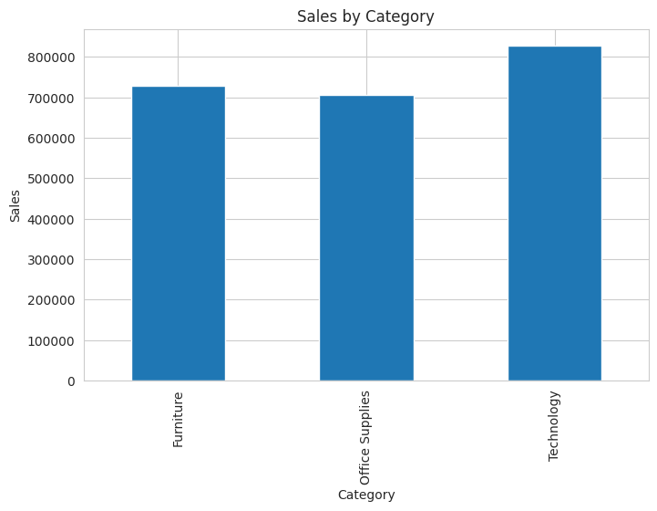
Technology generated the highest sales revenue, followed by Furniture and Office Supplies. This indicates strong demand for technology-related products.

Figure 2. Sales by Region
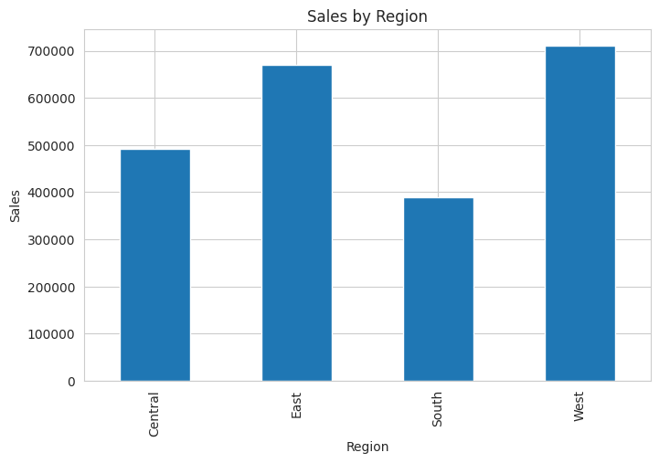
The West region recorded the highest sales, followed by the East region. The South region contributed the lowest sales and may require additional marketing efforts.

Figure 3. Top 10 States by Sales
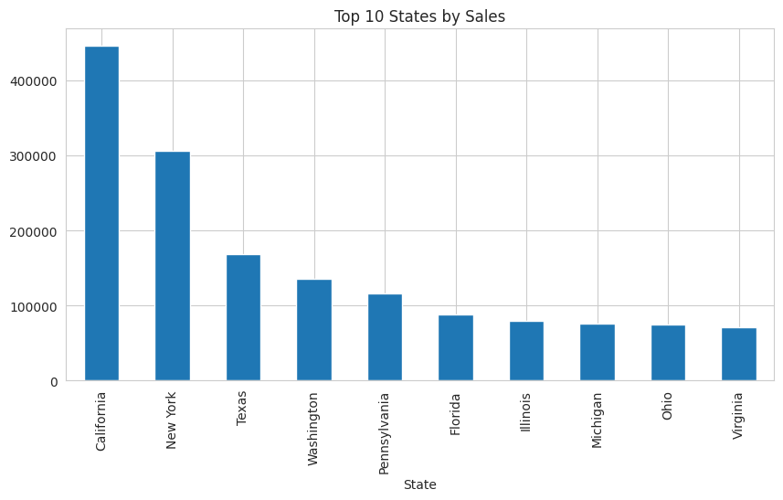
California is the leading state by sales, significantly outperforming other states. New York ranks second, followed by Texas and Washington.

Figure 4. Monthly Sales Trend
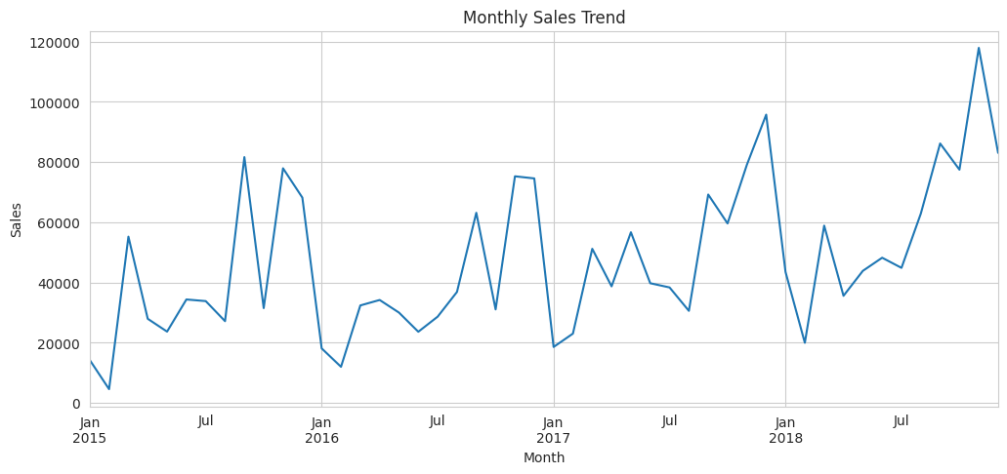
Sales fluctuate throughout the period with noticeable peaks toward the end of the timeline, suggesting seasonal demand and growth in later years.

Figure 5. Top 10 Products
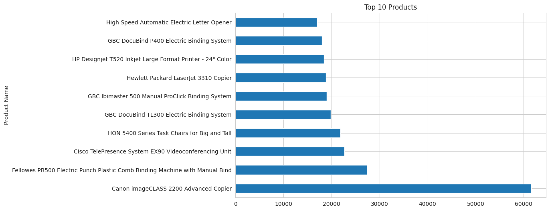
Canon imageCLASS 2200 Advanced Copier is the highest revenue-generating product. A small number of products account for a significant share of total sales.

Key Business Insights
1. Technology is the strongest-performing product category.
2. West and East regions drive most of the company revenue.
3. California and New York are the most valuable markets.
4. Sales show seasonal fluctuations, creating opportunities for targeted campaigns.
5. Revenue is concentrated among a limited number of high-performing products.

Recommendations
• Increase investment in Technology products.
• Strengthen marketing efforts in the South region.
• Maintain inventory levels for top-selling products.
• Focus customer acquisition and retention campaigns in high-performing states.
• Use seasonal trends to plan promotions and stock management.

Conclusion
The analysis demonstrates that sales performance is driven primarily by Technology products, the West region, and a small group of high-value products and states. Strategic focus on these areas can improve revenue growth and operational efficiency.

