**DAILY ONLINE ACTIVITIES SUMMARY**

|  |  |  |  |  |  |  |  |  |
| --- | --- | --- | --- | --- | --- | --- | --- | --- |
| **Date:** | **02-06-20** | | | | | **Name:** | **Raghavi H Gaonkar** | |
| **Sem & Sec** | **VI Sem & B Sec** | | | | | **USN:** | **4AL17CS071** | |
| **Online Test Summary** | | | | | | | | |
| **Subject** | | **CGV-3** | | | | | | |
| **Max. Marks** | | **30** | | **Score** | | | **30** | |
| **Certification Course Summary** | | | | | | | | |
| **Course** | **RPA** | | | | | | | |
| **Certificate Provider** | | | **S.P.BALAMURUGAN** | | **Duration** | | | **3hrs** |
| **Coding Challenges** | | | | | | | | |
| **Problem Statement:**  **1.given an array of positive integers. write a c program to find inversion count of array.**  **2.write a program to check if given linked list has a loop or not.**  **3.Python program to return a list containing first and last element using list slicing method.** | | | | | | | | |
| **Status: Completed** | | | | | | | | |
| **Uploaded the report in Github** | | | | | **Yes** | | | |
| **If yes Repository name** | | | | | <https://github.com/Raghavi26/dailystatus> | | | |
| **Uploaded the report in slack** | | | | | **Yes** | | | |

Online Test Details:

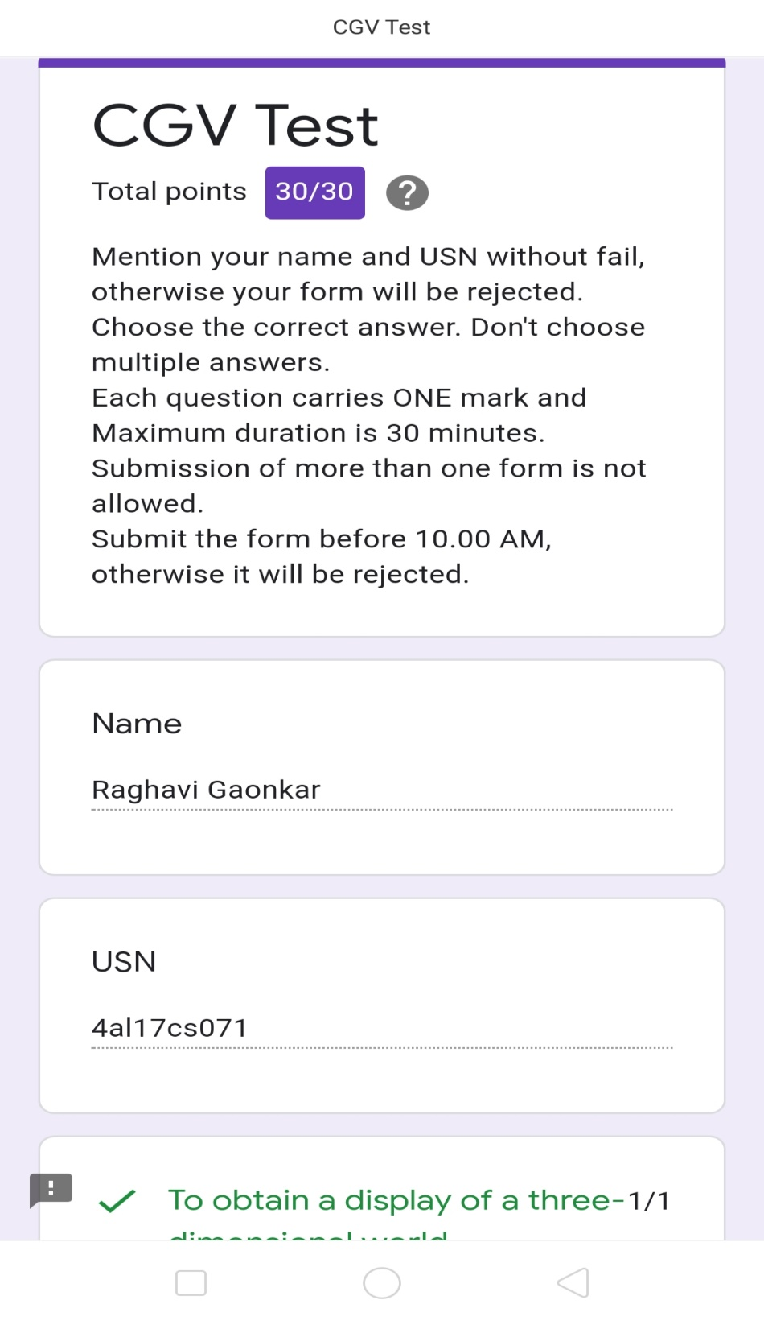

Certification Course Details:

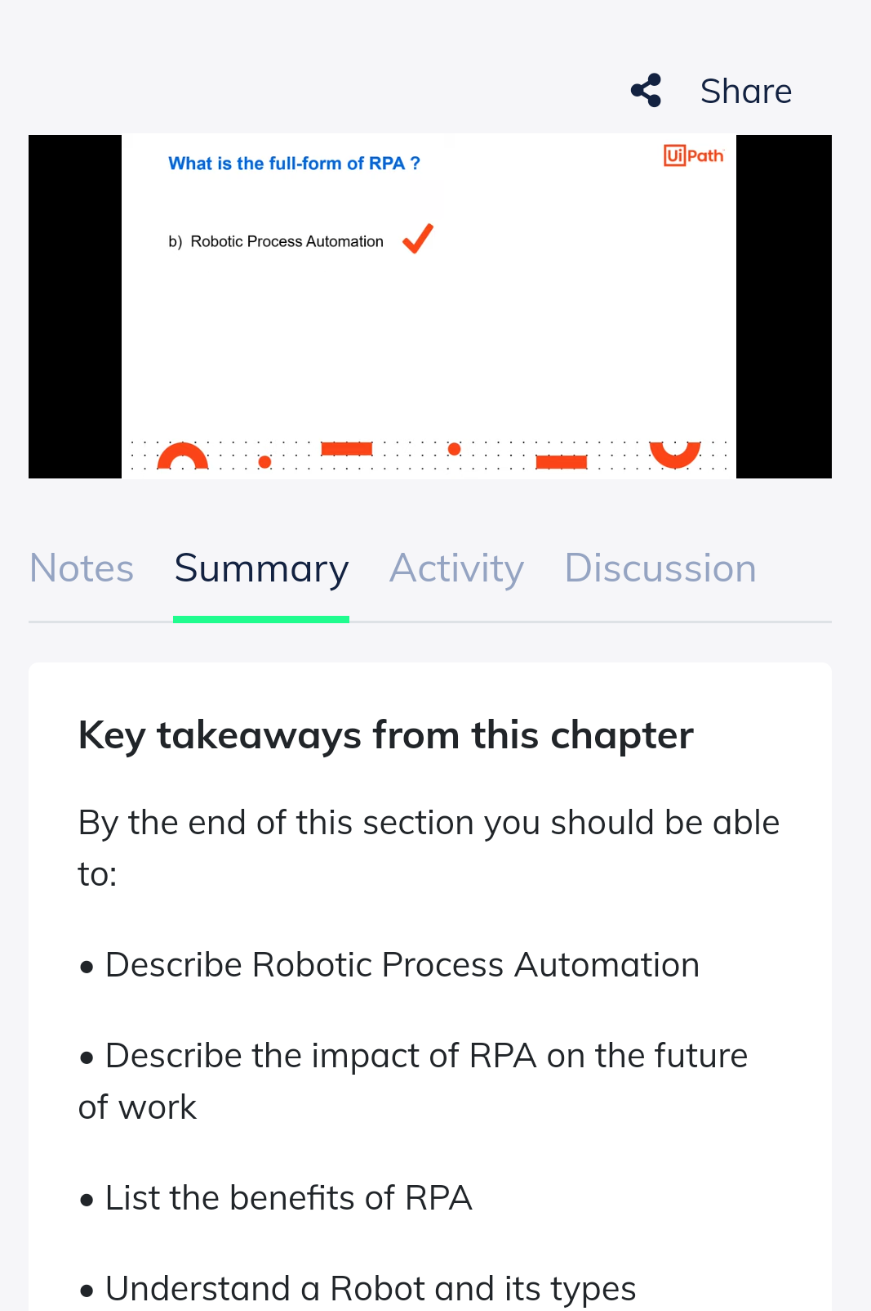

Coding Challenges Details:

<https://github.com/Raghavi26/dailystatus/blob/master/Online%20coding/2-6-2020p1.docx>

<https://github.com/Raghavi26/dailystatus/blob/master/Online%20coding/2-6-2020p2.docx>

<https://github.com/Raghavi26/dailystatus/blob/master/Online%20coding/2-6-2020p3.docx>