**DAILY ONLINE ACTIVITIES SUMMARY**

|  |  |  |  |  |  |  |  |  |
| --- | --- | --- | --- | --- | --- | --- | --- | --- |
| **Date:** | **05-06-20** | | | | | **Name:** | **Raghavi H Gaonkar** | |
| **Sem & Sec** | **VI Sem & B Sec** | | | | | **USN:** | **4AL17CS071** | |
| **Online Test Summary** | | | | | | | | |
| **Subject** | | **OR-3** | | | | | | |
| **Max. Marks** | | **30** | | **Score** | | | **30** | |
| **Certification Course Summary** | | | | | | | | |
| **Course** | **COGNITIVECLASS:PYTHON FOR DATA SCIENCE** | | | | | | | |
| **Certificate Provider** | | | **IBM** | | **Duration** | | | **10 hrs** |
| **Coding Challenges** | | | | | | | | |
| **Problem Statement:**  **1.Write a Java program to implement Circular linked list using array and class**  **2.Python program to square each odd number in the list** | | | | | | | | |
| **Status: Completed** | | | | | | | | |
| **Uploaded the report in Github** | | | | | **Yes** | | | |
| **If yes Repository name** | | | | | <https://github.com/Raghavi26/dailystatus> | | | |
| **Uploaded the report in slack** | | | | | **Yes** | | | |

Online Test Details:

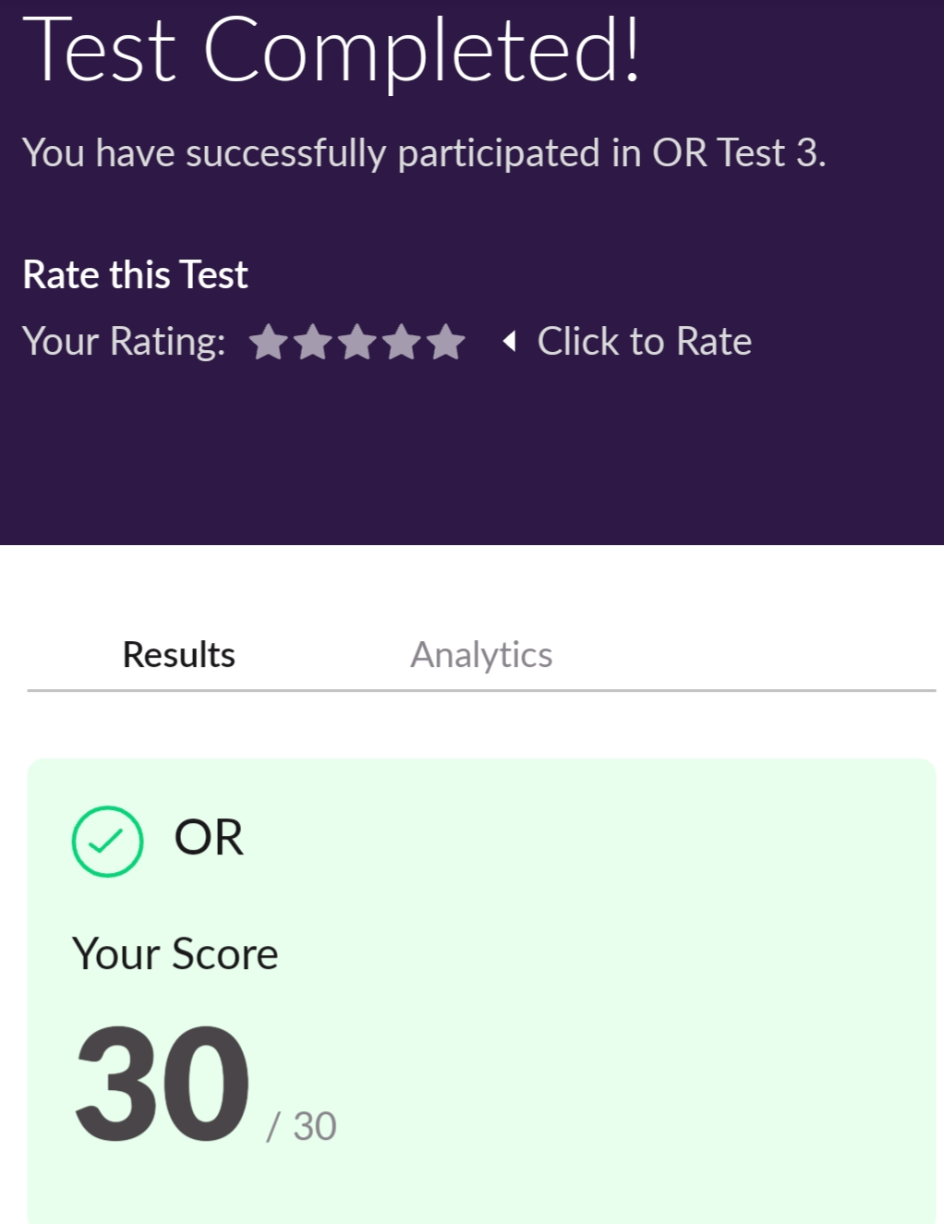

Certification Course Details:

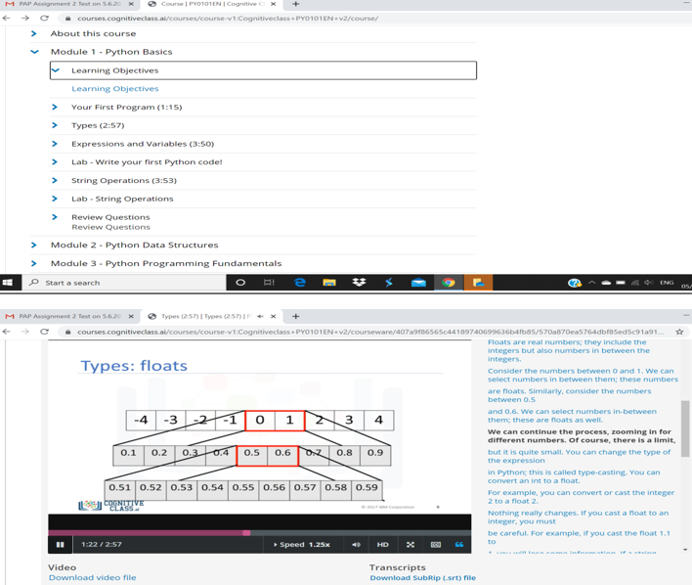

Coding Challenges Details:

<https://github.com/Raghavi26/dailystatus/blob/master/Online%20coding/5-06-2020program1.docx>

<https://github.com/Raghavi26/dailystatus/blob/master/Online%20coding/5-06-2020program2.docx>