**DAILY ONLINE ACTIVITIES SUMMARY**

|  |  |  |  |  |  |  |  |  |
| --- | --- | --- | --- | --- | --- | --- | --- | --- |
| **Date:** | **12-06-20** | | | | | **Name:** | **Raghavi H Gaonkar** | |
| **Sem & Sec** | **VI Sem & B Sec** | | | | | **USN:** | **4AL17CS071** | |
| **Online Test Summary** | | | | | | | | |
| **Subject** | |  | | | | | | |
| **Max. Marks** | |  | | **Score** | | |  | |
| **Certification Course Summary** | | | | | | | | |
| **Course** | **COGNITIVECLASS-Python For Data Science** | | | | | | | |
| **Certificate Provider** | | | **IBM** | | **Duration** | | | **5 hrs** |
| **Coding Challenges** | | | | | | | | |
| **Problem Statement:**  1. Write a Python program to implement Magic Square  2. Python program to print the pattern  3. Write a Java program to find maximum width of a binary tree | | | | | | | | |
| **Status:Completed** | | | | | | | | |
| **Uploaded the report in Github** | | | | | **Yes** | | | |
| **If yes Repository name** | | | | | <https://github.com/Raghavi26/dailystatus> | | | |
| **Uploaded the report in slack** | | | | | **Yes** | | | |

Certification Course Details: 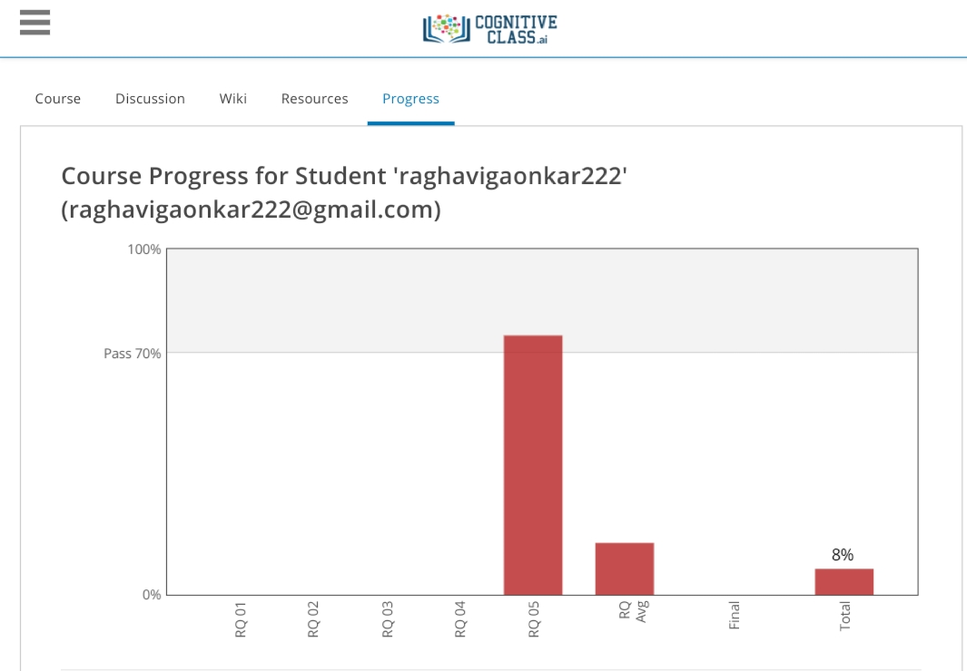

I learnt today Module 5 and Solved Review Questions

Coding Challenges Details:

<https://github.com/Raghavi26/dailystatus/blob/master/Online%20coding/12-06-2020program1.docx>

<https://github.com/Raghavi26/dailystatus/blob/master/Online%20coding/12-06-2020program2.docx>

<https://github.com/Raghavi26/dailystatus/blob/master/Online%20coding/12-06-2020program3.docx>

The Report is also available in:

<https://github.com/Raghavi26/dailystatus/upload/master/Online%20coding>