**DAILY ONLINE ACTIVITIES SUMMARY**

|  |  |  |  |  |  |  |  |  |
| --- | --- | --- | --- | --- | --- | --- | --- | --- |
| **Date:** | **15-06-20** | | | | | **Name:** | **Raghavi H Gaonkar** | |
| **Sem & Sec** | **VI Sem & B Sec** | | | | | **USN:** | **4AL17CS071** | |
| **Online Test Summary** | | | | | | | | |
| **Subject** | | **C programming Quiz and python workshop quiz** | | | | | | |
| **Max. Marks** | | **C programming-6**  **Python workshop-20** | | **Score** | | | **6**  **17** | |
| **Certification Course Summary** | | | | | | | | |
| **Course** | **Workshop exercise solving** | | | | | | | |
| **Certificate Provider** | | | **--** | | **Duration** | | | **--** |
| **Coding Challenges** | | | | | | | | |
| **Problem Statement: 2 PROGRAMS** | | | | | | | | |
| **Status: Executed** | | | | | | | | |
| **Uploaded the report in Github** | | | | | **Yes** | | | |
| **If yes Repository name** | | | | | <https://github.com/Raghavi26/dailystatus> | | | |
| **Uploaded the report in slack** | | | | | **Yes** | | | |

Class and Quiz Snapshots:

C Programming:

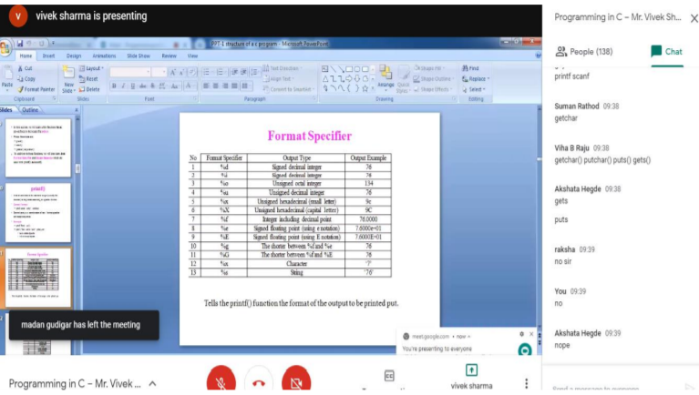

C Programming Quiz:

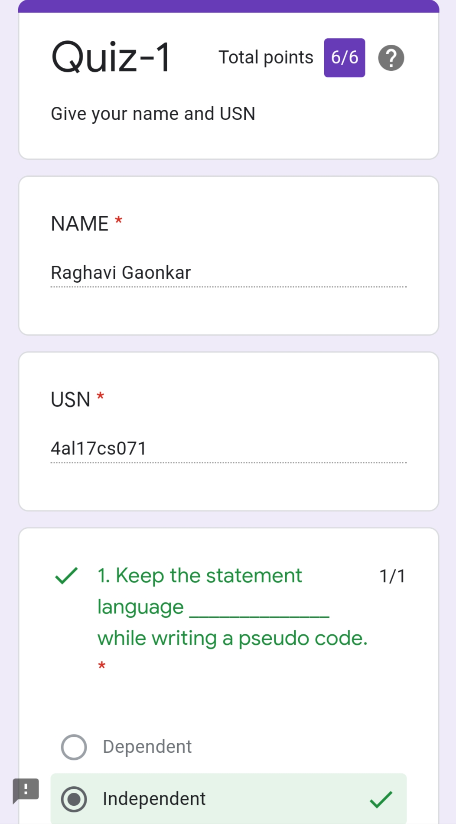

Python Workshop:

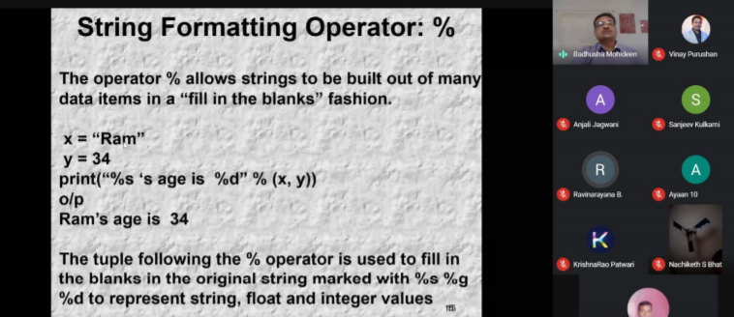

Python Workshop Quiz

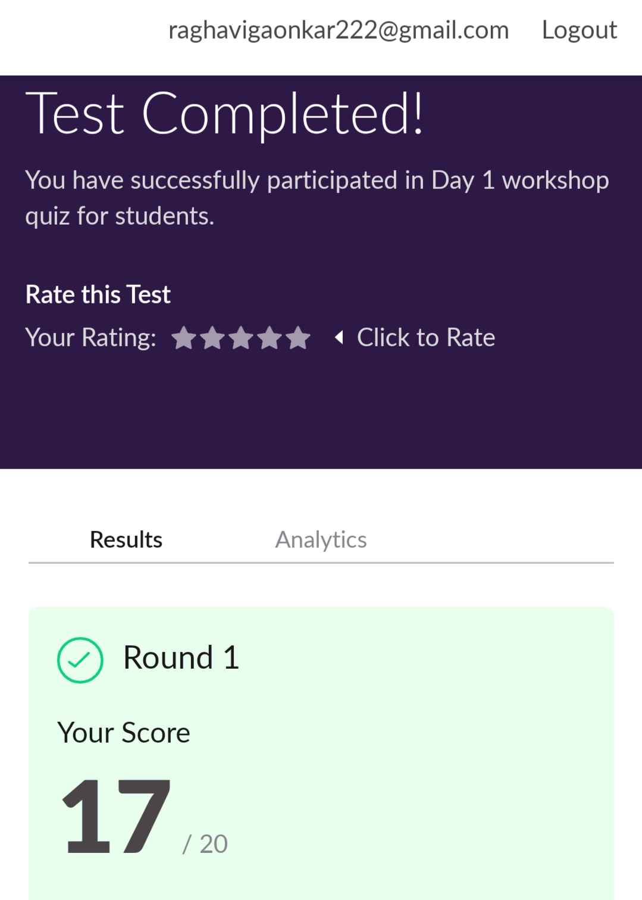

Refer the Github link for example programs and exercise programs:

<https://github.com/Raghavi26/Applications-0f-Python-Programming-in-DA-and-ML>

Online coding details:

<https://github.com/Raghavi26/Applications-0f-Python-Programming-in-DA-and-ML/tree/master/WorkshopDay-1/ONLINE%20CODING>