**DAILY ONLINE ACTIVITIES SUMMARY**

|  |  |  |  |  |  |  |  |  |
| --- | --- | --- | --- | --- | --- | --- | --- | --- |
| **Date:** | **16-06-20** | | | | | **Name:** | **Raghavi H Gaonkar** | |
| **Sem & Sec** | **VI Sem & B Sec** | | | | | **USN:** | **4AL17CS071** | |
| **Online Test Summary** | | | | | | | | |
| **Subject** | | 1.Programming in C  2.Applications of Python Programming in DA and ML | | | | | | |
| **Max. Marks** | | **-** | | **Score** | | | **-** | |
| **Certification Course Summary** | | | | | | | | |
| **Course** | Workshop on “Applications of Python Programming in DA and ML” | | | | | | | |
| **Certificate Provider** | | | **-** | | **Duration** | | | **-** |
| **Coding Challenges** | | | | | | | | |
| **Problem Statement:1 Python Program** | | | | | | | | |
| **Status:Executed** | | | | | | | | |
| **Uploaded the report in Github** | | | | | **Yes** | | | |
| **If yes Repository name** | | | | | <https://github.com/Raghavi26/dailystatus> | | | |
| **Uploaded the report in slack** | | | | | **Yes** | | | |

Online Test Details:

Programming In C

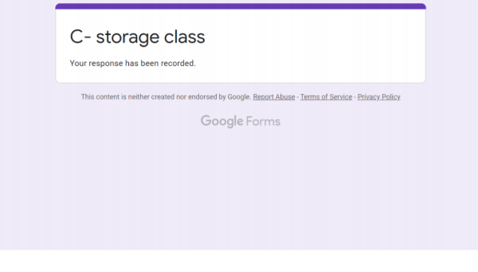

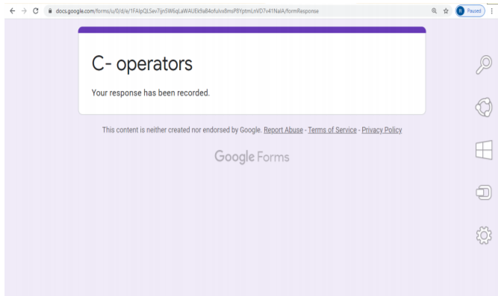

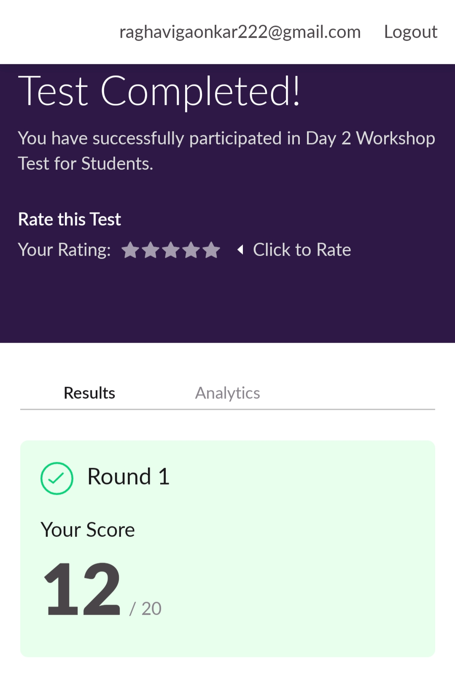

Certification Course Details:(Workshop)

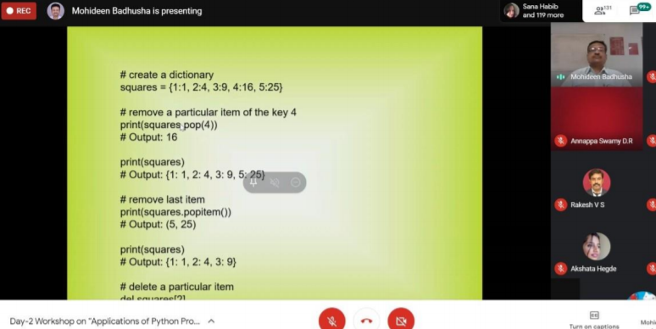

Coding Challenge Details:

Program

This is output of python program to check whether a given a binary tree is a valid binary search tree (BST) or not.

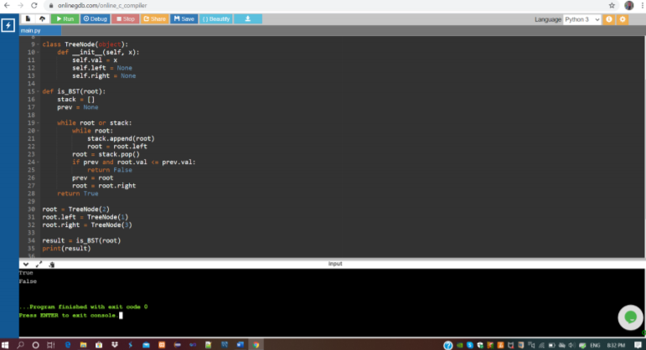

Workshop on “Applications of Python Programming in DA and ML”

<https://github.com/Raghavi26/Applications-0f-Python-Programming-in-DA-and-ML>