**DAILY ONLINE ACTIVITIES SUMMARY**

|  |  |  |  |  |  |  |  |  |
| --- | --- | --- | --- | --- | --- | --- | --- | --- |
| **Date:** | **18-05-20** | | | | | **Name:** | **Raghavi H Gaonkar** | |
| **Sem & Sec** | **VI Sem, B Sec** | | | | | **USN:** | **4AL17CS071** | |
| **Online Test Summary** | | | | | | | | |
| **Subject** | | **CNSC-1** | | | | | | |
| **Max. Marks** | | **60** | | **Score** | | | **25** | |
| **Certification Course Summary** | | | | | | | | |
| **Course** | **Machine learning with python** | | | | | | | |
| **Certificate Provider** | | | **Saeed Aghabozorgi** | | **Duration** | | | **12 hrs** |
| **Coding Challenges** | | | | | | | | |
| **Problem Statement:**  **1.We have a letter or a word then we need to add some letters to it and need to find out shortest palindrome.**  **2.Write a simple code to identify given linked list is palindrome or not by using stack. First take**  **a stack. Traverse through each node of the linked list and push each node value to the stack.** | | | | | | | | |
| **Status: Completed** | | | | | | | | |
| **Uploaded the report in Github** | | | | | **Yes** | | | |
| **If yes Repository name** | | | | | <https://github.com/Raghavi26/dailystatus> | | | |
| **Uploaded the report in slack** | | | | | **Yes** | | | |

Online Test Details:

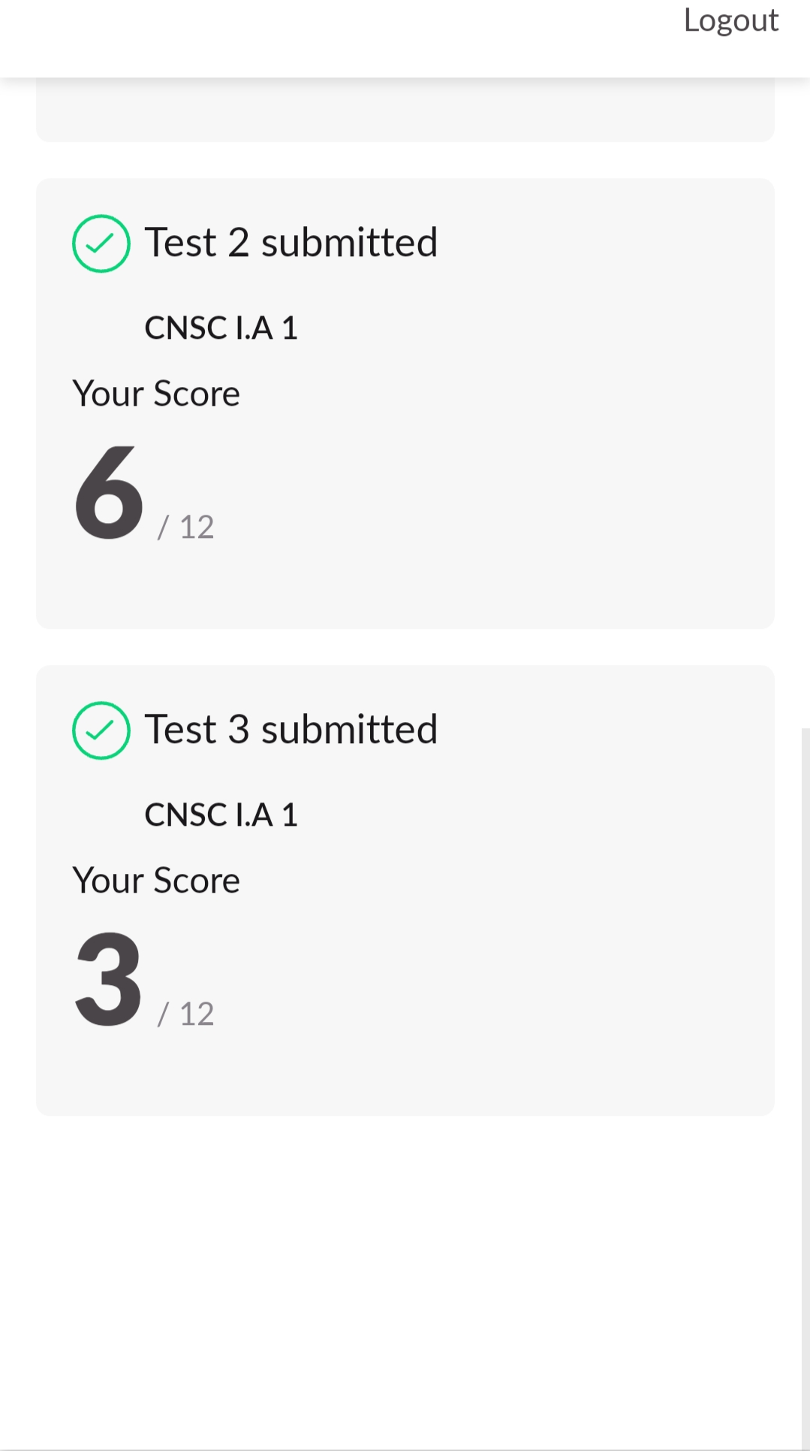

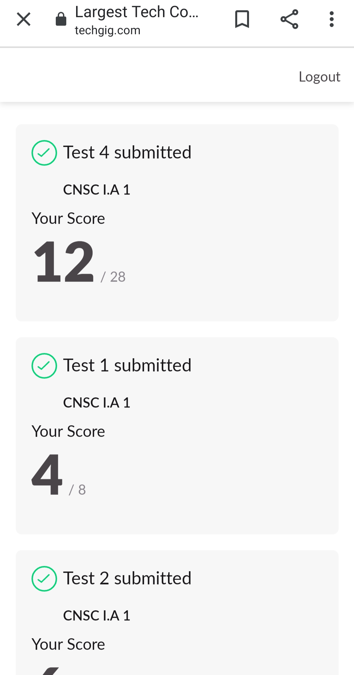

certification course details: Refer github account for detailed information:<https://github.com/Raghavi26/dailystatus/tree/master/CERTIFICATION%20COURSE>

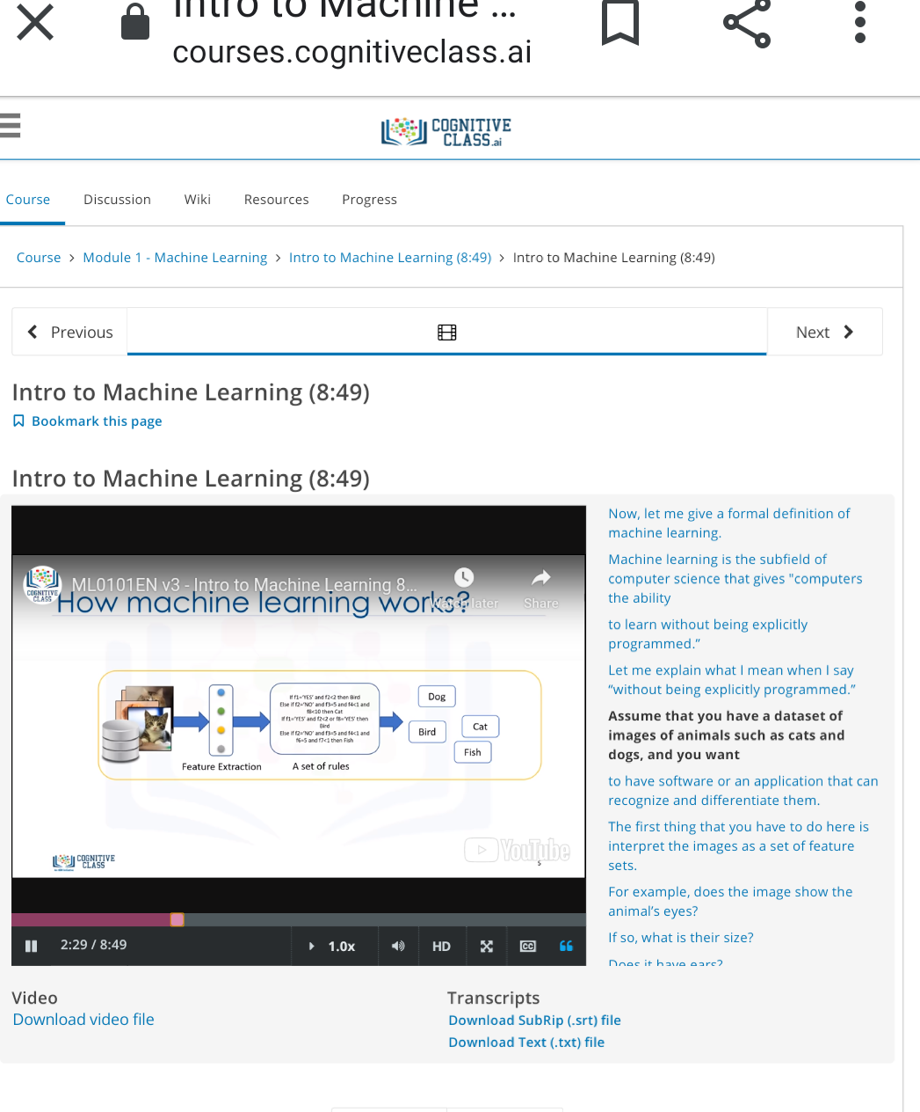

Coding Challenges Details:

<https://github.com/Raghavi26/dailystatus/tree/master/Online%20coding>