**DAILY ONLINE ACTIVITIES SUMMARY**

|  |  |  |  |  |  |  |  |  |
| --- | --- | --- | --- | --- | --- | --- | --- | --- |
| **Date:** | **18-06-20** | | | | | **Name:** | **Raghavi H Gaonkar** | |
| **Sem & Sec** | **VI Sem & B Sec** | | | | | **USN:** | **4AL17CS071** | |
| **Online Test Summary** | | | | | | | | |
| **Subject** | | **Programming in C** | | | | | | |
| **Max. Marks** | | **Quiz5-5**  **Quiz6-5** | | **Score** | | | **4**  **4** | |
| **Certification Course Summary** | | | | | | | | |
| **Course** | **Workshop on “Applications of Python Programming in DA and ML”** | | | | | | | |
| **Certificate Provider** | | | **-** | | **Duration** | | | **-** |
| **Coding Challenges** | | | | | | | | |
| **Problem Statement:1 Java and 1 C Program** | | | | | | | | |
| **Status:Executed** | | | | | | | | |
| **Uploaded the report in Github** | | | | | **Yes** | | | |
| **If yes Repository name** | | | | | <https://github.com/Raghavi26/dailystatus> | | | |
| **Uploaded the report in slack** | | | | | **Yes** | | | |

Online Test Details:

Programming in C

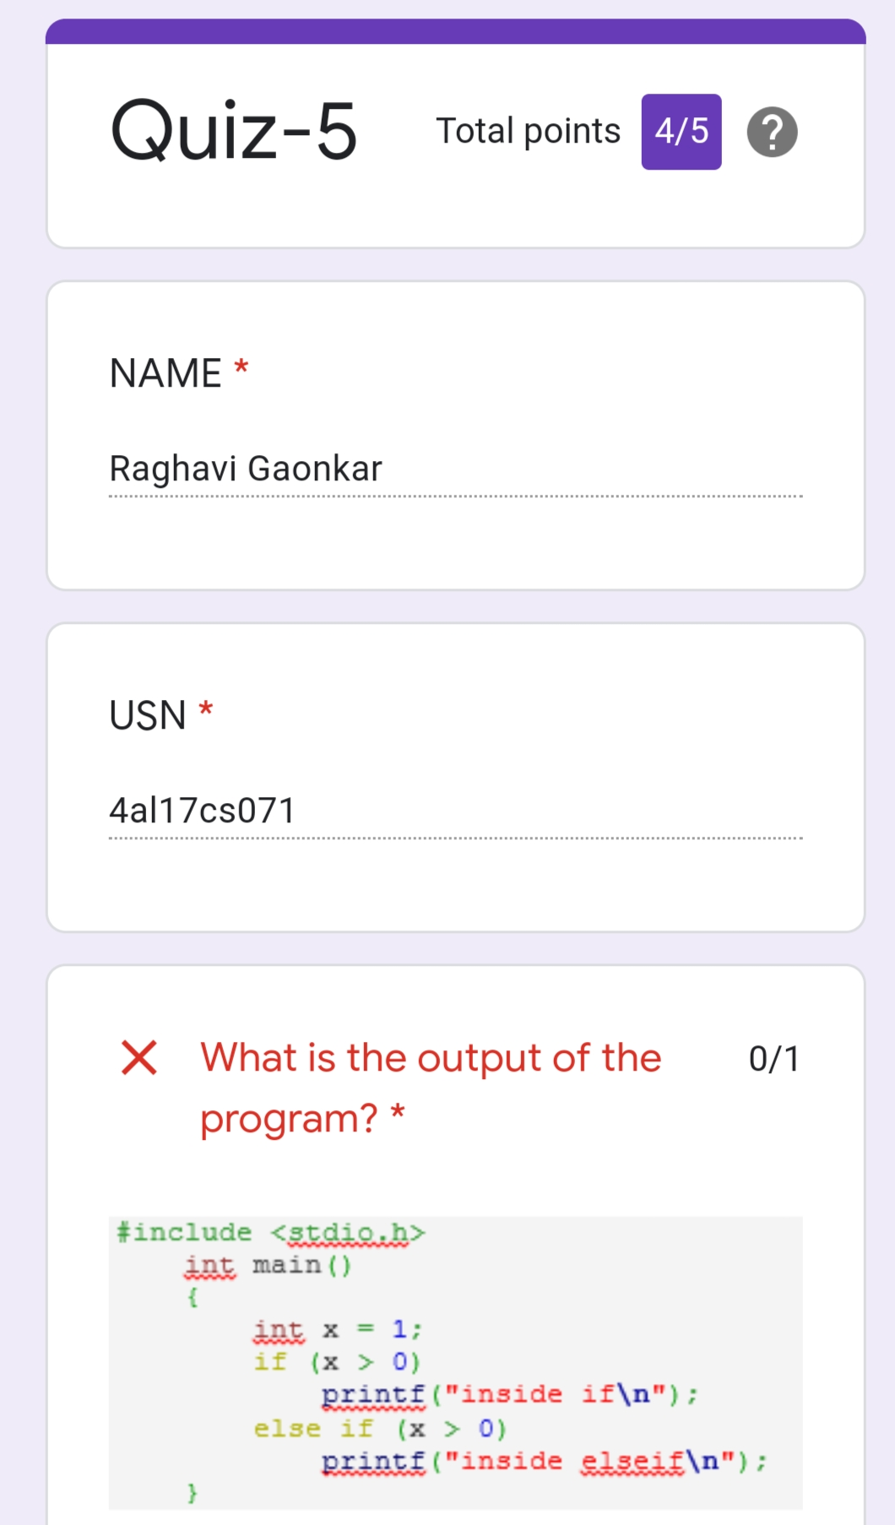

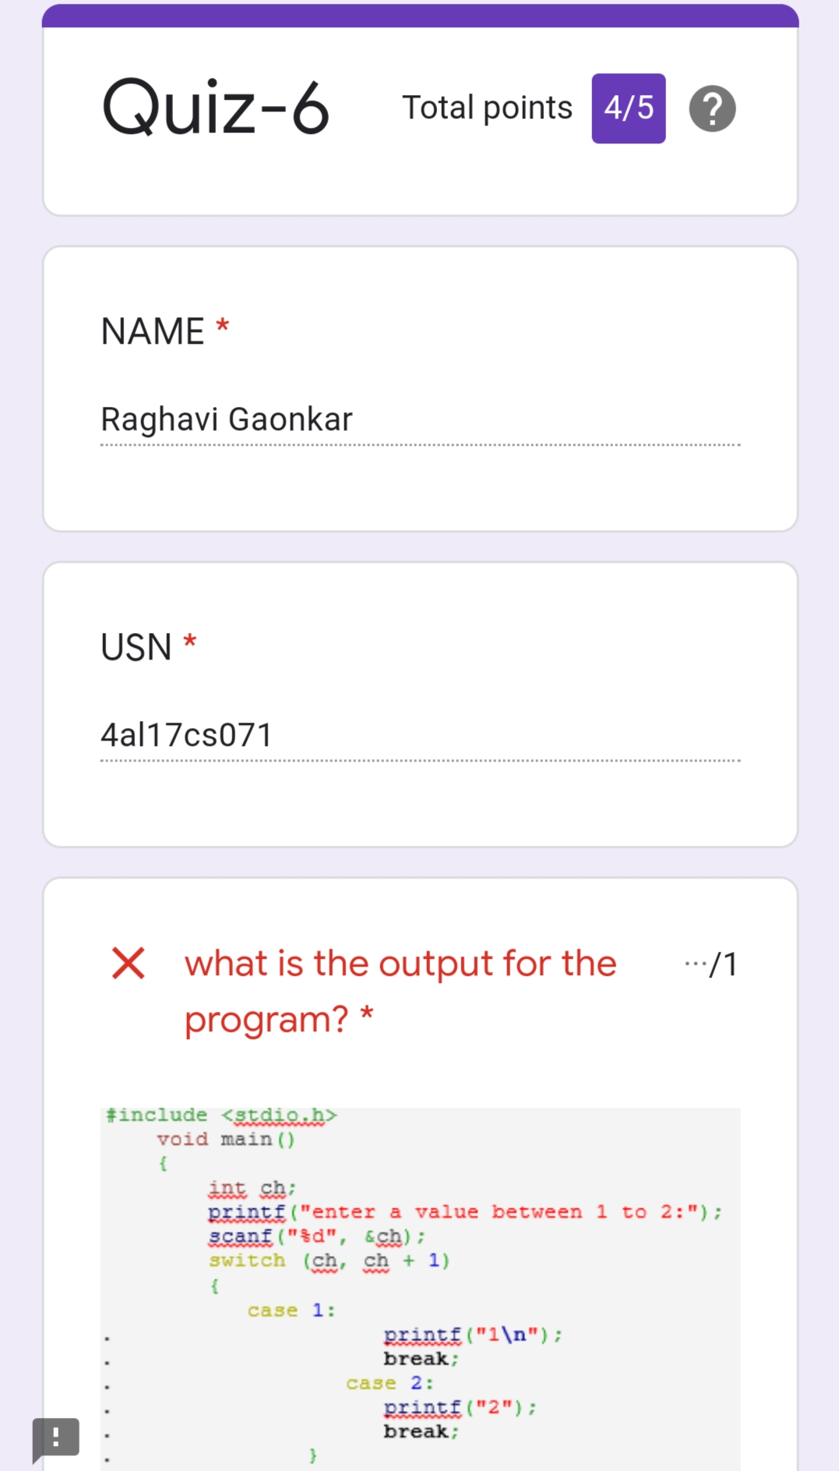

Workshop Details:

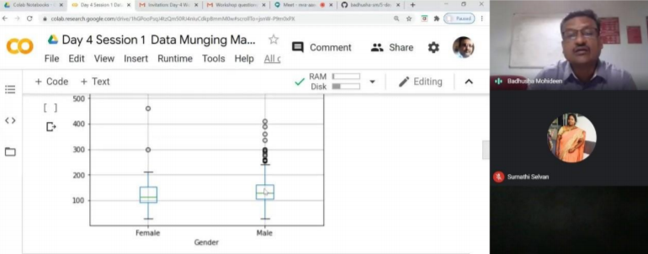

Coding Challenge Details:

Program 1:

This is output of java program to check if a binary tree is binary search tree(BST) or not

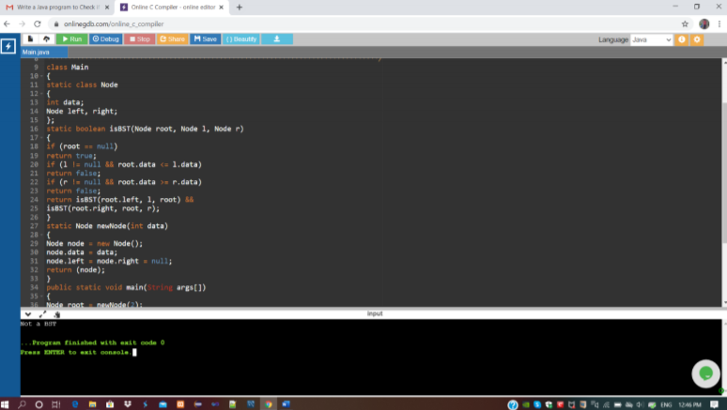

Program 2:

This is the output of C program to to generate first N Magic Numbers.

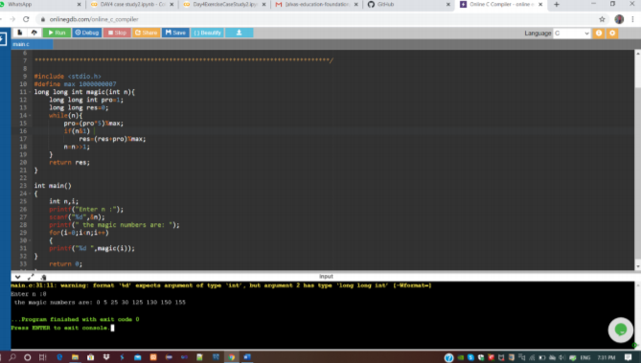

“Workshop on “Applications of Python Programming in DA and ML”

<https://github.com/Raghavi26/Applications-0f-Python-Programming-in-DA-and-ML>