**DAILY ONLINE ACTIVITIES SUMMARY**

|  |  |  |  |  |  |  |  |  |
| --- | --- | --- | --- | --- | --- | --- | --- | --- |
| **Date:** | **19-05-20** | | | | | **Name:** | **Raghavi H Gaonkar** | |
| **Sem & Sec** | **6th Sem & B Sec** | | | | | **USN:** | **4AL17CS071** | |
| **Online Test Summary** | | | | | | | | |
| **Subject** | | **CGV-1** | | | | | | |
| **Max. Marks** | | **60** | | **Score** | | | **43** | |
| **Certification Course Summary** | | | | | | | | |
| **Course** | **Machine learning with python** | | | | | | | |
| **Certificate Provider** | | | **Saeed Aghabozorgi** | | **Duration** | | | **12 hrs** |
| **Coding Challenges** | | | | | | | | |
| **Problem Statement: 1. We have a letter or a word that we need to add some letters to it and need to find out shortest palindrome**  **2. Write a simple code to identify given linked list is palindrome or not by using stack. First take a stack. Traverse through each node of the linked list and push each node value to stack.**  **3.A user will input two strings, and we find if one of the string is a sub sequence of the other. Program prints “yes” if either the first string is a subsequence of the second string or the first string. Assume the length of the first string is smaller than or equal to the second string.** | | | | | | | | |
| **Status: Completed** | | | | | | | | |
| **Uploaded the report in Github** | | | | | **yes** | | | |
| **If yes Repository name** | | | | | <https://github.com/Raghavi26/dailystatus> | | | |
| **Uploaded the report in slack** | | | | | **yes** | | | |

Online Test Details:

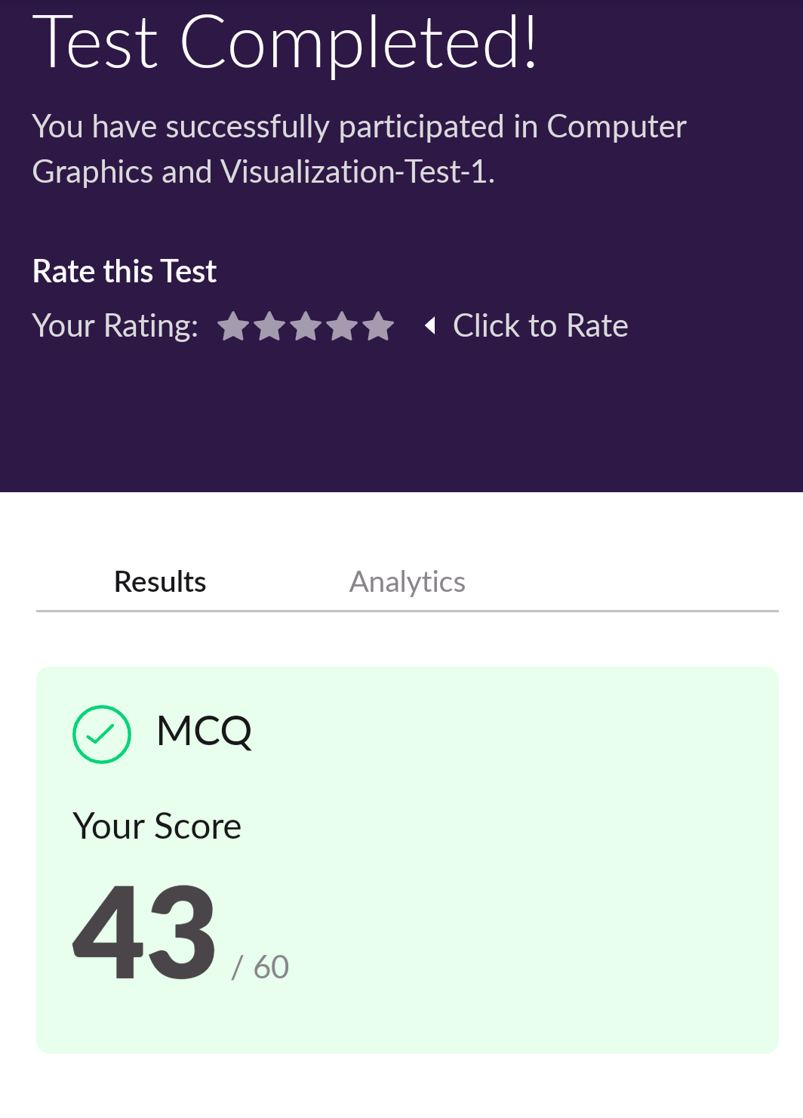

Certification course details:

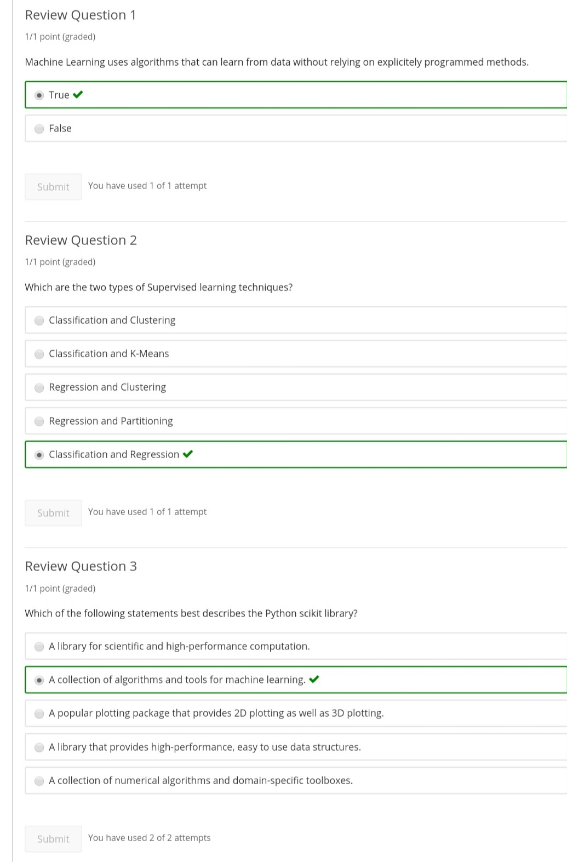

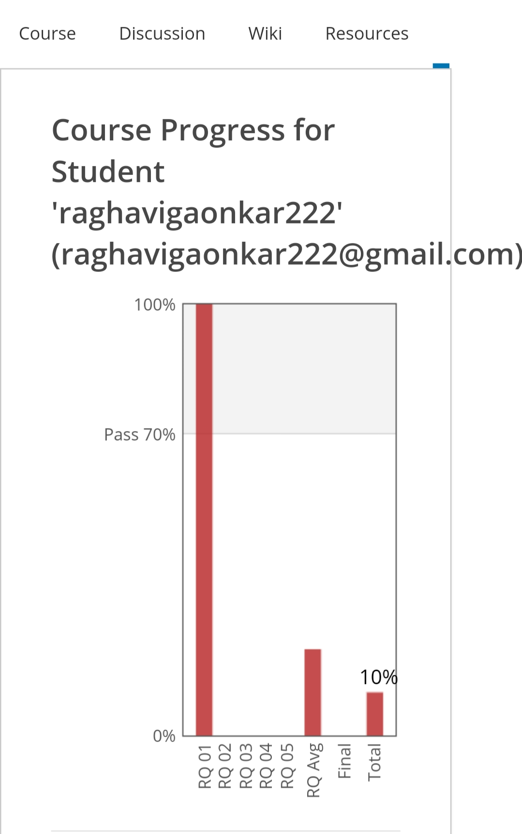

Coding Challenges Details:

<https://github.com/Raghavi26/dailystatus/blob/master/Online%20coding/19-05-20%20(2).docx>

The same report is also available on:

<https://github.com/Raghavi26/dailystatus/tree/master/Online%20coding>