**DAILY ONLINE ACTIVITIES SUMMARY**

|  |  |  |  |  |  |  |  |  |
| --- | --- | --- | --- | --- | --- | --- | --- | --- |
| **Date:** | **20-05-20** | | | | | **Name:** | **Raghavi H Gaonkar** | |
| **Sem & Sec** | **VI Sem & B Sec** | | | | | **USN:** | **4AL17CS071** | |
| **Online Test Summary** | | | | | | | | |
| **Subject** | | **SSCD-1** | | | | | | |
| **Max. Marks** | | **30** | | **Score** | | | **22** | |
| **Certification Course Summary** | | | | | | | | |
| **Course** | **Machine Learning With Python** | | | | | | | |
| **Certificate Provider** | | | **Saeed Aghabozorgi** | | **Duration** | | | **12 hrs** |
| **Coding Challenges** | | | | | | | | |
| **Problem Statement:**  **1.Write a C program to reverse a Linked list in groups of given size.**  **2.Write a simple Python program to implement Diffie-Hellman Key Exchange Example**  **3.Write a Java program which illustrates how to get column properties from ResultSet using ResultSetMetaData?**  **4.Write Python program to Reverse a given number.**  **5.Python Program to Exchange the values of Two Numbers using ^(exclusive or operator)** | | | | | | | | |
| **Status: Completed** | | | | | | | | |
| **Uploaded the report in Github** | | | | | **Yes** | | | |
| **If yes Repository name** | | | | | <https://github.com/Raghavi26/dailystatus> | | | |
| **Uploaded the report in slack** | | | | | **Yes** | | | |

Online Test Details:

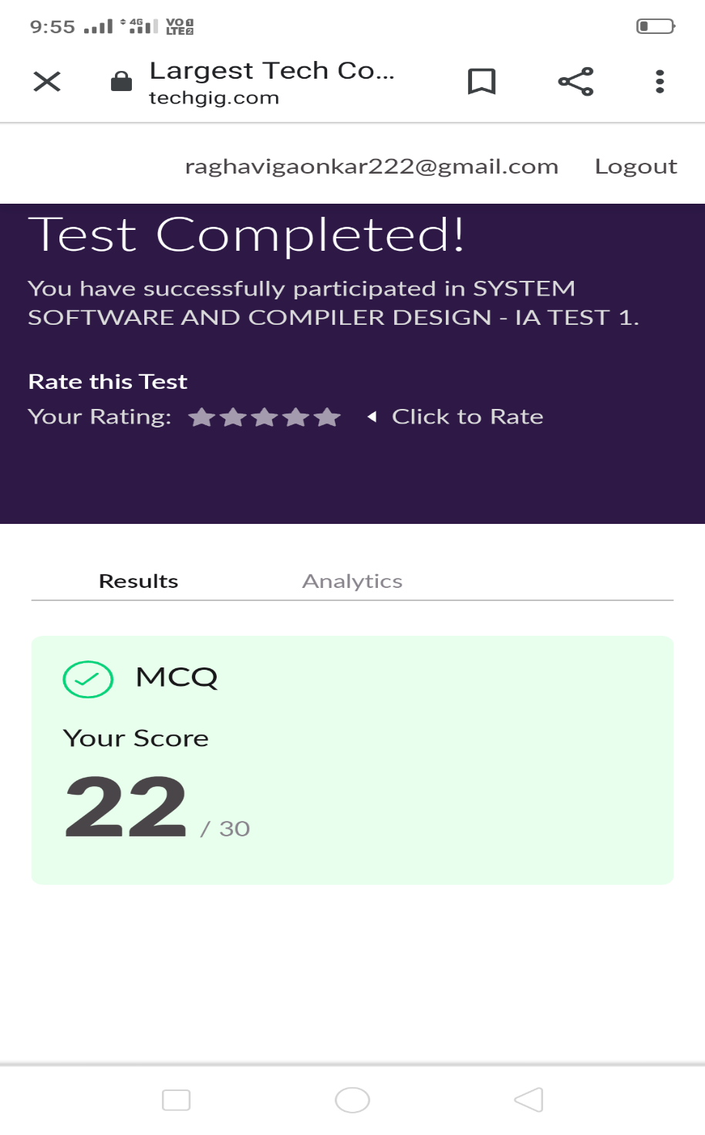

Certification Course Details:

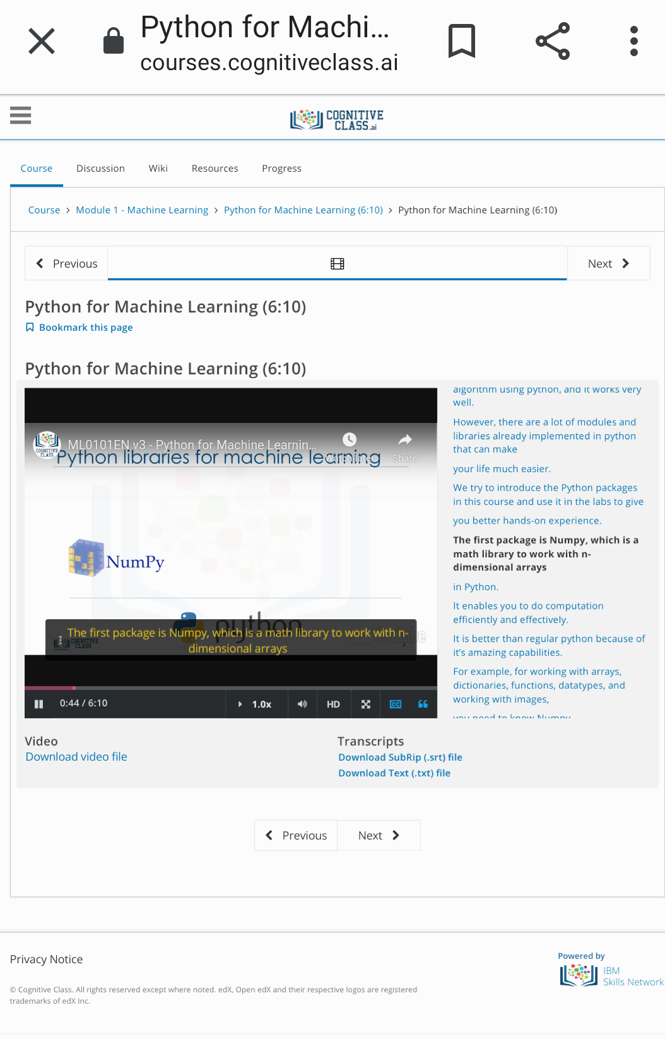

Coding Challenges Details:

<https://github.com/Raghavi26/dailystatus/blob/master/Online%20coding/20-05-20p1.docx>

<https://github.com/Raghavi26/dailystatus/blob/master/Online%20coding/20-05-20p2.docx>

<https://github.com/Raghavi26/dailystatus/blob/master/Online%20coding/20-05-20p3.docx>

<https://github.com/Raghavi26/dailystatus/blob/master/Online%20coding/20-05-20p4.docx>

<https://github.com/Raghavi26/dailystatus/blob/master/Online%20coding/20-05-20p5.docx>