**DAILY ONLINE ACTIVITIES SUMMARY**

|  |  |  |  |  |  |  |  |  |
| --- | --- | --- | --- | --- | --- | --- | --- | --- |
| **Date:** | **21-05-20** | | | | | **Name:** | **Raghavi H Gaonkar** | |
| **Sem & Sec** | **VI Sem & B Sec** | | | | | **USN:** | **4AL17CS071** | |
| **Online Test Summary** | | | | | | | | |
| **Subject** | | **SSCD** | | | | | | |
| **Max. Marks** | | **30** | | **Score** | | | **22** | |
| **Certification Course Summary** | | | | | | | | |
| **Course** | **Machine Learning With Python** | | | | | | | |
| **Certificate Provider** | | | **Saeed Aghabozorgi** | | **Duration** | | | **12 hrs** |
| **Coding Challenges** | | | | | | | | |
| **Problem Statement:**  **1.Getting a message printed through Applet.**  **2.AppletDemo**  **3.Write a C program to create a Singly Linked List with n elements and reverse the elements**  **4.Write a Java program to demonstrate a Basic Calculator using Applet**  **5.Write a C program to construct a Singly Linked List by removing duplicate elements in the Sorted Linked List**  **6.Write a Java program to implement Round Robin Scheduling Algorithm.Calculate AVG WT AND TAT.**  **7.write a Simple Applet Java program to check whether the given number is Armstrong Number or not.** | | | | | | | | |
| **Status:Completed** | | | | | | | | |
| **Uploaded the report in Github** | | | | | **Yes** | | | |
| **If yes Repository name** | | | | | <https://github.com/Raghavi26/dailystatus> | | | |
| **Uploaded the report in slack** | | | | | **Yes** | | | |

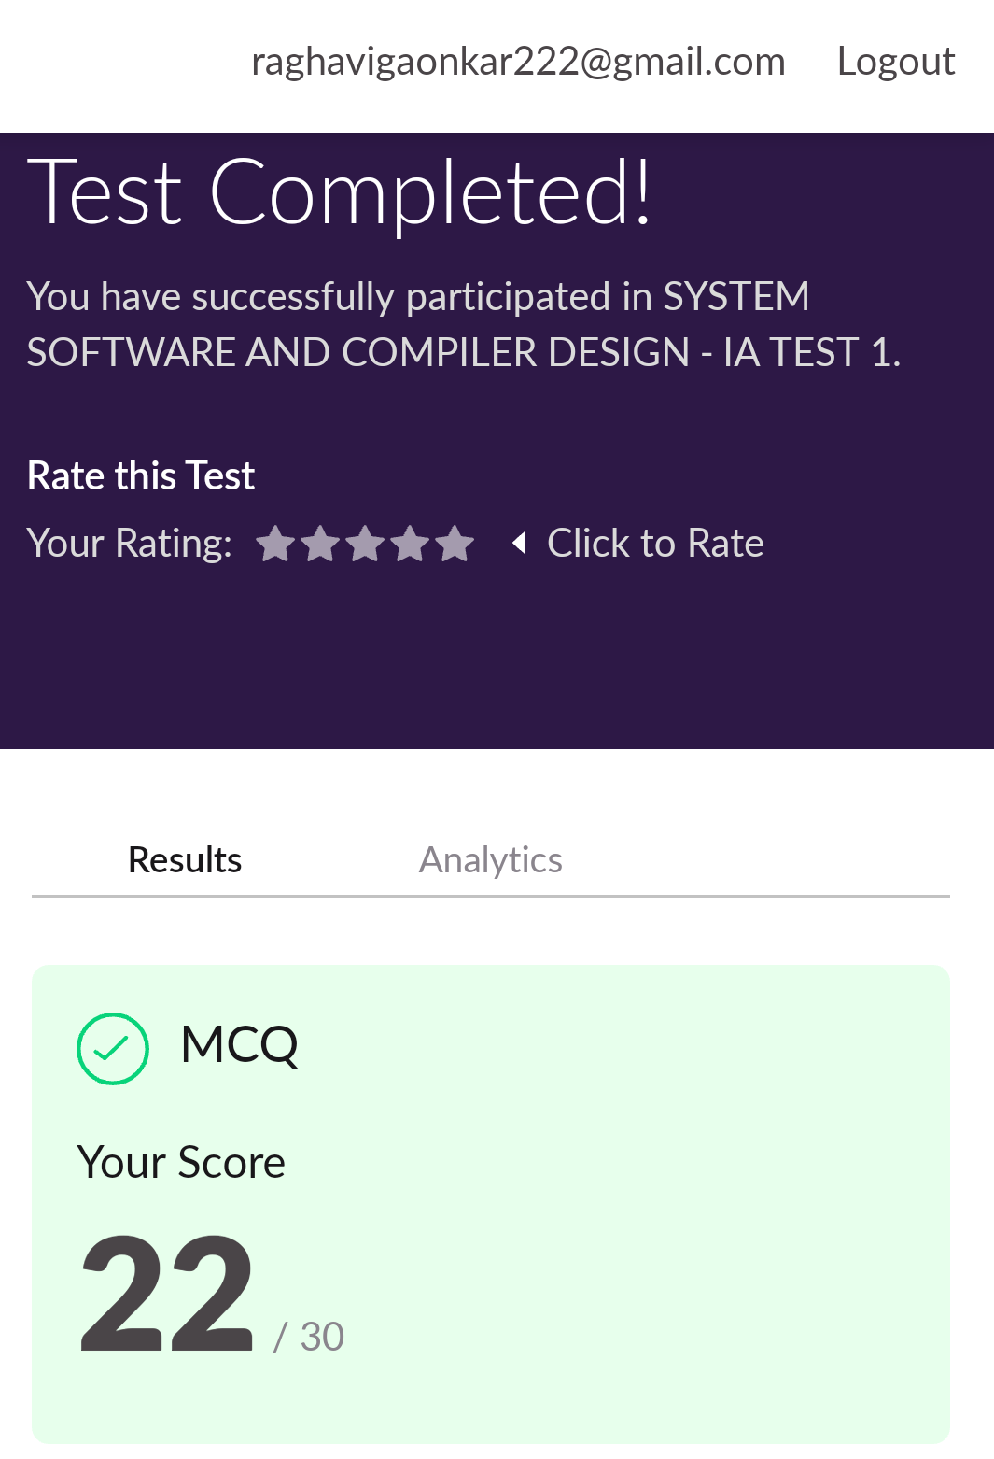online Test Details:

Certification Course Details:

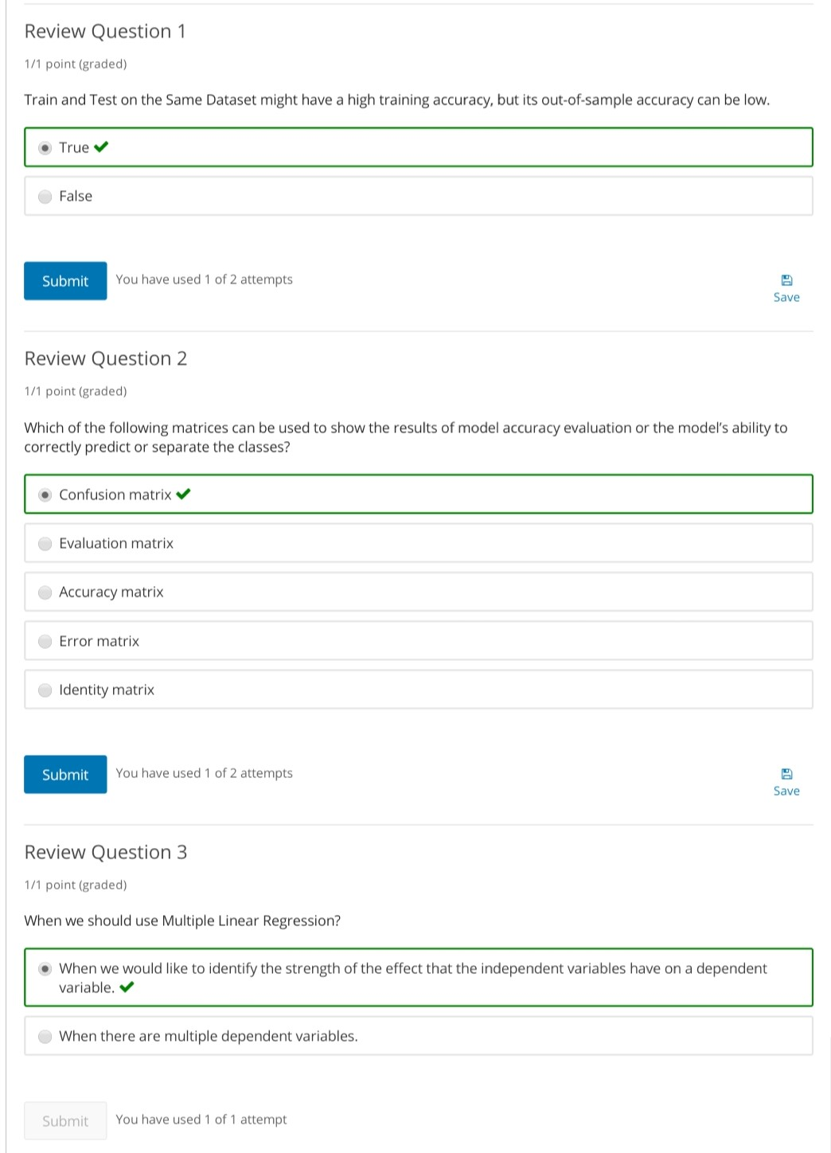

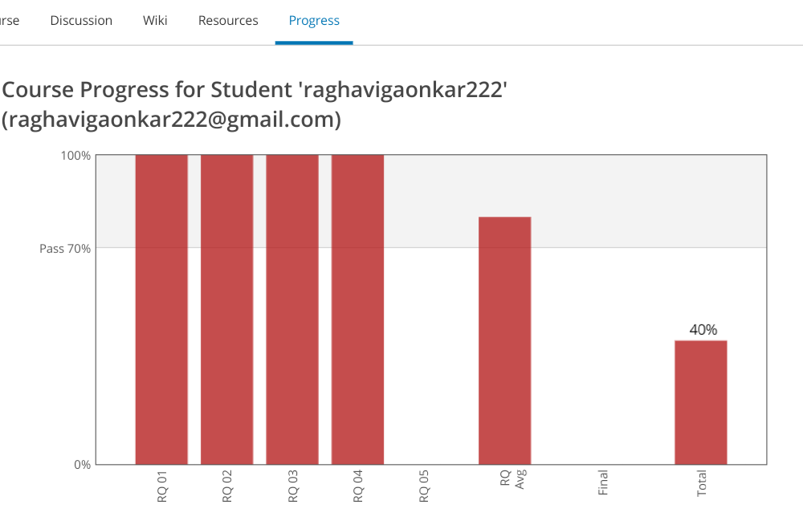

Coding Challenges Details:

<https://github.com/Raghavi26/dailystatus/blob/master/Online%20coding/21-05-20p1.txt>

<https://github.com/Raghavi26/dailystatus/blob/master/Online%20coding/21-5-20p3.docx>

<https://github.com/Raghavi26/dailystatus/blob/master/Online%20coding/21-5-20p4.docx>

<https://github.com/Raghavi26/dailystatus/blob/master/Online%20coding/21-5-20p5.docx>

<https://github.com/Raghavi26/dailystatus/blob/master/Online%20coding/21-5-20p6.docx>

<https://github.com/Raghavi26/dailystatus/blob/master/Online%20coding/21-5-20p7.docx>

The report is also available in:

<https://github.com/Raghavi26/dailystatus/tree/master/Online%20coding>