**DAILY ONLINE ACTIVITIES SUMMARY**

|  |  |  |  |  |  |  |  |  |
| --- | --- | --- | --- | --- | --- | --- | --- | --- |
| **Date:** | **23-05-20** | | | | | **Name:** | **Raghavi H Gaonkar** | |
| **Sem & Sec** | **VI Sem & B Sec** | | | | | **USN:** | **4AL17CS071** | |
| **Online Test Summary** | | | | | | | | |
| **Subject** | | **PAP-1** | | | | | | |
| **Max. Marks** | | **9** | | **Score** | | | **30** | |
| **Certification Course Summary** | | | | | | | | |
| **Course** | **Machine learning with python** | | | | | | | |
| **Certificate Provider** | | | **Saeed Aghabozorgi** | | **Duration** | | | **12 hrs** |
| **Coding Challenges** | | | | | | | | |
| **Problem Statement:**  **1.Write a C program to generate First N Triangle Numbers (Where N is read from the Keyboard)** | | | | | | | | |
| **Status:Completed** | | | | | | | | |
| **Uploaded the report in Github** | | | | | **Yes** | | | |
| **If yes Repository name** | | | | | <https://github.com/Raghavi26/dailystatus> | | | |
| **Uploaded the report in slack** | | | | | **Yes** | | | |

Online Test Details:

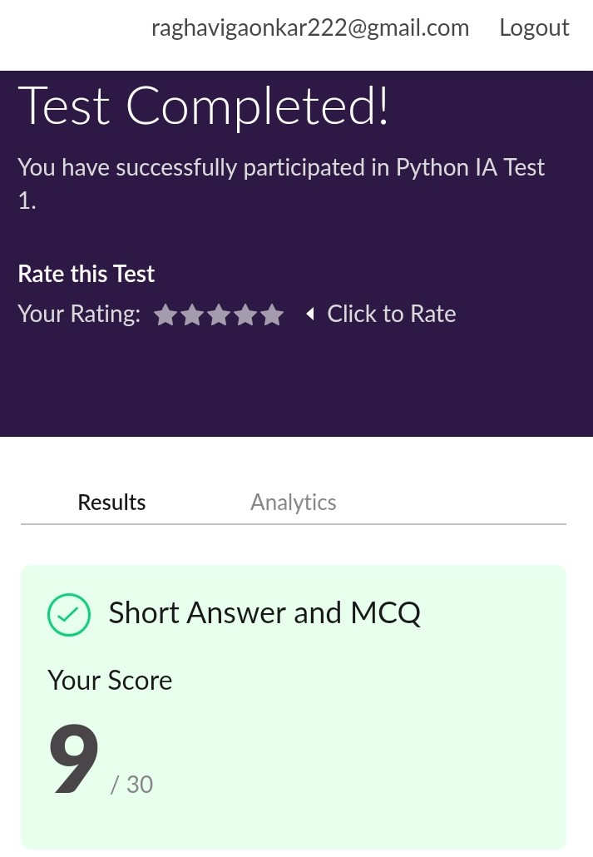

Certification Course Details:

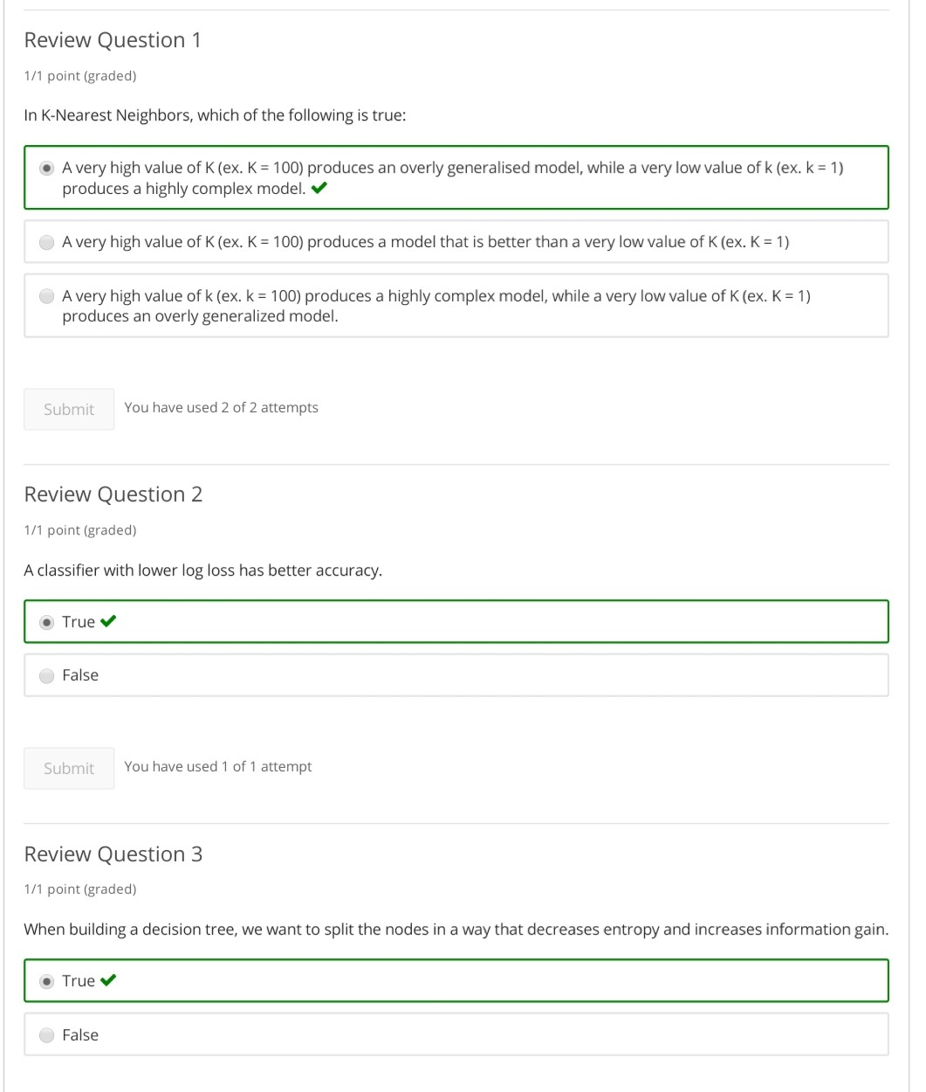

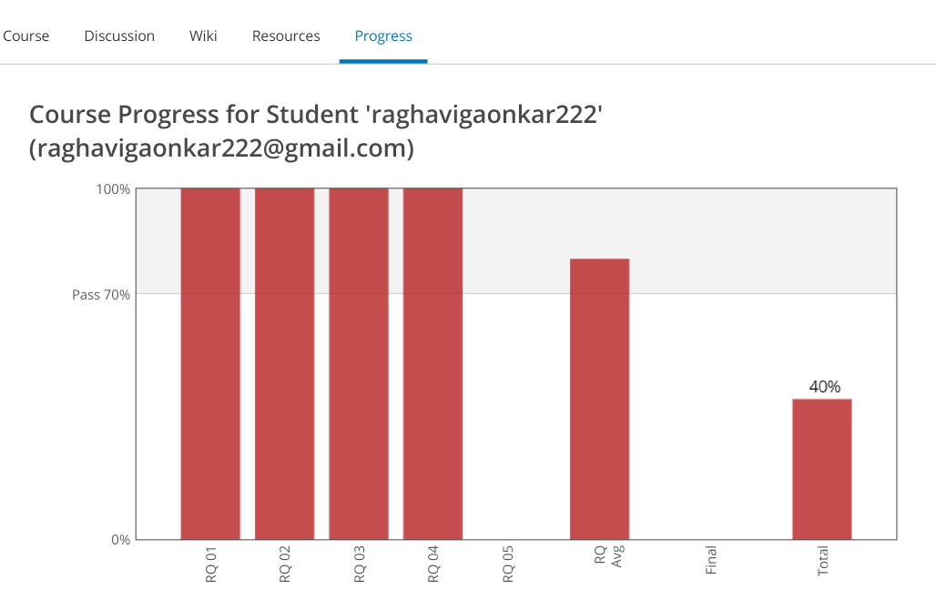

Coding Challenge Details:

<https://github.com/Raghavi26/dailystatus/blob/master/Online%20coding/23-5-2020.docx>

The report is also available in:

<https://github.com/Raghavi26/dailystatus/tree/master/Online%20coding>