**DAILY ONLINE ACTIVITIES SUMMARY**

|  |  |  |  |  |  |  |  |  |
| --- | --- | --- | --- | --- | --- | --- | --- | --- |
| **Date:** | **25-06-20** | | | | | **Name:** | **Raghavi H Gaonkar** | |
| **Sem & Sec** | **VI Sem & B Sec** | | | | | **USN:** | **4AL17CS071** | |
| **Online Test Summary** | | | | | | | | |
| **Subject** | | **JSP**  **Data structure in C** | | | | | | |
| **Max. Marks** | | **-** | | **Score** | | | **-** | |
| **Certification Course Summary** | | | | | | | | |
| **Course** | **-** | | | | | | | |
| **Certificate Provider** | | | **-** | | **Duration** | | | **-** |
| **Coding Challenges** | | | | | | | | |
| **Problem Statement:** 4 C program | | | | | | | | |
| **Status:Executed** | | | | | | | | |
| **Uploaded the report in Github** | | | | | **Yes** | | | |
| **If yes Repository name** | | | | | <https://github.com/Raghavi26/dailystatus> | | | |
| **Uploaded the report in slack** | | | | | **Yes** | | | |

Online Test Details:

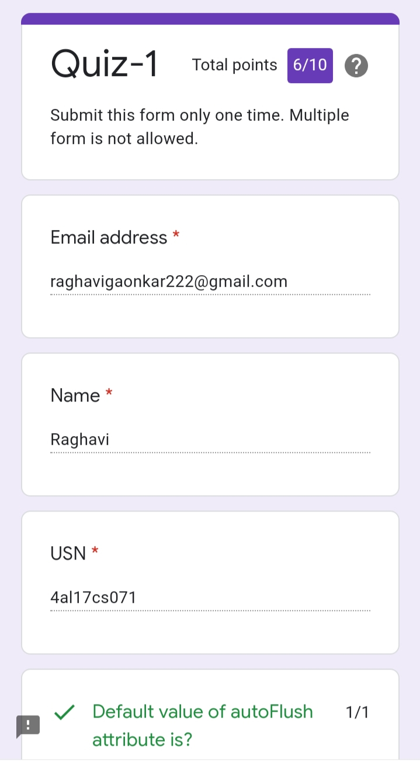

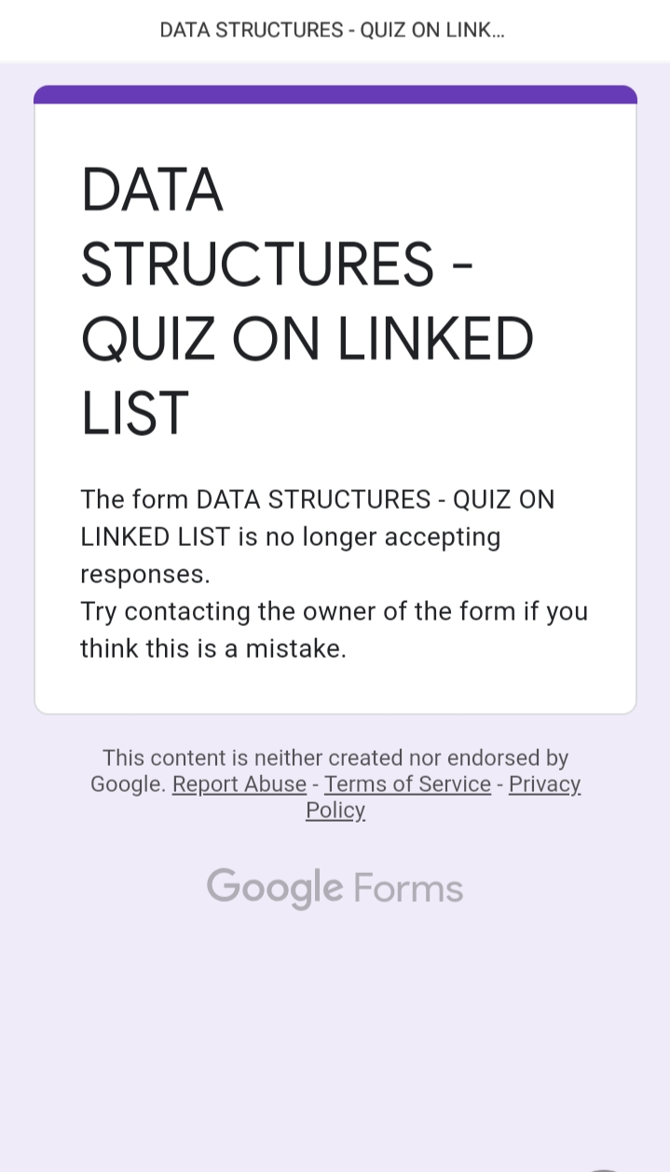

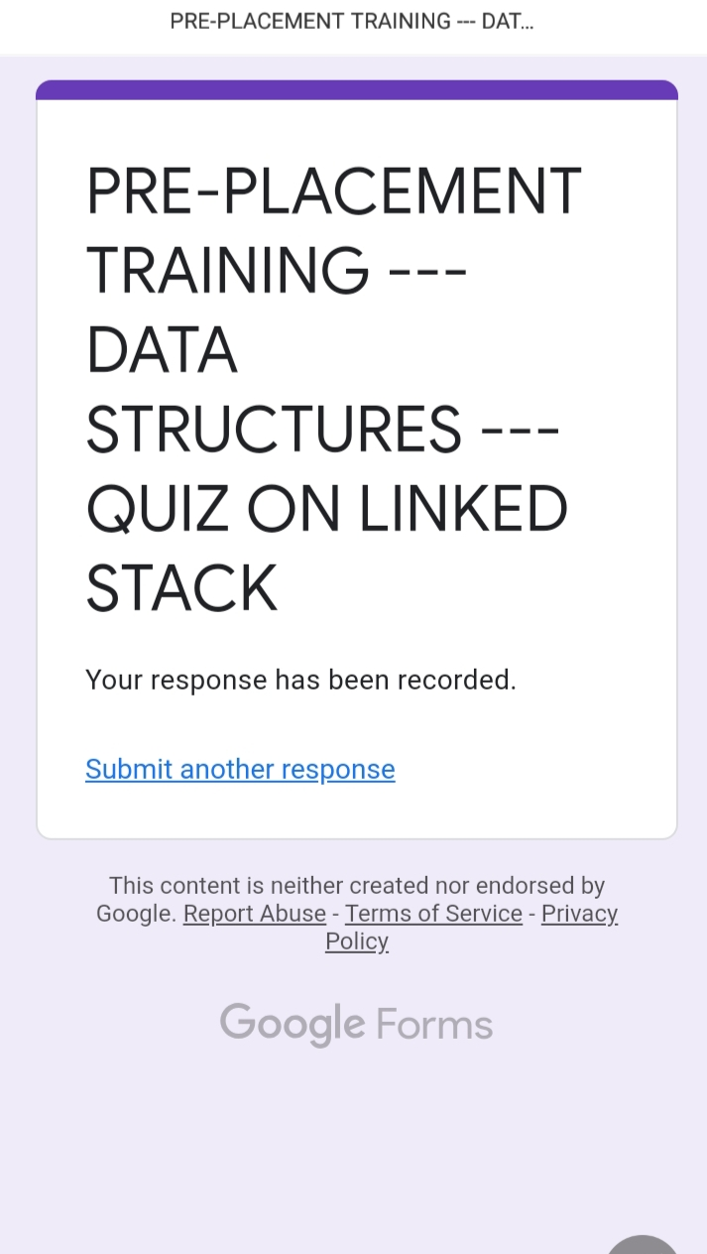

Workshop Details:

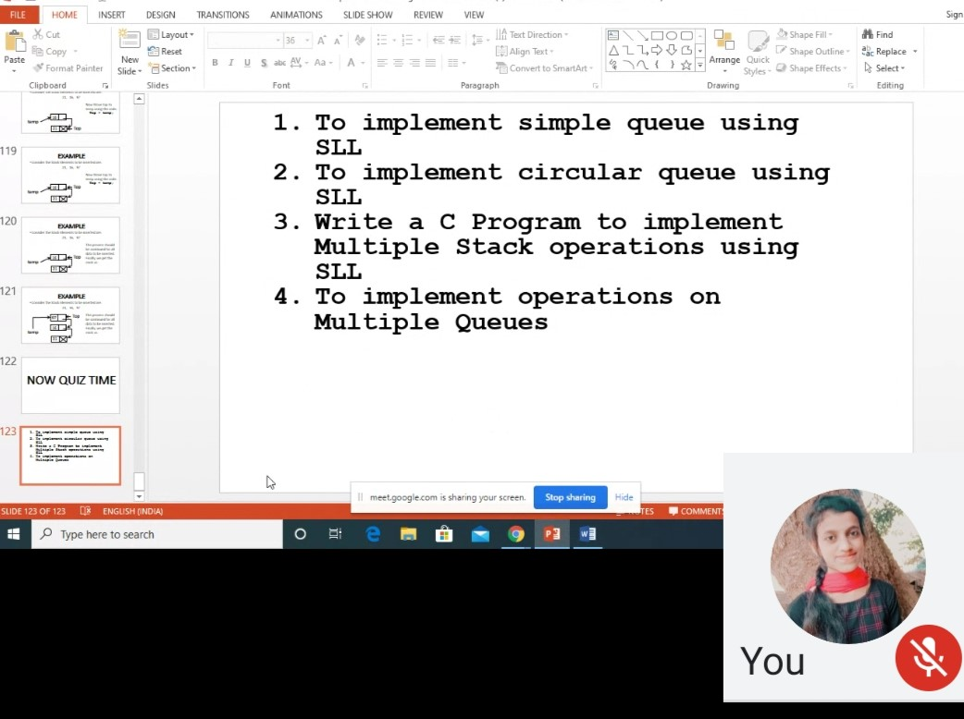

Refer Github Account For Detailed Information:

<https://github.com/Raghavi26/dailystatus/tree/master/Online%20coding>