**DAILY ONLINE ACTIVITIES SUMMARY**

|  |  |  |  |  |  |  |  |  |
| --- | --- | --- | --- | --- | --- | --- | --- | --- |
| **Date:** | **26-05-20** | | | | | **Name:** | **Raghavi H Gaonkar** | |
| **Sem & Sec** | **VI Sem & B Sec** | | | | | **USN:** | **4AL17CS071** | |
| **Online Test Summary** | | | | | | | | |
| **Subject** | | **CGV-2** | | | | | | |
| **Max. Marks** | | **13** | | **Score** | | | **30** | |
| **Certification Course Summary** | | | | | | | | |
| **Course** | **Machine learning with python** | | | | | | | |
| **Certificate Provider** | | | **Saeed Aghabozorgi** | | **Duration** | | | **12 hrs** |
| **Coding Challenges** | | | | | | | | |
| **Problem Statement:**  **1.This is a Python program to read a number n and print and complete the series “1+2+…+n=”.**  **2.Python program to count the number of digits is a number.**  **3.Python program to check if a number is a palindrome.**  **4.Python program to print all Integers that aren’t divisible by either 2 or 3 and lie between 1 and 50.**  **45.Given an array A of size N where the array elements contain values from 1 to N with duplicates, the task is to find total number of subarrays which start and end with the same**  **element.**  **6.Write a program in C to print all Permutations of a given String Pointers.** | | | | | | | | |
| **Status: completed** | | | | | | | | |
| **Uploaded the report in Github** | | | | | **Yes** | | | |
| **If yes Repository name** | | | | | <https://github.com/Raghavi26/dailystatus> | | | |
| **Uploaded the report in slack** | | | | | **Yes** | | | |

Certification Course Details:

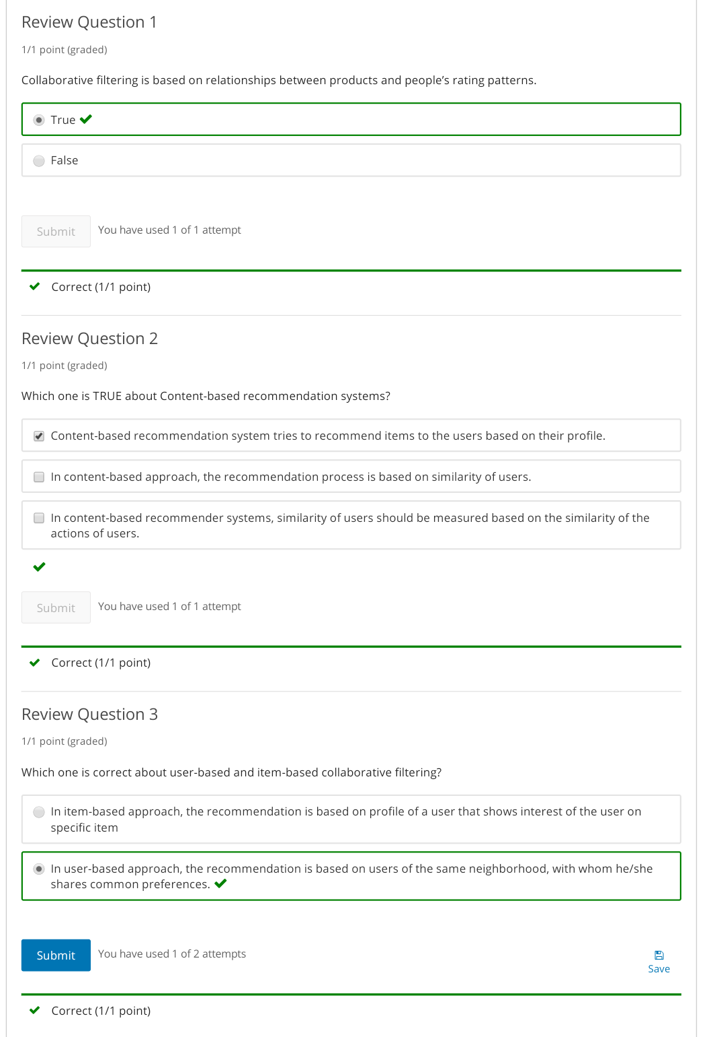

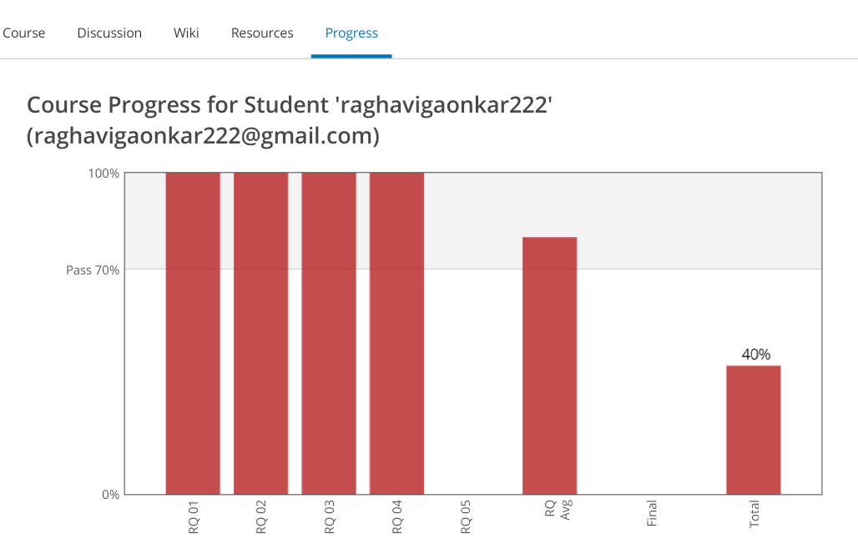

Coding Challenges Details:

<https://github.com/Raghavi26/dailystatus/blob/master/Online%20coding/26-05-20program1.docx>

<https://github.com/Raghavi26/dailystatus/blob/master/Online%20coding/26-05-20program2.docx>

<https://github.com/Raghavi26/dailystatus/blob/master/Online%20coding/26-05-20program3.docx>

<https://github.com/Raghavi26/dailystatus/blob/master/Online%20coding/26-05-20program4.doc>

<https://github.com/Raghavi26/dailystatus/blob/master/Online%20coding/26-05-20program5.docx>

<https://github.com/Raghavi26/dailystatus/blob/master/Online%20coding/26-05-20program6.docx>