**DAILY ONLINE ACTIVITIES SUMMARY**

|  |  |  |  |  |  |  |  |  |
| --- | --- | --- | --- | --- | --- | --- | --- | --- |
| **Date:** | **28-05-20** | | | | | **Name:** | **Raghavi H Gaonkar** | |
| **Sem & Sec** | **VI Sem & B Sec** | | | | | **USN:** | **4AL17CS071** | |
| **Online Test Summary** | | | | | | | | |
| **Subject** | | **OS** | | | | | | |
| **Max. Marks** | | **30** | | **Score** | | | **17** | |
| **Certification Course Summary** | | | | | | | | |
| **Course** | **Introduction to Information Security** | | | | | | | |
| **Certificate Provider** | | | **Great Learning Academy** | | **Duration** | | | **5.5 hrs** |
| **Coding Challenges** | | | | | | | | |
| **Problem Statement:**  **1.Python program to find digital root of a number.**  **2.Write a function that accepts a string considering entering of brackets ( {} ) and returns whether it is balanced.**  **3.Write a jsp code to display today’s date and time using expression tag.**  **4.Write jsp script to determine how many times the visitor has loaded the page.**  **5.Given an array arr[] of size N and integer K. The task is to find the last remaining element in the array after reducing the array.** | | | | | | | | |
| **Status:Completed** | | | | | | | | |
| **Uploaded the report in Github** | | | | | **Yes** | | | |
| **If yes Repository name** | | | | | <https://github.com/Raghavi26/dailystatus> | | | |
| **Uploaded the report in slack** | | | | | **Yes** | | | |

Online Test Details:

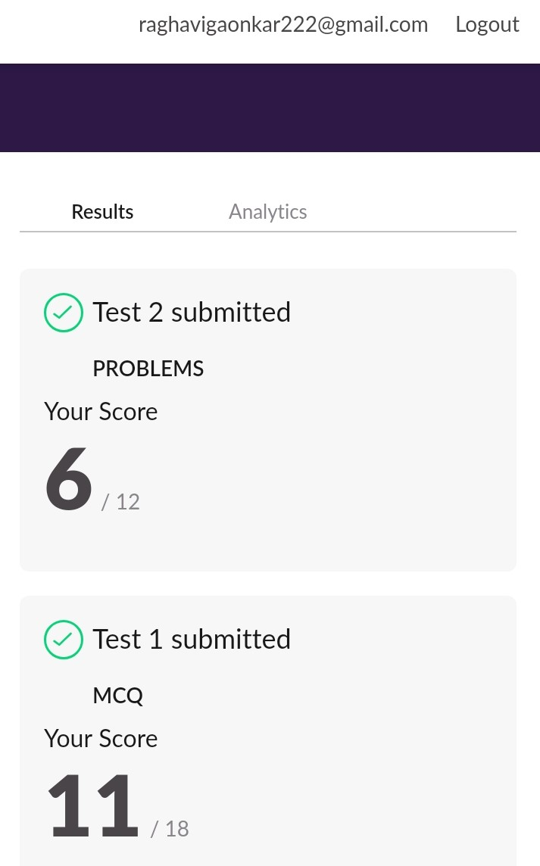

Certification Course Details:

**Introduction to Information Security:**

Today I learnt detailed information about “**Stanford and Computer Security”**

In that I learnt,

* Introduction of Stanford and Computer Security Field.
* Innovations in Cyber Security.
* Future of Cryptography.
* Computer Security.



Coding Challenges Details:

<https://github.com/Raghavi26/dailystatus/blob/master/Online%20coding/28-05-20program1.docx>

<https://github.com/Raghavi26/dailystatus/blob/master/Online%20coding/28-05-20program2.docx>

<https://github.com/Raghavi26/dailystatus/blob/master/Online%20coding/28-05-20program3.docx>

<https://github.com/Raghavi26/dailystatus/blob/master/Online%20coding/28-05-20program4.docx>