**DAILY ONLINE ACTIVITIES SUMMARY**

|  |  |  |  |  |  |  |  |  |
| --- | --- | --- | --- | --- | --- | --- | --- | --- |
| **Date:** | **08-06-20** | | | | | **Name:** | **Raghavi H Gaonkar** | |
| **Sem & Sec** | **VI Sem & B Sec** | | | | | **USN:** | **4AL17CS071** | |
| **Online Test Summary** | | | | | | | | |
| **Subject** | | **CNSC-3** | | | | | | |
| **Max. Marks** | | **60** | | **Score** | | | **10** | |
| **Certification Course Summary** | | | | | | | | |
| **Course** | **Cognitiveclass:Python for Data Science** | | | | | | | |
| **Certificate Provider** | | | **IBM** | | **Duration** | | | **6 hrs** |
| **Coding Challenges** | | | | | | | | |
| **Problem Statement:**  1. Write C++ program to Check whether a number can be represented as difference of two squares.  2. C Program to Generate All the Set Partitions of n Numbers Beginning from 1 and so on.  3. Java program to delete a node from the middle of the singly linked list.  4. Program program to find whether a string is a palindrome or not. | | | | | | | | |
| **Status: Completed** | | | | | | | | |
| **Uploaded the report in Github** | | | | | **Yes** | | | |
| **If yes Repository name** | | | | | <https://github.com/Raghavi26/dailystatus> | | | |
| **Uploaded the report in slack** | | | | | **Yes** | | | |

Online Test Details:

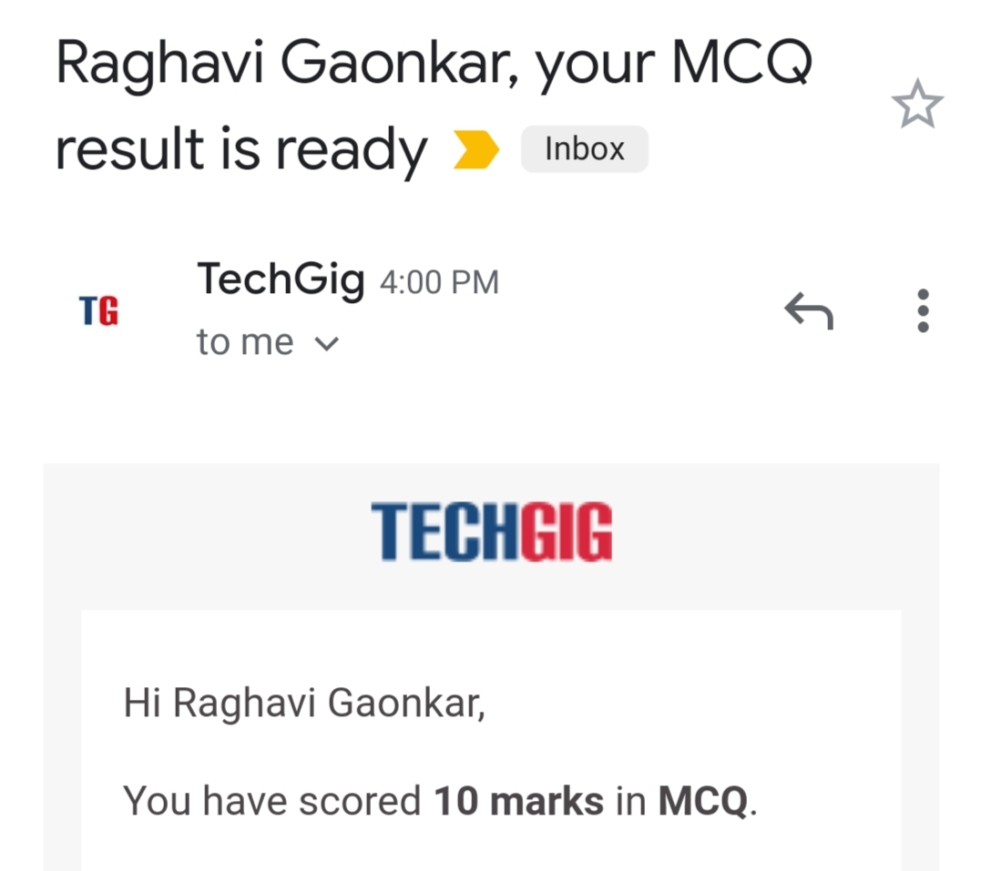

Certification Course Details:

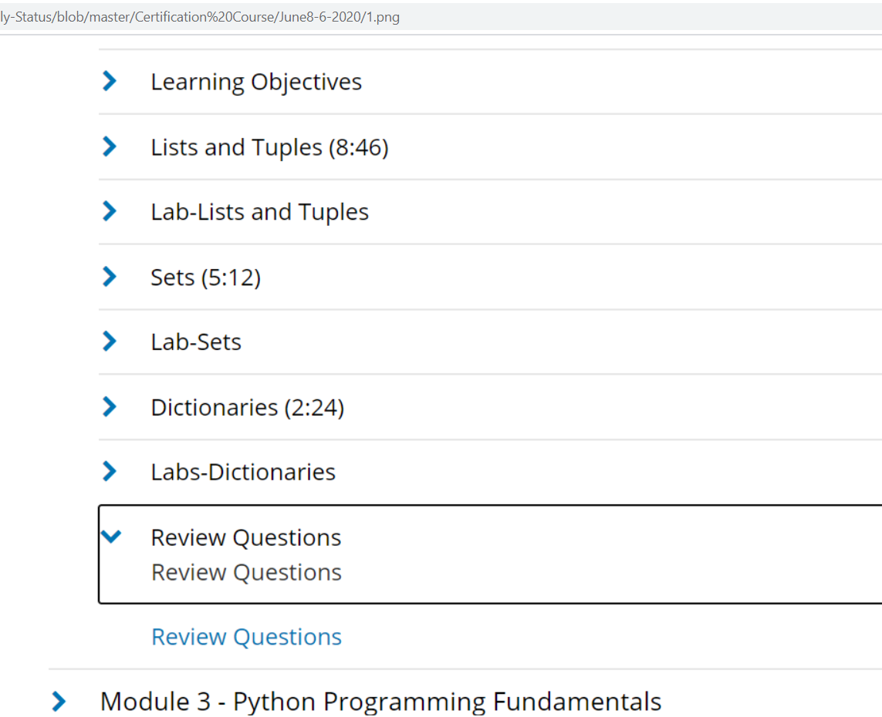

Coding Challenges Details: <https://github.com/Raghavi26/dailystatus/blob/master/Online%20coding/8-06-2020program1.docx>

<https://github.com/Raghavi26/dailystatus/blob/master/Online%20coding/8-06-2020program2.docx>

<https://github.com/Raghavi26/dailystatus/blob/master/Online%20coding/8-06-2020program3.docx>

<https://github.com/Raghavi26/dailystatus/blob/master/Online%20coding/8-06-2020program4.docx>