**DAILY ONLINE ACTIVITIES SUMMARY**

|  |  |  |  |  |  |  |  |  |
| --- | --- | --- | --- | --- | --- | --- | --- | --- |
| **Date:** | **09-06-20** | | | | | **Name:** | **Raghavi H Gaonkar** | |
| **Sem & Sec** | **VI Sem & B Sec** | | | | | **USN:** | **4AL17CS071** | |
| **Online Test Summary** | | | | | | | | |
| **Subject** | | **CGV-4**  **CNSC-3** | | | | | | |
| **Max. Marks** | | **CGV-30**  **CNSC-60** | | **Score** | | | **CGV-26**  **CNSC-28** | |
|  | |  | |  | | |  | |
| **Certification Course Summary** | | | | | | | | |
| **Course** | **Cognitiveclass:Python for Data Science** | | | | | | | |
| **Certificate Provider** | | | **IBM** | | **Duration** | | | **8 hrs** |
| **Coding Challenges** | | | | | | | | |
| **Problem Statement:**  **4 Programs** | | | | | | | | |
| **Status: completed** | | | | | | | | |
| **Uploaded the report in Github** | | | | | **Yes** | | | |
| **If yes Repository name** | | | | | <https://github.com/Raghavi26/dailystatus> | | | |
| **Uploaded the report in slack** | | | | | **Yes** | | | |

Online Test Details:

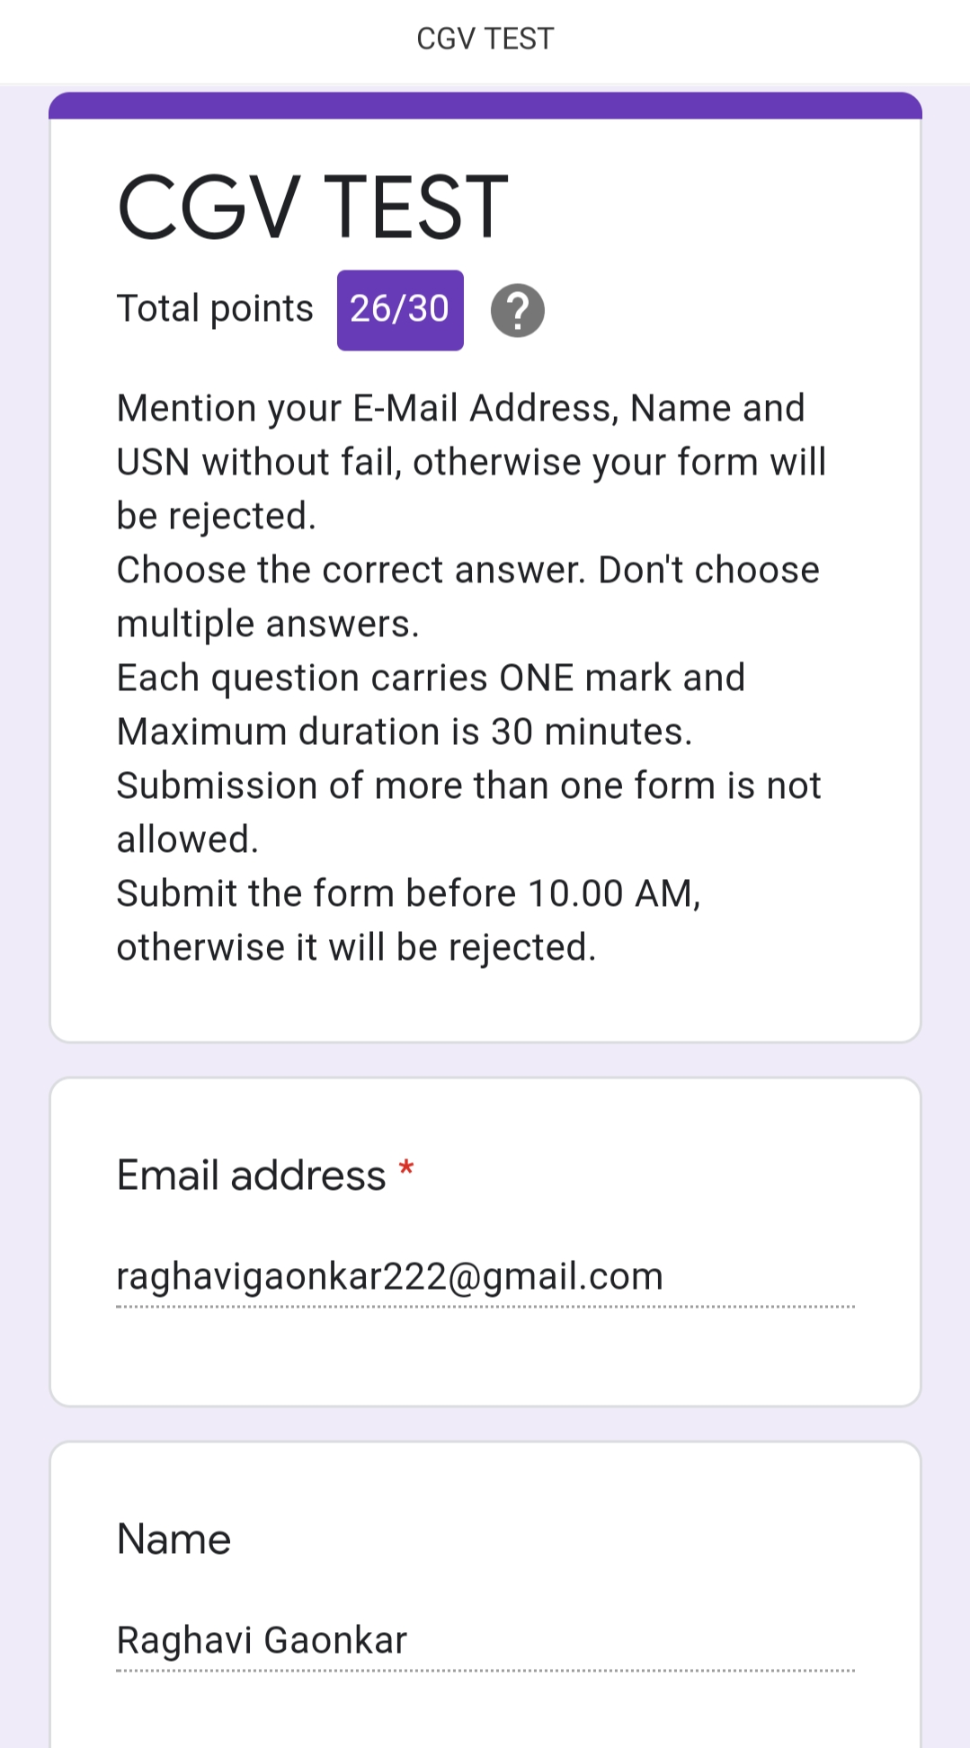

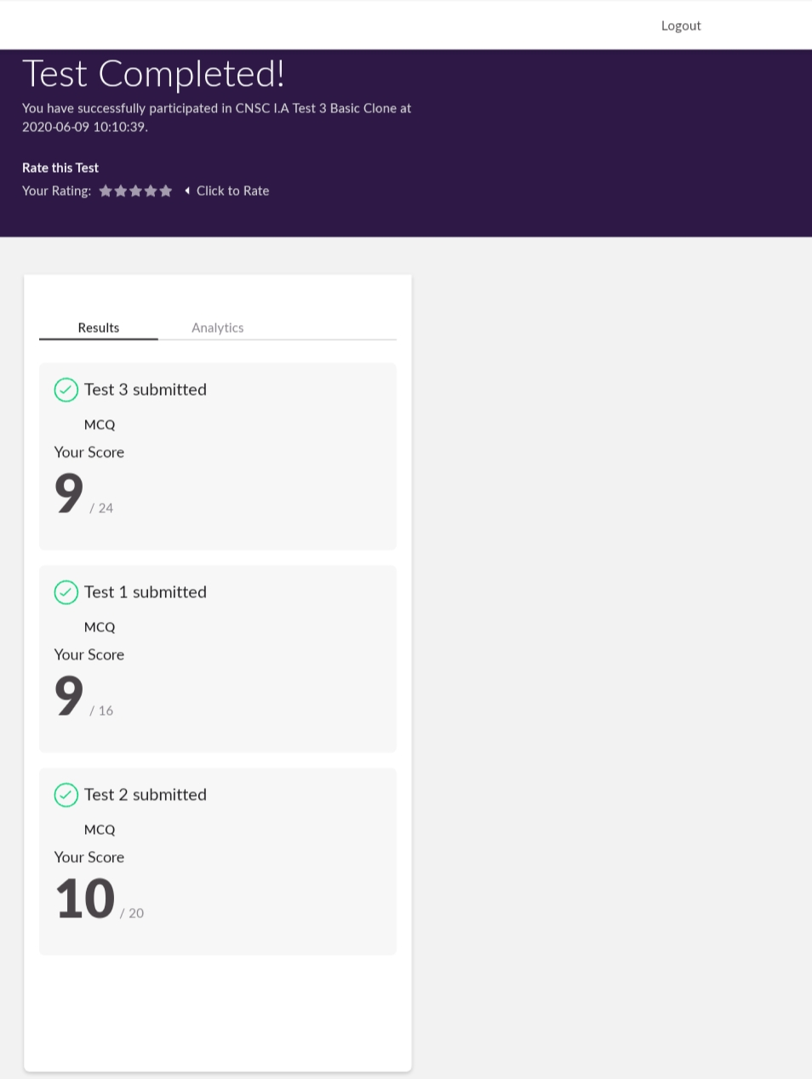

Certification Course Details:

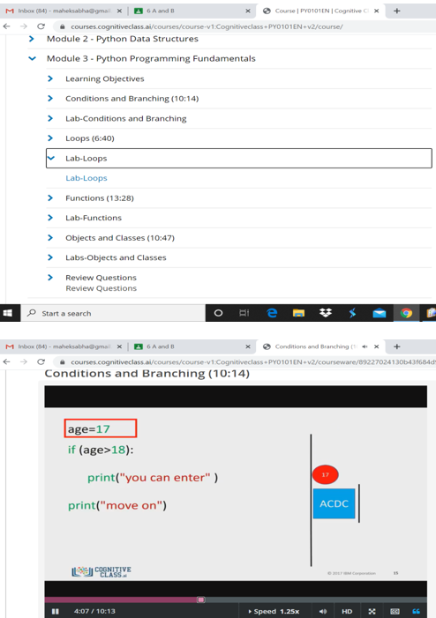

Coding Challenges Details:

<https://github.com/Raghavi26/dailystatus/blob/master/Online%20coding/p1.Perfect%20Sum%20Problem.docx>

<https://github.com/Raghavi26/dailystatus/blob/master/Online%20coding/p2.even%20and%20odd.docx>

<https://github.com/Raghavi26/dailystatus/blob/master/Online%20coding/p3.rotate%20matrix.docx>

<https://github.com/Raghavi26/dailystatus/blob/master/Online%20coding/p4.palindrome.docx>