DAILY ONLINE ACTIVITIES SUMMARY
Date: | 8-07-20 |  |  |  |  | Name: | Raghavi H Gaonkar
Sem & Sec | VI Sem & B Sec |  |  |  |  | USN: | 4AL17CS071
Online Test Summary
Subject |  | Cloud and Infrastructure Management
Max. Marks |  | - |  | Score |  |  | -
Certification Course Summary
Course | -
Certificate Provider |  |  | - |  | Duration |  |  | -
Coding Challenges
Problem Statement:1 Python Program
Status:Executed
Uploaded the report in Github |  |  |  |  | Yes
If yes Repository name |  |  |  |  | https://github.com/Raghavi26/dailystatus
Uploaded the report in slack |  |  |  |  | Yes

Online Certification Course Details:
Today I started module 2 (Etharium Blockchain)
• completed smart contract lesson and took quiz on this lesson.

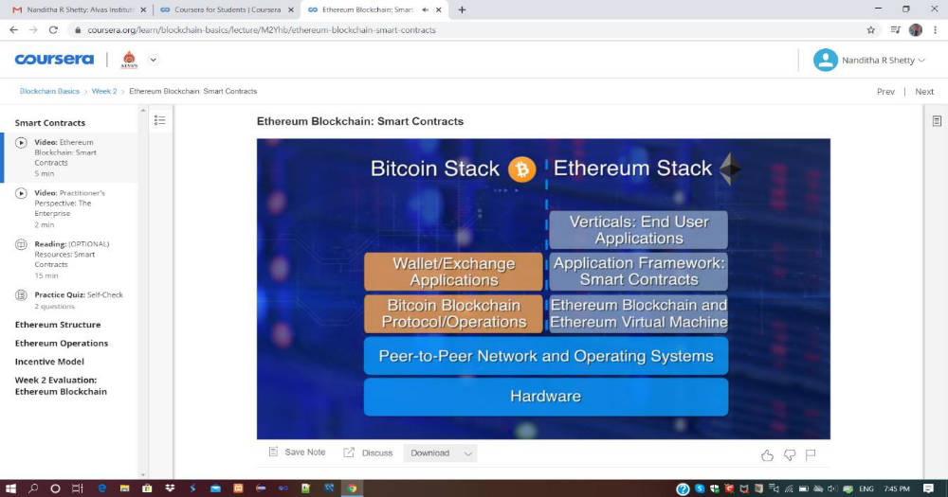

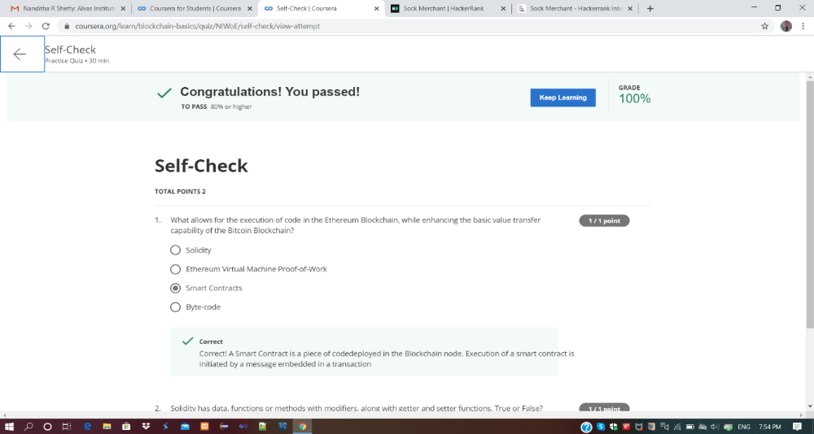

Coding Challenges Details:
Program 1:
This is output of python program for finding sum of odd factors of a number.
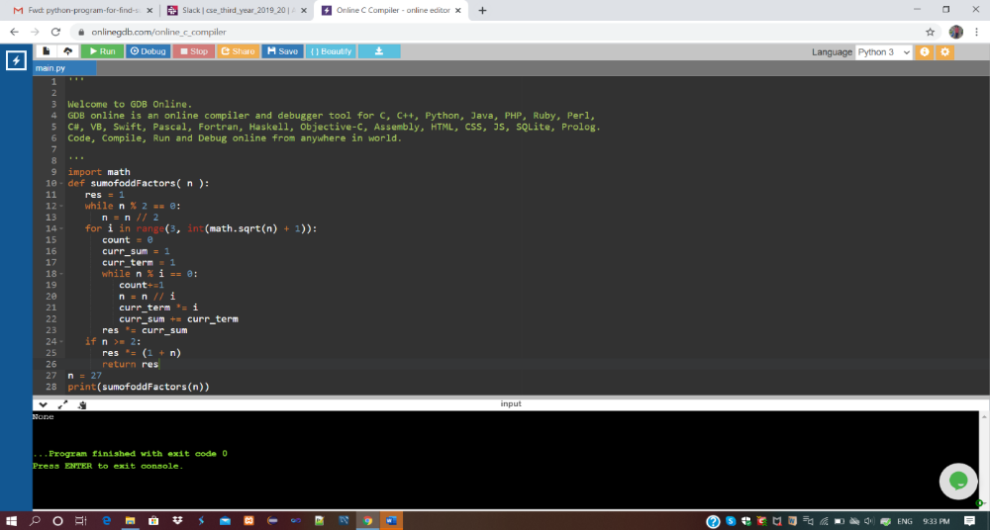

Refer Github Account For Detailed Information:
https://github.com/Raghavi26/dailystatus/tree/master/Online%20coding

