DAILY ONLINE ACTIVITIES SUMMARY
Date: | 17-06-20 |  |  |  |  | Name: | Raghavi H Gaonkar
Sem & Sec | VI Sem & B Sec |  |  |  |  | USN: | 4AL17CS071
Online Test Summary
Subject |  | Programming in C  Python Workshop
Max. Marks |  | 5  15 |  | Score |  |  | 5  11
Certification Course Summary
Course | Workshop on “Applications of Python Programming in DA and ML”
Certificate Provider |  |  | - |  | Duration |  |  | -
Coding Challenges
Problem Statement:2 Java Programs
Status:Executed
Uploaded the report in Github |  |  |  |  | Yes
If yes Repository name |  |  |  |  | https://github.com/Raghavi26/dailystatus
Uploaded the report in slack |  |  |  |  | Yes

Online Test Details:
Programming in C

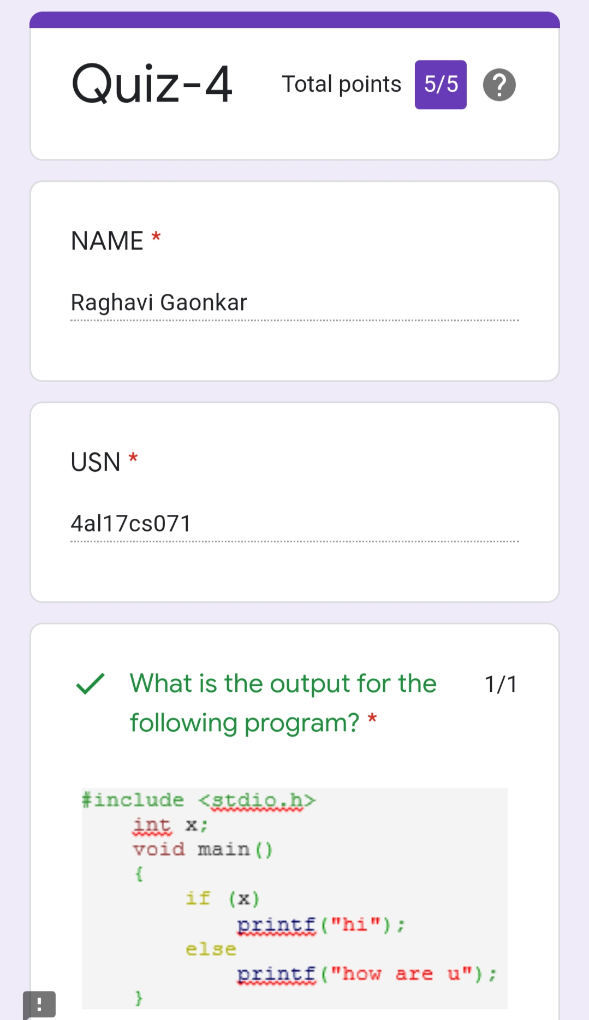
Python Workshop
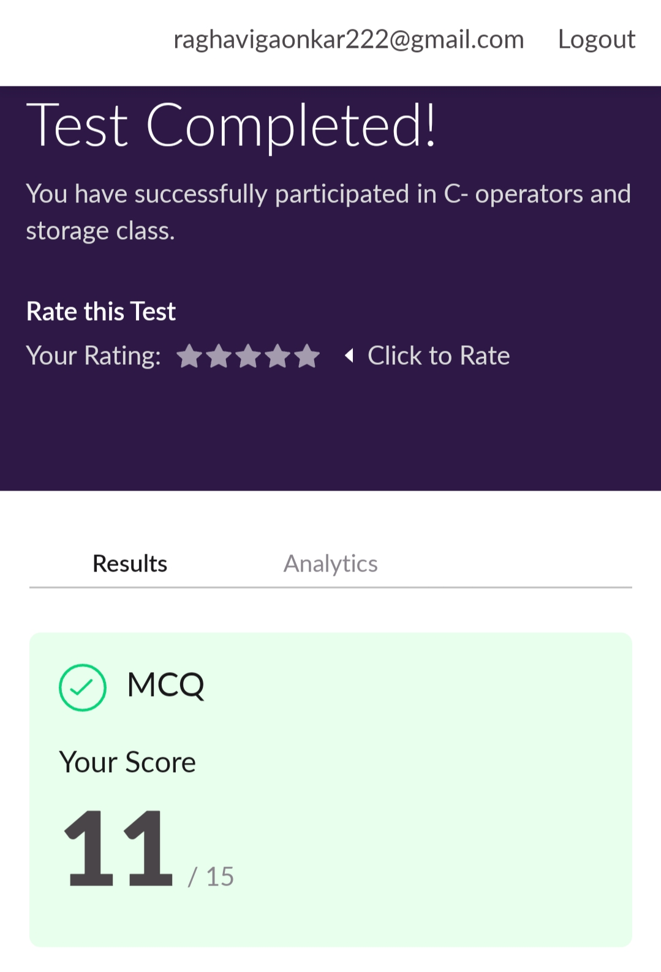

Workshop Details:
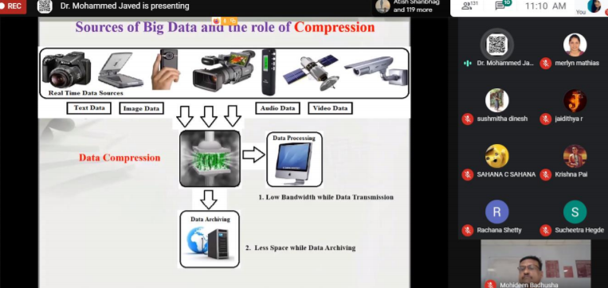

Coding Challenge Details:
Program1

This is the output of java program to find the smallest positive integer value that cannot be represented as sum of any subset of a given array sorted in ascending order.

Program 2:
This is output of java program to find the row, column position of a specified number (row, column position) in a given 2-dimensional array.

Refer Github Account for Detailed Information:
https://github.com/Raghavi26/dailystatus/tree/master/Online%20coding

“Workshop on “Applications of Python Programming in DA and ML”
https://github.com/Raghavi26/Applications-0f-Python-Programming-in-DA-and-ML

