DAILY ONLINE ACTIVITIES SUMMARY
Date: | 5-07-20 |  |  |  |  | Name: | Raghavi H Gaonkar
Sem & Sec | VI Sem & B Sec |  |  |  |  | USN: | 4AL17CS071
Online Test Summary
Subject |  | Blockchain Basics
Max. Marks |  | - |  | Score |  |  | -
Certification Course Summary
Course | -
Certificate Provider |  |  | - |  | Duration |  |  | -
Coding Challenges
Problem Statement:1 Python Program
Status:Executed
Uploaded the report in Github |  |  |  |  | Yes
If yes Repository name |  |  |  |  | https://github.com/Raghavi26/dailystatus
Uploaded the report in slack |  |  |  |  | Yes

Online Certification Course Details:
Today I started course “Blockchain Basics” from Coursera and took quiz on first
module.
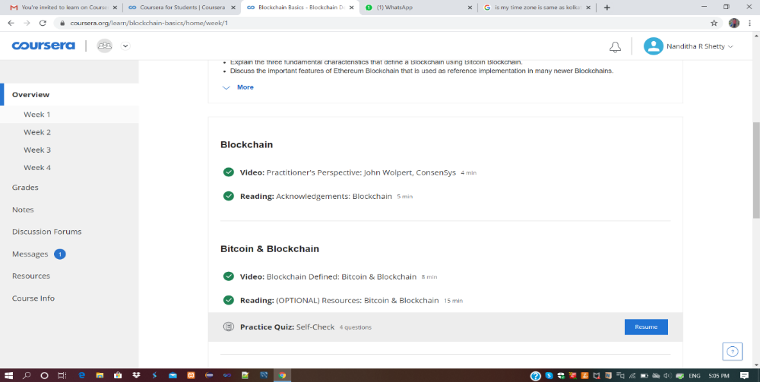

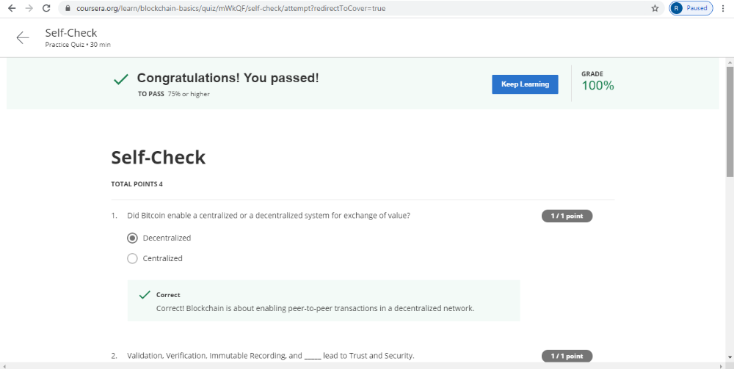

Coding Challenges Details:
Program 1:
This is output of Python program to sort the elements of the Circular Linked List.

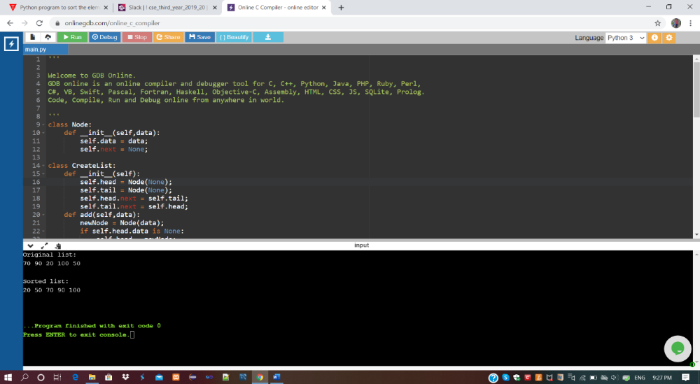

Refer Github Account For Detailed Information:
https://github.com/Raghavi26/dailystatus/blob/master/Online%20coding/5-07-2020program1.docx

