DAILY ONLINE ACTIVITIES SUMMARY
Date: | 23-06-20 |  |  |  |  | Name: | Raghavi H Gaonkar
Sem & Sec | VI Sem & B Sec |  |  |  |  | USN: | 4AL17CS071
Online Test Summary
Subject |  | Java and J2EE  Data Structures in C  Python Assignment Test
Max. Marks |  | Java-10  Pap-20 |  | Score |  |  | 9  13
Certification Course Summary
Course | -
Certificate Provider |  |  | - |  | Duration |  |  | -
Coding Challenges
Problem Statement:1 C and 1 Java Program
Status:Executed
Uploaded the report in Github |  |  |  |  | Yes
If yes Repository name |  |  |  |  | https://github.com/Raghavi26/dailystatus
Uploaded the report in slack |  |  |  |  | Yes

Online Test Details:

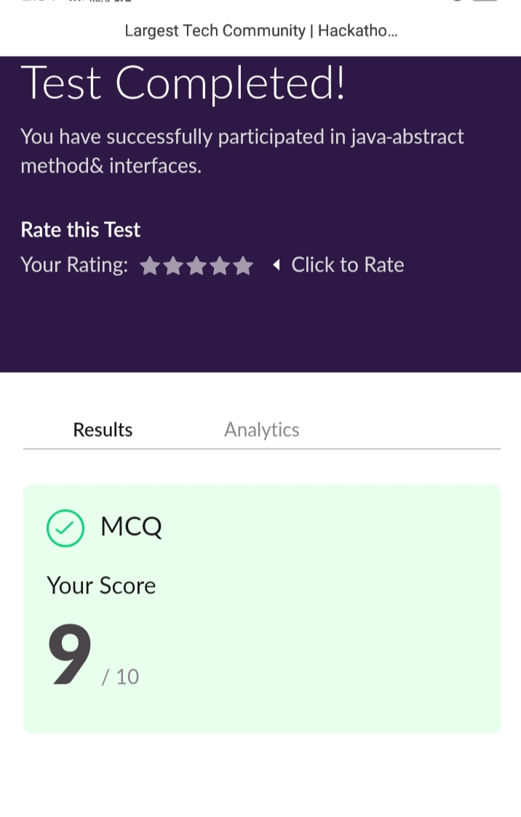
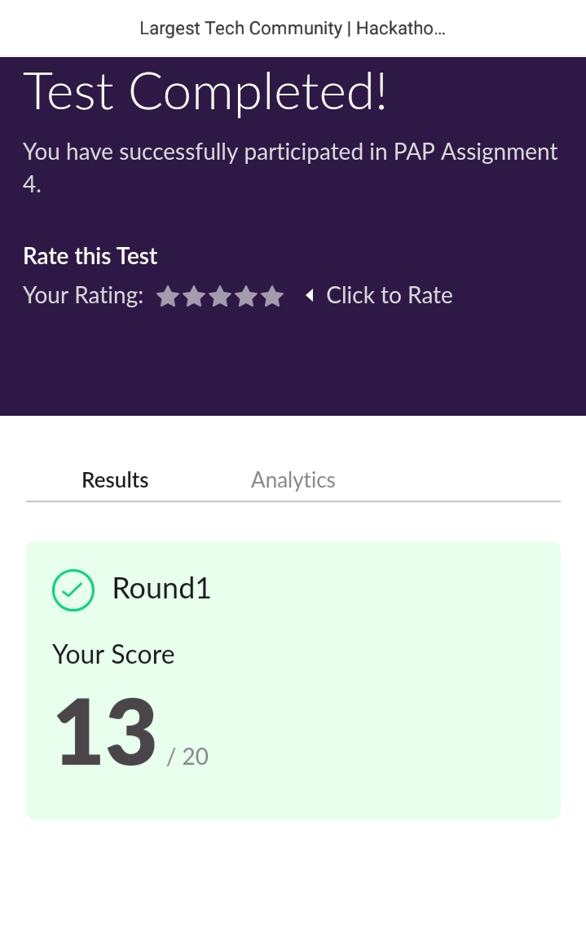
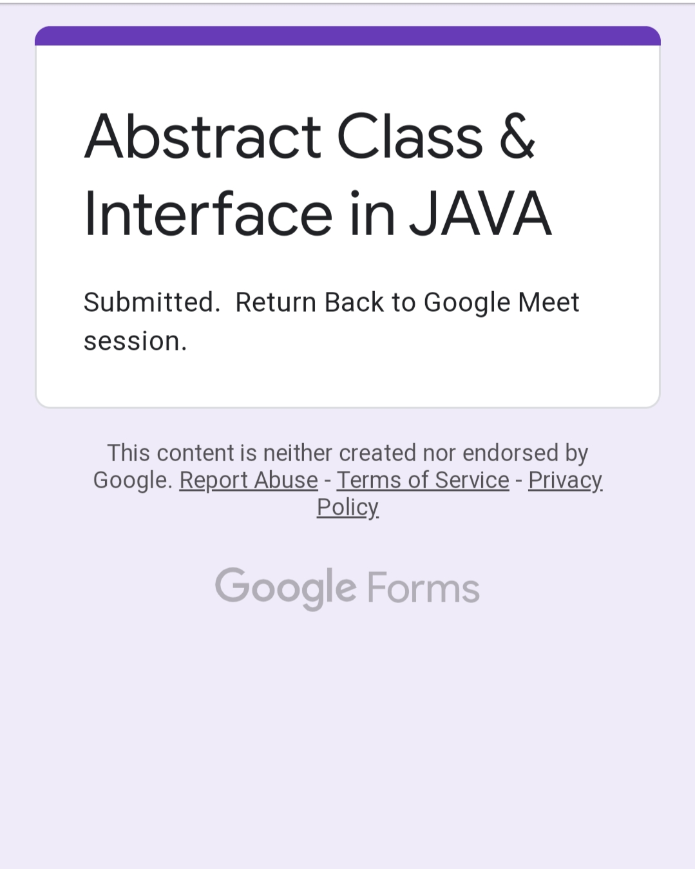

Workshop Details:
JAVA & J2EE:

Coding Challenge Details:
Program 1:
This is output of C program to sort a stack using Temporary Stack.

Program 2:
This is the output of the Java Program to traverse a binary tree using Pre Order traversal without recursion.

Refer GitHub for detailed information:
https://github.com/Raghavi26/dailystatus/tree/master/Online%20coding

