DAILY ONLINE ACTIVITIES SUMMARY
Date: | 27-06-20 |  |  |  |  | Name: | Raghavi H Gaonkar
Sem & Sec | VI Sem & B Sec |  |  |  |  | USN: | 4AL17CS071
Online Test Summary
Subject |  | DBMS and SQL  Java and J2EE
Max. Marks |  | - |  | Score |  |  | -
Certification Course Summary
Course | -
Certificate Provider |  |  | - |  | Duration |  |  | -
Coding Challenges
Problem Statement:2 Python Program
Status:Executed
Uploaded the report in Github |  |  |  |  | Yes
If yes Repository name |  |  |  |  | https://github.com/Raghavi26/dailystatus
Uploaded the report in slack |  |  |  |  | Yes

Online Test Details:

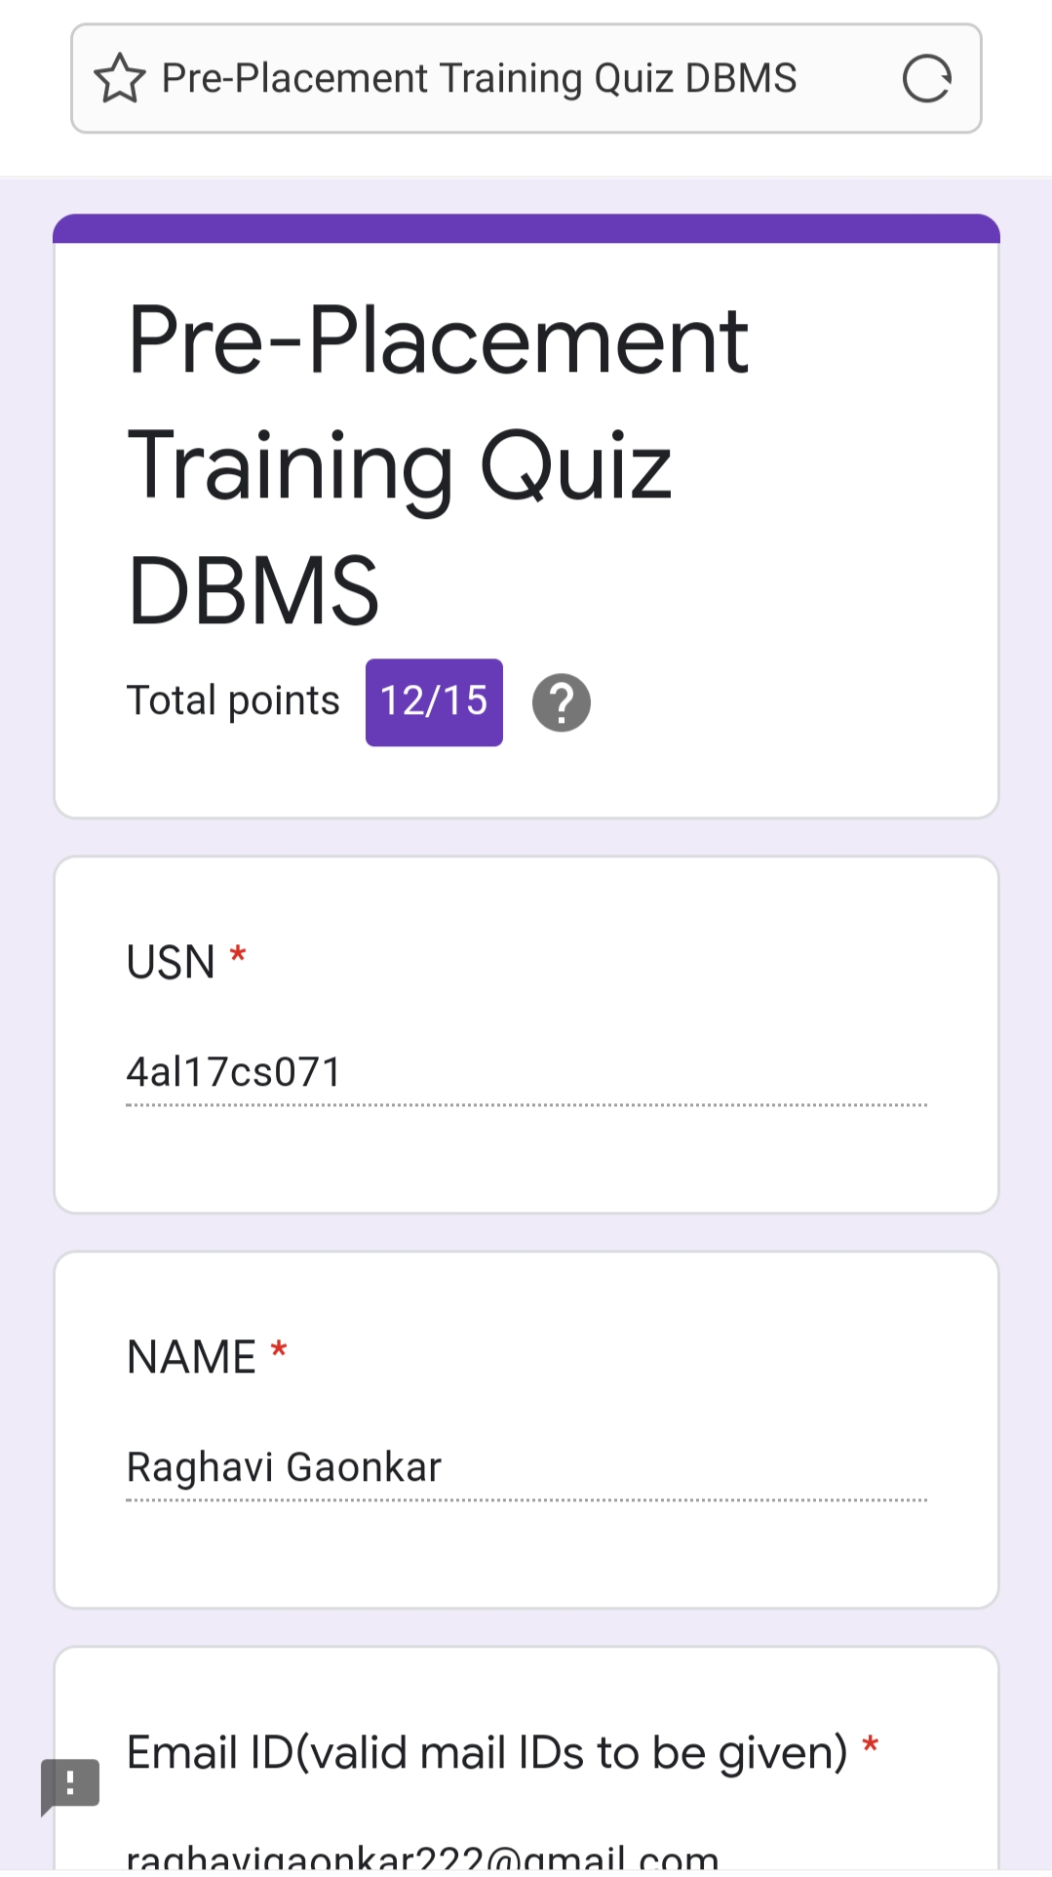
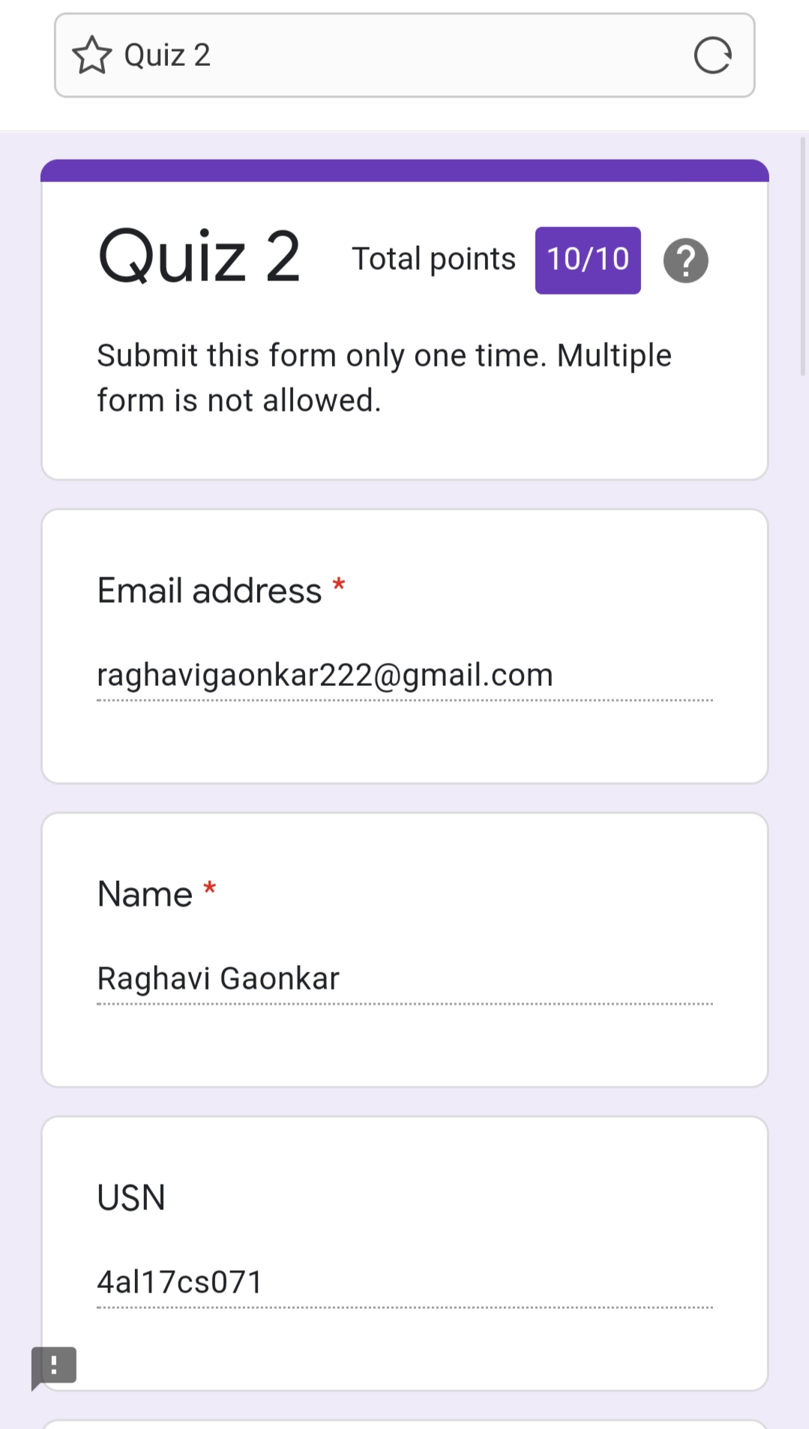

Workshop Details:

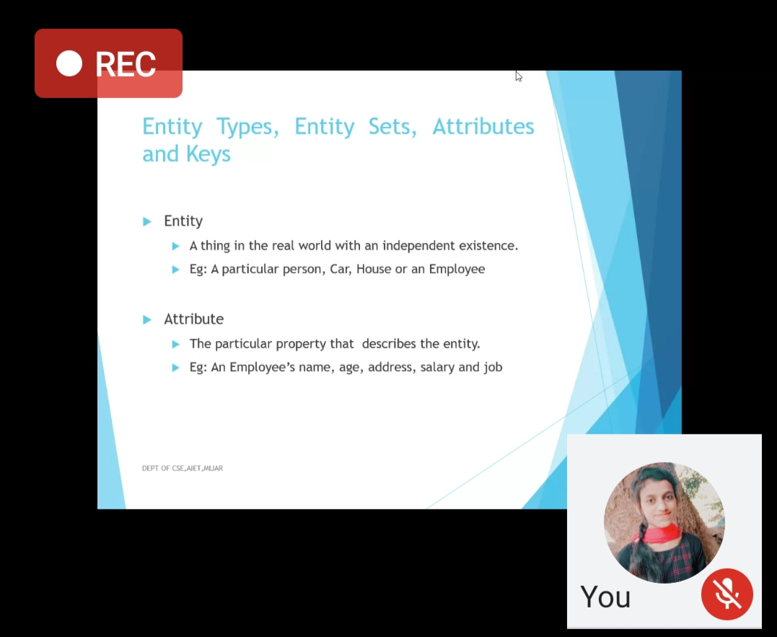
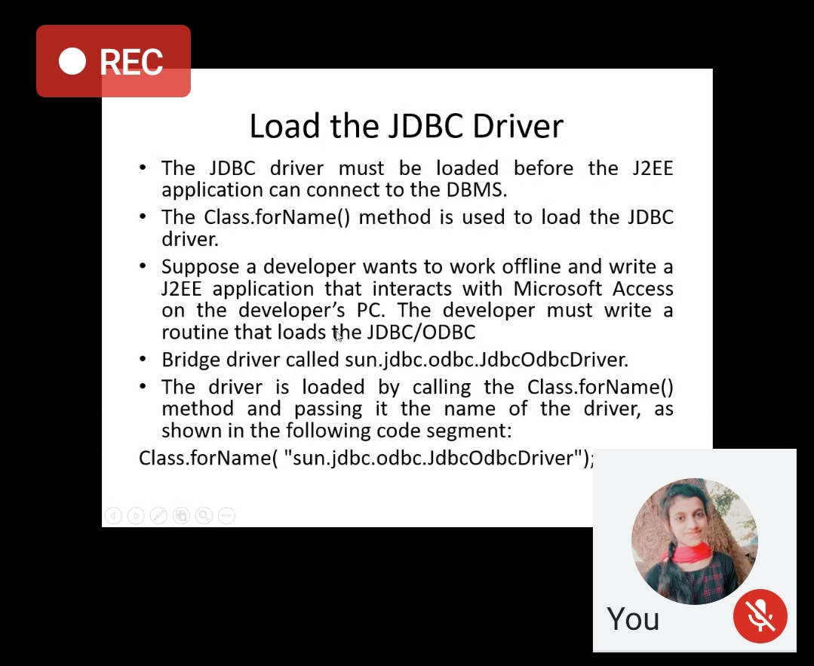

Coding Challenges Details:
Program 1:
This is output of python program to for cube sum of first n natural numbers.

Program 2:
This is the output of the python program to find quotient and reaminder.

Refer Github Account For Detailed Information:

https://github.com/Raghavi26/dailystatus/blob/master/Online%20coding/27-06-2020program1.docx

https://github.com/Raghavi26/dailystatus/blob/master/Online%20coding/27-06-2020program2.docx

DBMS and SQL:-
https://github.com/Raghavi26/dailystatus/blob/master/DBMS/SCHEMA%20AND%20ER(Raghavi).docx

